Insert your name, centre number and candidate number into the header above.
Save this evidence document as evidence_ followed by your centre number_ candidate number. For example: evidence_ zz999_9999.doc
Screenshots or program listings must be copied into appropriate cells in the following tables.
Examiners must be able to read the contents including any screenshots without the use of a magnifying glass. Answers that are not readable or missing will not be awarded any marks.
Save this evidence document at regular intervals, for example, every 10 minutes.
Question 1
Part 1(a)
DataStored = [] # A global 2D array of 20 integers
NumberItems = 0 # Global varible which stores the quantity of items the array contains

Part 1(b)
def Initialise():
global DataStored, NumberItems

# Prompt the user to input the quantity of numbers to enter
NumberItems = int(input("Please enter the number of items to enter: "))

# Validate the number no make sure it's within range
while NumberItems > 20 or NumberItems < 1:
NumberItems = int(input("Please enter the number of items to enter: "))

# Input each number
for i in range(NumberItems):
input_no = int(input())
DataStored.append(input_no)

Part 1(c)(i)
NumberItems = 0
Initialise()

print("Data stored:", DataStored)

Part 1(c)(ii)
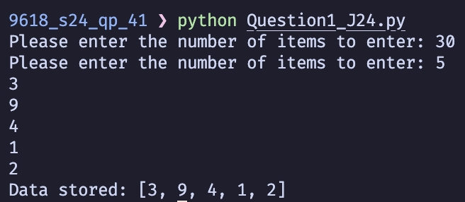

Part 1(d)(i)
def BubbleSort():
global DataStored

swapped = True

while swapped:
swapped = False

for i in range(len(DataStored)-1):
if DataStored[i] > DataStored[i+1]:
temp = DataStored[i]
DataStored[i] = DataStored[i+1]
DataStored[i+1] = temp
swapped = True

Part 1(d)(ii)
BubbleSort()
print("Data stored sorted:", DataStored)

Part 1(d)(iii)
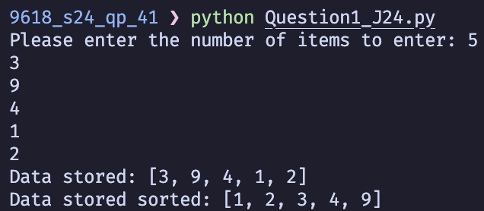

Part 1(e)(i)
def BinarySearch(DataToFind):
global DataStored

for i in range(NumberItems):
if DataStored[i] == DataToFind:
return i

return -1

Part 1(e)(ii)
{Copy and paste program code listing for question 1(e)(ii) here}

Part 1(e)(iii)
{Copy and paste screenshot for question 1(e)(iii) here}

Question 2
Part 2(a)(i)
{Copy and paste program code listing for question 2(a)(i) here}

Part 2(a)(ii)
{Copy and paste program code listing for question 2(a)(ii) here}

Part 2(b)
{Copy and paste program code listing for question 2(b) here}

Part 2(c)
{Copy and paste program code listing for question 2(c) here}

Part 2(d)(i)
{Copy and paste program code listing for question 2(d)(i) here}

Part 2(d)(ii)
{Copy and paste screenshot for question 2(d)(ii) here}

Part 2(e)(i)
{Copy and paste program code listing for question 2(e)(i) here}

Part 2(e)(ii)
{Copy and paste program code listing for question 2(e)(ii) here}

Part 2(e)(iii)
{Copy and paste screenshot for question 2(e)(iii) here}

Question 3
Part 3(a)
{Copy and paste program code listing for question 3(a) here}

Part 3(b)
{Copy and paste program code listing for question 3(b) here}

Part 3(c)
{Copy and paste program code listing for question 3(c) here}

Part 3(d)(i)
{Copy and paste program code listing for question 3(d)(i) here}

Part 3(d)(ii)
{Copy and paste program code listing for question 3(d)(ii) here}

Part 3(d)(iii)
{Copy and paste screenshot for question 3(d)(iii) here}

