Insert your name, centre number and candidate number into the header above.
Save this evidence document as evidence_ followed by your centre number_ candidate number. For example: evidence_ zz999_9999.doc
Screenshots or program listings must be copied into appropriate cells in the following tables.
Examiners must be able to read the contents including any screenshots without the use of a magnifying glass. Answers that are not readable or missing will not be awarded any marks.
Save this evidence document at regular intervals, for example, every 10 minutes.
Question 1
Part 1(a)(i)
class EventItem:
def __init__(self, EventName, Type, Difficulty):
self.__EventName = EventName # Name of Event
self.__Type = Type # Type of Event [jump, swim, run, drive]
self.__Difficulty = Difficulty # Difficulty of Event [1 .. 5]

Part 1(a)(ii)
def GetName(self):
return self.__EventName

def GetDifficulty(self):
return self.__Difficulty

def GetEventType(self):
return self.__Type

Part 1(b)(i)
Group = [] # type Event, 5 spaces

Part 1(b)(ii)
Group.append(EventItem('Bridge', 'jump', 3))
Group.append(EventItem('Water wade', 'swim', 4))
Group.append(EventItem('100 mile run', 'run', 5))
Group.append(EventItem('Gridlock', 'drive', 2))
Group.append(EventItem('Wall on wall', 'jump', 4))

Part 1(c)
class Character:
def __init__(self, Name, Jump, Swim, Run, Drive):
self.__Name = Name # Character Name
self.__Jump = Jump # Skill level at Event type of Jump
self.__Swim = Swim # Skill level at Event type of Swim
self.__Run = Run # Skill level at Event type of Run
self.__Drive = Drive # Skill level at Event type of Drive

def GetName(self):
return self.__Name

Part 1(d)
def CalculateScore(self, typeOfEvent, eventDifficulty):
CharacterSkill = -1 # Declare character skill varible

# Get Character Skill level
if typeOfEvent == 'jump':
CharacterSkill = self.__Jump
elif typeOfEvent == 'swim':
CharacterSkill = self.__Swim
elif typeOfEvent == 'run':
CharacterSkill = self.__Run
elif typeOfEvent == 'drive':
CharacterSkill = self.__Drive

# Calculate the score
if CharacterSkill >= eventDifficulty:
return 100
else:
difference = eventDifficulty - CharacterSkill

if difference == 1:
return 80
if difference == 2:
return 60
if difference == 3:
return 40
if difference == 4:
return 20
else:
return 0

Part 1(e)(i)
TarzCharacter = Character('Tarz', 5, 3, 5, 1)
GeniCharacter = Character('Geni', 2, 2, 3, 4)

Part 1(e)(ii)
TarzCharacter = Character('Tarz', 5, 3, 5, 1)
GeniCharacter = Character('Geni', 2, 2, 3, 4)

TarzScore = 0
GeniScore = 0

for i in range(5):
eventType = Group[i].GetEventType()
eventDifficulty = Group[i].GetDifficulty()

TarzChance = TarzCharacter.CalculateScore(eventType, eventDifficulty)
GeniChance = GeniCharacter.CalculateScore(eventType, eventDifficulty)

if TarzChance > GeniChance:
print("Tarz won event number " + str(i+1))
TarzScore = TarzScore + 1
elif GeniChance > TarzChance:
print("Geni won event number " + str(i+1))
GeniScore = GeniScore + 1
else:
print("Event number " + str(i+1) + " is a draw")

if TarzScore > GeniScore:
print("Tarz has the most points in the Group")
elif GeniScore > TarzScore:
print("Geni has the most points in the Group")
else:
print("Group is a draw")

Part 1(e)(iii)
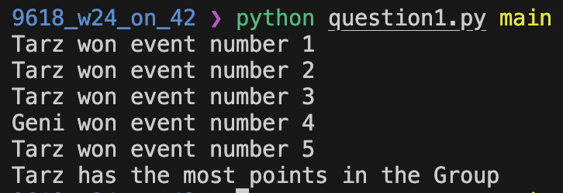

Question 2
Part 2(a)
class Queue:
def __init__(self, queue, headPointer, tailPointer):
self.QueueArray = queue # Array up to 100 INTEGER values
self.Headpointer = headPointer # Index first data Item
self.Tailpointer = tailPointer # Index next free location

Part 2(b)
emptyQueue = []
for i in range(100):
emptyQueue.append(-1)

TheQueue = Queue(emptyQueue, -1, 0)

Part 2(c)
def Enqueue(self, theData: int):
if self.Headpointer == -1:
self.QueueArray[self.Tailpointer] = theData
self.Headpointer = 0
self.Tailpointer = self.Tailpointer + 1
return 1
else:
if self.Tailpointer > 100:
return -1
else:
self.QueueArray[self.Tailpointer] = theData
self.Tailpointer = self.Tailpointer + 1
return 1

Part 2(d)
def ReturnAllData():
global TheQueue

OutputString = ""

for i in range(TheQueue.Headpointer, TheQueue.Tailpointer):
OutputString = OutputString + str(TheQueue.QueueArray[i]) + " "

return OutputString

Part 2(e)(i)
for i in range(10):
InputValue = -1

while InputValue < 0:
InputValue = int(input("Input next value: "))

ReturnValue = TheQueue.Enqueue(InputValue)

if ReturnValue == -1:
print("Queue is full")

outputString = ReturnAllData()

print(outputString)

Part 2(e)(ii)
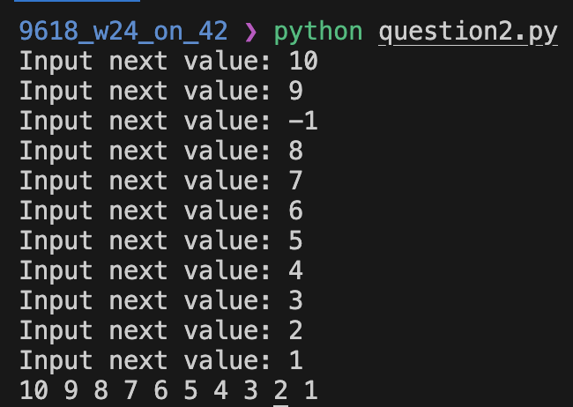

Part 2(f)
def Dequeue(self):
if self.Tailpointer == 0:
return -1
else:
nextItem = self.QueueArray[self.Headpointer]
self.Headpointer = self.Headpointer + 1

return nextItem

Part 2(g)(i)
for i in range(2):
NextValue = TheQueue.Dequeue()

if NextValue == -1:
print("Queue is empty")
else:
print(NextValue)

Part 2(g)(ii)
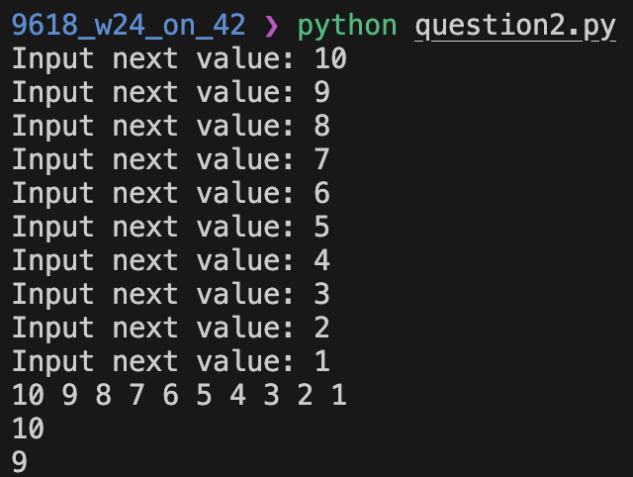

Question 3
Part 3(a)
HighScores = [] # ARRAY [0:10] OF ARRAY [STRING, INTEGER, INTEGER]

for i in range(7):
emptyScore = ["", "", ""]
HighScores.append(emptyScore)

Part 3(b)
def ReadData():
scoreData = []

try:
file = open('HighScoreTable.txt', 'r')

for i in range(7):
playerID = file.readline().strip()
gameLevel = int(file.readline().strip())
score = int(file.readline().strip())

scoreData.append([playerID, gameLevel, score])

return scoreData
except IOError:
print("File not found")

Part 3(c)
def OutputHighScores(scores):
for i in range(len(scores)):
print(str(scores[i][0])+ " reached level " + str(scores[i][1]) + " with a score of " + str(scores[i][2]))

Part 3(d)
def SortScores(scores):
sortedScores = scores

swapped = True

while swapped == True:
swapped = False

for i in range(len(sortedScores) - 1):
temp1 = sortedScores[i]

if sortedScores[i][1] < sortedScores[i+1][1]:
sortedScores[i] = sortedScores[i+1]
sortedScores[i+1] = temp1
swapped = True
elif sortedScores[i][1] == sortedScores[i+1][1]:
if sortedScores[i][2] < sortedScores[i+1][2]:
sortedScores[i] = sortedScores[i+1]
sortedScores[i+1] = temp1
swapped = True

return sortedScores

Part 3(e)(i)
HighScores = ReadData()
print("Before")
OutputHighScores(HighScores)
HighScores = SortScores(HighScores)
print("After")
OutputHighScores(HighScores)

Part 3(e)(ii)
