* Union: combine the result-set of two or more Select statements( select only distinct values). Union All: allow duplicate values. SELECT column_name(s) FROM table1 UNION SELECT column_name(s) FROM table2;
* Check constraint is to limit the values that can be placed in the column.
* Index: single-column indexes, unique indexes, composite indexes. Clustered Indexes: sort physical data inside the table, only one. Non-clustered is vice versa( non-clustered indexes are stored in 1 place and the table is stored in another place => cost more extra storage)
* Trigger is a special type of SP, automatically runs when event occurs in db server in order to check constraints, having no parameter. After (update other tables after executed), before (check data before execute). Use to check constraints on tables or rows. Trigger has 2 default tables: inserted ( insert and update records), deleted
* View and temporary table:  
   - View: doesn’t use extra storage, whereas temporary table
* View guarantees to see the current data in the source tables.
* Can modify data in temporary table, view has to change data in data source
* User defined function( create function): used in select statement
* Check Null: use IFNULL(), ISNULL(), COALESCE(). Select ProductName, UnitPrice*(UnitsInStock + IFNULL(UnitsInOrder, 0);
* Create SP Syntax: Create Procedure procedure_name @name_variable type

As sql_statment

GO;

* Create Function syntax: CREATE FUNCTION function_name(parameter_list)

Return data_type

Begin

Statement

Return value

end

* Formal Forms in DB:
* If a column contains multiple values. It violates first normal form. 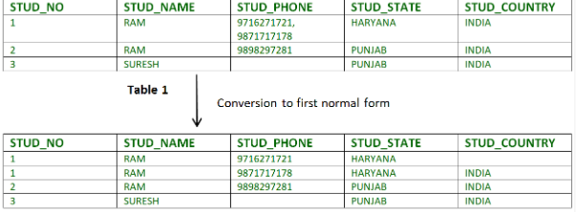
* 2NF: if it has partial dependency. ( A field is dependent on primary key). Like example below: STU_NO is dependent with COURSE_NO(primary key)

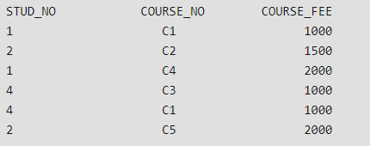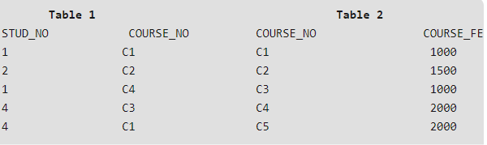

* Having transitive dependency. Like ex: Stud_STATE => Stud_COUNTRY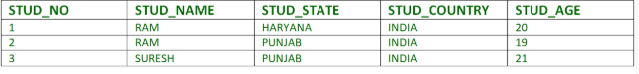
* Optimize select query:
* Avoid using asterisk (SELECT * FROM Sales.SalesOrderDetail;) => Select a, b from Sales.SalesOrderDetail.
* Don’t use scalar valued functions in where clause (SELECT ProductNumber FROM Production.Product WHERE SUBSTRING (ProductNumber,1,2) = 'AR'). Coz indexes can’t be used in this approach.
* When use ‘and’ in where clause => most can wrong put at first