5.1. (5 pages) Overfitting

What is overfitting.
Overfitting is when a machine learning model learns too much detail from the training data — including random noise or patterns that don’t generalize — instead of learning the underlying trend.
As a result:
- The model performs very well on training data.
- But it performs poorly on new, unseen data (validation/test data).
Example
- Suppose you want to predict house prices.
- A well-fit model might learn relationships like: “larger houses usually cost more.”
- An overfit model might memorize quirks, like “a house with exactly 3.7 bathrooms and blue walls costs $500,000.” That rule works for one house in the training set, but fails for new houses.
Symptoms of Overfitting
- Training accuracy is high, but validation/test accuracy is much lower.
- Model complexity is unnecessarily high (too many parameters/features).

Copy image from textbook_2 and explain
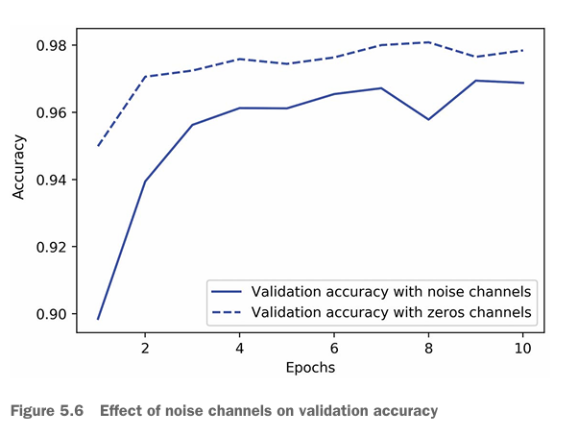

What the figure shows
- X-axis (horizontal): Training epochs (how many times the model has seen the data).
- Y-axis (vertical): Validation accuracy (how well the model performs on unseen data).
- Two curves:
  - Solid line: Validation accuracy when extra noise channels are added to the input.
  - Dashed line: Validation accuracy when extra channels are filled with zeros (no useful information, but also not random noise).

Key observations
- Early epochs (1–3):
  - Both models improve rapidly.
  - The model with zero channels (dashed line) achieves slightly higher accuracy early.
  - The noise channels make learning harder initially, since the model wastes effort trying to interpret random signals.
- Later epochs (4–10):
  - Both models plateau around ~0.97–0.98 accuracy.
  - The zero-channel model (dashed) consistently stays a little higher.
  - The noise-channel model (solid) fluctuates more — noise makes generalization harder.

Interpretation
- Noise channels act like distractions: The model may overfit to random patterns, hurting validation accuracy.
- Zero channels are harmless: They don’t add information, but they also don’t mislead the model.
- The takeaway: Feeding irrelevant or noisy features reduces validation accuracy, since the model might overfit to them.
✅ In short:
This figure demonstrates that adding noisy input features can hurt validation accuracy compared to adding empty (zeroed-out) features, even when the model has enough capacity to learn.

Techniques for decreasing/preventing overfitting: present each technique in detail
1. Get More Training Data
- Why it helps: Overfitting happens when the model memorizes the training set. More data gives the model more diverse examples, making it harder to memorize and forcing it to learn general patterns.
- How to do it:
  - Collect more real-world samples.
  - Use data augmentation (for images: rotations, flips, crops; for text: synonym replacement, paraphrasing; for audio: noise injection, pitch shift).
- Example: In image classification, flipping or rotating images of cats and dogs makes the dataset larger and reduces memorization.

2. Simplify the Model
- Why it helps: Very complex models (deep, wide, many parameters) can memorize data. Simpler models generalize better.
- How to do it:
  - Reduce the number of layers or neurons.
  - Prune decision trees (limit depth, remove unnecessary branches).
  - Use fewer features (feature selection).
- Trade-off: Too simple → risk of underfitting. Need balance.

3. Regularization
- Why it helps: Regularization penalizes complexity, discouraging the model from relying on any single weight or feature.
- Types:
  - L1 (Lasso): Adds penalty proportional to absolute weights. Encourages sparsity (many weights = 0).
  - L2 (Ridge/Weight Decay): Adds penalty proportional to squared weights. Keeps weights small, avoids dominance of any one feature.
  - Elastic Net: Combination of L1 + L2.
- Equation (L2 example):
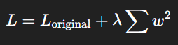
where λ\lambdaλ is the regularization strength.

4. Dropout (for Neural Networks)
- Why it helps: Dropout randomly “turns off” neurons during training. This prevents co-adaptation, forcing the network to spread learning across many neurons.
- How it works:
  - At each training step, randomly drop a percentage of neurons (e.g., 20–50%).
  - At test time, all neurons are active, but with scaled-down weights.
- Effect: Acts like training many smaller networks and averaging them → reduces overfitting.

5. Early Stopping
- Why it helps: Training too long makes the model start memorizing noise.
- How it works:
  - Track validation loss/accuracy during training.
  - Stop when validation performance stops improving, even if training accuracy is still going up.
- Practical tip: Use a “patience” setting (e.g., wait 5 epochs after last improvement before stopping).

6. Cross-Validation
- Why it helps: Ensures the model generalizes across different splits of the data. Prevents accidentally fitting quirks of a single training/validation split.
- How it works:
  - k-fold cross-validation: Split data into kkk folds, train on k−1k-1k−1, validate on 1, and repeat.
  - Average results to get a stable estimate of generalization.

7. Reduce Input Noise / Irrelevant Features
- Why it helps: Noisy or irrelevant features can trick the model into finding fake patterns.
- How to do it:
  - Feature selection (remove useless inputs).
  - Dimensionality reduction (PCA, autoencoders).
  - Clean data (remove mislabeled or corrupted samples).
- Example: In medical data, patient ID numbers shouldn’t be used as features — they carry no predictive meaning but might cause overfitting.

8. Ensemble Methods
- Why it helps: Combines multiple models to average out individual overfitting behaviors.
- Types:
  - Bagging (Bootstrap Aggregation): Train multiple models on random subsets (e.g., Random Forest).
  - Boosting: Sequentially train weak learners that correct previous mistakes (e.g., XGBoost, AdaBoost).
  - Stacking: Train different models and combine their outputs with another model.
- Effect: Reduces variance, improves robustness.

9. Data Noise Injection (Regularization via Augmentation)
- Why it helps: Adding controlled noise during training forces the model to generalize better.
- Examples:
  - Add Gaussian noise to inputs.
  - Randomly mask out input values.
  - Jitter labels slightly (in some reinforcement learning settings).

10. Batch Normalization
- Why it helps: Normalizes activations in each layer → smoother optimization, less dependency on initial weights, more robust training.
- Indirect effect: Also has a regularization-like effect that reduces overfitting.

✅ Summary:
- Data-focused methods: More data, augmentation, cleaning, feature selection.
- Model-focused methods: Simplify, dropout, regularization, early stopping, batch norm.
- Evaluation-focused methods: Cross-validation, ensembling.

Examples with codes
🔹 1. Regularization (L1 & L2)
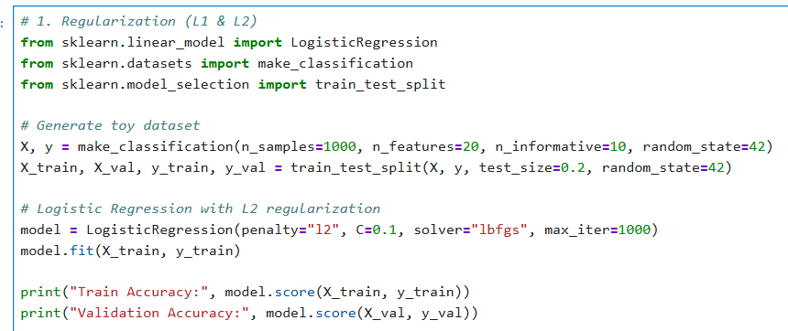
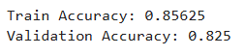
🔹 2. Dropout (Deep Learning)
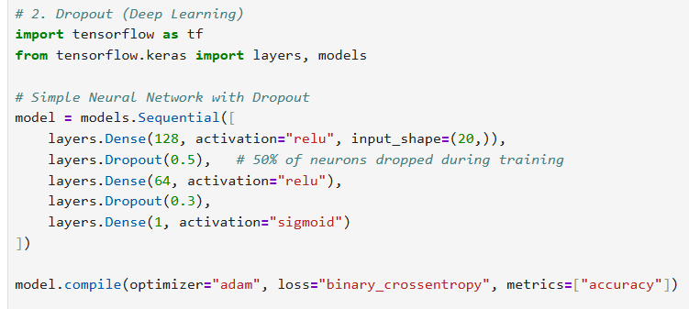
👉 Dropout forces the network to not rely on specific neurons → reduces overfitting.

🔹 3. Early Stopping
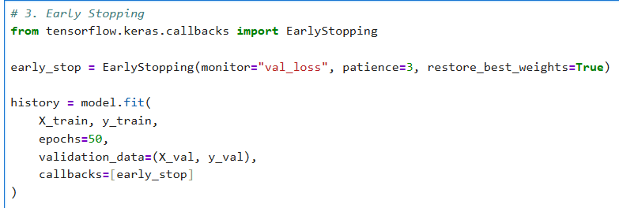
Training will stop if validation loss does not improve for 3 epochs.
🔹 4. Data Augmentation (Images)
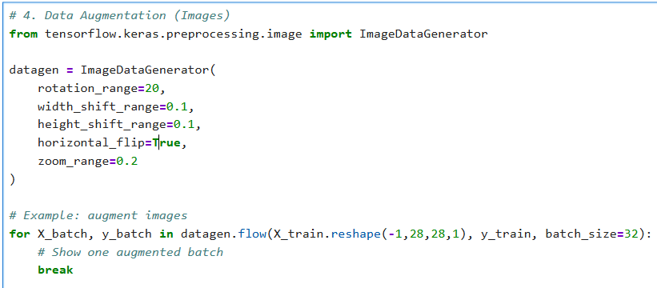
👉 This generates new “synthetic” training images to avoid memorization.

🔹 5. Cross-Validation
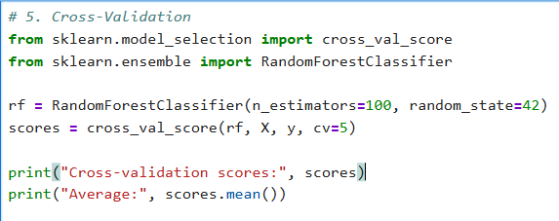
👉 Cross-validation ensures the model generalizes across different splits.

🔹 6. Ensemble (Bagging)
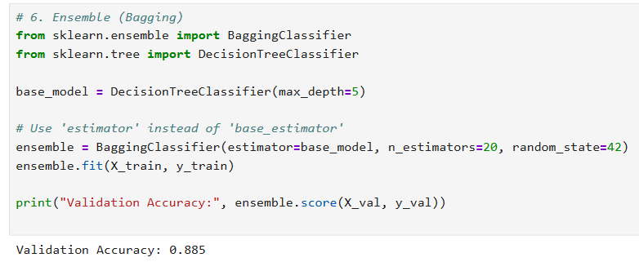
👉 Bagging reduces variance by averaging multiple models trained on random subsets.

🔹 7. Noise Injection (Regularization trick)
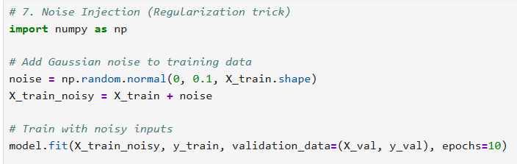
👉 Adding small noise to inputs makes the model more robust.

5.2. Using 2 techniques change learning rate, augmentation to decrease overfitting of models
Change learning rate:
Learning rate = 0.00001
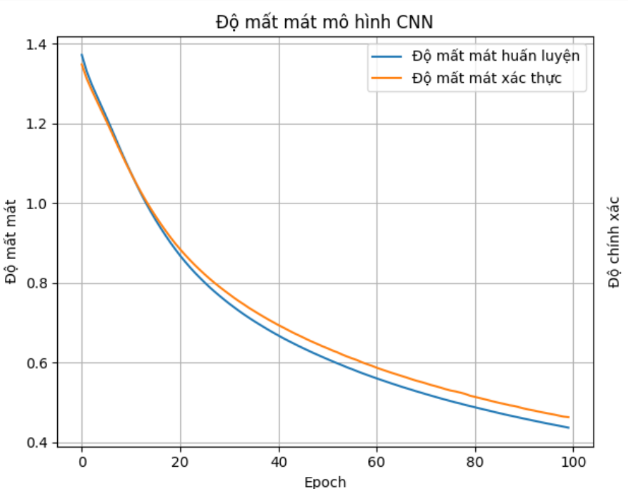
Với mô hình CNN thì từ epoch 20 loss của tập huấn luyện > loss của tập xác thực -> Mô hình bắt đầu bị overfitting
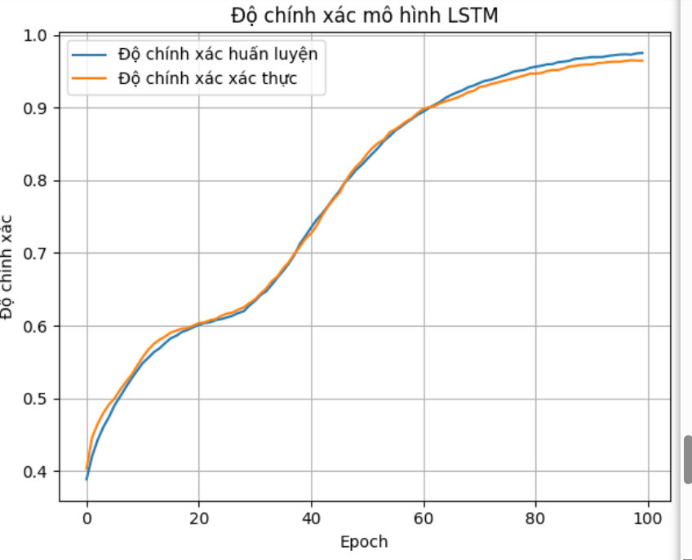
Với mô hình LSTM thì từ epoch khoảng 62 độ chính xác của tập huyến luyện cao hơn độ chính xác tập xác thực -> Mô hình bị overfitting
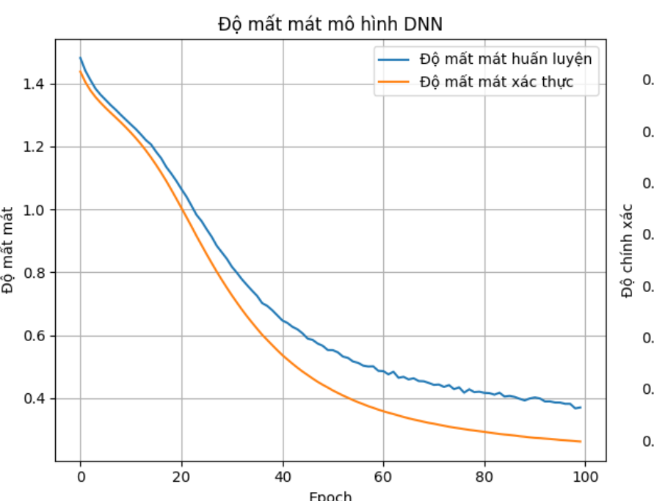
Loss của tập train > Loss của tập val -> mô hình không bị overfitting

Thay learning rate = 0.0001
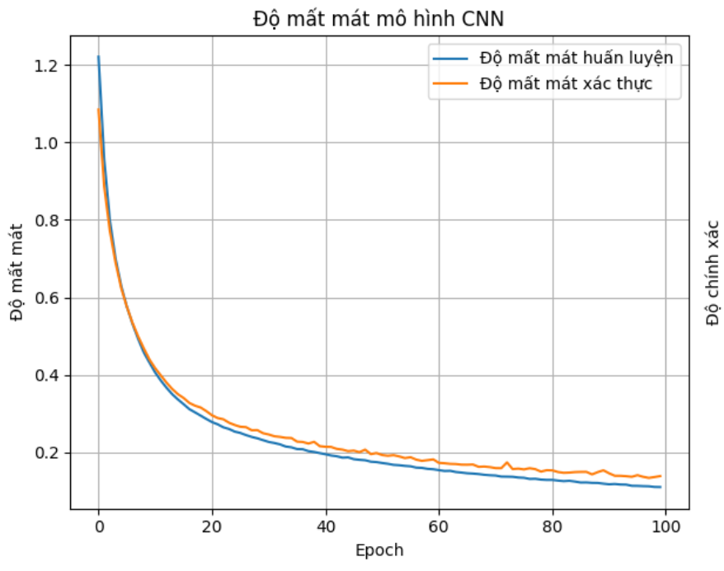
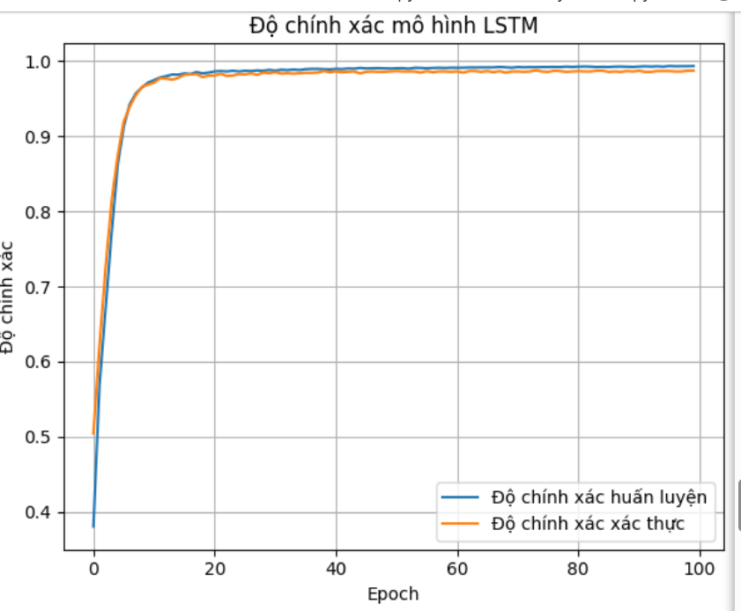
Mô hình CNN và LSTM đã không còn bị overfitting nữa

5.3. (5 pages) Presenting 10 techniques for representing text in vector/tensor 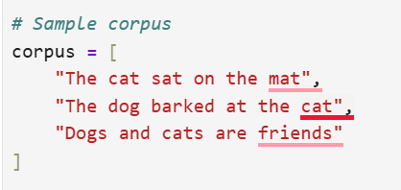
1. One-Hot Encoding (Word Counting)
One-hot encoding is the most basic vector representation for text. Each unique word in the vocabulary is assigned an index, and a word is represented by a binary vector where only the index corresponding to that word is 1, and all other entries are 0.
- Vocabulary: {cat, dog, mouse}
- One-hot vector for “dog”: [0, 1, 0]
Advantages: Simple, deterministic.
Disadvantages: Very sparse vectors, no semantic similarity between words.
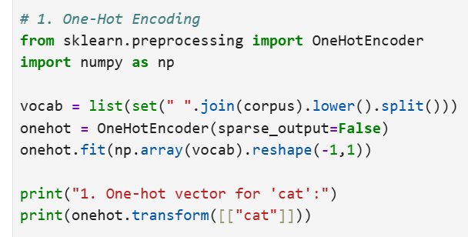
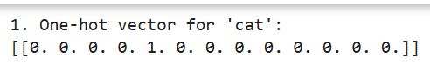

2. Bag-of-Words (BoW)
The Bag-of-Words model represents a document as a vector of word counts, disregarding word order but capturing frequency information.
Example with vocabulary {cat, dog, mouse}:
- Document: “dog dog cat”
- Vector: [1, 2, 0]
Advantages: Easy to compute, works well for simple tasks.
Disadvantages: Ignores word order, results in high-dimensional sparse vectors.
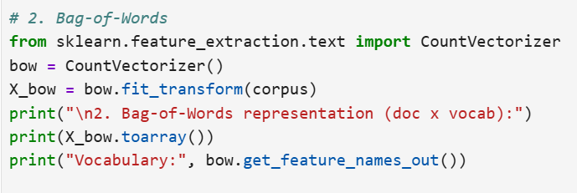
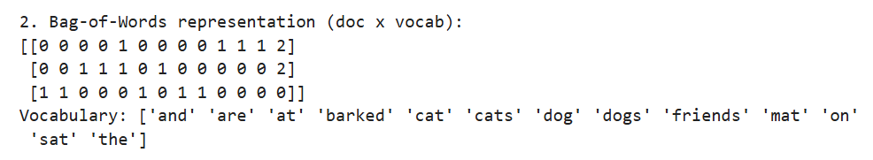

3. Term Frequency – Inverse Document Frequency (TF-IDF)
TF-IDF improves upon BoW by weighting words according to their importance in a document relative to the entire corpus.
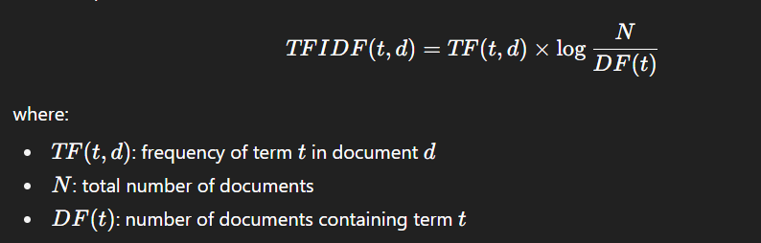Advantages: Reduces the weight of common words (e.g., “the”, “and”).
Disadvantages: Still ignores semantics and word order.
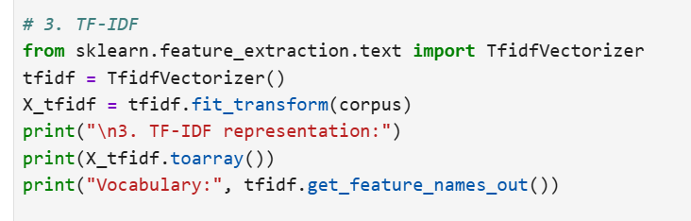
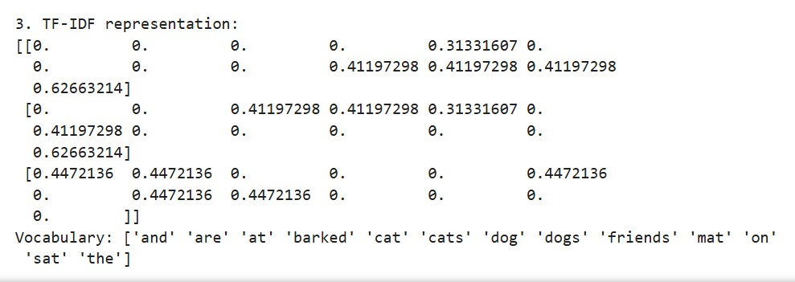

4. Word2Vec (Mikolov et al., 2013)
Word2Vec uses a shallow neural network to learn word embeddings such that words with similar meanings are close in vector space. Two main training architectures exist: Skip-gram and Continuous Bag-of-Words (CBOW).
- Skip-gram predicts context words from a target word.
- CBOW predicts a target word from surrounding context words.
Example: “king – man + woman ≈ queen”
Advantages: Captures semantic and syntactic relationships.
Disadvantages: Static embeddings; same vector for a word in all contexts.
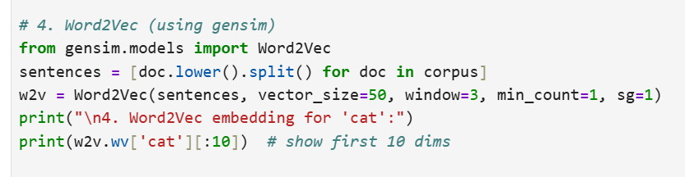
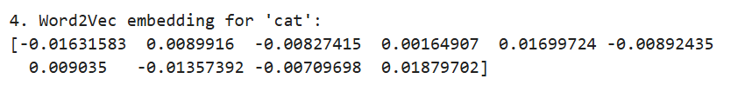

5. GloVe (Global Vectors for Word Representation)
GloVe combines the advantages of matrix factorization and predictive models. It uses word co-occurrence statistics from a large corpus to learn dense embeddings.
Objective function (simplified):
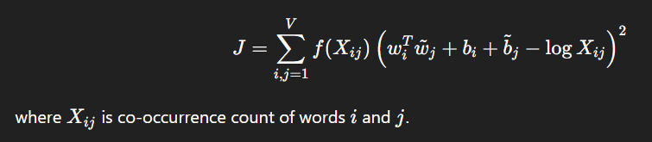
Advantages: Incorporates global corpus statistics.
Disadvantages: Still produces static embeddings.
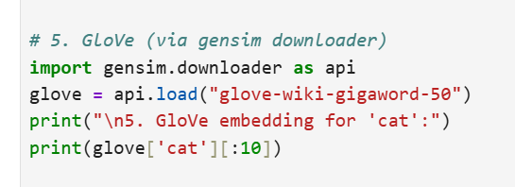
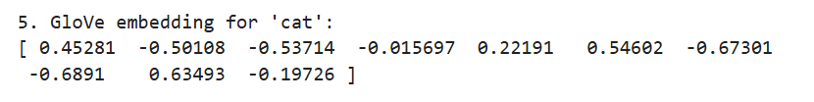
6. FastText
FastText (Facebook AI) improves Word2Vec by considering subword information (character n-grams). This allows it to handle rare and out-of-vocabulary words.
- Example: “playing” → subwords: “play”, “lay”, “ing”
- The final embedding is the sum of embeddings of its subwords.
Advantages: Handles morphology, useful for morphologically rich languages.
Disadvantages: Still context-independent.
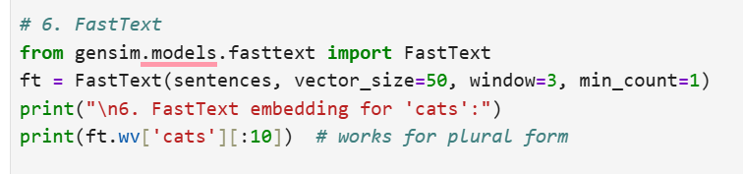
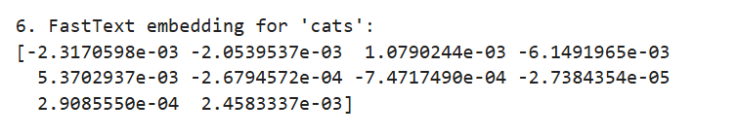

7. ELMo (Embeddings from Language Models)
ELMo (Peters et al., 2018) generates contextual word embeddings using deep bidirectional LSTMs trained on a language modeling objective. Each word’s representation depends on the entire sentence.
- Example: “bank” in “river bank” vs. “bank loan” → different vectors.
Advantages: Context-aware, captures polysemy.
Disadvantages: Computationally heavy, replaced by transformers in practice.
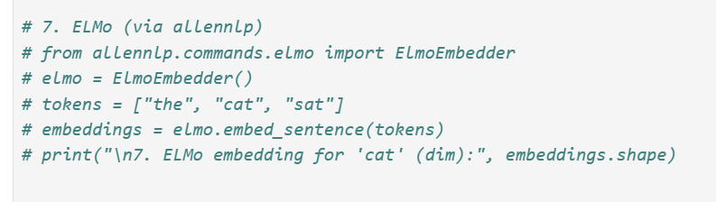

8. BERT (Bidirectional Encoder Representations from Transformers)
BERT (Devlin et al., 2019) uses a transformer encoder to generate deep contextual embeddings. It is pretrained using Masked Language Modeling (MLM) and Next Sentence Prediction (NSP).
- Input: “The cat sat on the [MASK].”
- Output: predicts “mat”.
Advantages: State-of-the-art performance across NLP tasks.
Disadvantages: Requires large-scale pretraining, resource intensive.
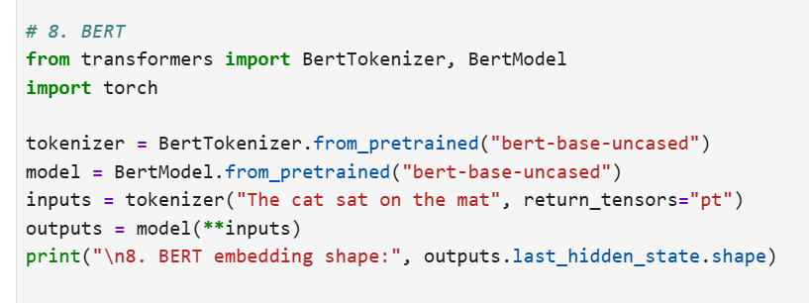

9. Sentence Embeddings (Doc2Vec, Sentence-BERT)
While word embeddings capture word-level meaning, document and sentence embeddings map entire sequences into a single vector.
- Doc2Vec (Le & Mikolov, 2014): Adds a paragraph vector to Word2Vec framework.
- Sentence-BERT: Fine-tunes BERT using a Siamese architecture to produce semantically meaningful sentence embeddings.
Advantages: Useful for semantic similarity and retrieval tasks.
Disadvantages: Training and fine-tuning can be resource-heavy.
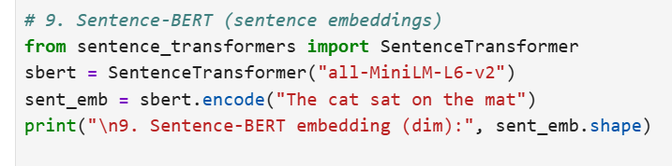
10. Transformer-based Large Language Models (GPT, T5, etc.)
Modern LLMs such as GPT and T5 provide contextualized embeddings at the token, sentence, and document levels. The hidden states of transformer layers serve as rich representations for downstream tasks.
Advantages: Extremely powerful, transfer learning across tasks.
Disadvantages: Very large models, require significant compute and storage.
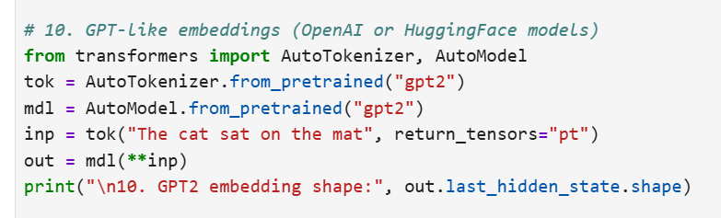
Conclusion
Text representation has evolved from simple sparse encodings (One-hot, BoW, TF-IDF) to dense neural embeddings (Word2Vec, GloVe, FastText) and finally to contextual embeddings from deep language models (ELMo, BERT, GPT). Each method offers a trade-off between simplicity, interpretability, and semantic richness. The choice of representation depends on the task, resources, and desired accuracy.

5.4
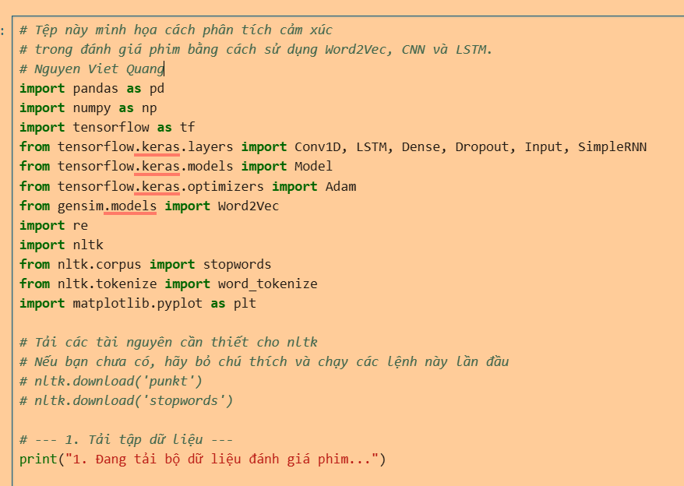
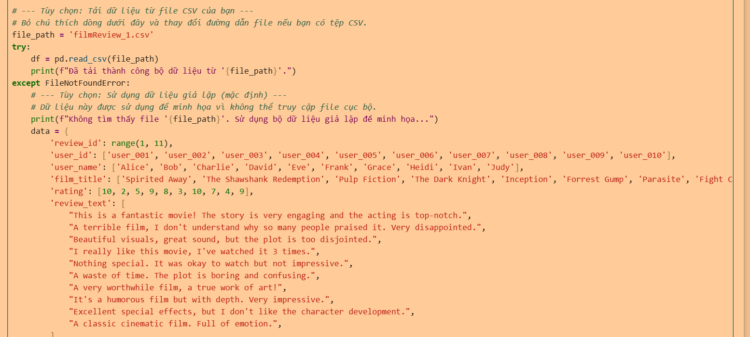
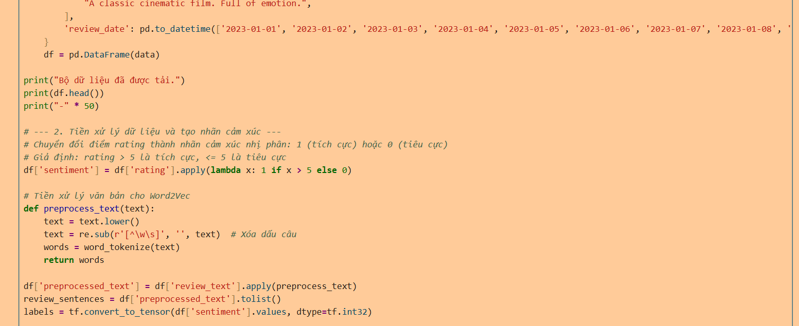
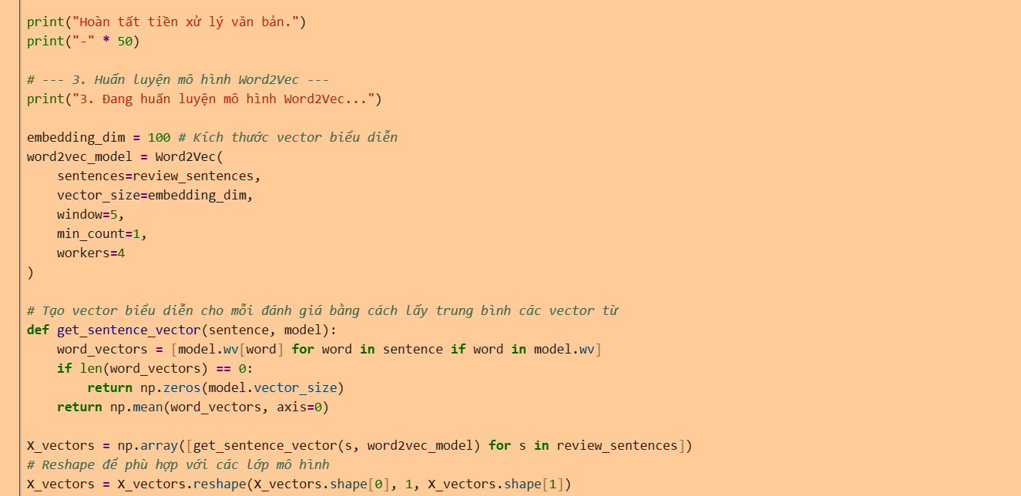
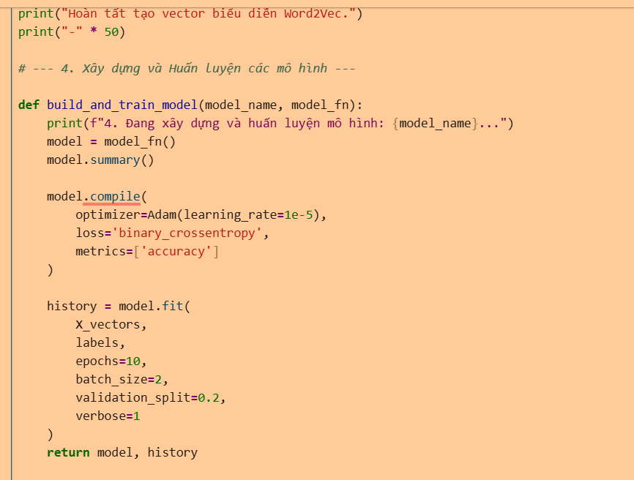
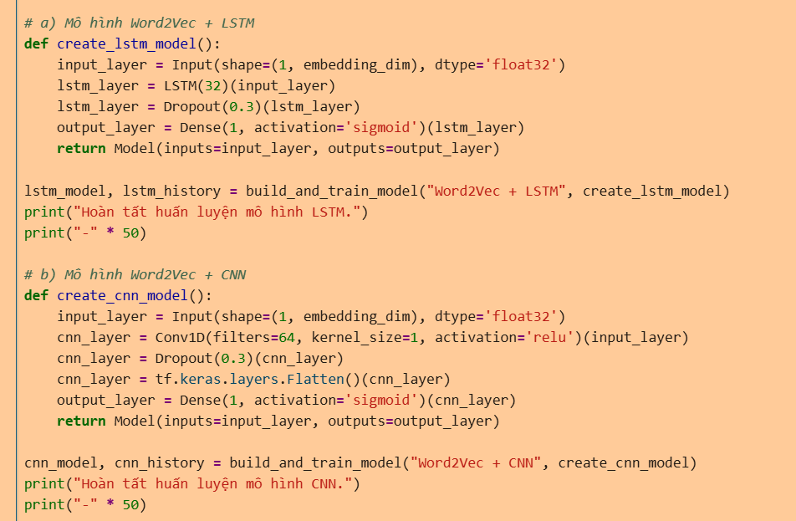
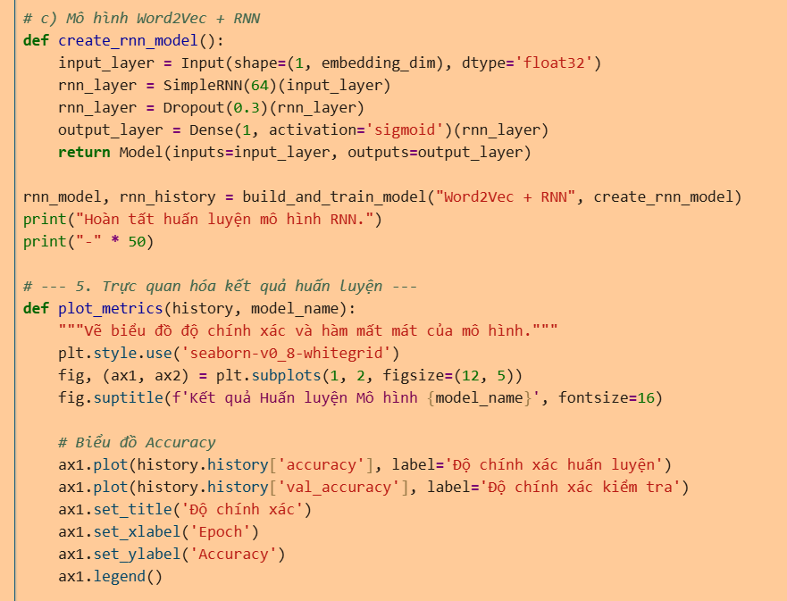
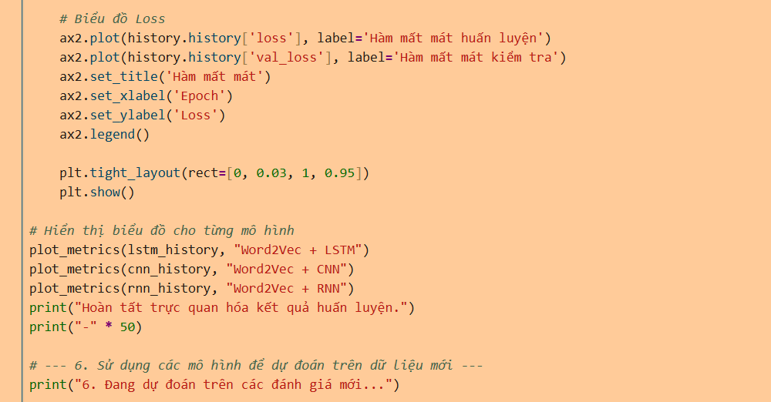
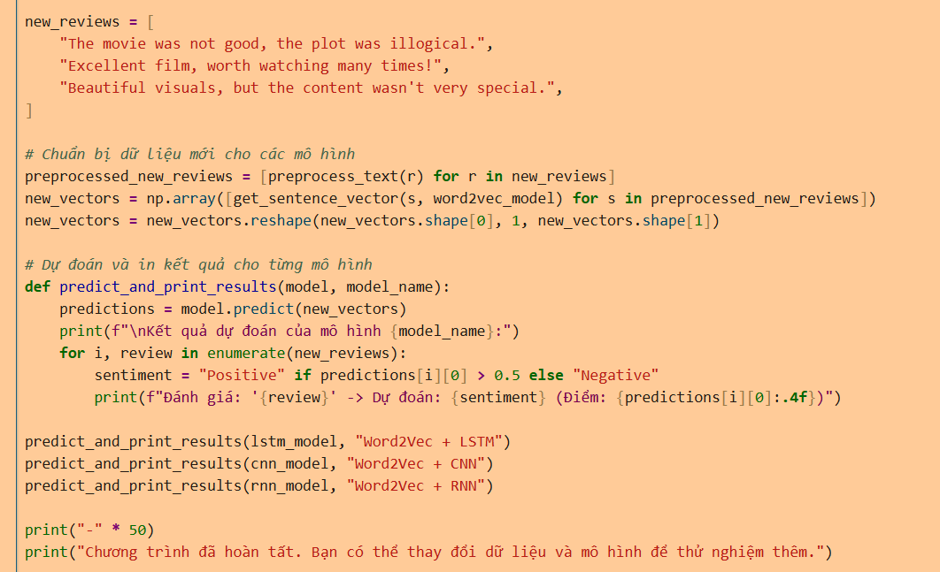
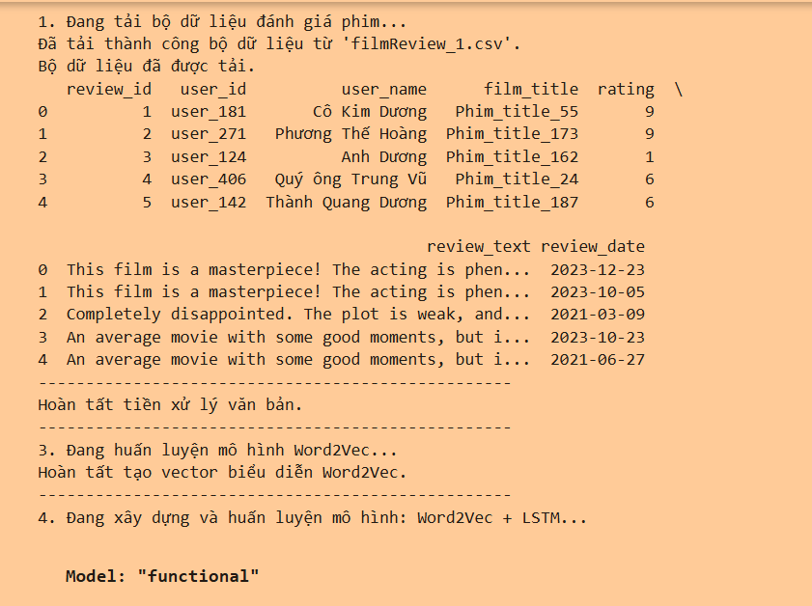
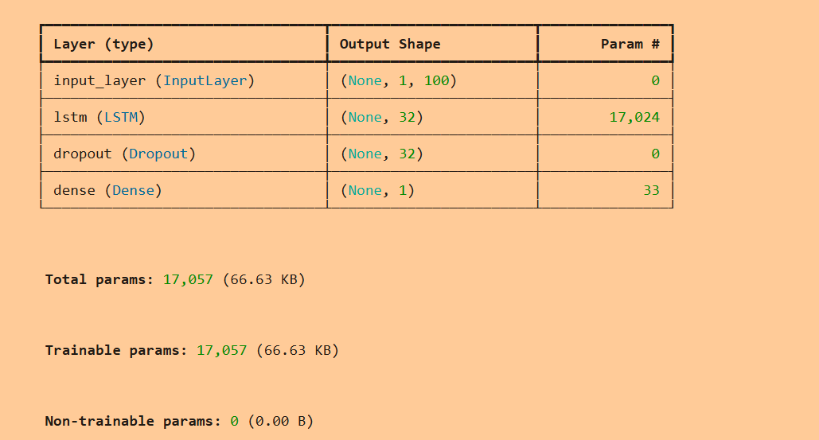
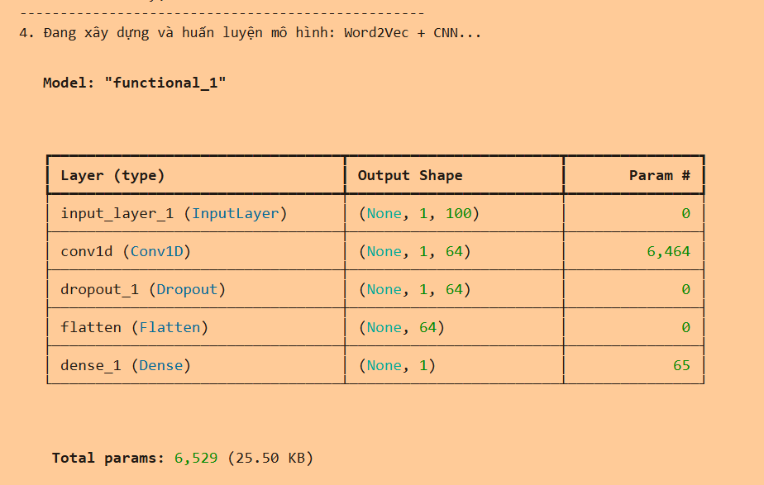
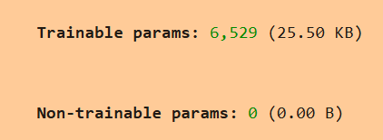
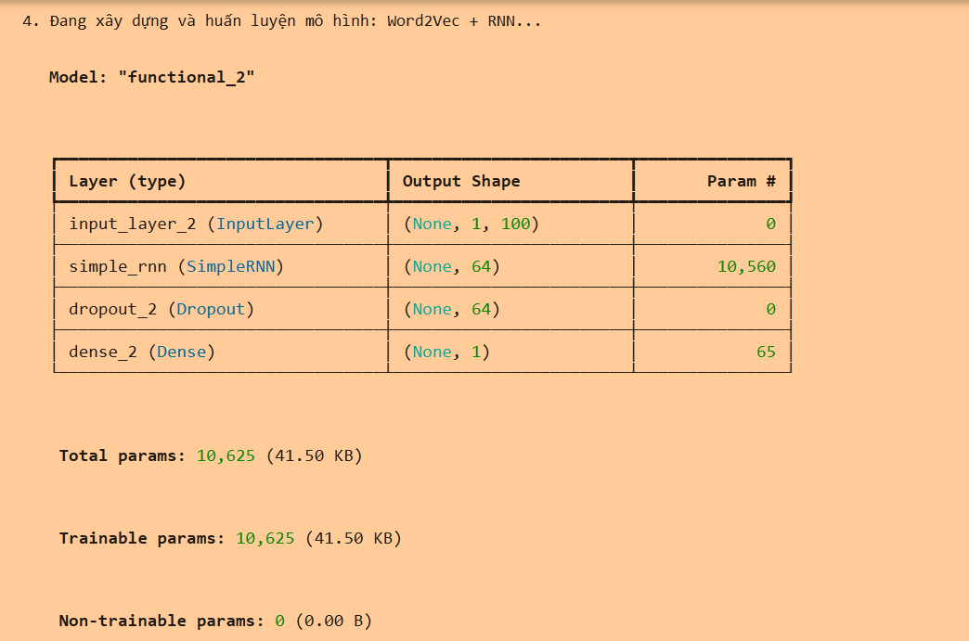
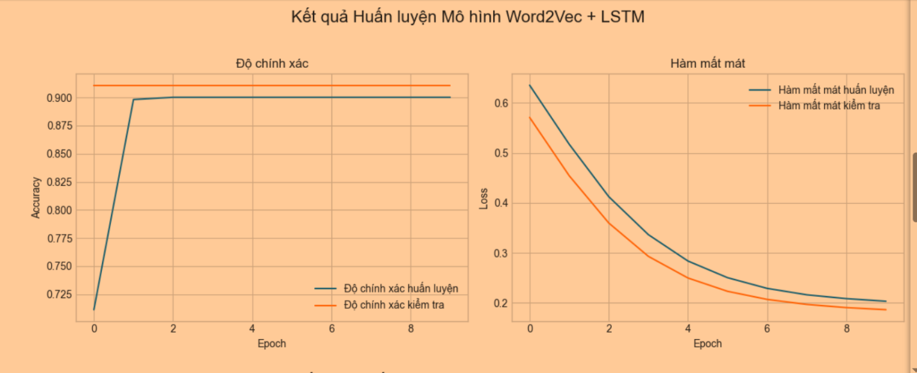
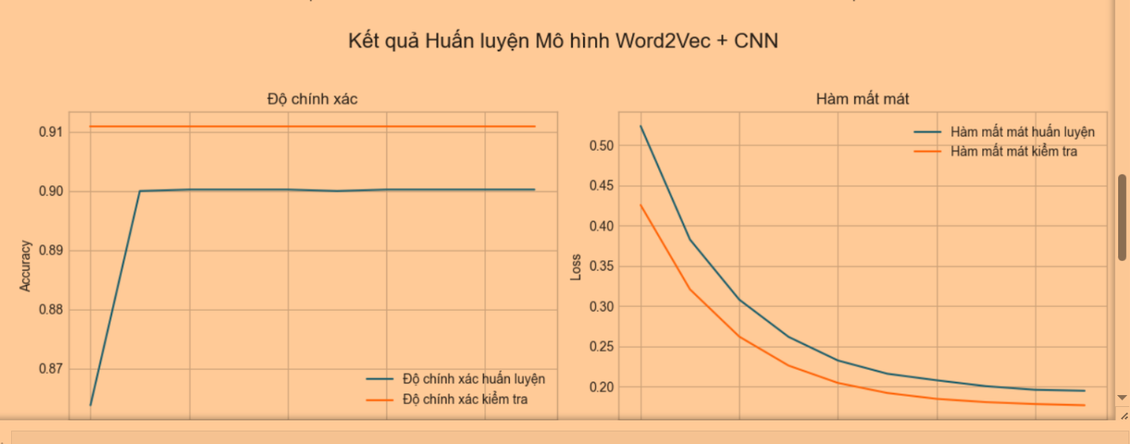
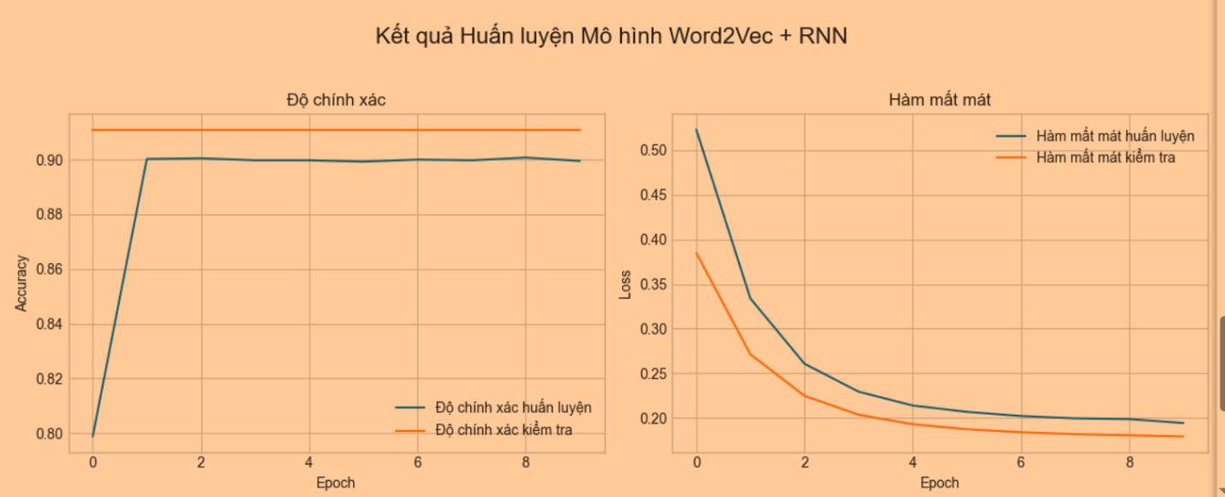
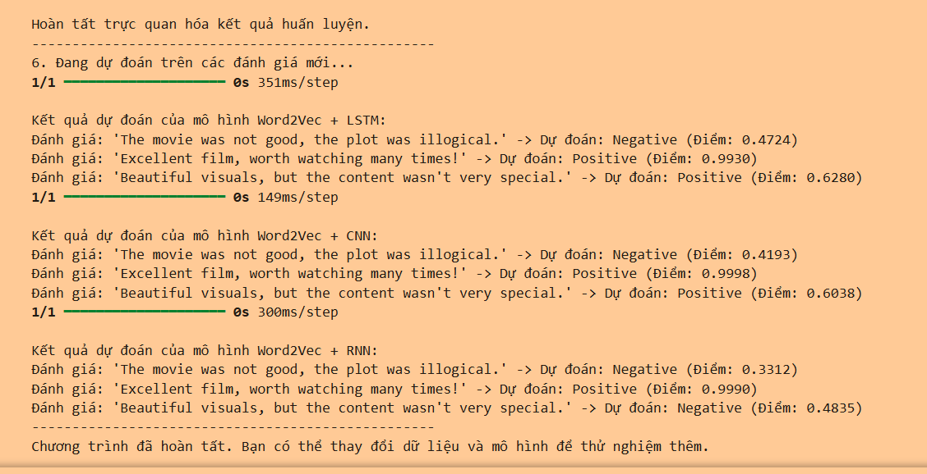
Các mô hình đều không bị overfitting

