**FPT UNIVERSITY**

**FPT POLYTECHNIC COLLEGE**

**PERSONALITY**

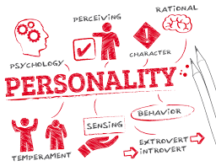

**Instructor:**

**Class:**

**Student name:**

**Student code:**

**Student name:**

**Student code:**

***Ho Chi Minh City, June 2020***

**COMMENTS**

***Lecturer 1:***

***Lecturer 2:***

**OUTLINE**

1. INTRODUCTION

The important thing to make a person is their personality, it is made up of when we were a child. Personality of each child is completely different whether they are in the same family. We often see elder siblings work more responsibly and the youngest ones does not like sharing his toys with others.

Birth order can affect their personality, behavior, the way they react to situations and views of the world. Many psychological studies have shown that birth order has certain effects on children’s personality along with education, genetics, gender, temperament and parenting styles.

1. DISCUSSION
2. Introvert & Extrovert

Introvert tend to

* Enjoy being alone
* Avoid interacting unnecessarily
* Be quiet
* Be interested in feelings
* Think without talking
* Be hard to understand
* Know few people, but well
* Listen
* Seek peace
* Keep their ideas to themselver

Extroverts ten to

* Enjoy being in a group
* Need to interact with other
* Be active
* Be interested in events
* Talk without thinking
* Be easy to understan
* Know many people a little
* Talk
* Seek excitement

1. Which are the other factors affecting personality development?
   1. Nature
   2. Nurture
2. How does birth order affect children’s personalities?
   1. The first child
   2. The middle child
   3. The youngest child
   4. The only child
3. CONCLUSION