**FPT UNIVERSITY**

**FPT POLYTECHNIC COLLEGE**

**PERSONALITY**

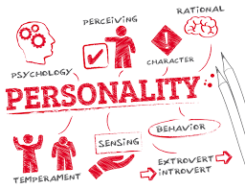

**Instructor:**

**Class:**

**Student name:**

**Student code:**

**Student name:**

**Student code:**

***Ho Chi Minh City, June 2020***

**COMMENTS**

***Lecturer 1:***

***Lecturer 2:***

**OUTLINE**

1. INTRODUCTION
2. DISCUSSION
3. How does birth order affect children’s personalities?
   1. The first child
   2. The middle child
   3. The youngest child
   4. The only child
4. Which are the other factors affecting personality development?
   1. Nature
   2. Nurture
5. CONCLUSION