**Họ và Tên: Ngô Minh Trí**

**MSSV:21550022**

**Lớp: LTDH-K21**

*Bài tập tương tự*:

Lập bảng chân trị cho các biểu thức sau

a/ 

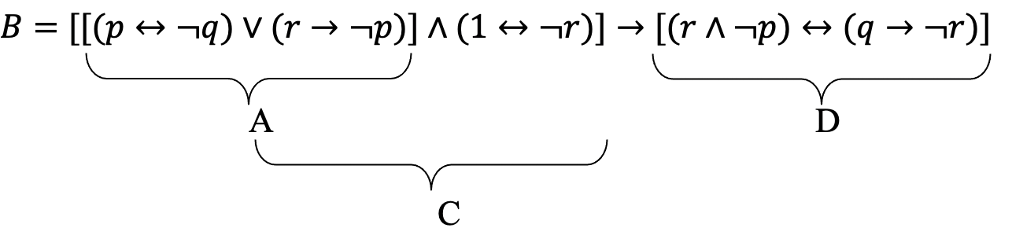

Bảng chân trị:

|  |  |  |  |  |  |  |  |  |  |  |
| --- | --- | --- | --- | --- | --- | --- | --- | --- | --- | --- |
| p | q | r | $$¬p$$ | $$¬q$$ | $$¬r$$ | $$(p↔¬q)$$ | $$(r→¬p)$$ | A | $$(1↔¬r)$$ | C |
| 0 | 0 | 0 | 1 | 1 | 1 | 0 | 1 | 1 | 1 | 1 |
| 0 | 0 | 1 | 1 | 1 | 0 | 0 | 1 | 1 | 0 | 0 |
| 0 | 1 | 0 | 1 | 0 | 1 | 1 | 1 | 1 | 1 | 1 |
| 0 | 1 | 1 | 1 | 0 | 0 | 1 | 1 | 1 | 0 | 0 |
| 1 | 0 | 0 | 0 | 1 | 1 | 1 | 1 | 1 | 1 | 1 |
| 1 | 0 | 1 | 0 | 1 | 0 | 1 | 0 | 1 | 0 | 0 |
| 1 | 1 | 0 | 0 | 0 | 1 | 0 | 1 | 1 | 1 | 1 |
| 1 | 1 | 1 | 0 | 0 | 0 | 0 | 0 | 0 | 0 | 0 |

|  |  |  |  |
| --- | --- | --- | --- |
|  |  | D | B |
| 0 | 1 | 0 | 0 |
| 1 | 1 | 1 | 1 |
| 0 | 1 | 0 | 0 |
| 1 | 0 | 0 | 1 |
| 0 | 1 | 0 | 0 |
| 0 | 1 | 0 | 1 |
| 0 | 1 | 0 | 0 |
| 0 | 0 | 1 | 1 |

b/

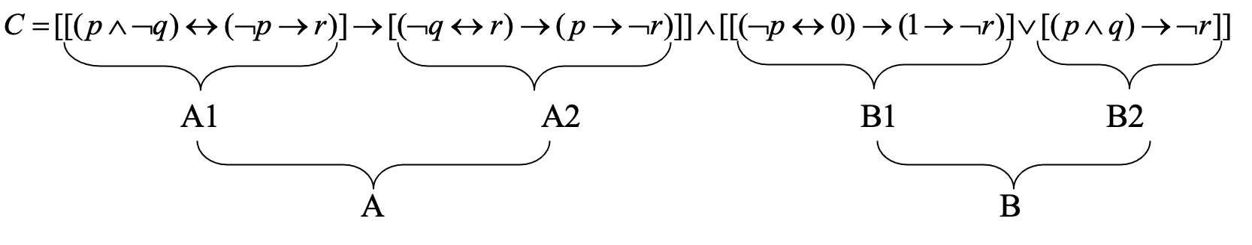

|  |  |  |  |  |  |  |  |  |  |  |
| --- | --- | --- | --- | --- | --- | --- | --- | --- | --- | --- |
| p | q | r | $$¬p$$ | $$¬q$$ | $$¬r$$ | $$(p∧¬q)$$ | $$(¬p→r)$$ | A1 | $$(¬q↔r)$$ | $$(p→¬r)$$ |
| 0 | 0 | 0 | 1 | 1 | 1 | 0 | 0 | 1 | 0 | 1 |
| 0 | 0 | 1 | 1 | 1 | 0 | 0 | 1 | 0 | 1 | 1 |
| 0 | 1 | 0 | 1 | 0 | 1 | 0 | 0 | 1 | 1 | 1 |
| 0 | 1 | 1 | 1 | 0 | 0 | 0 | 1 | 0 | 0 | 1 |
| 1 | 0 | 0 | 0 | 1 | 1 | 1 | 1 | 1 | 0 | 1 |
| 1 | 0 | 1 | 0 | 1 | 0 | 1 | 1 | 1 | 1 | 0 |
| 1 | 1 | 0 | 0 | 0 | 1 | 0 | 1 | 0 | 1 | 1 |
| 1 | 1 | 1 | 0 | 0 | 0 | 0 | 1 | 0 | 0 | 0 |

|  |  |  |  |  |  |  |  |  |
| --- | --- | --- | --- | --- | --- | --- | --- | --- |
| A2 | A | $$(¬p↔0)$$ | $$(1→¬r)$$ | B1 | $$(p∧q)$$ | B2 | B | C |
| 1 | 1 | 0 | 1 | 1 | 0 | 1 | 1 | 1 |
| 1 | 1 | 0 | 0 | 1 | 0 | 1 | 1 | 1 |
| 1 | 1 | 0 | 1 | 1 | 0 | 1 | 1 | 1 |
| 1 | 1 | 0 | 0 | 1 | 0 | 1 | 1 | 1 |
| 1 | 1 | 1 | 1 | 1 | 0 | 1 | 1 | 1 |
| 0 | 0 | 1 | 0 | 0 | 0 | 1 | 1 | 0 |
| 1 | 1 | 1 | 1 | 1 | 1 | 1 | 1 | 1 |
| 1 | 1 | 1 | 0 | 0 | 1 | 0 | 0 | 0 |

c/ 

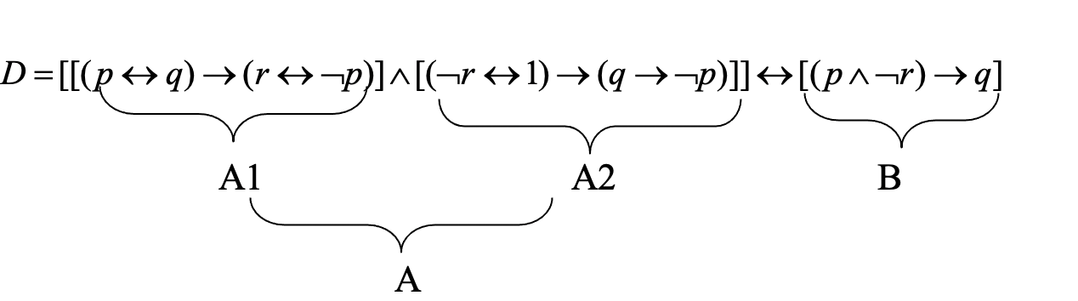

A

|  |  |  |  |  |  |  |  |  |  |  |
| --- | --- | --- | --- | --- | --- | --- | --- | --- | --- | --- |
| p | q | r | $$¬p$$ | $$¬q$$ | $$¬r$$ | $$(p↔q)$$ | $$(r↔¬p)$$ | A1 | $$(¬r↔1)$$ | $$(q→¬p)$$ |
| 0 | 0 | 0 | 1 | 1 | 1 | 1 | 0 | 0 | 1 | 1 |
| 0 | 0 | 1 | 1 | 1 | 0 | 1 | 1 | 1 | 0 | 1 |
| 0 | 1 | 0 | 1 | 0 | 1 | 0 | 0 | 1 | 1 | 1 |
| 0 | 1 | 1 | 1 | 0 | 0 | 0 | 1 | 1 | 0 | 1 |
| 1 | 0 | 0 | 0 | 1 | 1 | 0 | 1 | 1 | 1 | 1 |
| 1 | 0 | 1 | 0 | 1 | 0 | 0 | 0 | 1 | 0 | 1 |
| 1 | 1 | 0 | 0 | 0 | 1 | 1 | 1 | 1 | 1 | 0 |
| 1 | 1 | 1 | 0 | 0 | 0 | 1 | 0 | 0 | 0 | 0 |

|  |  |  |  |
| --- | --- | --- | --- |
| A2 | A | B | D |
| 1 | 0 | 1 | 0 |
| 1 | 1 | 1 | 1 |
| 1 | 1 | 1 | 1 |
| 1 | 1 | 1 | 1 |
| 1 | 1 | 0 | 0 |
| 1 | 1 | 1 | 1 |
| 0 | 0 | 1 | 0 |
| 1 | 0 | 1 | 0 |

d/ 

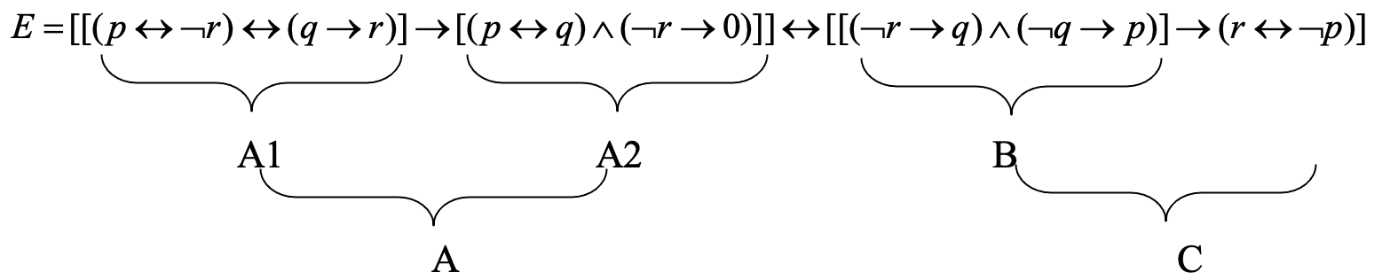

|  |  |  |  |  |  |  |  |  |  |  |
| --- | --- | --- | --- | --- | --- | --- | --- | --- | --- | --- |
| p | q | r | $$¬p$$ | $$¬q$$ | $$¬r$$ | $$(p↔¬r)$$ | $$(q→r)$$ | A1 | $$(p↔q)$$ | $$(¬r→0)$$ |
| 0 | 0 | 0 | 1 | 1 | 1 | 0 | 1 | 0 | 1 | 0 |
| 0 | 0 | 1 | 1 | 1 | 0 | 1 | 1 | 1 | 1 | 1 |
| 0 | 1 | 0 | 1 | 0 | 1 | 0 | 0 | 1 | 0 | 0 |
| 0 | 1 | 1 | 1 | 0 | 0 | 1 | 1 | 1 | 0 | 1 |
| 1 | 0 | 0 | 0 | 1 | 1 | 1 | 1 | 1 | 0 | 0 |
| 1 | 0 | 1 | 0 | 1 | 0 | 0 | 1 | 0 | 0 | 1 |
| 1 | 1 | 0 | 0 | 0 | 1 | 1 | 0 | 0 | 1 | 0 |
| 1 | 1 | 1 | 0 | 0 | 0 | 0 | 1 | 0 | 1 | 1 |

|  |  |  |  |  |  |  |  |
| --- | --- | --- | --- | --- | --- | --- | --- |
| A2 | A | $$(¬r→q)$$ | $$(¬q→p)$$ | B | $$(r↔¬p)$$ | C | E |
| 0 | 1 | 0 | 0 | 0 | 0 | 1 | 1 |
| 1 | 1 | 1 | 0 | 0 | 1 | 1 | 1 |
| 0 | 0 | 1 | 1 | 1 | 0 | 0 | 1 |
| 0 | 0 | 1 | 1 | 1 | 1 | 1 | 0 |
| 0 | 0 | 0 | 1 | 0 | 1 | 1 | 0 |
| 0 | 1 | 1 | 1 | 1 | 0 | 0 | 0 |
| 0 | 1 | 1 | 1 | 1 | 1 | 1 | 1 |
| 1 | 1 | 0 | 1 | 0 | 0 | 1 | 1 |

e/ 

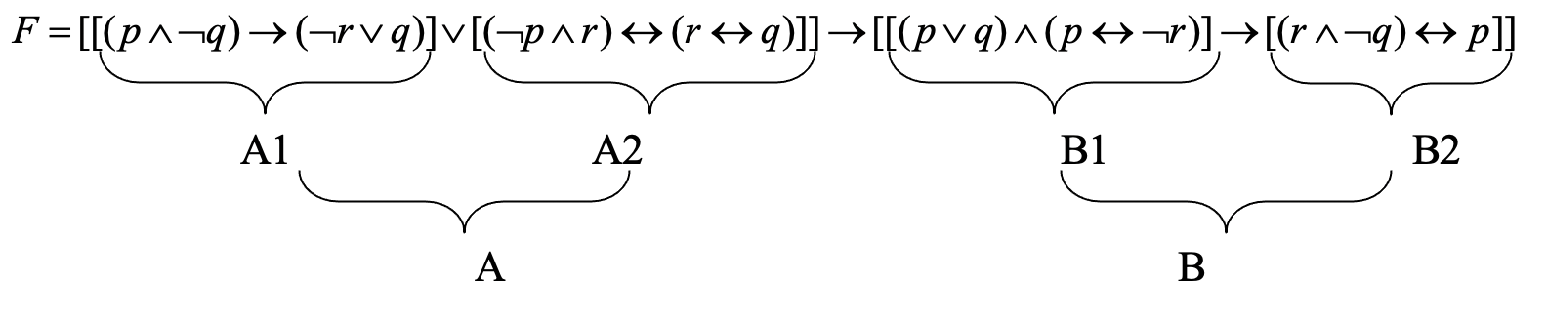

|  |  |  |  |  |  |  |  |  |  |  |
| --- | --- | --- | --- | --- | --- | --- | --- | --- | --- | --- |
| p | q | r | $$¬p$$ | $$¬q$$ | $$¬r$$ | $$(p∧¬q)$$ | $$(¬r∨q)$$ | A1 | $$(¬p∧r)$$ | $$(r↔q)$$ |
| 0 | 0 | 0 | 1 | 1 | 1 | 0 | 1 | 1 | 0 | 1 |
| 0 | 0 | 1 | 1 | 1 | 0 | 0 | 0 | 1 | 1 | 0 |
| 0 | 1 | 0 | 1 | 0 | 1 | 0 | 1 | 1 | 0 | 0 |
| 0 | 1 | 1 | 1 | 0 | 0 | 0 | 1 | 1 | 1 | 1 |
| 1 | 0 | 0 | 0 | 1 | 1 | 1 | 1 | 1 | 0 | 1 |
| 1 | 0 | 1 | 0 | 1 | 0 | 1 | 0 | 0 | 0 | 0 |
| 1 | 1 | 0 | 0 | 0 | 1 | 0 | 1 | 1 | 0 | 0 |
| 1 | 1 | 1 | 0 | 0 | 0 | 0 | 1 | 1 | 0 | 1 |

|  |  |  |  |  |  |  |  |
| --- | --- | --- | --- | --- | --- | --- | --- |
| A2 | A | $$(p∨q)$$ | $$(p↔¬r)$$ | B1 | $$(r∧¬q)$$ | B | F |
| 0 | 1 | 0 | 0 | 0 | 0 | 1 | 1 |
| 0 | 1 | 0 | 1 | 0 | 1 | 1 | 1 |
| 1 | 1 | 1 | 0 | 0 | 0 | 1 | 1 |
| 1 | 1 | 1 | 1 | 1 | 0 | 0 | 0 |
| 0 | 1 | 1 | 1 | 1 | 0 | 0 | 0 |
| 1 | 1 | 1 | 0 | 0 | 1 | 1 | 1 |
| 1 | 1 | 1 | 1 | 1 | 0 | 0 | 0 |
| 0 | 1 | 1 | 0 | 0 | 0 | 1 | 1 |

f/ 

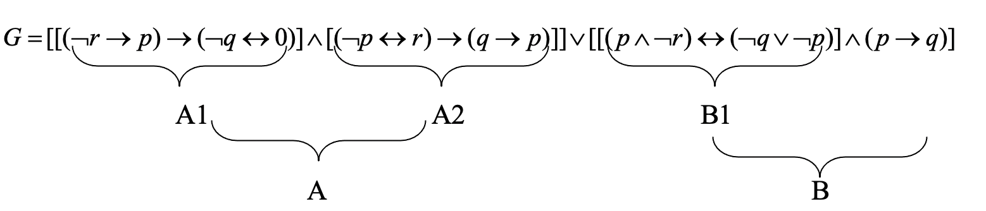

A B

|  |  |  |  |  |  |  |  |  |  |  |
| --- | --- | --- | --- | --- | --- | --- | --- | --- | --- | --- |
| p | q | r | $$¬p$$ | $$¬q$$ | $$¬r$$ | $$(¬r→p)$$ | $$(¬q↔0)$$ | A1 | $$(¬p↔r)$$ | $$(q→p)$$ |
| 0 | 0 | 0 | 1 | 1 | 1 | 0 | 0 | 1 | 0 | 1 |
| 0 | 0 | 1 | 1 | 1 | 0 | 1 | 0 | 0 | 1 | 1 |
| 0 | 1 | 0 | 1 | 0 | 1 | 0 | 1 | 1 | 0 | 0 |
| 0 | 1 | 1 | 1 | 0 | 0 | 1 | 1 | 1 | 1 | 0 |
| 1 | 0 | 0 | 0 | 1 | 1 | 1 | 0 | 0 | 1 | 1 |
| 1 | 0 | 1 | 0 | 1 | 0 | 1 | 0 | 0 | 0 | 1 |
| 1 | 1 | 0 | 0 | 0 | 1 | 1 | 1 | 1 | 1 | 1 |
| 1 | 1 | 1 | 0 | 0 | 0 | 1 | 1 | 1 | 0 | 1 |

|  |  |  |  |  |  |  |  |
| --- | --- | --- | --- | --- | --- | --- | --- |
| A2 | A | $$(p∧¬r)$$ | $$(¬q∨¬p)$$ | B1 | $$(p→q)$$ | B | G |
| 1 | 1 | 0 | 1 | 0 | 1 | 0 | 1 |
| 1 | 0 | 0 | 1 | 0 | 1 | 0 | 0 |
| 1 | 1 | 0 | 1 | 0 | 1 | 0 | 1 |
| 0 | 0 | 0 | 1 | 0 | 1 | 0 | 0 |
| 1 | 0 | 1 | 1 | 1 | 0 | 0 | 0 |
| 1 | 0 | 0 | 1 | 0 | 0 | 0 | 0 |
| 1 | 1 | 1 | 0 | 0 | 1 | 0 | 1 |
| 1 | 1 | 0 | 0 | 1 | 1 | 1 | 1 |

g/ 

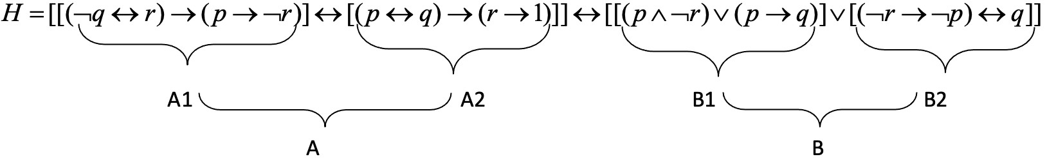

|  |  |  |  |  |  |  |  |  |  |  |
| --- | --- | --- | --- | --- | --- | --- | --- | --- | --- | --- |
| p | q | r | $$¬p$$ | $$¬q$$ | $$¬r$$ | $$(¬q↔r)$$ | $$(p→¬r)$$ | A1 | $$(p↔q)$$ | $$(r→1)$$ |
| 0 | 0 | 0 | 1 | 1 | 1 | 0 | 1 | 1 | 1 | 1 |
| 0 | 0 | 1 | 1 | 1 | 0 | 1 | 1 | 1 | 1 | 1 |
| 0 | 1 | 0 | 1 | 0 | 1 | 1 | 1 | 1 | 0 | 1 |
| 0 | 1 | 1 | 1 | 0 | 0 | 0 | 1 | 1 | 0 | 1 |
| 1 | 0 | 0 | 0 | 1 | 1 | 0 | 1 | 1 | 0 | 1 |
| 1 | 0 | 1 | 0 | 1 | 0 | 1 | 0 | 0 | 0 | 1 |
| 1 | 1 | 0 | 0 | 0 | 1 | 1 | 1 | 1 | 1 | 1 |
| 1 | 1 | 1 | 0 | 0 | 0 | 0 | 0 | 1 | 1 | 1 |

A B

|  |  |  |  |  |  |  |  |  |
| --- | --- | --- | --- | --- | --- | --- | --- | --- |
| A2 | A | $$(p∧¬r)$$ | $$(p→q)$$ | B1 | $$(¬r→¬p)$$ | B2 | B | H |
| 1 | 1 | 0 | 1 | 1 | 1 | 0 | 1 | 1 |
| 1 | 1 | 0 | 1 | 1 | 1 | 0 | 1 | 1 |
| 1 | 1 | 0 | 1 | 1 | 1 | 1 | 1 | 1 |
| 1 | 1 | 0 | 1 | 1 | 1 | 1 | 1 | 1 |
| 1 | 1 | 1 | 0 | 1 | 0 | 1 | 1 | 1 |
| 1 | 0 | 0 | 0 | 0 | 1 | 0 | 0 | 1 |
| 1 | 1 | 1 | 1 | 1 | 0 | 0 | 1 | 1 |
| 1 | 1 | 0 | 1 | 1 | 1 | 1 | 1 | 1 |