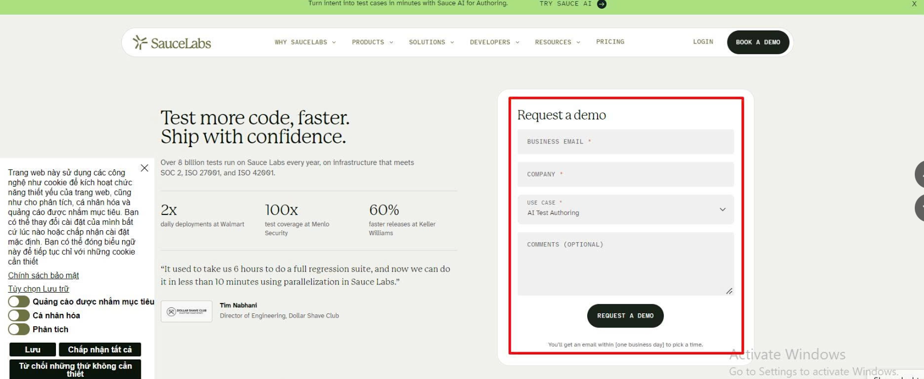
//div[contains(@class, 'v2-rd-form')]
//h3[contains(text(), 'Request')]
//input[contains(@id, 'Business')]
//input[contains(@id, 'Company')]
//select[contains(@id, 'Use-Case')]
//option[contains(@value, 'AI Test')]
//textarea[contains(@id, 'Comments')]
//button[contains(text(), 'demo')]
//p[contains(text(), 'within')]

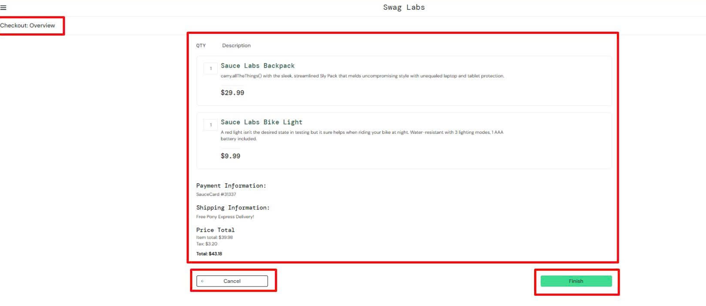
//span[contains(text(), 'Checkout')]
//div[@id='checkout_summary_container']

//div[contains(text(), 'Backpack')]/ancestor::div[@class='cart_item']
//div[contains(text(), 'Backpack')]/ancestor::div[@class='cart_item']/descendant::div[@class='cart_quantity']
//div[contains(text(), 'Backpack')]
//div[contains(text(), 'carry.all')]
//div[contains(text(), 'Backpack')]/ancestor::div[@class='cart_item']/descendant::div[contains(@class, '_item_price')]

//div[contains(text(), 'Payment')]
//div[contains(text(), 'SauceCard')]
//div[contains(text(), 'Shipping')]
//div[contains(text(), 'Free')]
//div[contains(@data-test, 'total-info-label')]
//div[contains(@data-test, 'subtotal-label')]
//div[contains(@data-test, 'tax-label')]
//div[contains(@data-test, 'total-label')]
//button[contains(@id, 'cancel')]
//button[contains(@id, 'finish')]
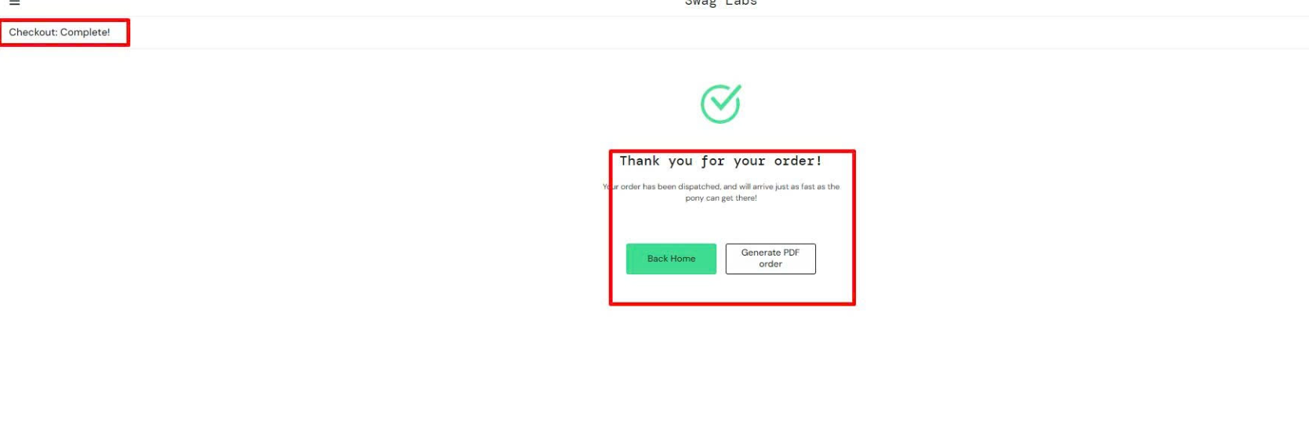
//div[@id = 'checkout_complete_container']
//span[contains(text(), 'Checkout')]
//h2[contains(text(), 'Thank you')]
//div[contains(text(), 'Your order')]
//button[@id = 'back-to-products']
//button[@id = 'generate-pdf-order']

