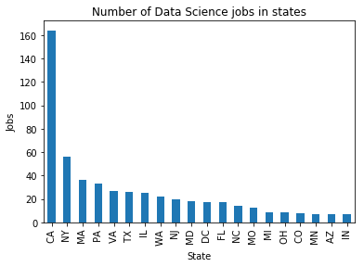

The first graph is about 20 states in the US have highest job offers in the first 1000 jobs advertisement. California has the highest job demand, which is over 160, nearly 4 times NY. Because most of the biggest tech companies headquarters are in CA, so the job demands data scientists are very high. New York is in the second place, with nearly 60 job offers. Because New York is the center of world business, the amount of data and works in NY are very high, not only for business but also for entertainment(newspaper, fashion, etc). That’s why despite the fact that not many giant tech companies are in NY, there are still a lot of data science jobs offer in NYC. The next 10 states are not so different in numbers of an offer, all are around 20 to 30 offers.

In the most 20 companies bar, we can see that Uber has the most job offers for data scientists. This means that Uber has a high demand for data problem solving because the way Uber operates create a lot of data every second. Moreover, Uber is a new company when compares to Google or Facebook, so it will need a more new employee to develop the company. The second place company, Carhartt, is a fashion brand, so it is surprising to know that Carhart has a high demand for data scientists. We can see in the middle of the graph some familiar companies like Apple, Facebook or Tumblr. The similarity of these companies is they need a lot of work to handling daily data from users, and their technology is very updated. In the top 20 companies graph, we can also see the appearance of JP Morgan Chase, one of the biggest bank in the US. So every company of all fields needs data scientists to work efficiently, not only tech companies.

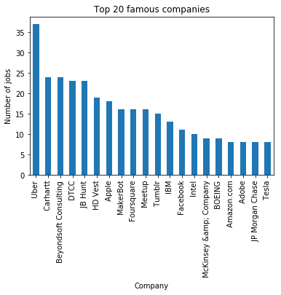

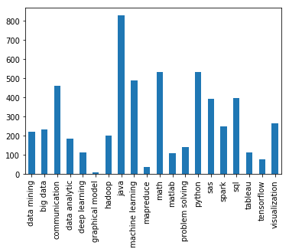

The last thing I want to express is that in the first 1000 jobs ads, programming skill is one of the most important skills every company required. Although most of us prefer Python when working with data, Java is still considered an important requirement for the data scientist, besides python or SQL. Other important skills are math, machine learning, visualization, SAS. Since there are a lot of data that humanity can handle, the demand for machine learning and AI has increased in the past few years and it will be an advantage for people who want to seek a job as data scientists if they have good knowledge of math and machine learning. One more skill is also important is communication skill, because, without this skill, we cannot express the insight of data to everyone, so even if we can analyze the data, we cannot make any benefit from them.