**Name**: ____________________________________________________ **Date**: ______________

**Lab: Conservation of Momentum**

**Preliminary Questions:**

Two objects, Object 1 and Object 2 are pushed together so that a spring is compressed between them, as seen in the figure below. When the objects are released, the spring pushes the two objects apart so that they are traveling away from each other in opposite directions on a frictionless surface.

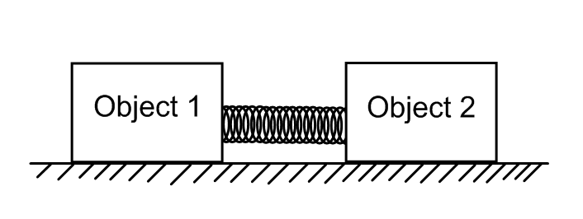

1. What is the momentum of ***each*** of the objects ***before*** they are released? ____________

What the ***total momentum*** of the two blocks ***before*** they are released? ____________

What must the ***total momentum*** of the two blocks be ***after*** they are released? ____________

1. If Object 1 and Object 2 have the same mass, how will their velocities compare when they are released? Discuss their relative speeds and directions in your answer.

____________________________________________________________________________________________________________________________________________________________

When the objects are released, which object has more momentum or are they the same? ____________________________________________________________________________________________________________________________________________________________

1. If the mass of Object 1 is now doubled, how will their velocities compare? Discuss their relative speeds and directions in your answer.

____________________________________________________________________________________________________________________________________________________________

If Object 2 travels to the right with a speed of ***v*** after they are released, what is the speed of Object 1 as it travels to the left?

____________

When the objects are released, which object has more momentum or are they the same? ____________________________________________________________________________________________________________________________________________________________

**Lab: Conservation of Momentum**

**Purpose**: The goal of this experiment is to demonstrate conservation of momentum for two carts pushing away from each other.

**Procedure**:

1. Place dynamics cart track on your table and make sure it is level. This can be accomplished by raising/lowering the bolts on either end of the track. Place a cart at three different locations on the track (left, middle, right) to see if the cart moves on its own. If it does, continue to level the track until there is no movement.
2. For each of the 4 trials in this lab, the two carts will be placed against each other with the plunger of the cart pushed completely in to its maximum position. That end of the cart will then be placed against the end of the other cart, as seen in the figure below.

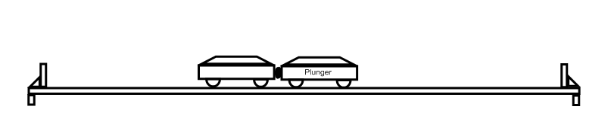

1. For the first trial, the carts will not have any extra masses added to them. As you progress, masses will be added in each subsequent trial. Place the two carts together as seen in the figure above and move them to a position where you think they will strike the barriers at the same time. Make sure you note the starting position before pressing the button. Release the carts and test your hypothesis. If they did not strike at the same time, adjust the starting position to compensate. Make sure you repeat your results a few times before recording your data to make sure it is accurate.
2. When finished with the first trial, add a bar mass to Cart 1. Place the two carts together as seen in the figure above and move them to a ***new*** position where you think they will strike the barriers at the same time. Follow the same procedure as before. Continue this for each trial.

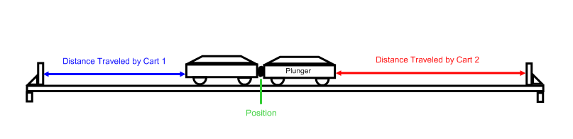 **Data**:

|  |  |  |  |  |  |  |  |
| --- | --- | --- | --- | --- | --- | --- | --- |
| Trial | Mass 1 (kg) | Mass 2 (kg) | Starting Position of Carts (cm) | Distance Traveled for Cart 1 (cm) | Distance Traveled for Cart 2 (cm) | $$\frac{Distance 1}{Distance 2}$$ | $$\frac{Mass 2}{Mass 1}$$ |
| Cart - Cart |  |  |  |  |  |  |  |
| Cart/Bar - Cart |  |  |  |  |  |  |  |
| Cart/Bar/Bar - Cart |  |  |  |  |  |  |  |
| Cart/Bar/Bar – Cart/Bar |  |  |  |  |  |  |  |

1. If the ratio of $\frac{Distance 1}{Distance 2}$ was equal to the ratio of $\frac{Mass 2}{Mass 1}$ within acceptable standards, then momentum was conserved. Was momentum conserved for the two carts in each of your trials?

____________________________________________________________________________________________________________________________________________________________

1. What happened to the velocity of a cart if mass was added to it?

____________________________________________________________________________________________________________________________________________________________

What happened to the velocity of a cart if no mass was added to it?

____________________________________________________________________________________________________________________________________________________________

1. In each trail, what was the total momentum before and after the carts shot apart?

____________________________________________________________________________________________________________________________________________________________

1. In trial 3, when Cart 1 (Cart/Bar/Bar) pushed away from Cart 2 (Cart), which cart had more momentum? Explain your answer with detail.

____________________________________________________________________________________________________________________________________________________________

**Extension**:

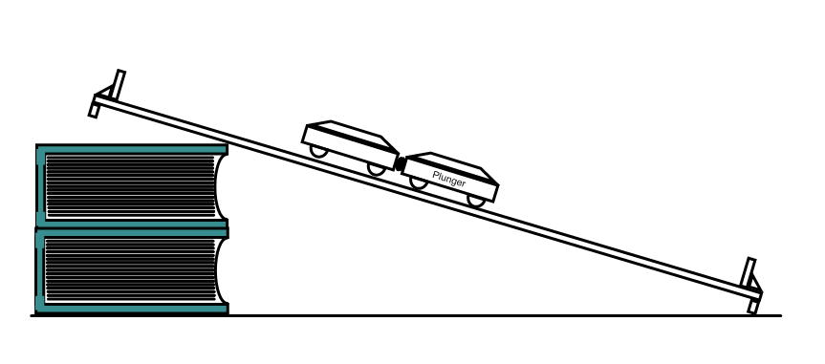

Two carts of equal masses are now positioned on an uneven track propped up by some books. Where would you need to place the carts now so that they hit the barriers at the same time?

Describe two procedures to find the velocity at which the carts shoot apart and the velocity of the plunger cart as it strikes the bottom barrier. One procedure may use technology; one may only use a triple-beam balance and a meter stick.