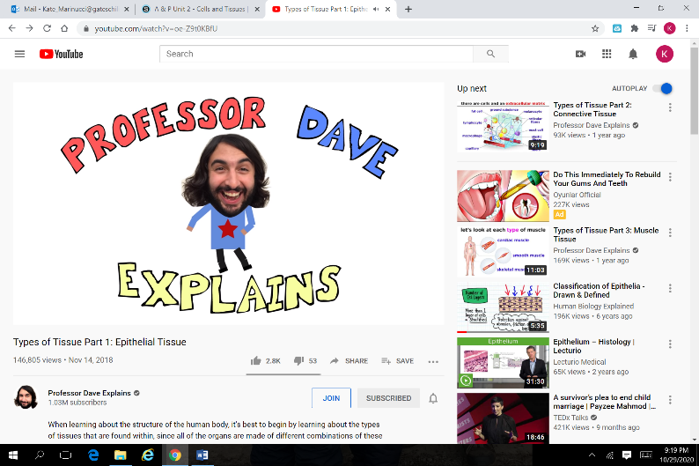Name: ___________________________________________

Muscle Tissue with Professor Dave

Directions: Watch the video using the link provided to answer the following questions about epithelial tissues.

<https://www.youtube.com/watch?v=7t-DGxG09l8>

1. The three types of muscle in our bodies are…

2. The basic function of muscles is to allow for m__________________________.

3. Muscles are made of muscle cells, which have the ability to c _ _ _ _ _ _ _.

4. True / False (circle one) There are over 650 skeletal muscles in the body.

5. What are the ways skeletal muscles can attach to bone?

6. Skeletal muscles are said to be v__________________ because they are under our conscious control.

7. Besides allowing for voluntary movement, basic functions of skeletal muscle include…

Maintaining p_____________

Allowing for swallowing/e______________

Maintain body t__________________

8. True / False (circle one) Muscle cells have a single, centralized nucleus.

9. Muscle contraction requires help from this branch of the nervous system:

10. Cardiac muscle is only found in the h _____________.

11. Cardiac muscle also has a s____________________ appearance like skeletal muscle.

12. The ways cardiac muscle is different than skeletal muscle include:

*

*

*

13. Cardiac muscle contraction are voluntary / involuntary (circle one)

14. The contraction of the heart muscle is helped by the a__________________________ nervous system.

15. True or False (circle one) Smooth muscle is found in most internal organs.

16. Examples of locations in the body where smooth muscle is found include:

*

*

*

*

*

17. The opposing contractions that move material through smooth muscle is known as p____________________________.

18. What is the shape of smooth muscle cells?

19. Smooth muscle can be described as

a. Striated

b. Non-striated

c. Branched

d. None of these

20. Label the following muscle tissue types:



  