**Vision Board Assignment**

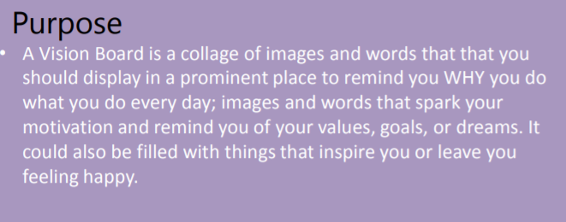

**Directions:**

1. Write down everything you can think of that brings you joy.
2. Use the Values handout and circle the values that are most important to you.
3. Read the List of Questions to Spark Mental Images handout. Jot down your answers to the questions.
4. Using your computer, find images/words that bring to mind things that make you smile, feel motivated, or inspired.
5. Copy and paste those images/words to a Power Point slide. PUT YOUR NAME IN THE CENTER OF THE SLIDE (FIRST & LAST).
6. Make sure that your document is neat. Submit your final Power Point Slide within this assignment.

Mrs. Mooney will grade your Vision Board, and she will print it, in color, to hang up!

**Supplies Needed:**

* scrap paper
* copies of the **values handout** & **questions to spark mental images handout**
* computer

**Due Date:**