|  |
| --- |
| **VERILOG PROGRAMING TUTORIAL 1** |
|  |

**IMPLEMENTATION OF BASIC COMBINATION LOGIC CIRCUIT USING VERILOG IN FPGA KIT**

### Experiment 1

##### AIM: WRITE HDL CODE TO REALIZE ALL LOGIC GATES

A logic gate performs a logical operation on one or more logic inputs and produces a single logic output. The logic normally performed is boolean logic and is most commonly found in digital circuits

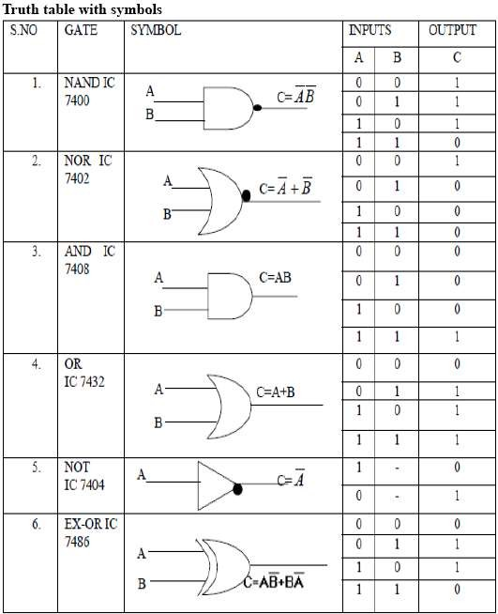

a) Write the Verilog module implement the all the basic logic gates using Structural Model :

module allgate ( a, b, yand,yor,ynot,ynand,ynor,yxor,yxnor );

input a,b;

output yand, yor, ynot, ynand, ynor, yxor, yxnor;

and G1(yand,a,b); // AND Operation

or G2(yor,a, b); // OR Operation

not G3(ynot,a) ; // NOT Operation

nand G4 (ynand,a,b); // NAND Operation

nor G5(ynor,a,b); //NOR Operation

xor G6(yxor,a,b); //XOR Operation

xnor G7(yxnor,a,b); //XNOR Operation

endmodule // END of the module

### Write the testbench to implement these modules in DE2-FPGA Kit

module lab1_ex1(SW,LEDG,LEDR);

input[17:0] SW;

output[7:0] LEDG;

output[17:0] LEDR;

assign LEDR=SW;

allgate DUT(SW[1],SW[2],LEDG[5],LEDG[4],LEDG[3],LEDG[2],LEDG[1],LEDG[0]);

endmodule

b) Write the Verilog module implement the all the basic logic gates using Dataflow model:

module allgate ( a, b, yand,yor,ynot,ynand,ynor,yxor,yxnor );

input a,b;

output yand, yor, ynot, ynand, ynor, yxor, yxnor;

assign yand = a & b; // AND Operation

assign yor = a | b; // OR Operation

assign ynot = ~a ; // NOT Operation

assign ynand = ~(a & b); // NAND Operation

assign ynor = ~(a | b); //NOR Operation

assign yxor = a ^ b; //XOR Operation

assign yxnor =~(a^b); //XNOR Operation

endmodule // END of the module

### Write the testbench to implement these modules in DE2-FPGA Kit

module lab1_ex1(SW,LEDG,LEDR);

input[17:0] SW;

output[7:0] LEDG;

output[17:0] LEDR;

assign LEDR=SW;

allgate DUT(SW[1],SW[2],LEDG[5],LEDG[4],LEDG[3],LEDG[2],LEDG[1],LEDG[0]);

endmodule

**EXPERIMENT 2**

**AIM: WRITE VERILOG HDL CODES TO SIMULATE AND IMPLEMENT THE** HALF ADDER

C**IRCUIT:**

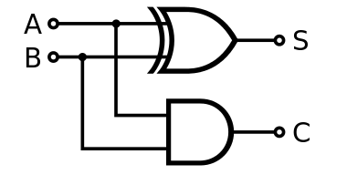 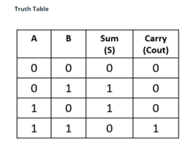

**Table 1**. Half Adder Dataflow Model

module half_adder_structeral(input a, b, output s, Cout);

xor G1(s,a,b);

and G2(Cout,a,b);

endmodule

module half_adder_dataflow(input a, b, output s, Cout);

assign s = a ^ b;

assign Cout = a & b;

endmodule

module half_adder_behavior(sum,carry,a,b );

output sum,carry;

input a,b;

reg sum,carry;

always @(a,b)

begin

sum <= a ^ b;

carry <= a&b ;

end

endmodule

module Half_Adder_test_FPGA(SW,LEDG,LEDR);

input [17:0] SW;

output [7:0] LEDG;

output[17:0] LEDR;

assign LEDR=SW;

half_adder_dataflow HA_DTFL_FPGA(SW[1],SW[0], LEDG[1], LEDG[0]);

half_adder_structeral HA_STRU_FPGA(SW[3],SW[2], LEDG[3], LEDG[2]);

half_adder_structeral HA_BHVR_FPGA(SW[5],SW[4], LEDG[5], LEDG[4]);

endmodule

TESTING RESULTS:

|  |  |  |  |  |  |  |  |
| --- | --- | --- | --- | --- | --- | --- | --- |
| A | B | Sum | Carry | Sum (Sim) | Carry (Sim) | Sum (FPGA) | Carry (FPGA) |
| 0 | 0 | 0 | 0 | 0 | 0 | 0 | 0 |
| 0 | 1 | 1 | 0 | 1 | 0 | 1 | 0 |
| 1 | 0 | 1 | 0 | 1 | 0 | 1 | 0 |
| 1 | 1 | 0 | 1 | 0 | 1 | 0 | 1 |

**EXPERIMENT 3**

**AIM: WRITE VERILOG HDL CODES TO SIMULATE AND IMPLEMENT THE FULL ADDER CIRCUIT:**

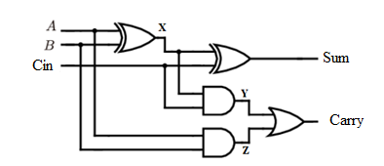

module full_adder_STRU(a,b,cin,Cum,Carry);

output Sum,Carry;

input A,B,Cin;

wire x,y,z;

xor g1(x,A,B);

xor g2(Sum,x,Cin);

and g3(y,x,Cin);

and g4(z,A,B);

or g5(Carry,x,y);

endmodule

module full_adder_DTFL(input a, b, cin, output S, Cout);

assign S = a ^ b ^ cin;

assign Cout = (a & b) | (b & cin) | (a & cin);

endmodule

module full_adder_behavior(a,b,c,sum,carry);

output sum,carry;

input a,b,c;

reg sum,carry;

always @ (a,b,c)

begin

sum <= a^ b^c;

carry <=(a&b) | (b&c) | (c&a);

end

endmodule

module Full_Adder_test_FPGA(SW,LEDG,LEDR);

input [17:0] SW;

output [7:0] LEDG;

output [17:0] LEDR;

assign LEDR=SW;

full_adder_DTFL DUT1(SW[2],SW[1],SW[0], LEDG[1], LEDG[0]);

full_adder_STRU DUT2(SW[5],SW[4],SW[3], LEDG[3], LEDG[2]);

full_adder_behavior DUT3(SW[8],SW[7],SW[6], LEDG[5], LEDG[4]);

endmodule

TESTING RESULTS:

**Table 4.** Full Adder

|  |  |  |  |  |  |  |  |  |
| --- | --- | --- | --- | --- | --- | --- | --- | --- |
| A | B | Cin | Sum | Carry | Sum (Sim) | Carry (Sim) | Sum (FPGA) | Carry (FPGA) |
| 0 | 0 | 0 | 0 | 0 | 0 | 0 | 0 | 0 |
| 0 | 0 | 1 | 1 | 0 | 1 | 0 | 1 | 0 |
| 0 | 1 | 0 | 1 | 0 | 1 | 0 | 1 | 0 |
| 0 | 1 | 1 | 0 | 1 | 0 | 1 | 0 | 1 |
| 1 | 0 | 0 | 1 | 0 | 1 | 0 | 1 | 0 |
| 1 | 0 | 1 | 0 | 1 | 0 | 1 | 0 | 1 |
| 1 | 1 | 0 | 0 | 1 | 0 | 1 | 0 | 1 |
| 1 | 1 | 1 | 1 | 1 | 1 | 1 | 1 | 1 |

**EXPERIMENT 4**

**AIM: WRITE VERILOG HDL CODES TO SIMULATE AND IMPLEMENT THE HALF SUBTRACTOR CIRCUIT:**

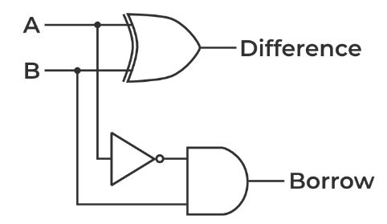  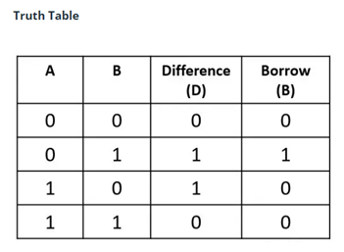

module half_sub_structeral(input a, b, output dif, bor);

xor(dif,a,b);

and(bor,~a,b);

endmodule

module half_sub_dataflow(input a, b, output dif, bor);

assign dif = a ^ b;

assign bor = ~a & b;

endmodule

module half_sub_behaviour(a,b,diff,borrow);

output diff, borrow;

input a, b;

reg diff,borrow;

always @(a,b)

begin

diff = a ^ b;

borrow =(~a&b);

end

endmodule

module Half_Sub_test_FPGA(SW,LEDG,LEDR);

input[17:0] SW;

output[7:0] LEDG;

output[17:0] LEDR;

assign LEDR=SW;

half_sub_dataflow HB_DTFL_FPGA(SW[1],SW[0], LEDG[1], LEDG[0]);

half_sub_structeral HB_STRU_FPGA(SW[3],SW[2], LEDG[3], LEDG[2]);

half_sub_behaviour HB_BHVR_FPGA(SW[5],SW[4], LEDG[5], LEDG[4]);

endmodule

**EXPERIMENT 5**

**AIM: WRITE VERILOG HDL CODES TO SIMULATE AND IMPLEMENT THE FULL SUBTRACTOR CIRCUIT:**

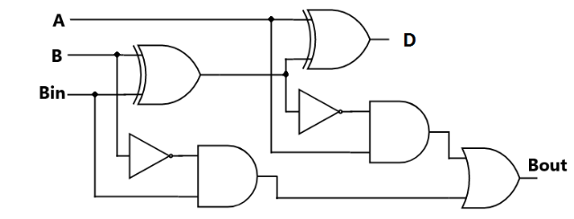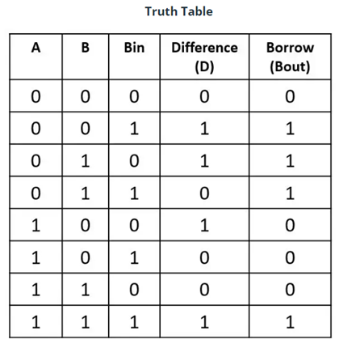

module full_subtractor(input a, b, Bin, output D, Bout);

assign D = a ^ b ^ Bin;

assign Bout = (~a & b) | (~(a ^ b) & Bin);

endmodule

module Full_Sub_test_FPGA(SW,LEDG,LEDR);

input[17:0] SW;

output[7:0] LEDG;

output[17:0] LEDR;

assign LEDR=SW;

full_sub_dataflow FPGA(SW[2],SW[1],SW[0], LEDG[1], LEDG[0]);

endmodule

**EXPERIMENT 6**

**AIM: WRITE VERILOG HDL CODES TO SIMULATE AND IMPLEMENT THE RIPPLE CARRY ADDER CIRCUIT:**

module full_adder_STRU(a,b,cin,Cum,Carry);

output Sum,Carry;

input A,B,Cin;

wire x,y,z;

xor g1(x,A,B);

xor g2(Sum,x,Cin);

and g3(y,x,Cin);

and g4(z,A,B);

or g5(Carry,x,y);

endmodule

module four_bit_adder(cin,a,b,s,cout);

input [3:0] a,b;

input cin;

output [3:0] s;

output cout;

wire [2:0] w_carry;

full_adder_STRU C1(a[0],b[0],cin,s[0], w_carry[0]);

full_adder_STRU C2(a[1],b[1], w_carry[0],s[1], w_carry[1]);

full_adder_STRU C3(a[2],b[2], w_carry[1],s[2], w_carry[2]);

full_adder_STRU C4(a[3],b[3], w_carry[2],s[3], cout);

endmodule

module Ripple_Carry_Adder_test_FPGA(SW,LEDR);

input [17:0] SW;

output [17:0] LEDR;

four_bit_adder DUT_FPGA(SW[8],SW[7:4],SW[3:0],LEDR[4:1],LEDR[0]);

endmodule

**EXPERIMENT 7**

**AIM: WRITE VERILOG HDL CODES TO SIMULATE AND IMPLEMENT 2:1 MULTIPLEXER CIRCUIT:**

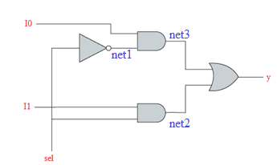 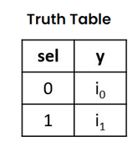

module mux21_structural(i0,i1,sel,y);

input i0,i1,sel;

output y;

wire net1,net2,net3;

not g1(net1,sel);

and g2(net2,i1,sel);

and g3(net3,i0,net1);

or g4(y,net3,net2);

endmodule

module mux21_data_flow(i0,i1,sel,y);

input i0,i1,sel;

output y;

assign y =(i0&(~sel))|(i1&sel);

endmodule

module mux21_Behavioural (i0,i1,sel,y);

input i0,i1,sel;

output y;

reg y;

always@(*)

begin

if(sel==0) y=i0;

if(sel==1)y=i1;

end

endmodule

module Multiplexer_2_1(SW,LEDR,LEDG);

input [17:0] SW;

output [17:0] LEDR;

output [7:0] LEDG;

assign LEDR=SW;

mux21_structural DUT1(.i0(SW[8]), .i1(SW[7]),.s(SW[6]),.y(LEDG[2]));

mux21_data_flow DUT2(.i0(SW[5]), .i1(SW[4]),.s(SW[3]),.y(LEDG[1]));

mux21_Behavioural DUT3(.i0(SW[2]), .i1(SW[1]),.s(SW[0]),.y(LEDG[0]));

endmodule

**EXPERIMENT 8**

**AIM: WRITE VERILOG HDL CODES TO SIMULATE AND IMPLEMENT 4:1 MULTIPLEXER CIRCUIT:**

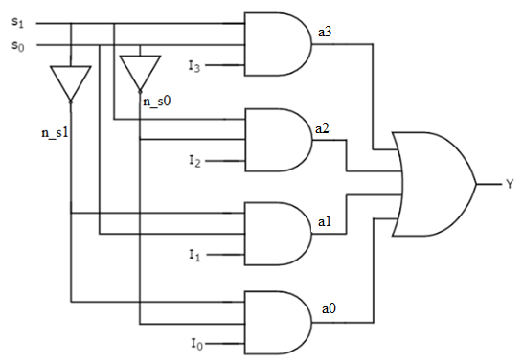 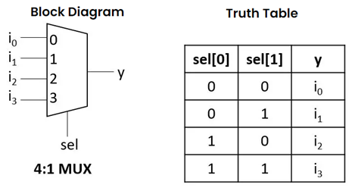

module mux41_strutural (i0,i1,i2,i3,s0,s1,y);

input i0,i1,i2,i3,s0,s1;

output y;

wire n_s0,n_s1, a0,a1,a2,a3;

not g0(n_s0,s0);

not g1(n_s1,s1);

and g2(a0,i0,n_s0,n_s1);

and g3(a1,i1,n_s1,s0);

and g4(a2,i2,s1,n_s0);

and g5(a3,i3,s1,s0);

or g6(y,a0,a1,a2,a3);

endmodule

module mux41_df (i0,i1,i2,i3,s0,s1,y);

input i0,i1,i2,i3,s0,s1;

output y;

assign y= i0&(~s1)&(~s0) | i1 &(~s1)&s0 | i2&s1&(~s0) | i3&s1&s0;

endmodule

module mux41beh_v1(in,s,y );

output y ;

input [3:0] in ;

input [1:0] s ;

reg y;

always @ (in,s)

begin

if (s[0]==0&s[1]==0)

y <= in[0];

else if (s[0]==0&s[1]==1)

y <= in[1];

else if (s[0]==1&s[1]==0)

y <= in[2];

else

y <= in[3];

end

endmodule

module mux41beh_v2(in,s,y );

output y ;

input [3:0]in ;

input [1:0]s ;

reg y;

always@(in,s)

begin

case ({s[1],s[0]})

2'b00: y <= in[0];

2'b01: y <= in[1];

2'b10: y <= in[2];

2'b11: y <= in[3];

endcase

end

endmodule

module Mux_4_1(SW,LEDR,LEDG);

input [17:0] SW;

output [17:0] LEDR;

output [7:0] LEDG;

assign LEDR=SW;

mux41_strutural C1(.i0(SW[5]),.i1(SW[4]),.i2(SW[3]), .i3(SW[2]), .s1(SW[1]), .s0(SW[0]),.y (LEDG[3]));

mux41_df (.i0(SW[5]), .i1(SW[4]), .i2(SW[3]), .i3(SW[2]), .s1(SW[1]), .s0(SW[0]),.y(LEDG[2]));

mux41beh_v1 (.in(SW[5:2]), .s(SW[1:0]),.y (LEDG[1]));

mux41beh_v2 (.in(SW[5:2]), .s(SW[1:0]), .y (LEDG[0]));

endmodule

**EXPERIMENT 9**

**AIM: WRITE VERILOG HDL CODES TO SIMULATE 4:1 MULTIPLEXER USING 2:1 MULTIPLEXER:**

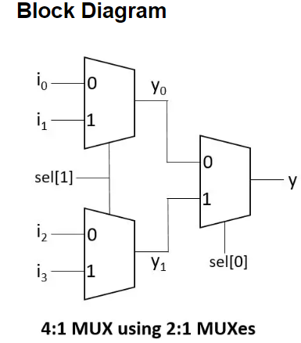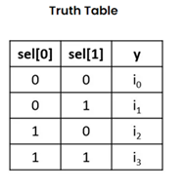

module mux_2_1(

input sel,

input i0, i1,

output y);

assign y = sel ? i1 : i0;

endmodule

module mux_4_1_using_2_to_1(

input sel0, sel1,

input i0,i1,i2,i3,

output reg y);

wire y0, y1;

mux_2_1 m1(sel1, i2, i3, y1);

mux_2_1 m2(sel1, i0, i1, y0);

mux_2_1 m3(sel0, y0, y1, y);

endmodule

module tb;

reg sel0, sel1;

reg i0,i1,i2,i3;

wire y;

mux_4_1_using_2_to_1 DUT(sel0, sel1, i0, i1, i2, i3, y);

initial begin

$monitor("sel0=%b, sel1=%b -> i3 = %0b, i2 = %0b ,i1 = %0b, i0 = %0b -> y = %0b", sel0,sel1,i3,i2,i1,i0, y);

{i3,i2,i1,i0} = 4'h5;

repeat(6) begin

{sel0, sel1} = $random;

#5;

end

end

endmodule

module Mux_4_1_test_FPGA(SW,LEDR,LEDG);

input [17:0] SW;

output [17:0] LEDR;

output [7:0] LEDG;

assign LEDR=SW;

mux_4_1_using_2_to_1 C1(.i0(SW[5]),.i1(SW[4]),.i2(SW[3]), .i3(SW[2]), .s1(SW[1]), .s0(SW[0]),.y (LEDG[3]));

endmodule

**EXPERIMENT 10**

**AIM: WRITE VERILOG HDL CODES TO SIMULATE AND IMPLEMENT 8 TO 3 ENCODER WITHOUT PRIORITY:**

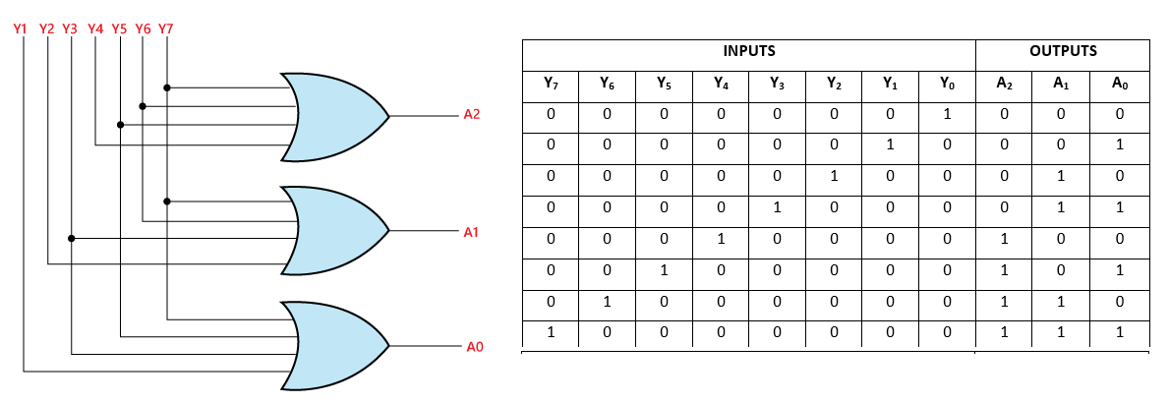

module encoder_stru (din, dout);

input [7:0] din;

output [2:0] dout;

reg [2:0] dout;

or g1(dout[0],din[1],din[3],din[5],din[7]);

or g2(dout[1],din[2],din[3],din[6],din[7]);

or g3(dout[2],din[4]4,din[5],din[6],din[7]);

endmodule

module encoder_df(din, dout);

input [7:0] din;

output [2:0] dout;

reg [2:0] dout;

assign=dout[0],din[1],din[3],din[5],din[7]);

or g2(dout[1],din[2],din[3],din[6],din[7]);

or g3(dout[2],din[4]4,din[5],din[6],din[7]);

endmodule

module encoder (din, dout);

input [7:0] din;

output [2:0] dout;

reg [2:0] dout;

always @(din)

begin

if (din ==8'b00000001) dout=3'b000;

else if (din==8'b00000010) dout=3'b001;

else if (din==8'b00000100) dout=3'b010;

else if (din==8'b00001000) dout=3'b011;

else if (din==8'b00010000) dout=3'b100;

else if (din ==8'b00100000) dout=3'b101;

else if (din==8'b01000000) dout=3'b110;

else if (din==8'b10000000) dout=3'b111;

else dout=3'bX;

end

endmodule

module encoder_without_prio(a,en,y);

input [7:0] a;

input en;

output reg [2:0] y;

always@(a or en)

begin

if(!en)

y<=1'b0;

else

case(a)

8'b00000001:y<=3'b000;

8'b00000010:y<=3'b001;

8'b00000100:y<=3'b010;

8'b00001000:y<=3'b011;

8'b00010000:y<=3'b100;

8'b00100000:y<=3'b101;

8'b01000000:y<=3'b110;

8'b10000000:y<=3'b111;

endcase

end

endmodule