

DEKIRU NIHONGO

Software Requirement Specification

**Project Code: DN**

**Document Code: DN-DOC – v1.1**

**<Hoa Lac, 21/09/2016>**

Record of change

*A - Added M - Modified D - Deleted

|  |  |  |  |  |
| --- | --- | --- | --- | --- |
| Effective Date | Changed Items | A* M, D | Change Description | New Version |
| 18/09/2016 | The whole document | A | Initiate version | 1.0 |
| 21/09/2016 | Appendix | A | Some user interface for easy implementation | 1.1 |
|  |  |  |  |  |
|  |  |  |  |  |
|  |  |  |  |  |
|  |  |  |  |  |
|  |  |  |  |  |
|  |  |  |  |  |
|  |  |  |  |  |
|  |  |  |  |  |
|  |  |  |  |  |
|  |  |  |  |  |
|  |  |  |  |  |
|  |  |  |  |  |
|  |  |  |  |  |
|  |  |  |  |  |
|  |  |  |  |  |
|  |  |  |  |  |
|  |  |  |  |  |
|  |  |  |  |  |

TABLE OF CONTENTS

1 Introduction 4

1.1 Purpose 4

1.2 Scope 4

1.3 Definitions, Acronyms, and Abbreviations 4

1.4 References 5

1.5 Overview 5

2 Overall Description 6

2.1 Product Perspective: 6

2.2 Product Functions: 6

2.3 User characteristics 7

2.4 General Constraints 7

3 Specific Requirements 8

3.1 Functionality 8

3.2 Reliability 14

3.3 Performance 14

3.4 Supportability 14

3.5 Interfaces 14

4 Appendix 16

4.1 Appendix A: Menu of List of Lessons. 16

4.2 Appendix B: Vocabulary 16

4.3 Appendix C: Learn Vocabulary 17

4.4 Appendix D: Grammar 17

4.5 Appendix E: Grammar Explanation 18

4.6 Appendix F: Kanji 18

4.7 Appendix G: Kanji Infomation 19

4.8 Appendix H: Quiz 19

4.9 Appendix I: Confirm exit Dialog 20

# Introduction

## Purpose

* The purpose of this document is to provide a consistent and complete description of the requirements for the software: Dekiru Nihongo. Which identify existing project information and the software components that should be tested.

## Scope

We describe what features are in the scope of the software and what are not in the scope of the software to be developed.

*In Scope:*

1. Study Vocabulary function which help user to learn all of vocabulary of each lesson.
2. Study Grammar function which help user to learn Grammar of each lesson with Vietnamese Explanation.
3. Study Kanji function which help user to learn Kanji with all information.
4. Quiz function which help user to review learned knowledge with 10 question in each lesson.
5. Search function which help user to find a word in all vocabulary.

## Definitions, Acronyms, and Abbreviations

|  |  |  |
| --- | --- | --- |
| ID | Acronym | Definition |
| **1** | SRS | Software Requirement Specification |
| **2** | App | Application |
| **3** | DN | Dekiru Nihongo (Software’s name) |
| **4** | OS | Operating System |
| **5** | GUI | Graphic User Interface |
| **6** | CMS | Content Manager System |
| **7** | DB | Database |
| **8** | CM | Content Manager |

## References

* Software requirement specification form
* SRS of Cafeteria Ordering System (by Karl Wiegers)
* Software engineering – Ninth Edition (by Ian Sommerville)
* Dekiru Nihongo - ShoChyuKyuu

## Overview

We intend to develop the application with the following main part:

Client side: this part contains four main functions:

* + Study Vocabulary function: include feature to help user study Vocabulary of each lesson in the book names Dekiru Nihongo by a list of Japanese Vocabulary with that meanings.
  + Study Grammar function: include feature to help user study all Grammar’s structure of each lesson in the book names Dekiru Nihongo by Vietnamese explanations.
  + Study Kanji function: include feature to help user study all Kanji of each lesson in the book names Dekiru Nihongo with all information of each Kanji letter.
  + Quiz function: include feature to help user to review and prepare for class’s test with 10 questions for each lesson.
  + Search Vocabulary function: include feature to help user input a Japanese word and search in data of all vocabulary, result will display word, meaning and lesson number of inputted word.

# Overall Description

## Product Perspective:

* DN is aimed toward student who:
  + Study following the book names Dekiru Nihongo (FPT student)
  + Have diffuculty in learning Japanese in class with the book names Dekiru Nihongo
  + Want to learning Japanese easily and take the good mark in class.
* DN is an Desktop Java Application. Which means it works on PC features. The GUI should be as friendly as possible, easy to use and attractive to pupils and students.
* DN is intended to be a stand-alone product and should not depend on the availability of other software.

## Product Functions:

|  |  |  |
| --- | --- | --- |
| Class of use cases | Functions need to implement | Description of function |
| Use cases related to learn Vocabulary | Display Vocabulary list | Load data of Vocabulary and display to the list of all vocabulary. Scroll up and down to see all Vocabylary with that meanning. |
| Learn Vocabulary | Pick randomly an item from list of Vocabulary, display meaning and allow user to enter Japanese word to an text field. |
| Display result | On top of the Vocabulary interface, there is an progress bar to display the grade of user when they learning vocabylary by percentage. |
| Use cases related to learn Grammar | Display Grammar list | Load data of Grammar and display to the list of grammar. Scroll up and down to see all Grammar and pick an item to see the description. |
| Display an Grammar explanation | Load data and display the Vietnamese explanation of that grammar. |
| Use cases related to learn Kanji | Display Kanji list | Load data and display the list of Kanji. |
| Choose an item of list of Kanji | The information of Kanji that was choosen will be appear such as : ON- sound, KUN- sound and compound word. |
| Use cases related to Quiz | Display Quiz | Display the quiz interface. There are one question and four answer. |
| Start again | Start Quiz again |
| Next | Go to next question |
| Display result | On top of the Quiz interface, we have number of wright and wrong answer with icon. |
| Use cases related to Search Vocabulary | Search Vocabulary | Search in data of all vocabulary the inputted word |
| Display result | Display all word and meaning contains key word in a list. |

## User characteristics

Software doesn’t require any special characteristics of user. User just to have a PC device.

## General Constraints

1. DN currently only support PC devices
2. DN is single-user software

# Specific Requirements

## Functionality

|  |  |
| --- | --- |
| Primary Actor | Use Cases |
| User | 1. Choose Lesson to Learn 2. Learn Vocabulary 3. Learn Grammar 4. Learn Kanji 5. Try Quiz 6. Search Vocabulary 7. Exit |

|  |  |  |  |
| --- | --- | --- | --- |
| Use Case ID: | DN01 | | |
| **Use Case Name:** | Choose Lesson to Learn | | |
| **Created By:** | QuangTM | **Last Updated By:** | QuangTM |
| **Date Created:** | September 18, 2016 | **Date Last Updated:** | September 21, 2016 |
| **Actors:** | User | | |
| **Description:** | User click on First page to enter List of Lesson interface. The list contains name of 15 lesson of this book. If user click on an item of list, application will be change to Study interface. Study interface contains 4 tab, user can enter switch to each tab to learn Vocabulary, Grammar, Kanji and Quiz. | | |
| **Pre-conditions:** | User opened application | | |
| **Post-conditions:** | User click on the Main Menu interface | | |
| **Normal Flow:** | **1.0 Click enter List of Lesson**   1. User click on first background to enter List of Lessons. 2. List of name of lessons is appeared, allow user to scroll down to see full and click on. 3. User click on an item of List of Lessons to enter that lesson. 4. Study interface is appeared with four tab: Vocabulary, Grammar, Kanji and Quiz. 5. User switch tab to learn what they want. | | |
| **Alternative Flows:** | **N/A** | | |
| **Exceptions:** | **No Exception** | | |
| **Priority:** | Medium | | |
| **Special Requirements:** | **N/A** | | |
| **Notes and Issues:** | N/A | | |

|  |  |  |  |
| --- | --- | --- | --- |
| Use Case ID: | DN02 | | |
| **Use Case Name:** | Learn Vocabulary | | |
| **Created By:** | QuangTM | **Last Updated By:** | QuangTM |
| **Date Created:** | September 18, 20116 | **Date Last Updated:** | September 21, 20116 |
| **Actors:** | User | | |
| **Description:** | Learning Vocabulary. After enter Study interface, user switch to Vocabulary tab ( default tab), the list of Vocabulary will be appear and allow user to scroll down and up to see all vocabulary and meannings to learn. And user can click to the Learn Vocabulary to enter Learning function. In learning interface we display meaning of a random word of current lesson and allow user to enter that Japanese word to an text field. | | |
| **Pre-conditions:** | User opened application | | |
| **Post-conditions:** | User entered List of Lessons.  User must config tool to type Japanese letter. (Japanese keyboard) | | |
| **Normal Flow:** | **1.0 User enter vocabulary tab**   1. User choose an lesson and click on that item. 2. The Study Interface is appeared. Default tab is Vocabulary tab 3. User scroll down and up to see the list of vocabulary of current lesson to learn with meaning. | | |
| **Alternative Flows:** | **1.1 User enter Learning mode**(branch after step 2)   1. User click on [Learn Vocabulary] button 2. A meaning of a word is appeared, user click to text field and input the Japanese word and press Enter to check wright or wrong. App will display correct answer if user wrong, calculate grade and display on grade bar 3. User click on [Next] button 4. Continue same as step 2( 1.1).   **1.2 User Start learning again.** (branch after step 3 (1.1))   1. User click on [Start again] button 2. Continue as above till step 2 (1.1) | | |
| **Exceptions:** | **In learning function:**   * If user click on [Next] button without do the question, an message will popup that : “Please write your answer before do next question” | | |
| **Priority:** | High | | |
| **Special Requirements:** | **User must input Japanese letter to text field** | | |
| **Notes and Issues:** | N/A | | |

|  |  |  |  |
| --- | --- | --- | --- |
| Use Case ID: | DN03 | | |
| **Use Case Name:** | Learn Grammar | | |
| **Created By:** | QuangTM | **Last Updated By:** | QuangTM |
| **Date Created:** | September 18, 2016 | **Date Last Updated:** | September 21, 2016 |
| **Actors:** | User | | |
| **Description:** | After enter Study interface, user switch to Grammar tab, the list of Grammar structure will be appear. User click on a grammar to see Vietnamese explanation and example. | | |
| **Pre-conditions:** | User opened application | | |
| **Post-conditions:** | User entered List of Lessons. | | |
| **Normal Flow:** | **1.0 User enter Grammar tab**   1. User choose an lesson and click on that item. 2. The Study interface is appeared, user switch to Grammar tab. 3. User scroll down to see all grammar structure 4. User click on an grammar 5. The Explanation interface is appeared 6. User scroll down to see explanation and example to study. | | |
| **Alternative Flows:** | **N/A** | | |
| **Exceptions:** | No Exception | | |
| **Priority:** | Medium | | |
| **Special Requirements:** | N/A | | |
| **Notes and Issues:** | N/A | | |

|  |  |  |  |
| --- | --- | --- | --- |
| Use Case ID: | DN04 | | |
| **Use Case Name:** | Learn Kanji | | |
| **Created By:** | QuangTM | **Last Updated By:** | QuangTM |
| **Date Created:** | September 21, 2016 | **Date Last Updated:** | September 21, 2016 |
| **Actors:** | User | | |
| **Description:** | After enter Study interface, user switch to Kanji tab, the list of Kanji letter will be appear. User click on a Kanji item to see all information of that Kanji letter. | | |
| **Pre-conditions:** | User opened application. | | |
| **Post-conditions:** | User entered List of Lessons. | | |
| **Normal Flow:** | **1.0 User enter Kanji tab**   1. User choose an lesson and click on that item. 2. The Study interface is appeared, user switch to Kanji tab. 3. User scroll down to see all Kanji letter 4. User click on an Kanji 5. Kanji information interface is appeared 6. User read ON – sound, KUN – sound and compound word of that Kanji. | | |
| **Alternative Flows:** | **N/A** | | |
| **Exceptions:** | No Exception | | |
| **Priority:** | Medium | | |
| **Special Requirements:** | N/A | | |
| **Notes and Issues:** | N/A | | |

|  |  |  |  |
| --- | --- | --- | --- |
| Use Case ID: | DN05 | | |
| **Use Case Name:** | Try Quiz | | |
| **Created By:** | QuangTM | **Last Updated By:** | QuangTM |
| **Date Created:** | September 21, 2016 | **Date Last Updated:** | September 21, 2016 |
| **Actors:** | User | | |
| **Description:** | After enter Study interface, usser switch to Quiz tab. Each lesson have 10 questions to review and restudy. User try to do quiz to check their knowledge. | | |
| **Pre-conditions:** | User openned application | | |
| **Post-conditions:** | User Entered List of Lesson | | |
| **Normal Flow:** | **1.0 User try to attemp quiz**   1. User choose an lesson and click on that item. 2. After studying, user switch to Quiz tab 3. A question and four answer are appeared 4. User choose an answer, app will display correct answer, calculate grade and display to grade bar. 5. User click on [Next] button 6. Continue same as step 2 | | |
| **Alternative Flows:** | **1.1 User start quiz again** (branch after step 3)   1. User click on [Start again] button 2. Quiz is start again with a new order. 3. 3. Continue as the above flow till step 3. | | |
| **Exceptions:** | * If user click on [Next] button without do the question, an message will popup that : “Please choose an answer before do next question” | | |
| **Priority:** | High | | |
| **Special Requirements:** | N/A | | |
| **Notes and Issues:** | * User ought to learn before attemp quiz | | |

|  |  |  |  |
| --- | --- | --- | --- |
| Use Case ID: | DN06 | | |
| **Use Case Name:** | Search Vocabulary | | |
| **Created By:** | QuangTM | **Last Updated By:** | QuangTM |
| **Date Created:** | September 21, 2016 | **Date Last Updated:** | September 21, 2016 |
| **Actors:** | User | | |
| **Description:** | After enter Study interface, there is an search icon at the right conner of titile bar. User click on search icon and input a Japanese word. App will search in data of all Vocabulary and display all word contains inputted key word with meaning and lesson number in a list. | | |
| **Pre-conditions:** | User openned the application | | |
| **Post-conditions:** | User entered Study interface  User config to use Japanese keyboard | | |
| **Normal Flow:** | **1.0 User click on Search icon**   1. User choose a lesson and click on that item 2. User click on Search icon on title bar 3. A text field is appeared 4. User input a word to text field 5. User press Enter 6. App search that word and display in a list | | |
| **Alternative Flows:** | N/A | | |
| **Exceptions:** | No Exception | | |
| **Priority:** | High | | |
| **Special Requirements:** | * User have to input by Japanese Keyboard | | |
| **Notes and Issues:** | * User ought to config the keyboard before use Search function | | |

|  |  |  |  |
| --- | --- | --- | --- |
| Use Case ID: | DN07 | | |
| **Use Case Name:** | Exit | | |
| **Created By:** | QuangTM | **Last Updated By:** | QuangTM |
| **Date Created:** | September 21, 2016 | **Date Last Updated:** | September 21, 2016 |
| **Actors:** | User | | |
| **Description:** | User exit application | | |
| **Pre-conditions:** | User opened application | | |
| **Post-conditions:** | N/A | | |
| **Normal Flow:** | **1.0 User want to exit program**   1. User click on [Close] button on right top of windows. 2. App will show a dialog to confirm exit program 3. User click on [Yes] button 4. Application exitted. | | |
| **Alternative Flows:** | **1.1 User suddenly want to continue using application** (branch after step 2)   1. User click on [No] button. 2. App will do nothing and user can continue studing. | | |
| **Exceptions:** | No Exception. | | |
| **Priority:** | Low | | |
| **Special Requirements:** | N/A | | |
| **Notes and Issues:** | N/A | | |

## Reliability

* CMS server can be available 24/7 and can support a large number of queries for update new content and receive feedback from user.
* When system failed it would took 10 minutes to completely restart and fully operate again.
* The maximum defect rate is about 20-25 bugs per 1000 lines of code.

## Performance

1. DN should be able to run on PC device.
2. 90% of responses should be within 1 sec.

## Supportability

* The software development phase will follow the Project Coding Convention which is designed to help the team create explicit source code.
* Besides, the development will follow the Object-Oriented Paradigm. This will lead to easily maintenance and upgrading of the application in the future.

## Interfaces

### User Interfaces

A graphic user interface will be available in all workflow scenarios to allow easy to access to all features of the system. The navigation options in every screen will be similar in order to help user can reduce the time learning and using system. All error occurring and exception handling will be catch and display for user with friendly messages.

GUI should follow Swing GUI Pattern.

### Software Interfaces

Computer: Any OS version can run this application.

# Appendix

## Appendix A: Menu of List of Lessons.

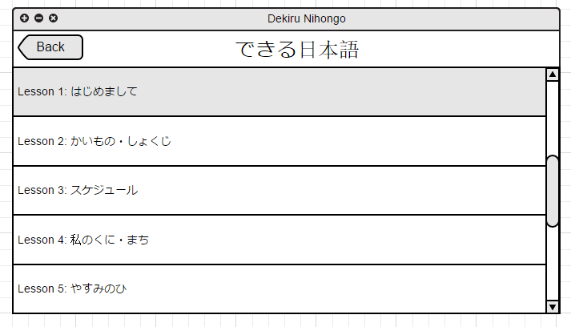

## Appendix B: Vocabulary

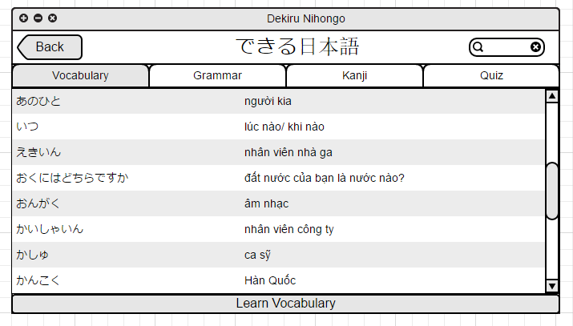

## Appendix C: Learn Vocabulary

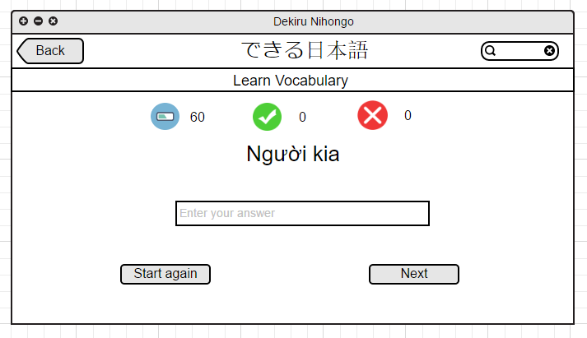

## Appendix D: Grammar

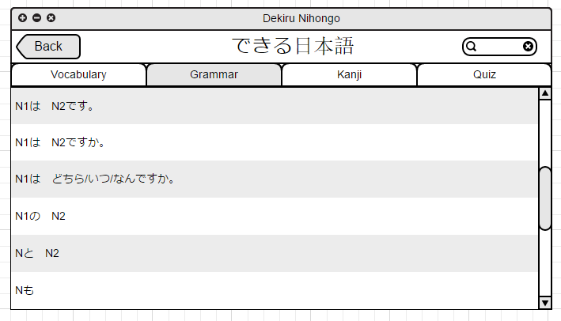

## Appendix E: Grammar Explanation

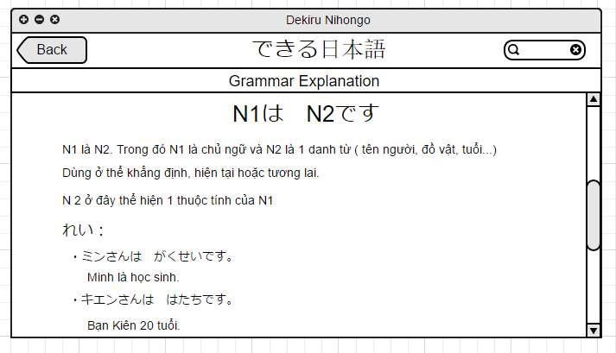

## Appendix F: Kanji

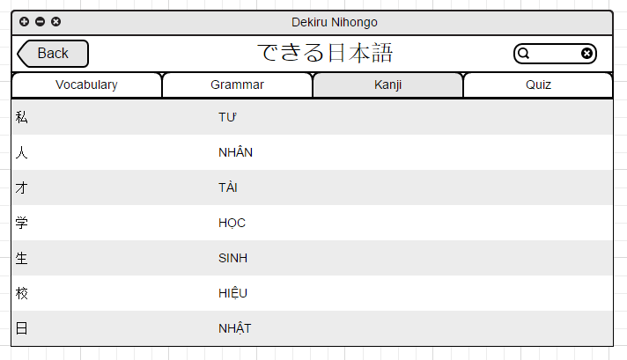

## Appendix G: Kanji Infomation

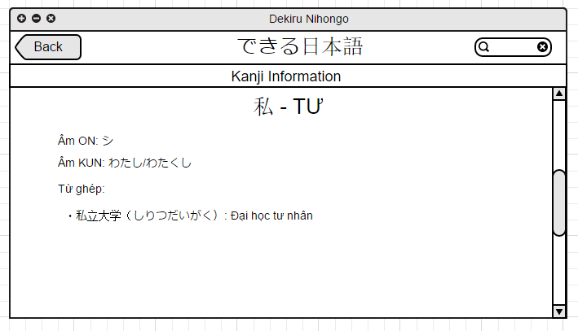

## Appendix H: Quiz

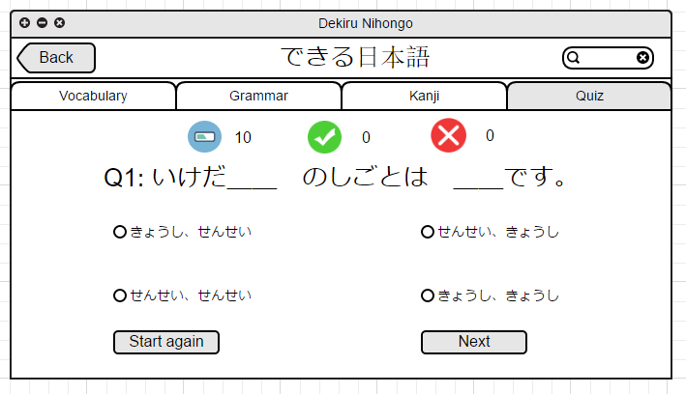

## Appendix I: Confirm exit Dialog

