LAB 2: SERVLET & JSP

Full name: Trần Minh Quang

Student Code: SE04402

For instance, I have learn following stuffs:

* Create project Java-Web-App
* Config server Apache Tomcat
* Practicing Demo with JSP and Servlets
* HTML Tag: Bold, Paragraph, Form, Input, Header,…
* CSS: Color, Text-align, Font family, font size,…
* BootStrap: No

1. ANSWER FOLLOWING QUESTIONS:

* **What is servlet/jsp really?**
  + JSP is a webpage scripting language that can generate dynamic content while Servlets are Java programs that are already compiled which also creates dynamic web content
  + JSP can be compiled into Java Servlets
  + JSP are generally preferred when there is not much processing of data required. But servlets are best for use when there is more processing and manipulation involved.
  + The advantage of JSP programming over servlets is that we can build custom tags which can directly call Java beans. There is no such facility in servlets.
* **Describe the structure of Java-Web-project.**
* The WEB-INF directory contains the deployment descriptors for the Web application (web.xml and weblogic.xml) and two subdirectories for storing compiled Java classes and library JAR files. These subdirectories are respectively named classes and lib. JSP taglibs are stored in the WEB-INF directory at the top level of the staging directory. The Java classes include servlets, helper classes and, if desired, precompiled JSPs.
* All servlets, classes, static files, and other resources belonging to a Web application are organized under a directory hierarchy.
* The entire directory, once staged, is bundled into a WAR file using the jar command. The WAR file can be deployed alone or as part of an Enterprise application (recommended) with other application components, including other Web applications, EJB components, and WebLogic Server components.
* JSP pages and HTTP servlets can access all services and APIs available in WebLogic Server. These services include EJBs, database connections through Java Database Connectivity (JDBC), JavaMessaging Service (JMS), XML, and more.
* **What is war file?**

WAR file is a "Web Application Archive" -- it's comprised of all the pieces of your web application: JSPs, Servlets, Images, Static HTML, images, etc. -- and all packaged in a single snazzy little file.

1. BASIC SERVLET

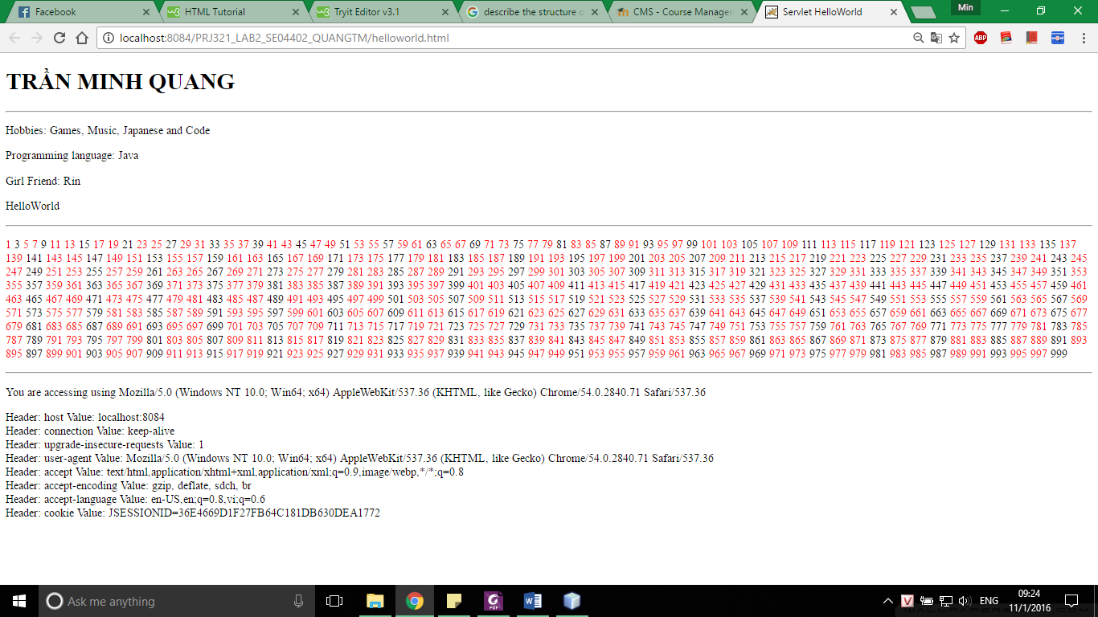

1. TO UNDERSTAND JSP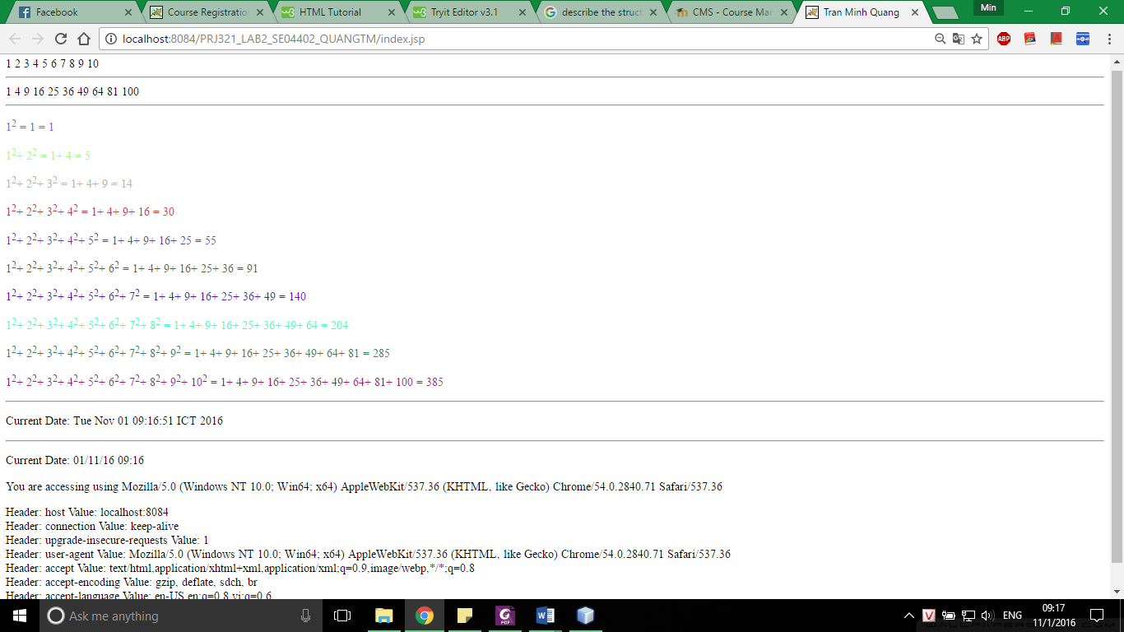
2. PASSING HTTP PARAMETERS USING HTML FORM

