LAB 3: SERVLET & JSP

Full name: Trần Minh Quang

Student Code: SE04402

For instance, I have learn following stuffs:

* How to create a responsive design web.
* How to create a template which include several files, for instance, header, footer, ….
* How to include other file to create a web.
* Forward from servlet to JSP
* Redirect from a page to another
* Create a simple login and course validation page.

1. Answer following question:

* How do we forward from a servlet to jsp?

Use this function:

request.getRequestDispatcher("courseForm.jsp").forward(request, response);

Ex: we did it in PRACTICING.

* How do we redirect from a page to another?

Use this function:

response.sendRedirect("page2.jsp");

Ex: we did it in PRACTICING.

* Describe differences between send redirect and forward.

Redirect :

1. User requests a resource.
2. Response sent to the user.
3. This is not the requested resource, this is response with HTTP code 302 and contains the URL of the requested resource.
4. URL could be same or different from the requested URL.
5. Client browser makes request for resource again with the new URL, this time the actual resource is sent to the user.

Forward:

It is the process of simply displaying the requested resource to the user. It happens entirely on the server side.

Beside: forward can attach a message and redirect can not.

* How do include other file?

Use this function:

“<[%@include file="included/courseContent.jsp" %](mailto:%25@include%20file=%22included/courseContent.jsp%22%20%25)>”

***Login exercise:***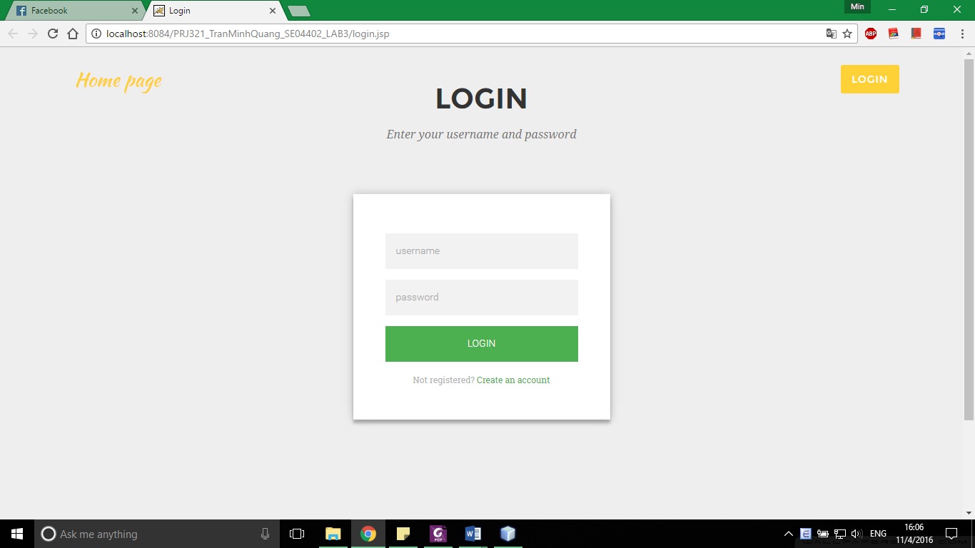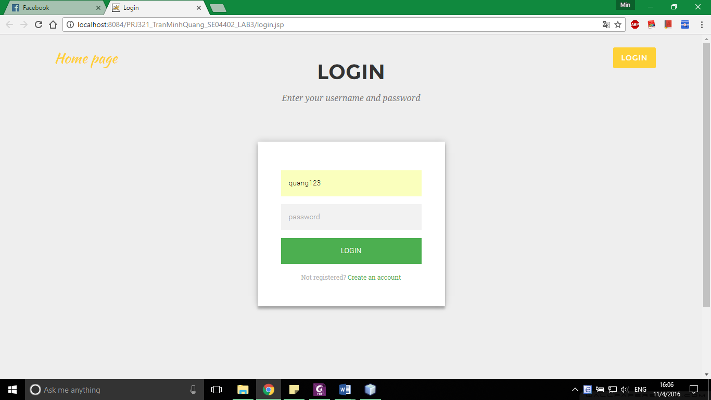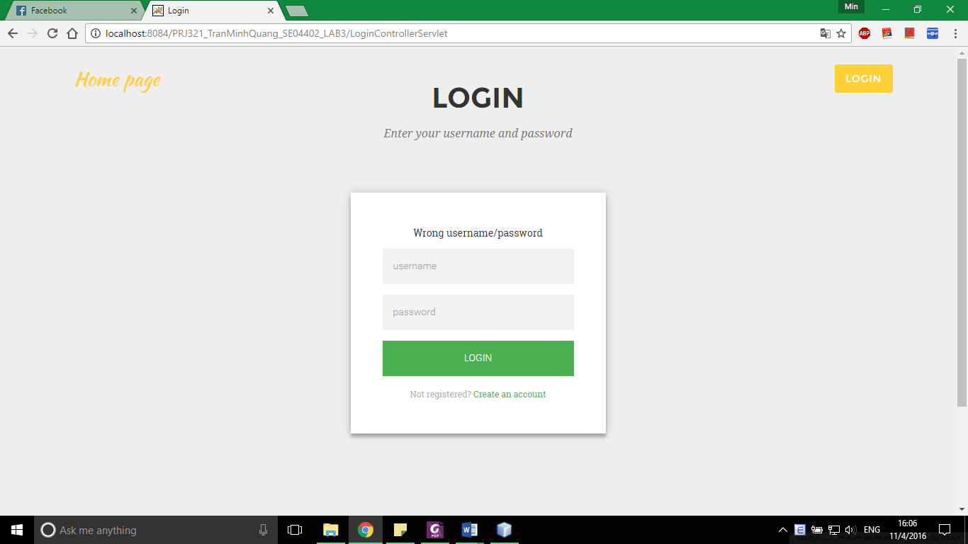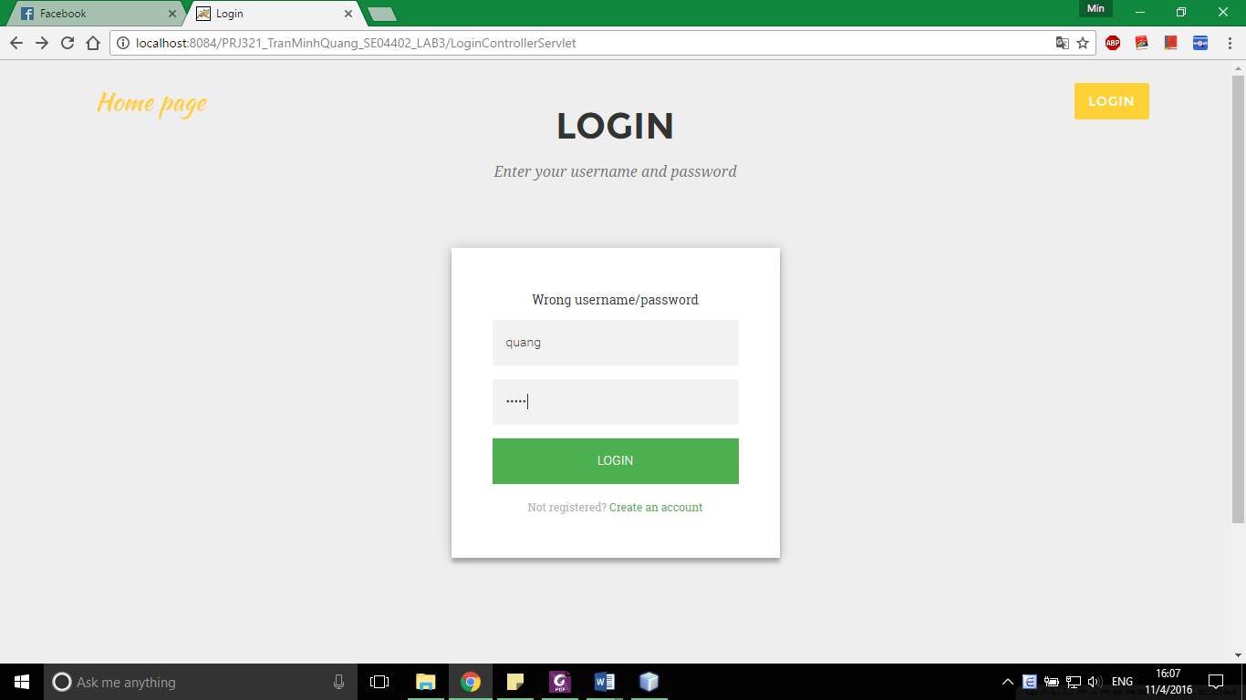

***Form validation execise:***

