LAB 4: JSP SESSION TRACKING

Full name: Trần Minh Quang

Student Code: SE04402

For instance, I have learn following stuffs:

* Revision about JSP:
  + Directive: <%@ include….
  + Scriptlet: <% …. %>
  + Declaration: <%!....%>
  + Expression: <%= %>
* Revision about WAR file structure :
  + Resources: html, css, js….
  + JSP/ Folder
  + Web-INF:
    - Classes
    - Library
    - Web.xml
* Listeners:
  + Application Listener, Session Listener
* Scopes:
  + Page
  + Request
  + Session
  + Application

1. Answer following question:

* In JSP, how many scopes do we have? Explain each of them?

There are four types of scopes available for JSP objects. These are:

* + **application** - an object having this scope will be available to all the JSP pages belonging to the same web application. Example: implicit object 'application' has this scope.
  + **session** - an object having this scope will be available for all the JSP pages belonging to the same session in which this object was instantiated. Example: implicit object 'session' has this scope.
  + **request** - an object having this scope will be available to all the pages which are involved in serving the same request. Example: implicit object 'request' has this scope.
  + **page** - an object having this scope will be available only on that particular JSP page where it was instantiated. This is the default scope for any object created from within a JSP page and most of the implicit objects have this scope only including 'page', 'out', 'exception', 'config', 'pageContext', and 'response'.
* What is implicit object(s) in JSP?

Implicit Objects in JSP are those objects which are created/instantiated implicitly by the JSP Engine (part of the underlying Web Container) as a convenience feature for the JSP page writers who can use them without having to instantiate them. These implicit objects implement the interfaces defined in the JSP/Servlet APIs. There are **nine** implicit objects in JSP, which are:

* Request
* Response
* PageContext
* Application
* Out
* Config
* Session
* Page
* Exception

Captured pictures:



*First time visit page*

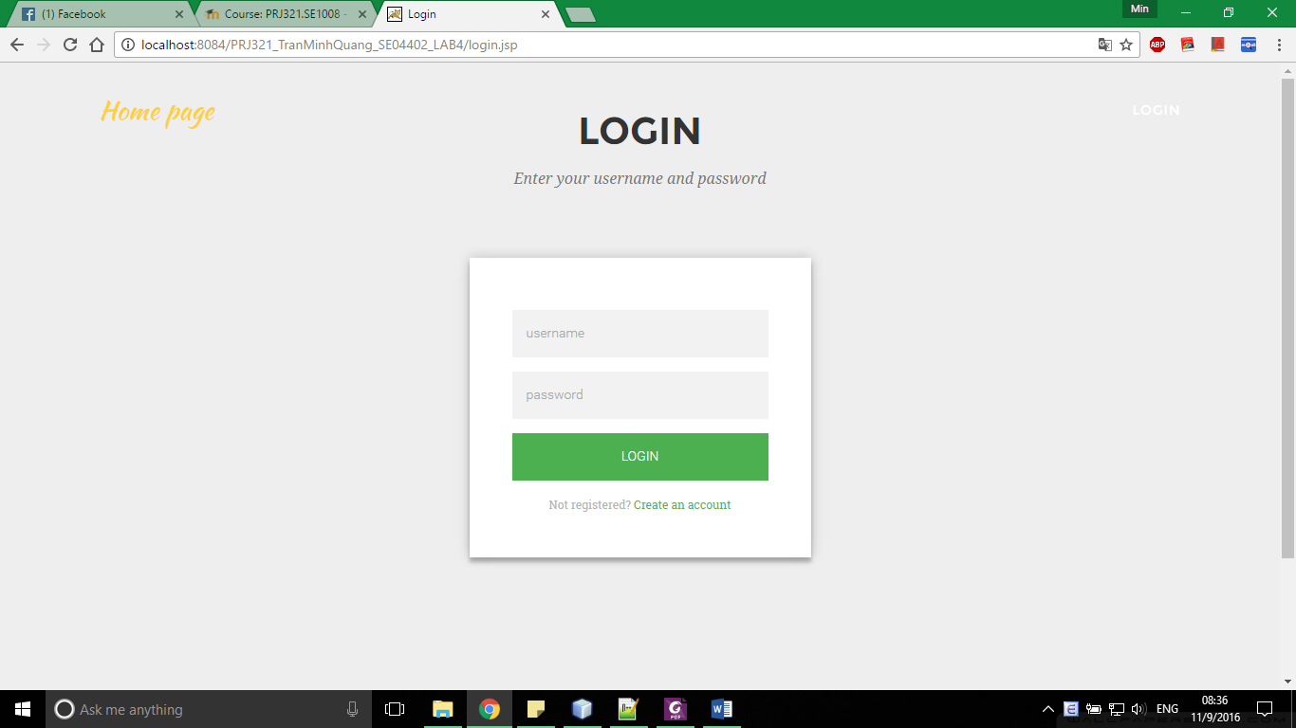

*Login Interface*

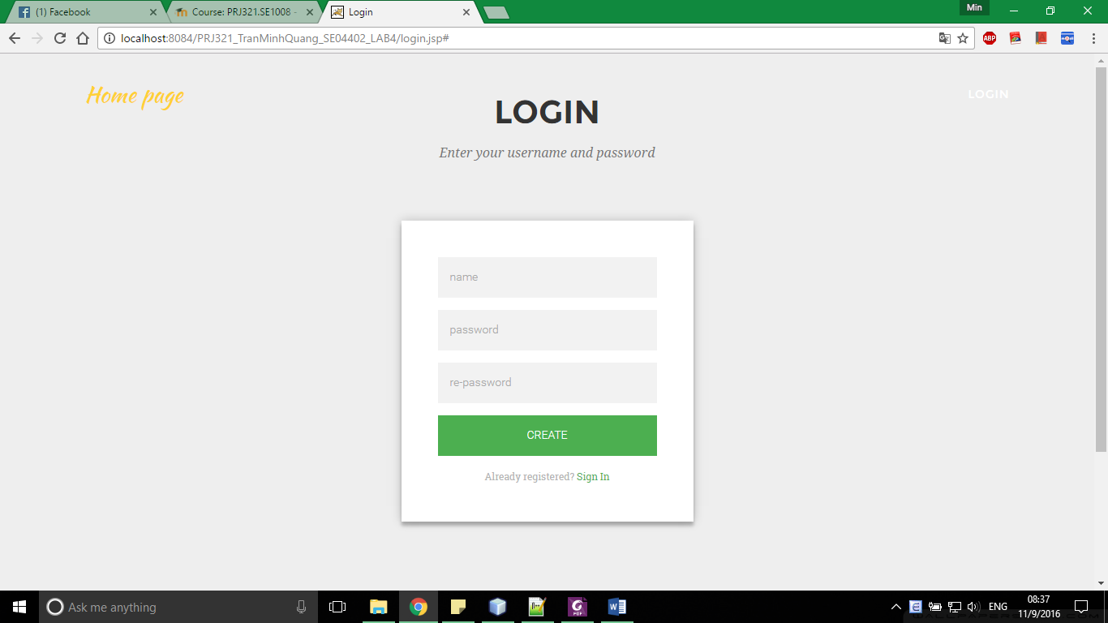

*Register interface*

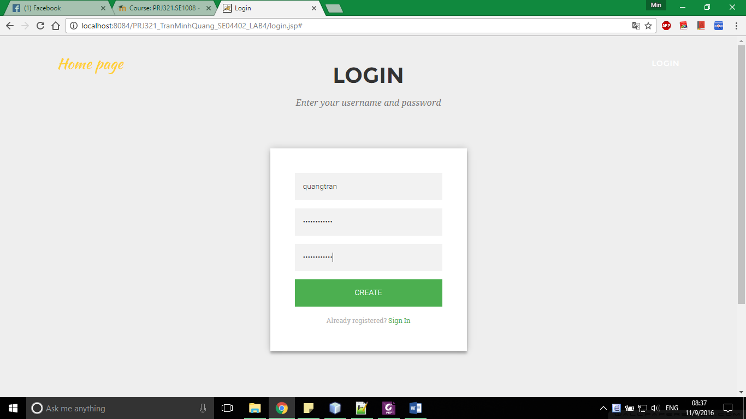

*Filled Information*

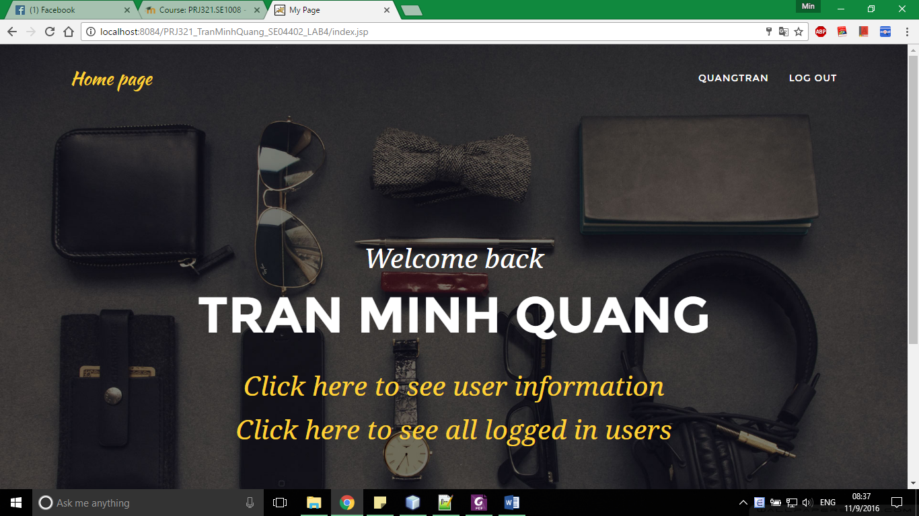

*After register successful, automatically login and back to welcome page*

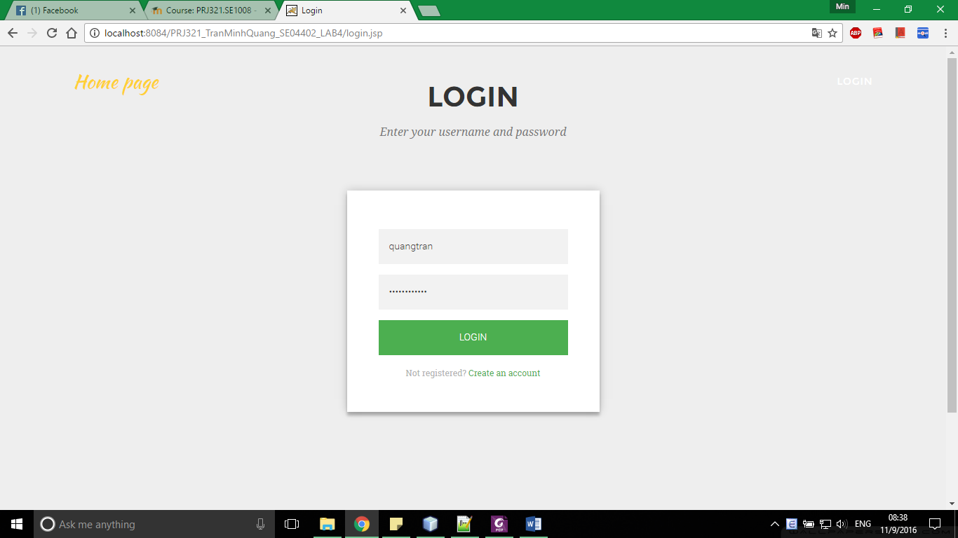

*Logged out, login again*

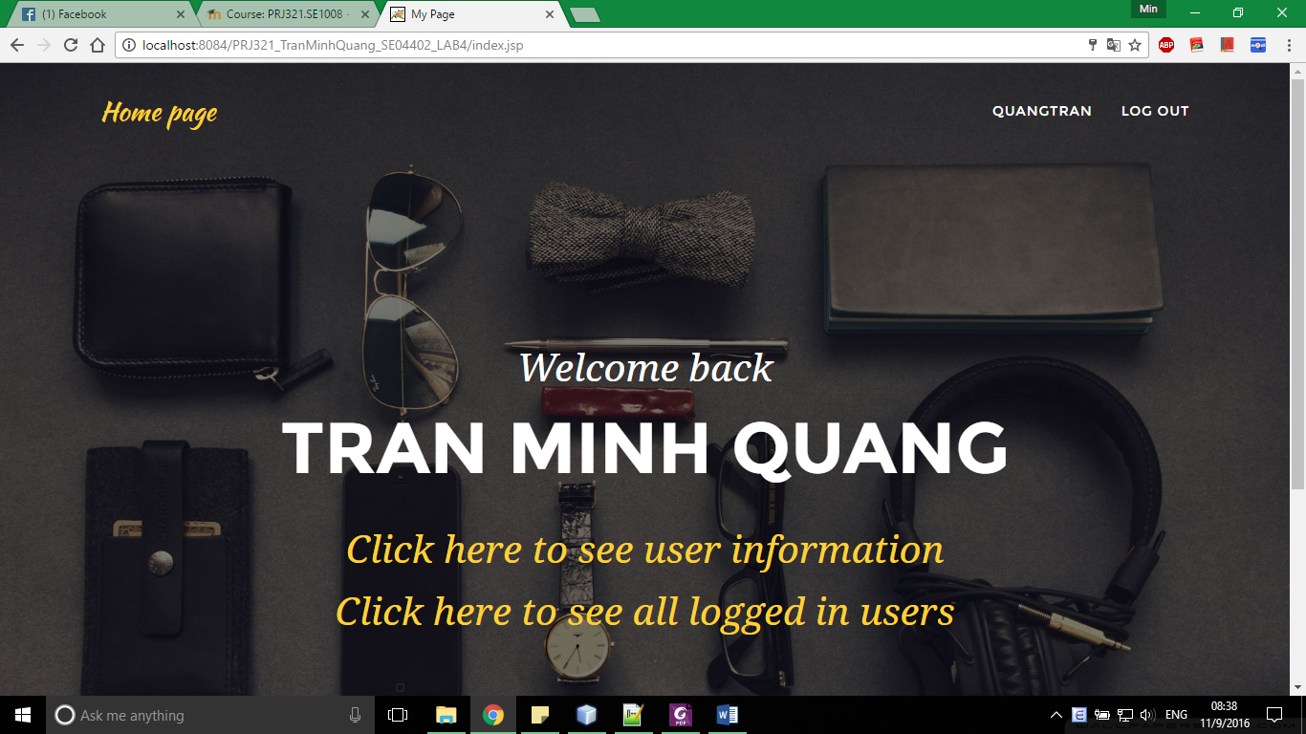

*Login successfull*