Environment Ubuntu Server

Python 3.x

Tesseract-OCR

OpenCV 4.x

**Manual Installation**

1. First of all, make sure you have Python3 installed

sudo apt-get install python3 python3-pip

1. Install Tesseract-ocr

sudo apt-get install tesseract-ocr

1. Install the dependency library

sudo apt-get install libsm6

1. Download my source code to your specified server directory

cd ~

git clone https://github.com/reyzeal/score-tesseract

cd score-tesseract

1. Install the virtualenv to make python environment for this project

pip3 install virtualenv

python3 -m virtualenv venv

1. Activate the environment

source venv/bin/activate

1. Install all requirements library using requirements.txt

pip3 install -r requirements.txt

1. you can try to run it:

venv/bin/gunicorn -b 127.0.0.1:5000 app:app

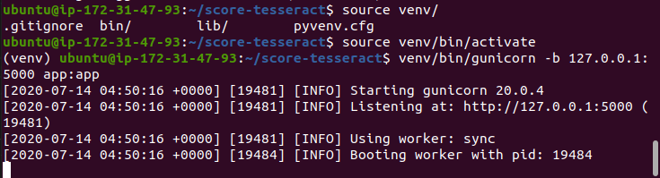

1. Done, if you prefer to run it as server service, stop the execution and do the following steps below.

**Deploy as Systemd Service**

1. You can use the template file that I’ve put in the folder server > score.service . If you know how to use vim / nano, you can directly create new file in **/etc/systemd/system/score.service** using this command : “sudo nano **/etc/systemd/system/score.service**”.

[Unit]

Description=Reyzeal Score Tesseract Gunicorn daemon

After=network.target

[Service]

User=**ubuntu**

Group=**ubuntu**

WorkingDirectory=**/home/ubuntu/score-tesseract**

ExecStart=**/home/ubuntu/score-tesseract/**venv/bin/gunicorn -w 3 -b 127.0.0.1:5000 app:app

[Install]

WantedBy=multi-user.target

1. Change all variables, focus on the red mark:

User=**<your username>**

Group=**<your username>**

WorkingDirectory=**/path/to/project**

ExecStart=**/path/to/project/**venv/bin/gunicorn -w 3 -b 127.0.0.1:5000 app:app

1. Save the file on **/etc/systemd/system/score.service.** Just save and close it if you already using vim / nano directly.
2. Enable and start:

sudo systemctl enable score.service

sudo systemctl start score.service

1. Check the status, it must be look like this:

sudo systemctl status score.service

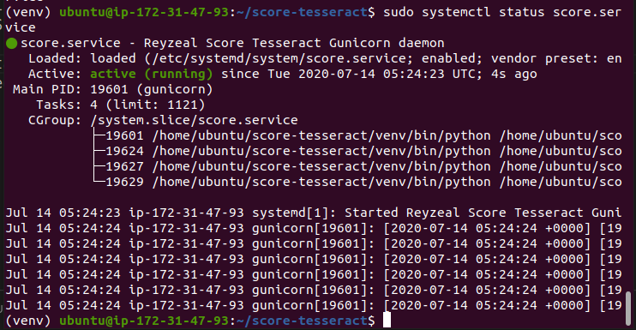

**Apache2 Configuration**

If you want to make proxy through apache2 (make it public), you can add this following lines to your current site config file.

ProxyPreserveHost On

ProxyPass / http://127.0.0.1:5000/

ProxyPassReverse / http://127.0.0.1:5000/

**Note : Make sure you have these mod enabled:**

sudo a2enmod proxy

sudo a2enmod proxy_http