User Guide

ITS Interceptor Extension

November 2018

Version 0.01

DXC

Document Revisions

|  |  |  |
| --- | --- | --- |
| Date | Version Number | Document Changes |
| 26/11/2018 | 0.1 | Guidelines |
|  |  |  |
|  |  |  |
|  |  |  |
|  |  |  |
|  |  |  |
|  |  |  |
|  |  |  |
|  |  |  |

Table of Contents

1 Introduction 4

1.1 Scope and Purpose 4

1.2 Overview 4

2 Setup ITS Interceptor Extension 4

3 Step by step to use 7

How to recording HTTP/S requests, responses ? 7

Awnser: Example, capture GET request: https://reqres.in/api/users?page=2 7

Request information 7

Response this request: 7

Recording HTTP/S requests, responses: 8

Step 1: Click icon ITS on browser bar 8

Step 2: Select button Start recording 8

Step 3: Enter URL: https://reqres.in/api/users?page=2 in the browser 9

Step 4: Select button Save 9

Step 5: A file is downloaded, browser save file to Downloads folder. 9

Step 6: Content of file data 10

# Introduction

## Scope and Purpose

Guideline how to setup ITS Interceptor Extension, step by step to use this tool to capture HTTP/S resquests, responses.

## Overview

Sequence for using ITS Interceptor Extension:

1. Setup ITS Interceptor Extension
2. Start recording HTTP/S requests, responses
3. Stop recording HTTP/S requests, responses
4. Save (Export data HTTP/S requests, responses to file JSON)

# Setup ITS Interceptor Extension

**Step 1**: Open **Chrome**

**Step 2:** On menu of Chrome, select **More tools/Extensions**, select **Developer Mode** is On.

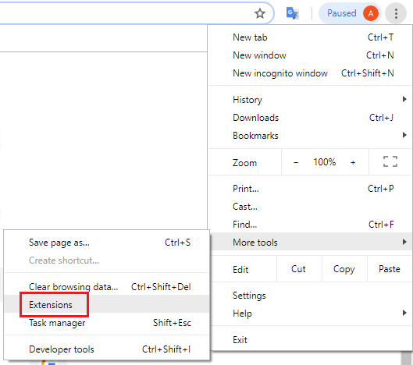

**Developer mode**:

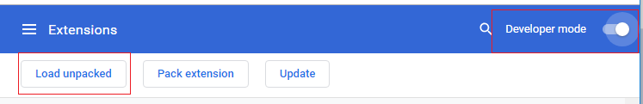

**Step 3**: Click button **Load unpackaged**, browser to the source code location, select **OK**

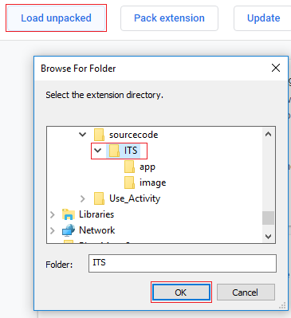

**Result**: **Finish setup**

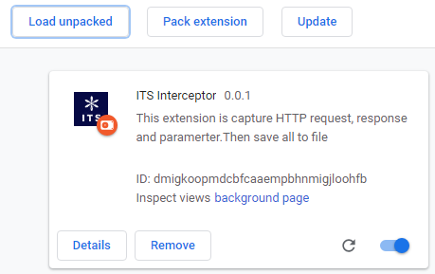

# Step by step to use

Include three functions:

* + Start recording
  + Stop recording
  + Save

## How to recording HTTP/S requests, responses ?

## Awnser: Example, capture GET request: <https://reqres.in/api/users?page=2>

## Request information

**General of request:**

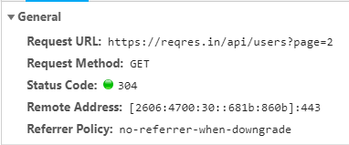

**Request header:**

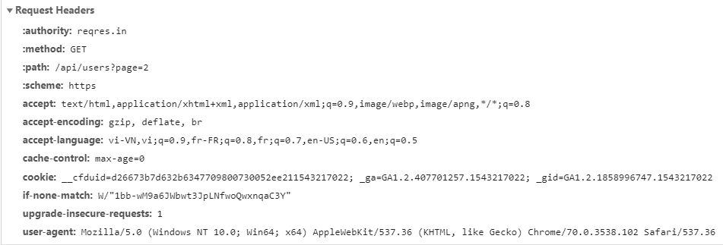

## Response this request:

**Response header:**

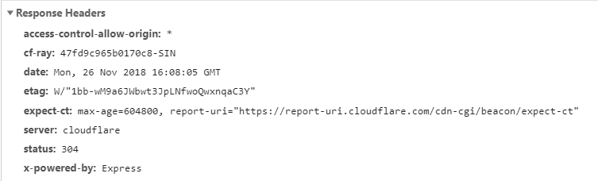

**Response body:**

{"page":2,"per_page":3,"total":12,"total_pages":4,"data":[{"id":4,"first_name":"Eve","last_name":"Holt","avatar":"https://s3.amazonaws.com/uifaces/faces/twitter/marcoramires/128.jpg"},{"id":5,"first_name":"Charles","last_name":"Morris","avatar":"https://s3.amazonaws.com/uifaces/faces/twitter/stephenmoon/128.jpg"},{"id":6,"first_name":"Tracey","last_name":"Ramos","avatar":"https://s3.amazonaws.com/uifaces/faces/twitter/bigmancho/128.jpg"}]}

## Recording HTTP/S requests, responses:

### Step 1: Click icon ITS on browser bar



### Step 2: Select button Start recording

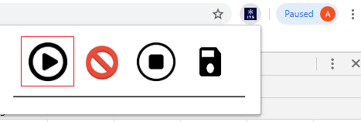

Started recording

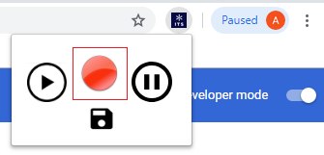

### Step 3: Enter URL: <https://reqres.in/api/users?page=2> in the browser

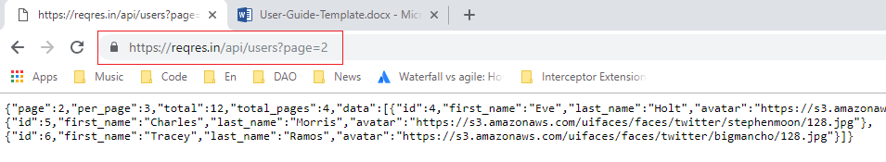

### Step 4: Select button Save

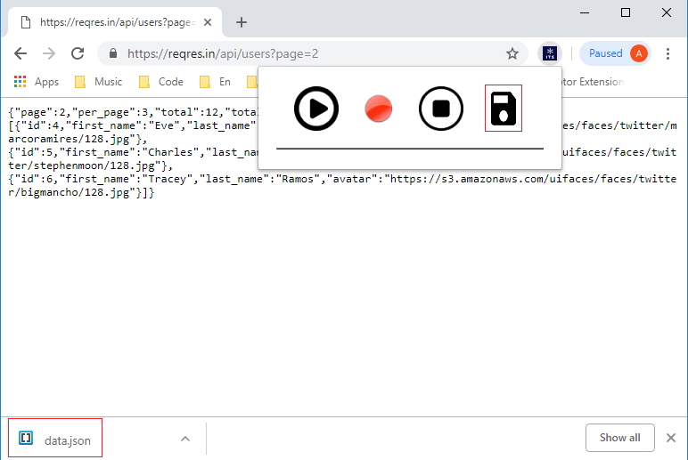

### Step 5: A file is downloaded, browser save file to Downloads folder.

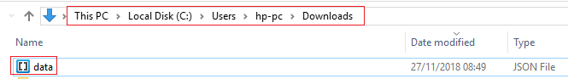

### Step 6: Content of file data

Request header:

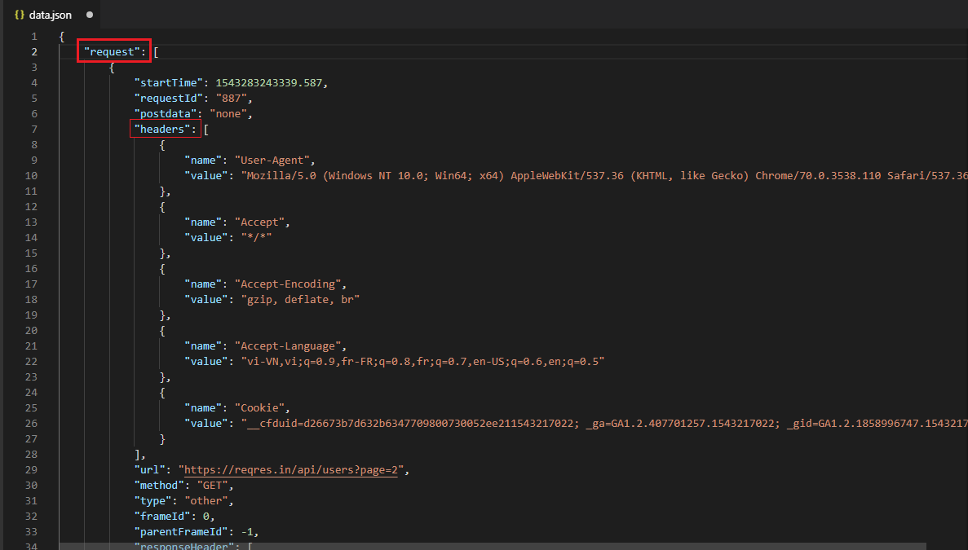

Response header:

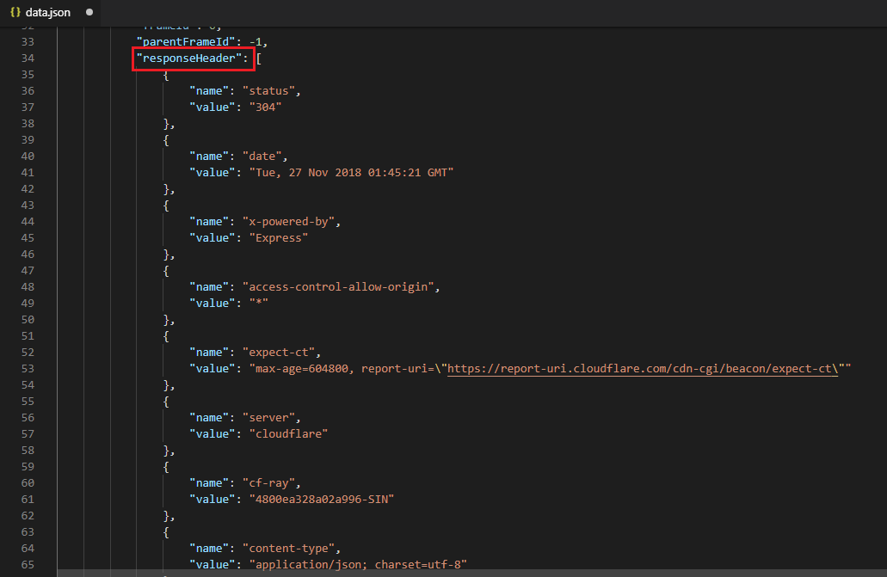

Response body:

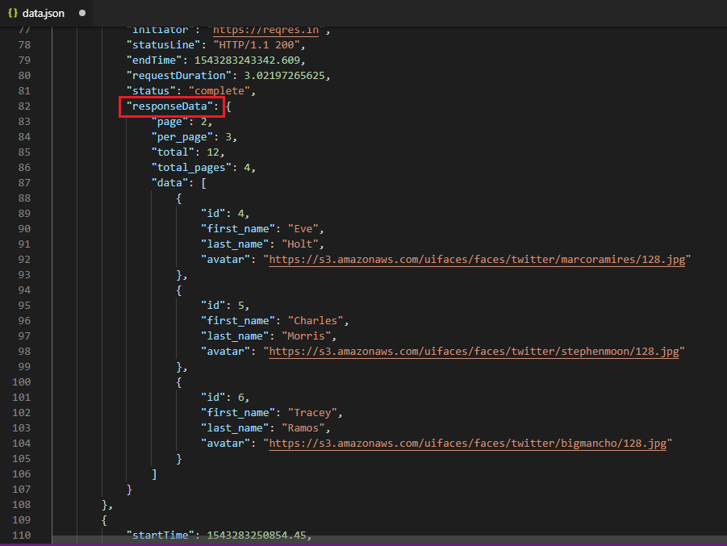

**Note**: *If you stop recording, then you can not save data*.