Building BBB Kernel on Ubuntu 14.04
- Install tools
$ apt-get install gcc-arm-linux-gnueabi
$ apt-get install lzop
$ apt-get install libssl-dev

- Download Uboot
$ wget ftp://ftp.denx.de/pub/u-boot/u-boot-latest.tar.bz2
$ tar -xjf u-boot-latest.tar.bz2
$ cd u-boot-<version>
$ make sandbox_defconfig tools-only
$ install tools/mkimage /usr/local/bin

- Downloading and building the Linux Kernel
$ git clone git://github.com/beagleboard/kernel.git
$ cd kernel
$ git checkout 3.8
$ git config --global user.email <EMAIL>
$ git config --global user.name <NAME>
$ ./patch.sh (This step may take 10 minutes or longer)

Some further preparations before the kernel is built:
$ cp configs/beaglebone kernel/arch/arm/configs/beaglebone_defconfig
$ wget http://arago-project.org/git/projects/?p=am33x-cm3.git\;a=blob_plain\;f=bin/am335x-pm-firmware.bin\;hb=HEAD -O kernel/firmware/am335x-pm-firmware.bin

These steps will compile the kernel and some kernel modules
$ cd kernel
$ make ARCH=arm CROSS_COMPILE=arm-linux-gnueabi- beaglebone_defconfig
$ make ARCH=arm CROSS_COMPILE=arm-linux-gnueabi- uImage dtbs
$ make ARCH=arm CROSS_COMPILE=arm-linux-gnueabi- uImage-dtb.am335x-boneblack
$ make ARCH=arm CROSS_COMPILE=arm-linux-gnueabi- modules

Tất cả output sẽ ở trong folder: …/kernel/arch/arm/boot

- Install TFTP server

https://askubuntu.com/questions/201505/how-do-i-install-and-run-a-tftp-server

- Install tftp on BBB
Refer file [Connect_BBB_to_internet_via_USB.docx]
- Copy uImage-dtb.am335x-boneblack to /tftproot
$ cp …/kernel/arch/arm/boot/uImage-dtb.am335x-boneblack /tftproot/
$ mkimage -l uImage-BBB
- Setup Ethernet Static IP for BBB
- Install & run DHCP on Ubuntu
$ sudo apt-get install isc-dhcp-server

https://www.vultr.com/docs/setting-up-a-dhcp-server-on-ubuntu

- Setup minicom
Refer [Setup_Serial_Debug.docx]

- Transferring the image to the BBB via TFTP
- Press reset button on BBB, quickly press space repeatedly to stop it at the u-boot prompt
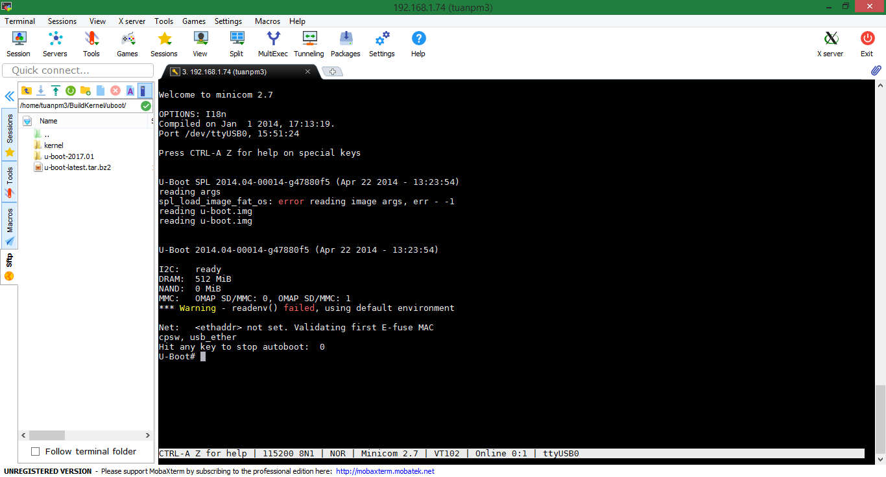

- U-Boot# setenv autoload no
- U-Boot# setenv ipaddr <board-ip> (ex: setenv ipaddr 192.168.0.1)
- U-Boot# setenv serverip <ubuntu-host-ip> (ex: setenv serverip 192.168.0.20)
- U-Boot# tftp 0x80200000 uImage-BBB
