*OENG1130 – Technology Leadership*

Name: Mai Chieu Thuy

sID: s3877746

Lecturer: Mr. Vinh Truong

1. **Introduction**

Zalo, a flagship product of VNG Corporation, stands at the forefront of technological innovation and leadership in the realm of communication and social networking. Developed by VNG, one of Vietnam's leading technology companies, Zalo has emerged as a prominent player in the global tech landscape. As a messaging and social media platform, Zalo has not only transformed the way individuals connect and communicate but also showcased VNG's commitment to pushing the boundaries of technology. This introduction, emphasizing VNG's commitment to technological leadership and its impact on the evolution of technology ecosystems, offers an overview of Zalo's crucial role in drawing up a Digital Communication landscape. Zalo exemplifies VNG's efforts to pursue excellence in the evolving technology sector, thanks to its innovative features and user-centric design.

1. **Description of the company**

Set up in 2004, VNG Joint Stock Company (VNG) is now one of the driving innovation companies in Ho Chi Minh City, Vietnam. With spearheading innovation and quality items, VNG serves hundreds of millions of people and organizational clients in more than 100 nations with the same mission: "Making innovation and Human Improvement. From Vietnam to reach the world". VNG centers on four fundamental trade sections: Online diversions, Networks, Fintech, Advanced Change Stages such as Cloud Administrations, and AI.

With the want to pioneer and continually improve, VNG points to create Vietnamese innovation undertakings to go worldwide, make an environment of high-class items and administrations, contribute to making strides in the quality of life for the country, and upgrade the position of Vietnamese brands. With such an advancement vision, VNG has set a mission and objective of creating innovation and human improvement, bringing Zalo's technology and applications from Vietnam to the world. To attain such incredible goals, VNG particularly emphasizes center values ​​such as grasping challenges, creating accomplices, and maintaining integrity.

**Business Strategy**

Proceeding target 2332 (reported in 2019): In 2023, VNG will reach 320 million clients all inclusive, 32 million clients for items such as ZaloPay, VNG Cloud, AI and coming to 320 thousand corporate client [1].

1. **Online Game**

* VNG Games is oriented to become a game publisher global online.
* Focus on expanding business market share in Vietnam, research to exploit market potential from unused target groups Internet (accounting for 19% of Vietnam's population, according to Internet statistics 2021)[1].
* Invest in game development studios, materialize the plan to build a portfolio of Vietnamese game products globally.

1. **Connection Platform**

* Aiming to build a content technology platform, using artificial intelligence as the core.
* Invest in technology and user experience, becoming a multi-service, highly applicable integration platform.
* Entering the new wave, providing core services: media and communications, artificial intelligence, Zalo cloud services for individual and corporate customers.

1. **Fintech**

* Expand cooperation with reputable banks and financial institutions.
* Increase ZaloPay payment experience through the Zalo platform, personalize ads and tighten relationships with strategic partners.
* Become a one-stop payment service provider: e-wallet, payment gateway and solutions to increase convenience for merchants

1. **Digital Transformation**

* VNG Cloud aims to become an international cloud service provider, not only creating technology platforms and products but also builds solutions and solves problems in digital transformation.
* VNG Data Center aims to be the safest and most modern data center, diversifying services and ensuring to meet the needs of customer requirements, compliance with standards and security.
* Orientation to build Vietnamese AI products that meet national standards economy with highly accurate fraud detection technologies, promoting the trend of digitalization in the banking, finance and insurance industries.

1. **Responsibility to Society**

* Focus on building social activities in three main areas: Health, Education and Technology
* Aiming to build a transparent and sustainable organization associated with core values ​​and corporate culture.
* Promote internal contributions to initiatives and participation in community projects.

**Management culture and Training employees strategy**

1. **Management Culture**

* Empower: VNG's human development strategy is expressed right in the way the business is organized: subordinates are allowed to make more decisions. VNG believes that empowering employees is extremely important, helping each person work and be creative according to their position.
* Learn: “Never stop learning” is what VNG always encourages Starters: learn from challenging projects, from colleagues, from books, and from many professional training programs both technical and soft capabilities that VNG builds.

1. **Engage and Training employees**

* Regularly disseminate information regarding VNG's vision and mission, fostering connections among Starters across all domestic and international offices during special occasions.
* Focus on attracting and retaining talented people, creating different values ​​from businesses in the market: building an ideal environment, specific learning paths for each individual.
* Building a culture of "companion" in the workplace, in which generations of Starters will use mentoring and coaching to help new Starters easily integrate and develop in the right direction.

1. **Retain and attract talent**

* Nurture and develop a generation of multinational talent, through attractive fresher training programs in many industry groups, in parallel with training programs to improve the capacity of management teams from front-line management levels to middle level and leadership team.
* Develop a partner network with Universities to access talented candidates.
* Recruiting core, experienced personnel when expanding business scope in international markets, focusing on training management skills and empowering members.
* Develop competitive remuneration policies, creating a different experience for each employee.

1. **Products and Services**

VNG Corporation may be an unmistakable innovation company headquartered in Vietnam, recognized for its different run of imaginative products and administrations. As a driving player in the tech industry, VNG has made noteworthy commitments to different segments. The company's portfolio incorporates Zalo, a well-known informing social media app, and advertising highlights like messaging, voice and video calls, gaming, and monetary exchanges. VNG is additionally known for its online amusement stages, giving clients locks in substance such as music, recordings, and diversions. Moreover, the company amplifies its administration to businesses through arrangements like the Zalo Official Account, empowering client engagement and e-commerce intelligence. With a commitment to protection and security, VNG proceeds to shape the advanced scene in Vietnam and the past, cultivating network and mechanical progressions.

1. **Target market, competitors and competitive advantages**

With a center on giving a flexible communication stage, Zalo caters to clients of all ages, emphasizing availability, user-friendly highlights, and a dynamic cluster of stickers and emoticons that resound with neighborhood inclinations. Within the competitive scene, Zalo faces rivals such as Facebook Flag-bearer, WhatsApp, and other territorial informing apps [2]. Be that as it may, Zalo has particular competitive preferences, including its solid neighborhood nearness, socially custom-fitted substance, and integration with VNG's administration environment. Zalo's consistent integration with ZaloPay, its computerized wallet benefit, advance positions it as a comprehensive arrangement for communication and money-related exchanges. The app's commitment to client security demonstrated through end-to-end encryption, which makes it a critical differentiator. Through these vital preferences, Zalo continues to be a leading choice for millions of clients in Vietnam, giving an interesting and localized elective within the competitive informing app field.

1. **Analysis and Recommendations**

VNG Corporation, as an energetic innovation company, may benefit of embracing two administration approaches—Transformational Authority and Hireling Leadership—each contributing unique viewpoints to cultivate advancement, representative engagement, and organizational development.

1. **Transformational Leadership**

Zalo, beneath the umbrella of VNG, may use Transformational Leadership to rouse and persuade its groups. This approach emphasizes visionary administration, empowering representatives to share the company's driven objectives. Pioneers utilizing this fashion such as cultivating a sense of reason, advancing imagination, and empowering risk-taking, can impel Zalo's advancement and flexibility within the ever-changing tech scene. The accentuation of individualized thought and mental incitement adjusts with the inventive nature of VNG, cultivating a culture of ceaseless enhancement and readiness to grasp modern challenges.

1. **Servant Leadership**

Within the setting of VNG - embracing Servant Leadership can develop a culture of benefit and collaboration. Pioneers grasping this approach prioritize the well-being of their groups and emphasize sympathy, lowliness, and a commitment to worker development. By centering on the requirements of workers and cultivating a collaborative environment, Zalo can improve group cohesion and representative fulfillment. The servant-leader mentality adjusts with VNG's accentuation on corporate obligation and social effect, strengthening a sense of shared reason and obligation.

1. **Company Functioning**
2. **Investment**

VNG Data Center has invested about 991.7 billion VND. The project is located at Tan Thuan Export Processing Zone, Tan Thuan Dong Ward, District 7, Ho Chi Minh City. This is a new data center that meets Uptime Tier III international standards, with a scale of 7,800 m2 and a usable floor area of ​​up to 12,400 m2. Initially, VNG Data Center will provide 410 cabinet racks (server installation cabinets). In the future, VNG will then expand to 1,600 rack cabinets to promptly meet the expected strong growth in the digital transformation process in Vietnam. [1]

1. **Production activities**

|  |  |  |  |
| --- | --- | --- | --- |
| Spending | 2021 (billion VND) | 2022 (billion VND) | Increase/Decrease |
| Net revenue from sales and service provision | 7.649 | 7.801 | 2% |
| Gross profit on sales and service provision | 3.543 | 3.543 | -3% |
| Accounting profit {loss} before tax | 255 | {1.119} | -538% |
| Loss after corporate income tax | {71} | {1.534} | 2060% |
| Profit (loss) after tax of the holding company | 414 | {1.077} | -360% |

Note: number with {} bracket meaning loss figures in that category

***Table 1. Summary of production activities of VNG compare between 2021 and 2022 [1]***

This table iindicates an increase in net revenue, but a notable decline in profitability for the year 2022. The company experienced a significant accounting loss before tax, leading to a substantial loss after corporate income tax. The holding company also faced a decline in overall profit, indicating financial challenges during the specified period.

1. **Achievement**
   * Online game: 188 game are running in 154 countries and 11 offices. In 2022, VNGGames had introduce 12 new games, increase coverage in 7 markets, notably with Play Together attracted 1 million users on first day landing, Gunny Origin achieve top2 on the rankings of the highest-grossing games on iOS in Taiwan and Top 5 in Hong Kong, Thien Long Bat Bo 2 attracted 500 thousands new users, 1 billion Impressions in the first month launched, Top 1 Trend on Store on launch day. Zingplay continues to maintain its leading position in the Vietnamese market in two segments Game Card and Fish Hunter (8), 80 games in 15 markets at 3 areas Southeast Asia, Latin America with 20 millions global users per month. [1]
   * Connection Platform: achieve 73,4 millions user in 12/2022 with 2 billions message sent everyday. Moreover, there are more than 10 thousands State agencies and public services use Zalo to connect with citizen. [1]
   * Fintech: reach 10 millions users milestone in 12/2022, with 5 thousands partners at 20 thousands payment location including 4100 public school using ZaloPay is the leading payment method. [1]
2. **Challenges related to Organization structure**
3. **Communication Bottlenecks:**

The hierarchical layers, especially in larger organizations, can lead to communication bottlenecks. Information may take time to trickle down from the top to the operational levels, potentially affecting decision-making and responsiveness.

1. **Decision-Making Delays:**

Decisions might be delayed as they often need approval or input from multiple levels of management. This can hinder the organization's agility, particularly in fast-paced industries where quick decision-making is crucial.

1. **Risk of Management:**

The layers of management may lead to a risk of micromanagement. Lower-level managers might feel pressured to adhere strictly to the directives from higher management, limiting their autonomy and creativity.

1. **Resistance to Change:**

Employees and middle managers might resist changes to the established structure. Implementing organizational changes or introducing new processes may face resistance, affecting the organization's ability to evolve.

1. **Challenges related to customers, competitors, partners**
2. **Challenges with Customers**

VNG Corporation encounters significant challenges in managing its customer relationships. Acquiring new customers poses a notable hurdle, particularly in the fiercely competitive tech market where attracting and retaining a substantial user base demands innovative strategies. Ensuring customer satisfaction remains paramount, requiring VNG to continually meet evolving expectations, provide timely support, and address issues effectively. Moreover, the dynamic nature of customer preferences in the technology sector necessitates constant adaptation to stay aligned with users' ever-changing needs. In my opinion, there are two appropriate strategies which can resovle the problems that VNG facing. [4][5]

1. **Customer Acquistion Strategy:**

Execute focused on showcasing campaigns, leveraging information analytics to recognize and draw in potential clients. Offer special motivations, elite highlights, or trial periods to empower client appropriation. Prioritize client encounters and clients back to improve fulfillment and cultivate brand dependability.

1. **Personalize and Innovation:**

Contribute to personalized client encounters by leveraging information to get it and expect client inclinations. Ceaselessly enhance items and administrations, remaining adjusted to showcase patterns. Routinely assemble client criticism and coordinate experiences into item advancement to meet advancing desires.

1. **Challenges with Competitors**

The competitive landscape poses formidable challenges for VNG as it navigates the tech industry. Intense competition, both locally and internationally, demands strategic differentiation to maintain a distinctive edge. Constant innovation becomes imperative as technological advancements unfold rapidly, pressuring VNG to stay ahead of competitors by offering cutting-edge products and services. Additionally, market share battles and pricing strategies require careful management to strike a balance between competitiveness and profitability. In particular, in the US, where the IPO market is the most vibrant in the world, and where unicorn VNG aims to realize its ambition of offering shares, is also experiencing the longest "drought" of the century. As of September, the total value of US IPOs decreased by 94% over the same period last year. From the beginning of the year until now, only more than 7 billion USD has been mobilized compared to 110 billion USD in the same period last year, according to Daelogic [3]. With these challenges, there are two appropriate solution.

1. **Differentiation through Innovation:**

Maintain a focus on development to distinguish items and administrations from competitors. Frequently evaluate mechanical headways and contribute to investigate and advancement to remain ahead. Present interesting highlights or functionalities that set VNG separated within the advertisement.

1. **Strategic Pricing and Market Positioning:**

Conduct intensive showcase examinations to decide on ideal estimating methodologies. Consider value-based estimating, bundling alternatives, or devotion programs to draw in and hold clients. Emphasize the special esteem recommendation to position VNG deliberately against competitors.

1. **Challenges with Partners**

VNG grapples with challenges related to its strategic partnerships, a crucial aspect of its business ecosystem. Building and sustaining these partnerships demand meticulous alignment of goals and the identification of mutually beneficial collaborations. Collaboration itself introduces complexities, particularly in joint ventures, requiring effective coordination, communication, and integration of systems or processes with partners. Moreover, any dependence on specific partners for critical components or services poses risks, prompting VNG to diversify its partner network to mitigate potential disruptions or disputes. With VNG, partner businesses play an important role in holding revenue as well as the ability to reach international goals, and with the difficulties being encountered, in my opinion, VNG has three directions to solve the problem at hand.

1. **Strategic Partnership Management:**

Build up clear communication channels and adjusted objectives with vital accomplices. Routinely evaluate the common benefits of organizations and alter techniques appropriately. Cultivate collaborative activities to reinforce connections and guarantee both parties infer esteem from the affiliation.

1. **Diversity of Partner Network:**

Decrease reliance on particular accomplices by expanding the accomplice arrangement. Recognize and lock in with modern potential collaborators, considering their qualities and compatibility with VNG's trade goals. This approach minimizes dangers related to overreliance on personal accomplices.

1. **Effective Collaboration Framework:**

Actualize effective collaboration systems, counting streamlined communication channels and coordinates frameworks. Contribute in innovation that encourages consistent collaboration and information trade. Conduct standard evaluations of collaborative forms to distinguish and address potential bottlenecks or wasteful aspects.

1. **Conclusion**

In conclusion, VNG Corporation stands as a dynamic force in the technology sector, exemplified by its flagship product, Zalo, which has redefined communication and social networking. The company's commitment to technological leadership is evident through its diverse portfolio, including online games, connection platforms, fintech, and digital transformation initiatives. Despite notable achievements, VNG faces organizational challenges, such as communication bottlenecks and resistance to change, associated with its hierarchical structure. Additionally, customer acquisition, market competition, and strategic partnerships present ongoing hurdles that require innovative solutions. The company's emphasis on transformational and servant leadership, coupled with a proactive approach to management culture and employee training, positions it well for continued success. By leveraging its strengths, embracing innovation, and addressing organizational challenges, VNG can navigate the evolving tech landscape, delivering value to customers and maintaining its competitive edge.

1. **Appendix**

***Figure 1: Organization Structure***

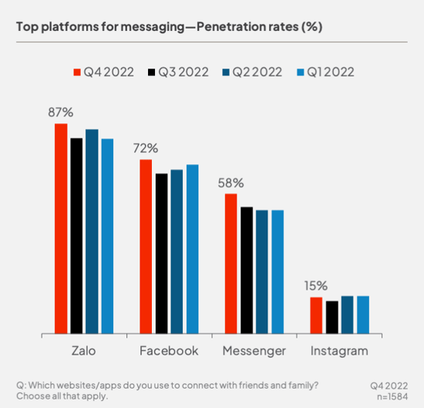

***Figure 2: Compare users between popular connection platform [6]***

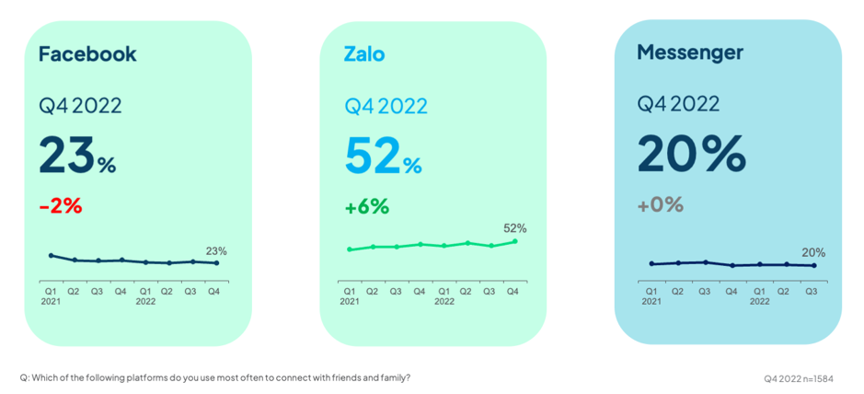

***Figure 3: Compare most use connection platform [6]***

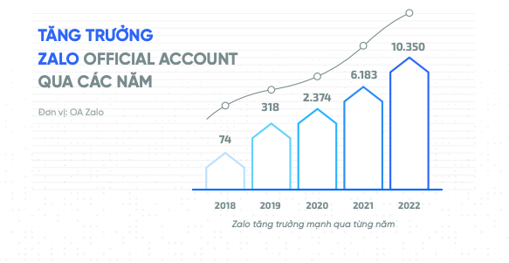

**Figure 4: Zalo Official Account tracking**

**XI. Reference**

[1] VNG Corporation, “BÁO CÁO THƯỜNG NIÊN 2022”. VNG Corporation, Ho Chi Minh city, Vietnam. June 16th, 2023. Accessed Dec 7th. 2023. [Online]. Available: https://static2.vietstock.vn/data/HNX/2022/BCTN/VN/VNZ_Baocaothuongnien_2022.pdf

# [2] The Lam. “Người dùng có lựa chọn nào khác một khi Zalo bóp tính năng quá mức?”. Lao Động. Accessed: Dec. 8th, 2023. [Online]. Available: https://laodong.vn/ban-doc/nguoi-dung-co-lua-chon-nao-khac-mot-khi-zalo-bop-tinh-nang-qua-muc-1065834.ldo

[3] Huyen Trang. “Tương lai IPO khó khăn của kỳ lân VNG”. Doanh Nhân Trẻ. Accessed: Dec. 8th, 2023. [Online]. Available: https://doanhnhantrevietnam.vn/tuong-lai-ipo-kho-khan-cua-ky-lan-vng-d17348.html

[4] Dinh Dang. “VNG bị ngừng 6 game Mobile, người chơi bất ngờ”. Thanh Niên. Accessed: Dec. 8th, 2023. [Online]. Available: https://thanhnien.vn/vng-bi-ngung-6-game-mobile-nguoi-choi-lo-lang-185231209114224743.htm

[5] HCMC Open University, “Những vấn đề Zalo đang và sẽ gặp phải”. HCMC Open University, Ho Chi Minh City, Vietnam. Accessed: Dec 9th.2023. [Online]. Available: https://www.studocu.com/vn/document/truong-dai-hoc-mo-thanh-pho-ho-chi-minh/nghien-cuu-marketing/zalo-sadfasdf/33440105

[6] genk.vn. “Zalo vượt qua Facebook, Messenger về lượng người dùng ở Việt Nam”. (accessed Dec 10, 2023). [Online]. Available: https://baoquangninh.vn/zalo-vuot-qua-facebook-messenger-ve-luong-nguoi-dung-o-viet-nam-3229739.html