Overview of GAN Applications
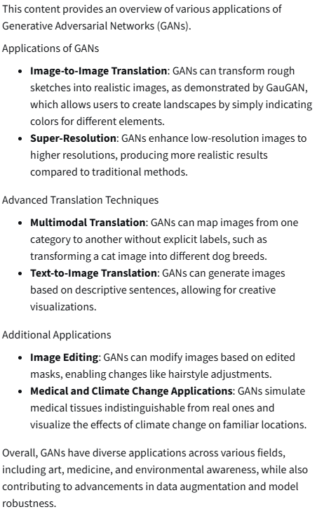

Data Augmentation: Methods and Uses
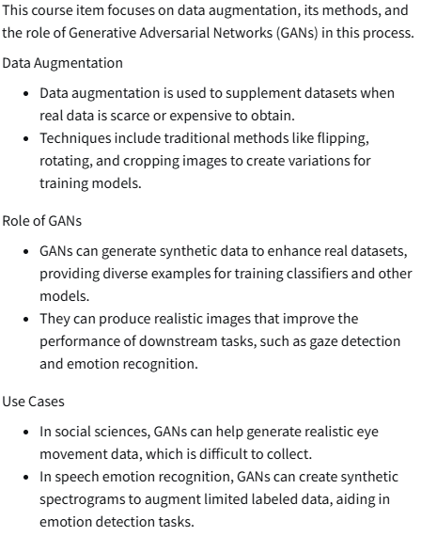
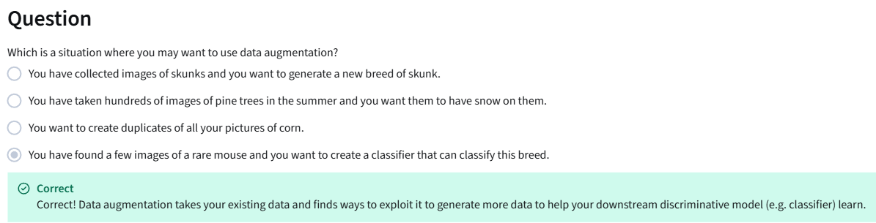

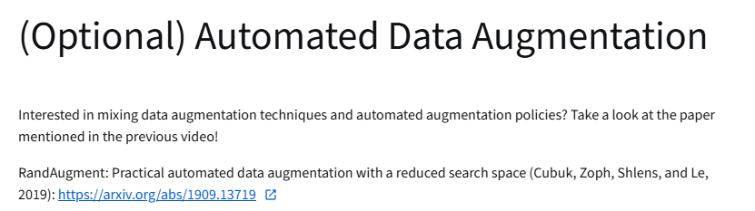
https://arxiv.org/abs/1909.13719
Data Augmentation: Pros & Cons
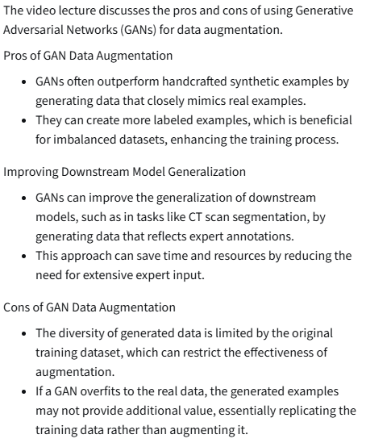

GANs for Privacy
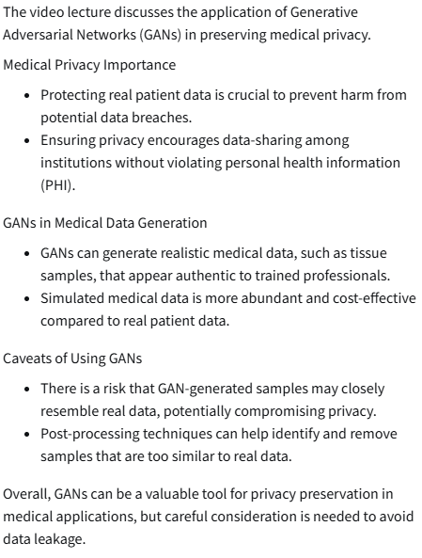

GANs for Anonymity
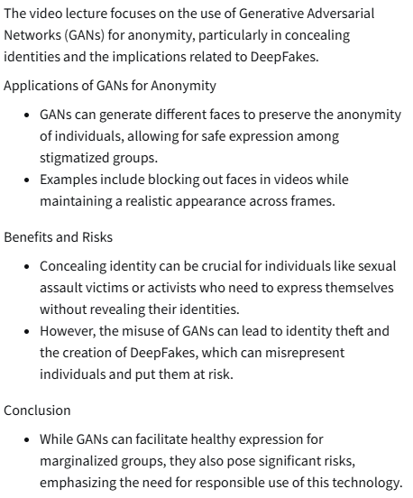

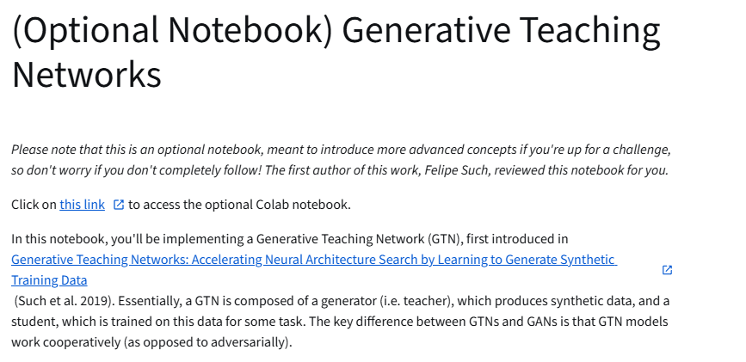
https://colab.research.google.com/github/https-deeplearning-ai/GANs-Public/blob/master/C3W1_Generative_Teaching_Networks_(Optional).ipynb
https://arxiv.org/abs/1912.07768

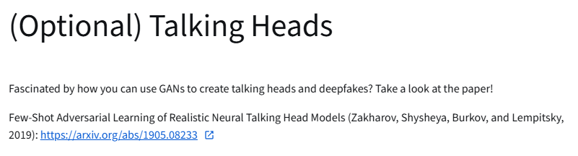
https://arxiv.org/abs/1905.08233

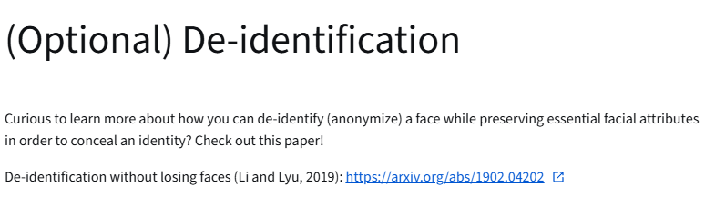
https://arxiv.org/abs/1902.04202

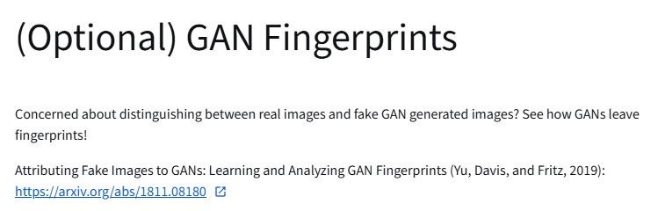
https://arxiv.org/abs/1811.08180

