Disadvantages of GANs
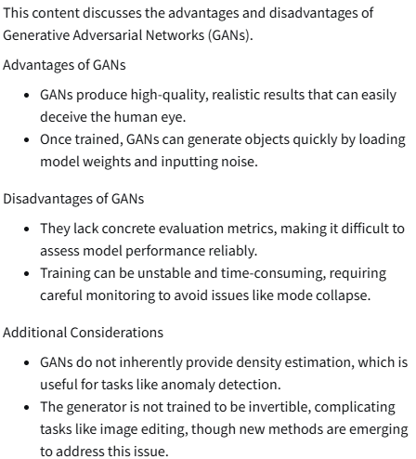
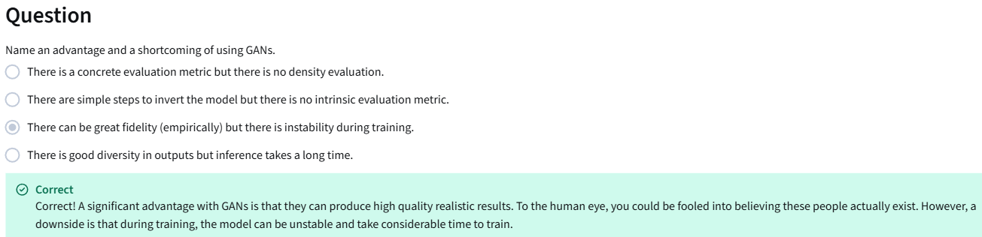

Alternatives to GANs
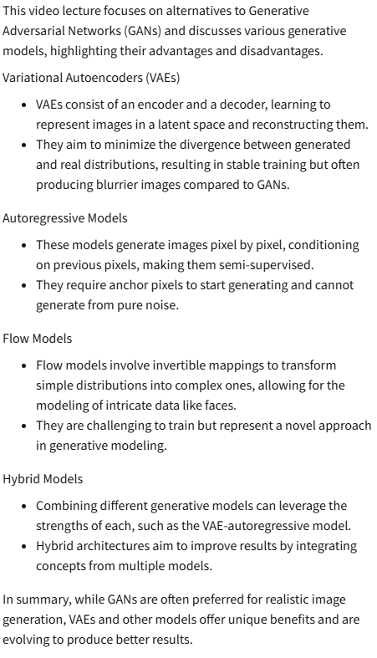
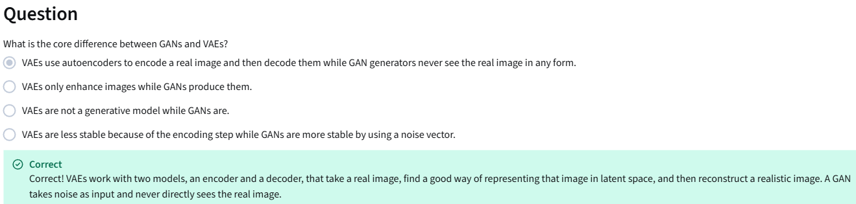
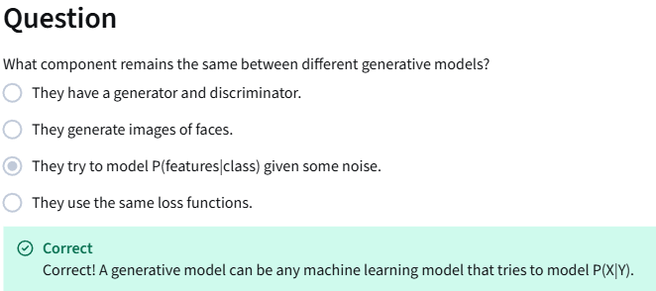

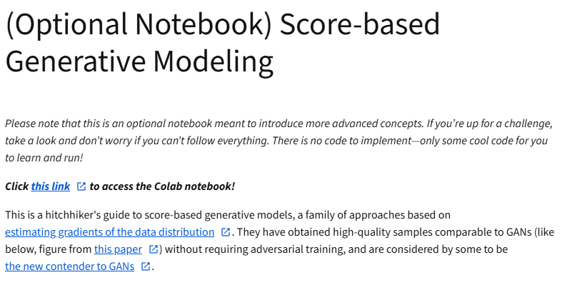
https://colab.research.google.com/github/https-deeplearning-ai/GANs-Public/blob/master/C2W2_(Optional_Notebook)_Score_Based_Generative_Modeling.ipynb
https://arxiv.org/abs/1907.05600
https://arxiv.org/abs/2006.09011
https://ajolicoeur.wordpress.com/the-new-contender-to-gans-score-matching-with-langevin-sampling/
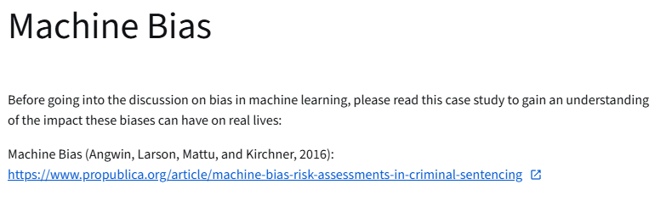
https://www.propublica.org/article/machine-bias-risk-assessments-in-criminal-sentencing

Intro to Machine Bias
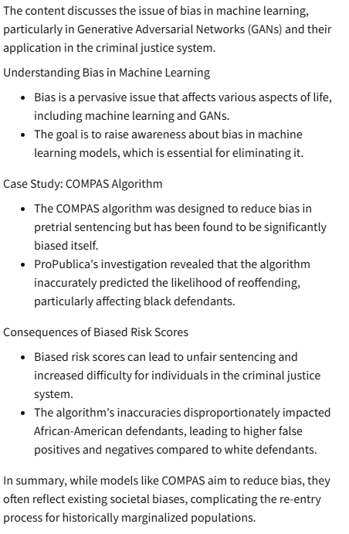

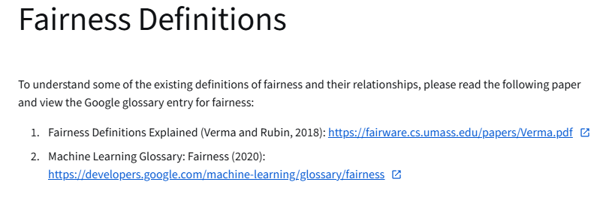
https://fairware.cs.umass.edu/papers/Verma.pdf
https://developers.google.com/machine-learning/glossary/responsible-ai
Define Fairness
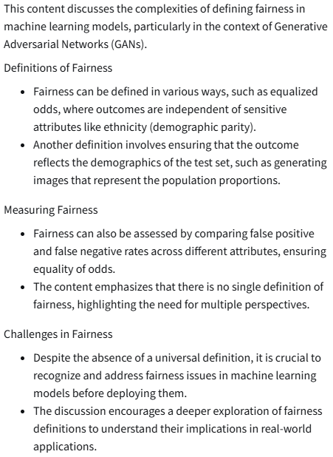
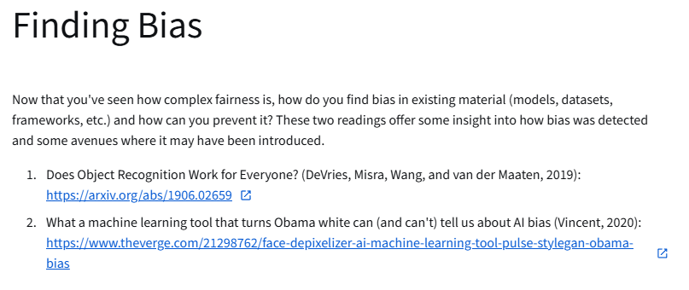
https://arxiv.org/abs/1906.02659
https://www.theverge.com/21298762/face-depixelizer-ai-machine-learning-tool-pulse-stylegan-obama-bias

Ways Bias is Introduced
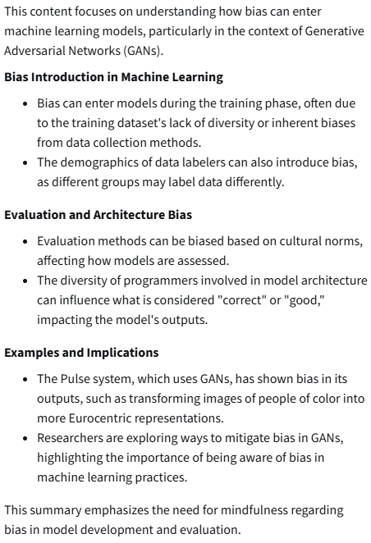
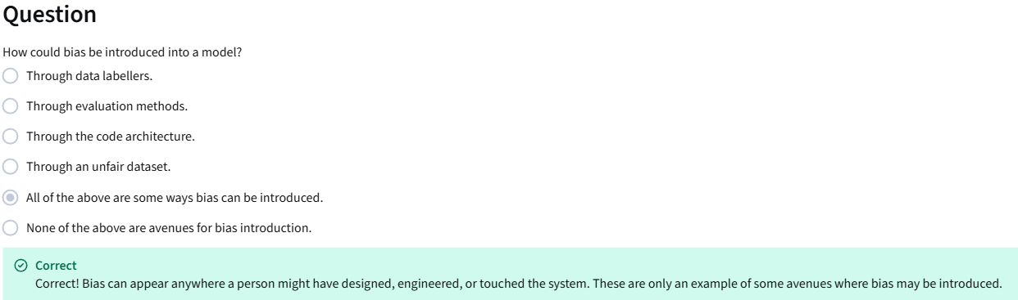

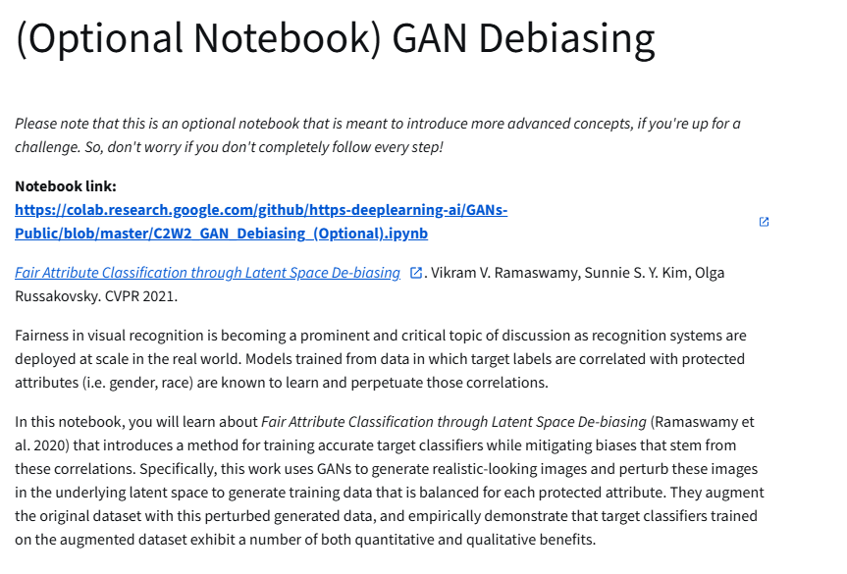
https://colab.research.google.com/github/https-deeplearning-ai/GANs-Public/blob/master/C2W2_GAN_Debiasing_(Optional).ipynb
https://princetonvisualai.github.io/gan-debiasing/
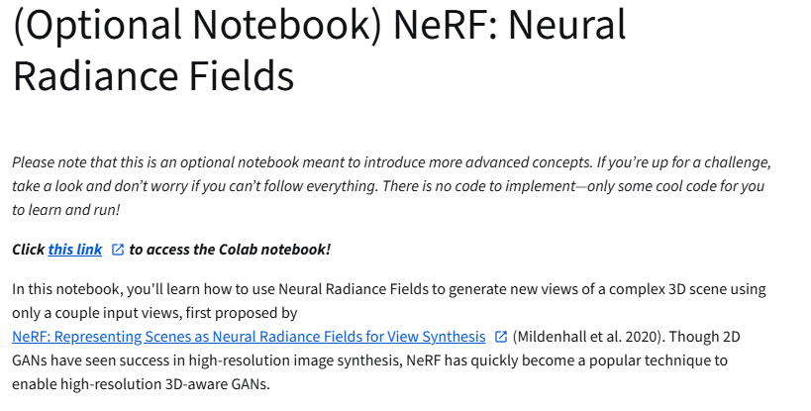
https://colab.research.google.com/drive/18DladhUz7_U8iBkkQxMBk2f7C2NAvPCC?usp=sharing
https://arxiv.org/abs/2003.08934

