Mode Collapse
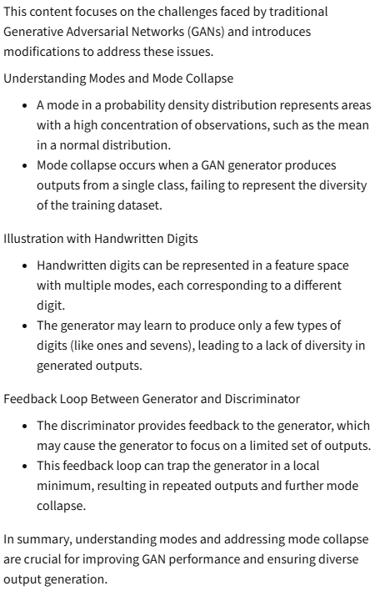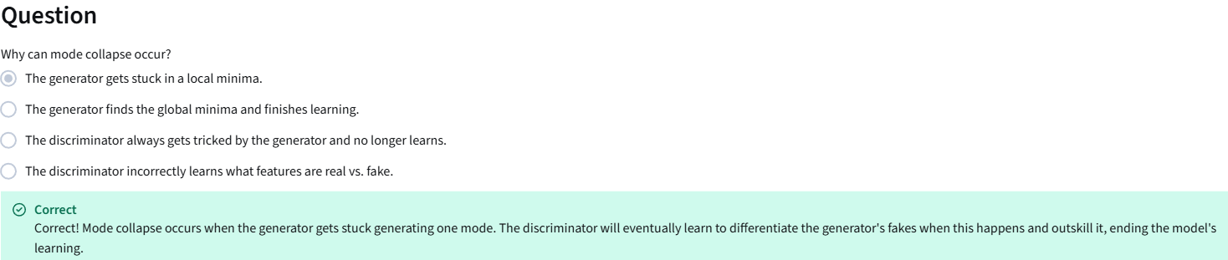

Problem with BCE Loss
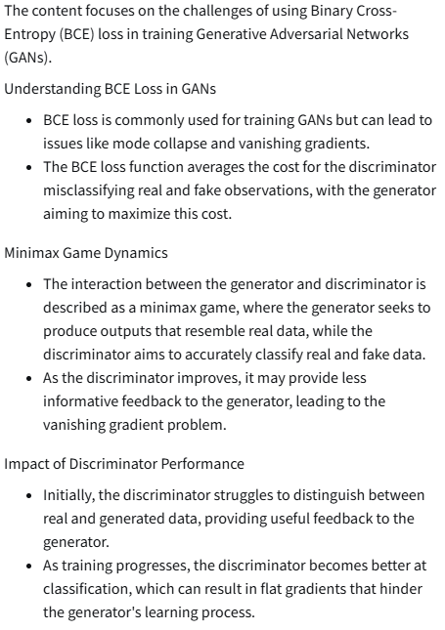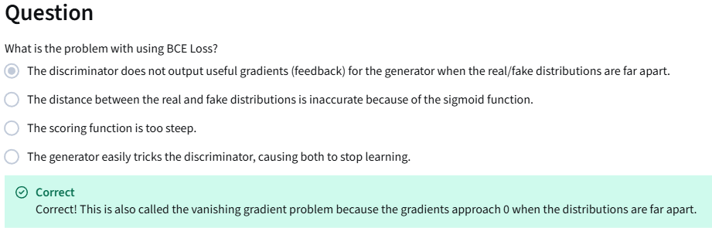

Earth Mover’s Distance
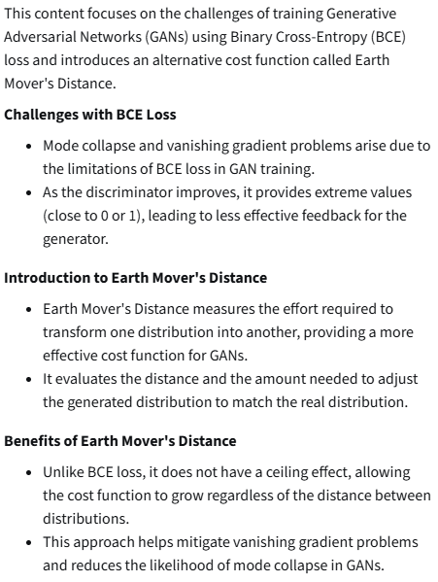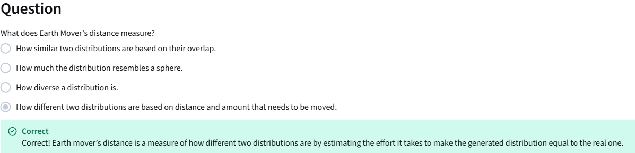

Wasserstein Loss
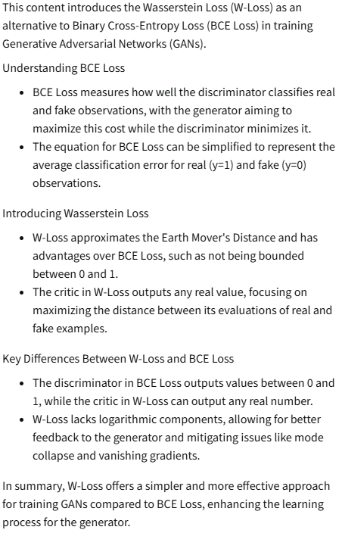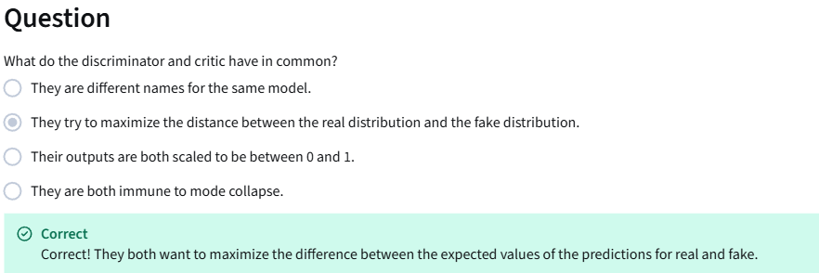
Condition on Wasserstein Critic
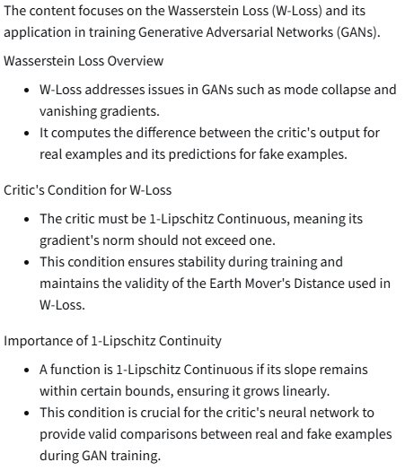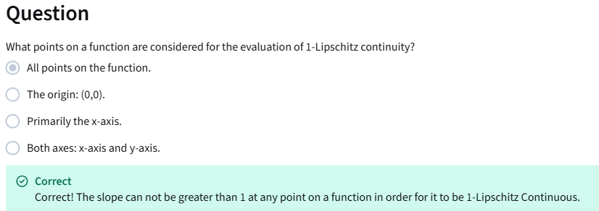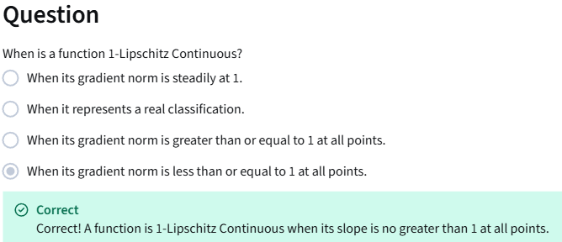
1-Lipschitz Continuity Enforcement
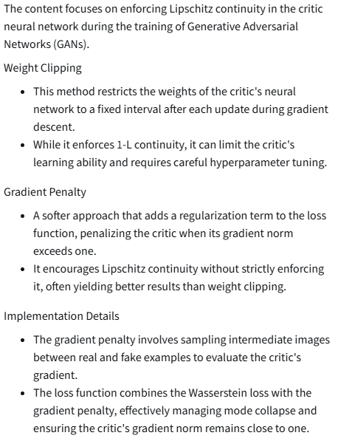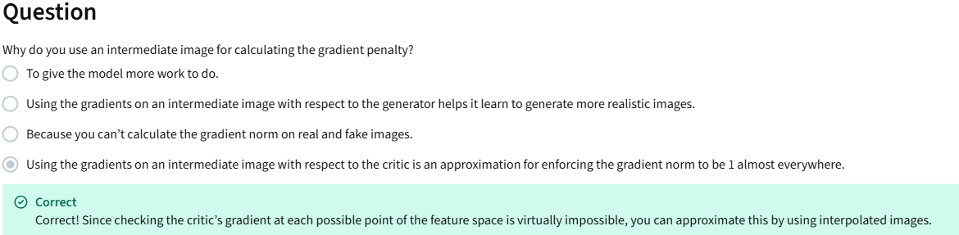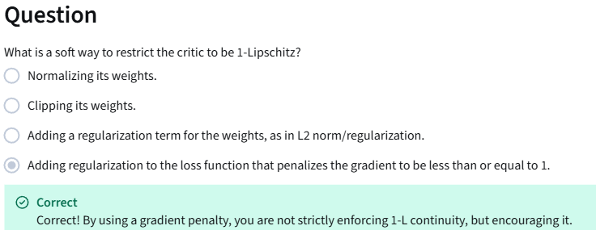

https://colab.research.google.com/github/https-deeplearning-ai/GANs-Public/blob/master/ProteinGAN.ipynb
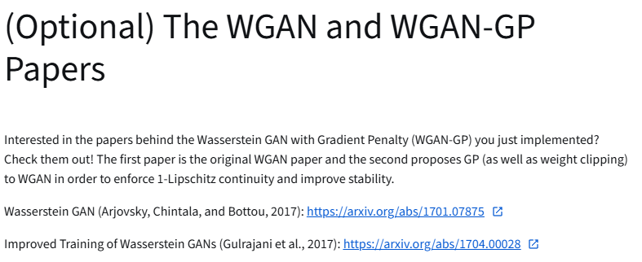
https://arxiv.org/abs/1701.07875
https://arxiv.org/abs/1704.00028

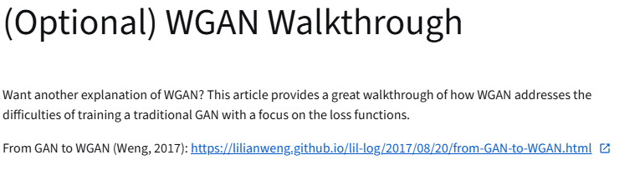
https://lilianweng.github.io/posts/2017-08-20-gan/

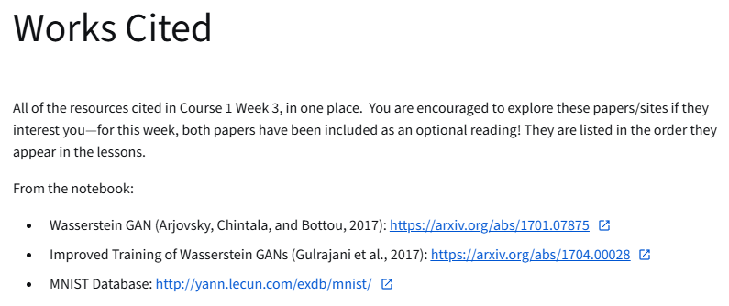
https://arxiv.org/abs/1701.07875
http://arxiv.org/abs/1704.00028
http://yann.lecun.com/exdb/mnist/

