Evaluation
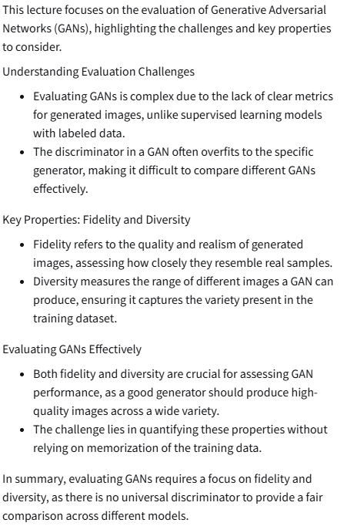
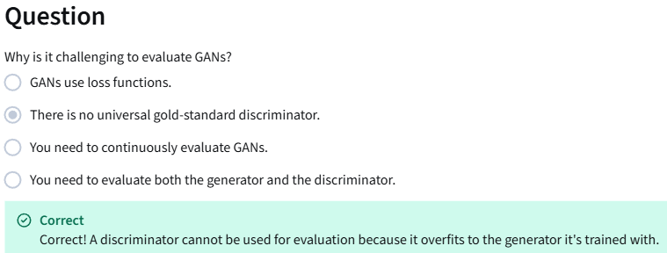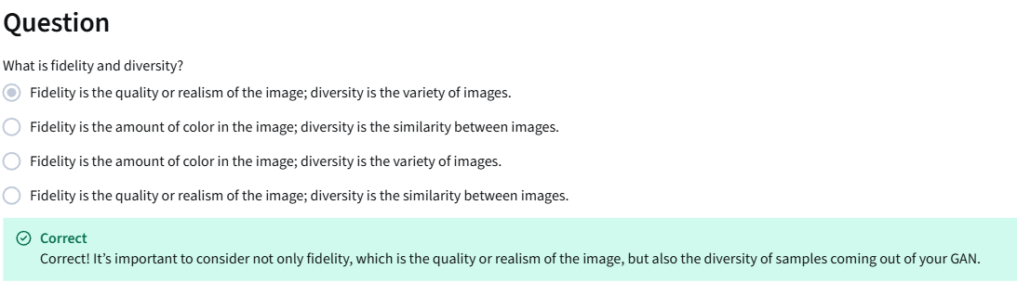

Comparing Images
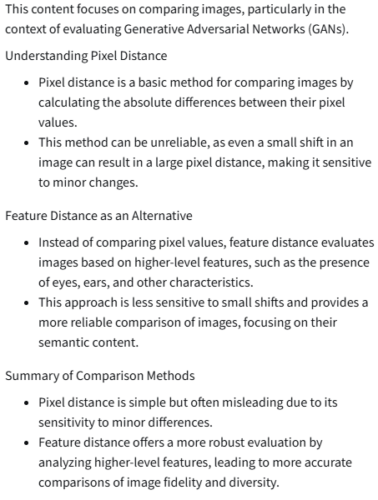

Feature Extraction
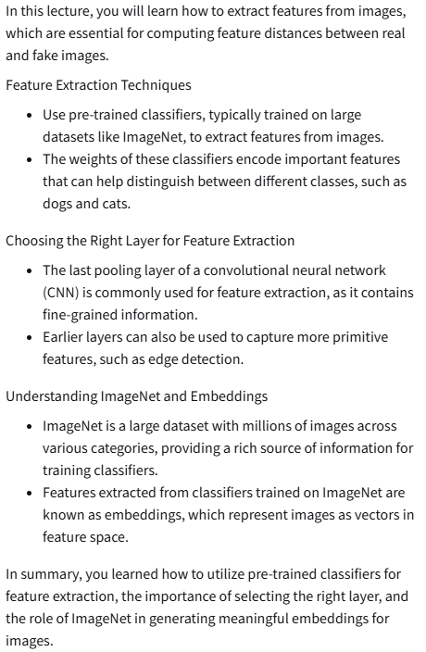
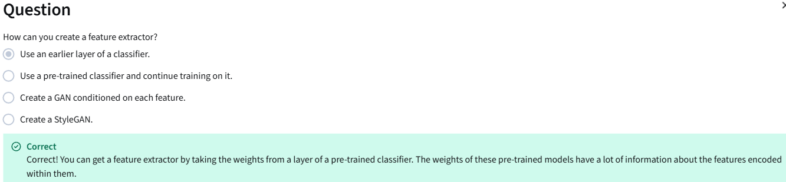

Inception-v3 and Embeddings
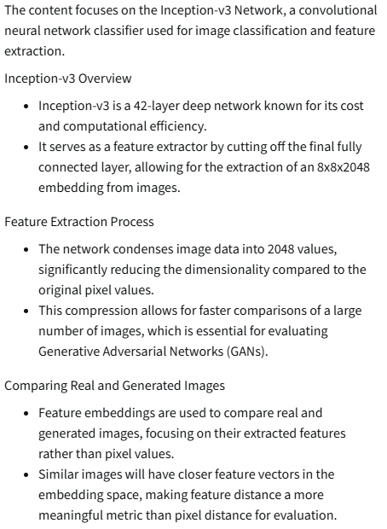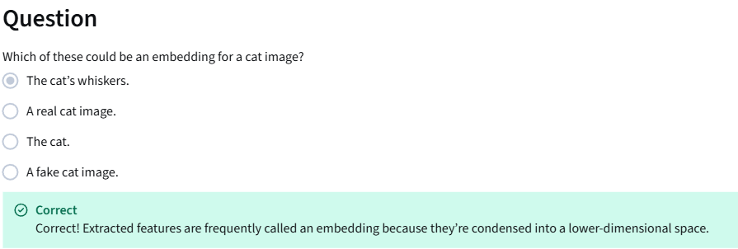

Frechet-Inception Distance (FID)
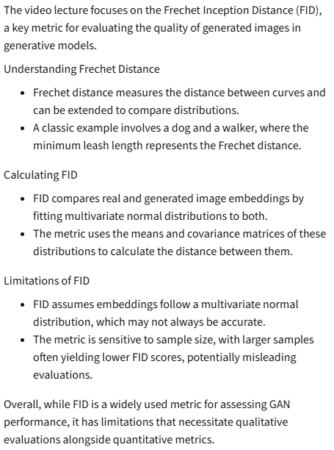
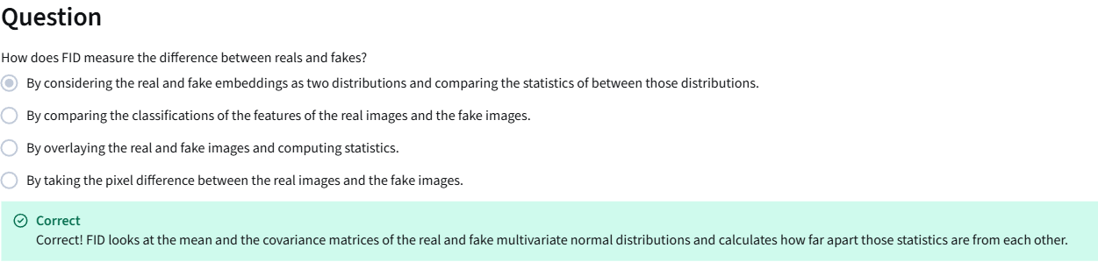

Inception Score
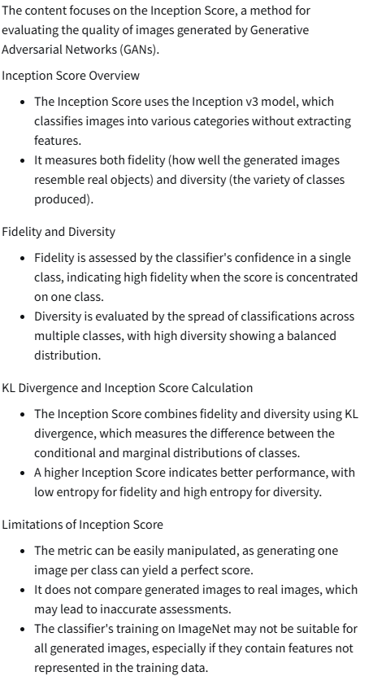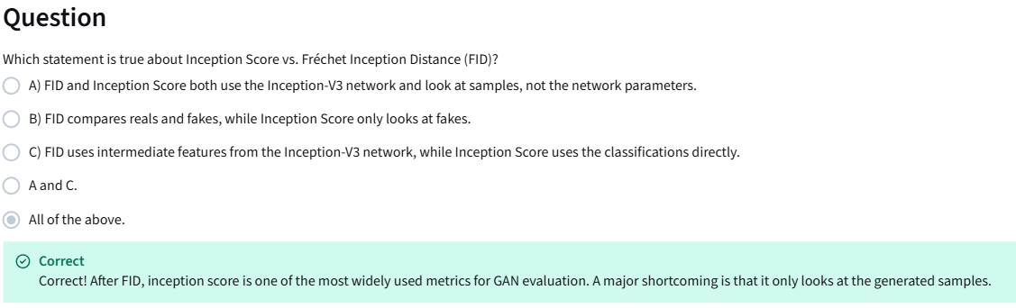
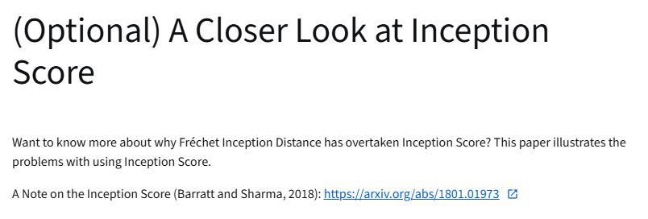
https://arxiv.org/abs/1801.01973

Sampling and Truncation
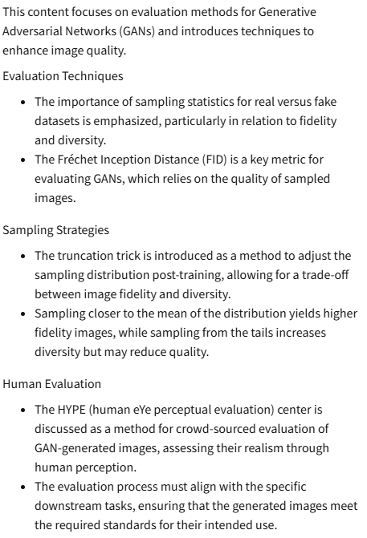
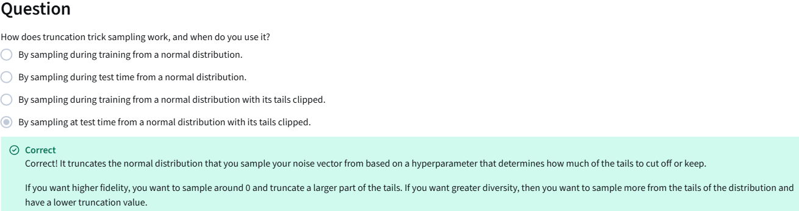

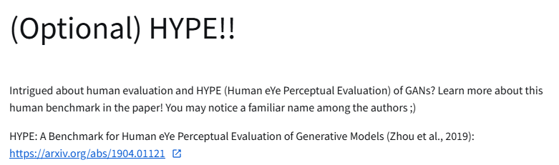
https://arxiv.org/abs/1904.01121

Precision and Recall
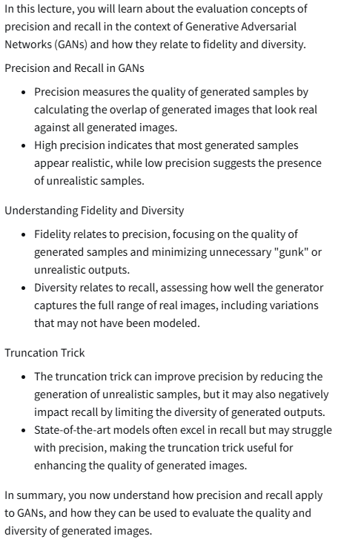
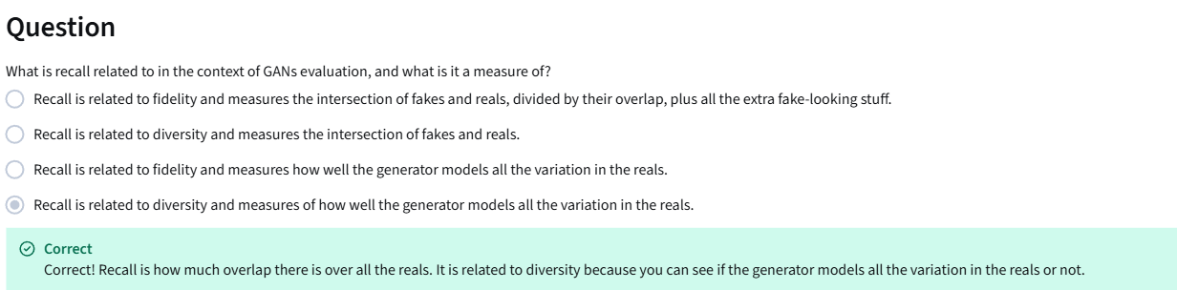

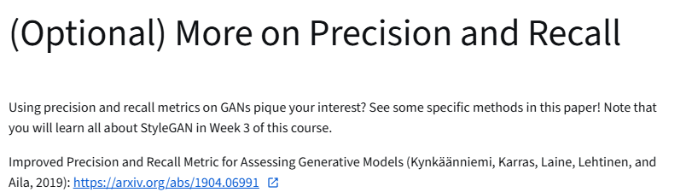
https://arxiv.org/abs/1904.06991

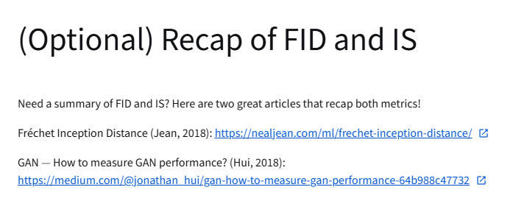
https://nealjean.com/ml/frechet-inception-distance
https://jonathan-hui.medium.com/gan-how-to-measure-gan-performance-64b988c47732

