Generative Models
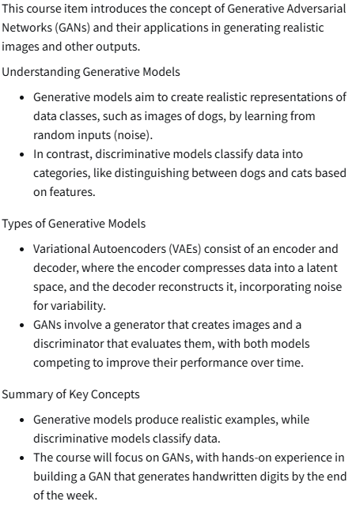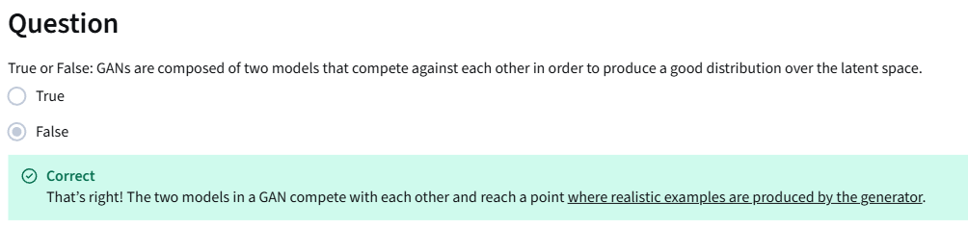

Real Life GANs
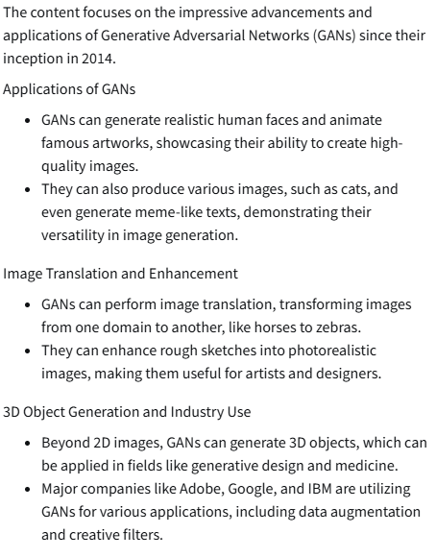

Intuition Behind GANs
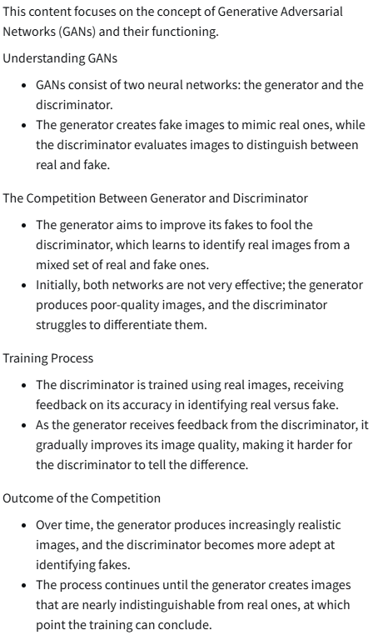
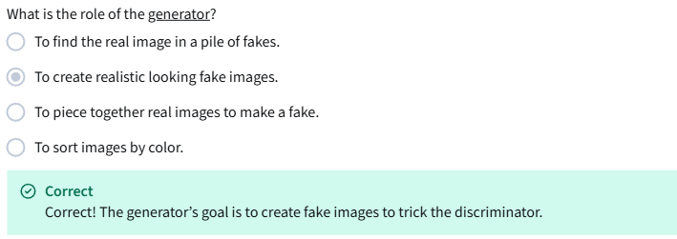
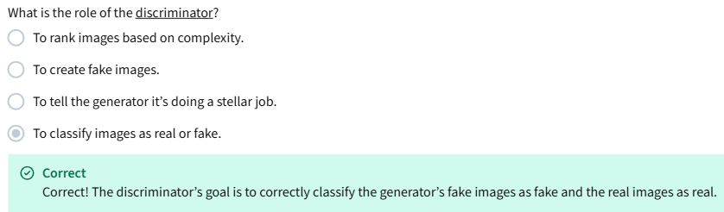

Discriminator
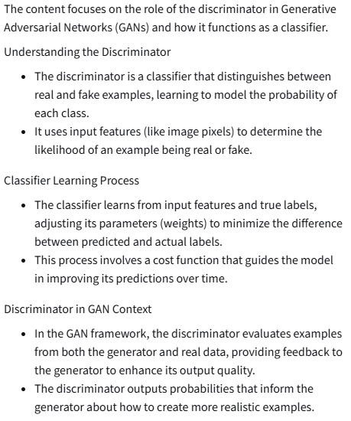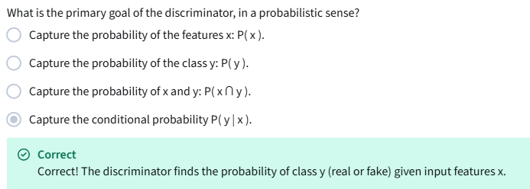

Generator
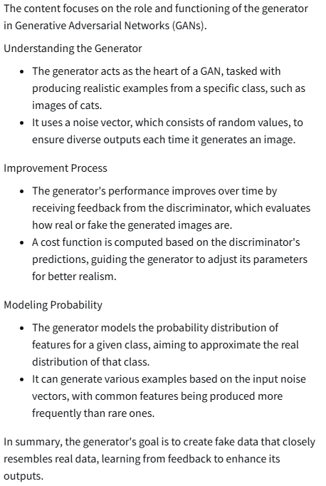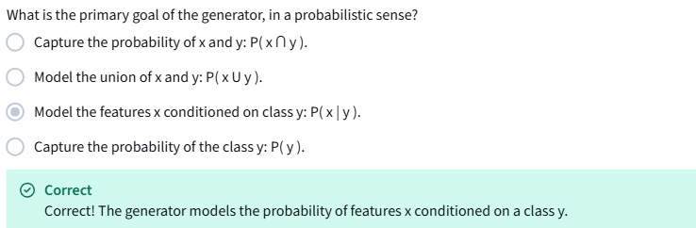
BCE Cost Function
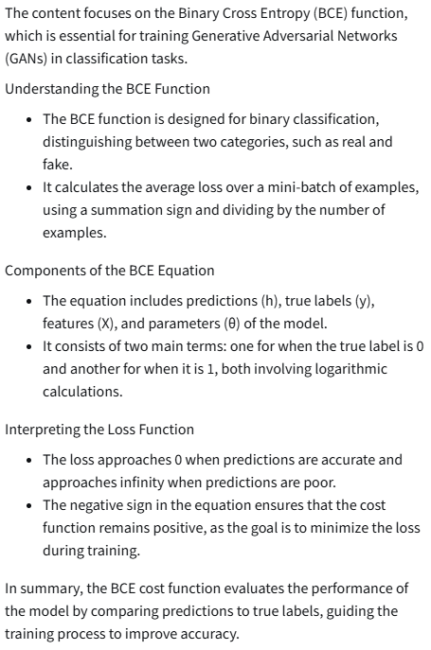

Putting It All Together
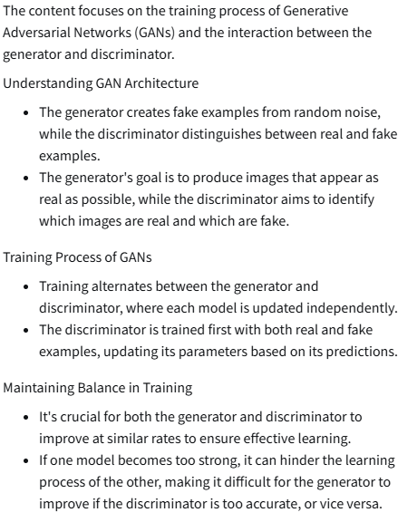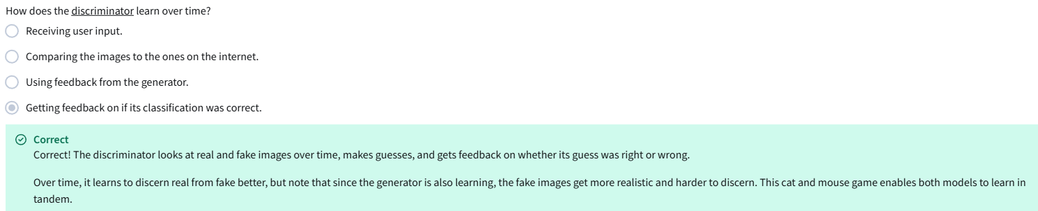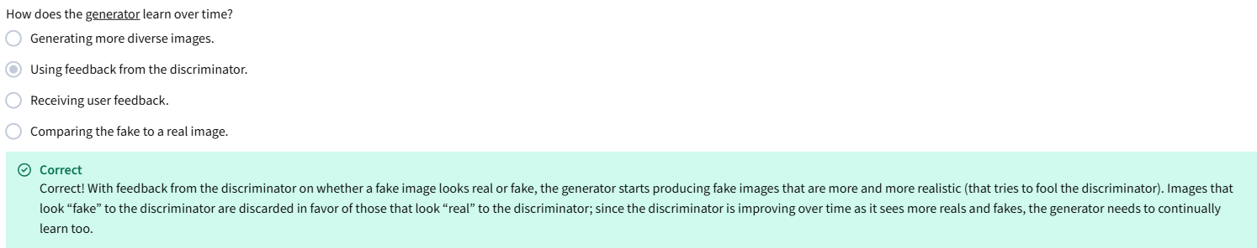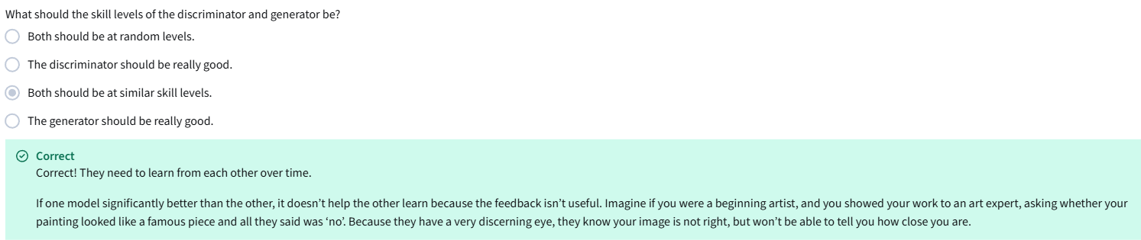

Intro to PyTorch (Optional)
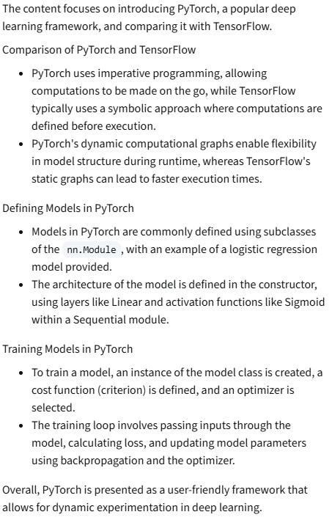

All of the resources cited in Course 1 Week 1, in one place. You are encouraged to explore these papers/sites if they interest you! They are listed in the order they appear in the lessons.
From the videos:
Hyperspherical Variational Auto-Encoders (Davidson, Falorsi, De Cao, Kipf, and Tomczak, 2018): https://www.researchgate.net/figure/Latent-space-visualization-of-the-10-MNIST-digits-in-2-dimensions-of-both-N-VAE-left_fig2_324182043
Analyzing and Improving the Image Quality of StyleGAN (Karras et al., 2020): https://arxiv.org/abs/1912.04958
Semantic Image Synthesis with Spatially-Adaptive Normalization (Park, Liu, Wang, and Zhu, 2019): https://arxiv.org/abs/1903.07291
Few-shot Adversarial Learning of Realistic Neural Talking Head Models (Zakharov, Shysheya, Burkov, and Lempitsky, 2019): https://arxiv.org/abs/1905.08233
Learning a Probabilistic Latent Space of Object Shapes via 3D Generative-Adversarial Modeling (Wu, Zhang, Xue, Freeman, and Tenenbaum, 2017): https://arxiv.org/abs/1610.07584
These Cats Do Not Exist (Glover and Mott, 2019): http://thesecatsdonotexist.com/

From the notebooks:
Large Scale GAN Training for High Fidelity Natural Image Synthesis (Brock, Donahue, and Simonyan, 2019): https://arxiv.org/abs/1809.11096
PyTorch Documentation: https://pytorch.org/docs/stable/index.html#pytorch-documentation
MNIST Database: http://yann.lecun.com/exdb/mnist/

