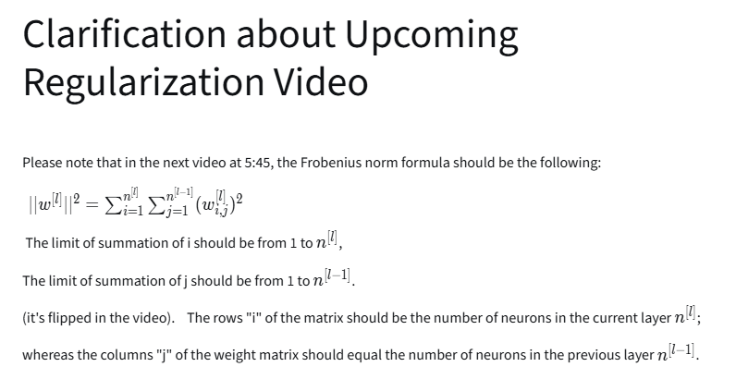
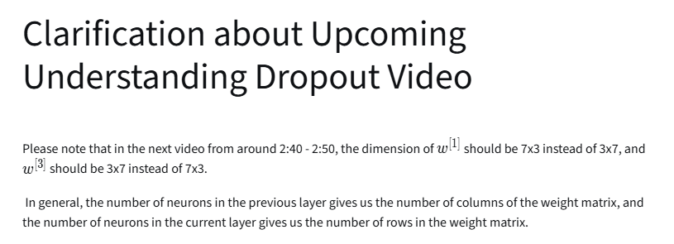

Regularization:
The content discusses the concept of regularization in neural networks, which is essential for preventing overfitting.

Understanding Regularization

- Regularization is a technique used to reduce overfitting in models, which occurs when a model learns the training data too well and performs poorly on new data.
- It can be addressed by adding regularization techniques or obtaining more reliable training data.
Types of Regularization

- L2 Regularization: This involves adding a penalty to the cost function based on the squared values of the model's weights, encouraging smaller weights to prevent overfitting.
- L1 Regularization: This adds a penalty based on the absolute values of the weights, leading to sparse weight vectors, which can help in model compression.
Implementation in Neural Networks

- In neural networks, regularization is incorporated into the cost function, and the update rules for weights during training are adjusted to include the regularization term.
- The regularization parameter (lambda) is a hyperparameter that needs to be tuned to balance training performance and model complexity.
Overall, regularization is a crucial aspect of training neural networks to ensure they generalize well to new data.

Why Regularization Reduces Overfitting?
The lecture discusses the importance of regularization in neural networks to combat overfitting and reduce variance.

Understanding Regularization

- Regularization adds a penalty term to the cost function, discouraging large weights in the model.
- The Frobenius norm is commonly used for this purpose, which helps simplify the model.
Effects of Regularization

- A high regularization parameter (lambda) can shrink weights close to zero, effectively simplifying the network.
- This simplification can lead to a model that behaves more like logistic regression, reducing overfitting.
Activation Function and Regularization

- Using the tanh activation function, smaller weights lead to a more linear behavior of the network.
- If the network behaves linearly, it becomes less capable of fitting complex, non-linear decision boundaries, thus reducing overfitting.
Implementation Tips

- When implementing regularization, modify the cost function to include the penalty term.
- Ensure that the cost function decreases monotonically during gradient descent by using the updated definition.
The lecture concludes by mentioning dropout regularization as another technique to be explored in future content.

Dropout Regularization
The lecture discusses the dropout technique in neural networks, which is used to prevent overfitting during training.

Understanding Dropout

- Dropout involves randomly eliminating neurons in a neural network during training to create a smaller, varied network for each training example.
- Each neuron has a probability (e.g., 0.5) of being kept or dropped, which helps the model learn to generalize better.
Implementation of Dropout

- The most common method is called inverted dropout, where a dropout vector is created to determine which neurons to keep or drop.
- The activations of the remaining neurons are scaled to maintain the expected value, ensuring consistent performance.
Testing with Dropout

- During testing, dropout is not applied; all neurons are used to make predictions, avoiding randomness in outputs.
- The inverted dropout technique ensures that the expected values remain unchanged, simplifying the testing process.

Understanding Dropout
Coach
The lecture discusses the concept of dropout as a regularization technique in neural networks to prevent overfitting.

Understanding Dropout

- Dropout randomly removes units (neurons) from the network during training, making the model act like a smaller network.
- This prevents any single unit from relying too heavily on specific inputs, encouraging a more distributed learning approach.
Effects of Dropout

- Dropout has a similar effect to L2 regularization by shrinking the weights and helping to generalize the model better.
- It can be adapted by varying the "keep probability" (the chance of keeping a unit) for different layers, allowing for more control over regularization.
Implementation Considerations

- Dropout is commonly used in computer vision due to the large input sizes and the tendency to overfit.
- It is important to monitor the cost function during training, as dropout can make it less well-defined, complicating performance checks.
Overall, dropout is a valuable technique for improving the robustness of neural networks, especially in scenarios where overfitting is a concern.

Other Regularization Methods
This content discusses techniques to reduce overfitting in neural networks, focusing on data augmentation and early stopping.

Data Augmentation

- Involves creating new training examples by modifying existing data, such as flipping images horizontally or applying random crops.
- Helps increase the size of the training set without the need for additional data collection, making it a cost-effective way to improve model performance.
Early Stopping

- A technique where training is halted when the model's performance on a validation set starts to decline, indicating potential overfitting.
- By stopping training early, the model retains a balance between learning and generalization, similar to keeping model parameters at a moderate size.
Overall, these methods aim to enhance the model's ability to generalize to new data while managing the complexity of training.

Normalizing Inputs
The content discusses the importance of normalizing input features when training neural networks to improve the efficiency and effectiveness of the learning process.

Normalization Process

- Zeroing the Mean: The first step involves subtracting the mean from each input feature, centering the data around zero.
- Normalizing Variance: The second step adjusts the variance of the features so that they all have a similar scale, typically set to one.
Benefits of Normalization

- Improved Cost Function: Normalized features lead to a more symmetric cost function, making it easier for optimization algorithms like gradient descent to find the minimum.
- Faster Convergence: With features on similar scales, the learning algorithm can take larger steps towards the minimum, speeding up the training process.
When to Normalize

- Normalization is crucial when input features have dramatically different scales. If features are already on similar scales, normalization may be less critical but can still be beneficial.
Overall, normalizing input features helps ensure that the neural network learns more effectively and efficiently.

Vanishing/Exploding Gradients
This content discusses the challenges of training deep neural networks, specifically focusing on the issues of exploding and vanishing gradients.

Understanding Exploding and Vanishing Gradients

- Exploding gradients occur when the weights in a neural network are too large, causing the gradients to grow exponentially, which makes training difficult.
- Vanishing gradients happen when the weights are too small, leading to gradients that shrink significantly, slowing down the learning process.
Impact on Neural Networks

- In very deep networks, if the weights are slightly larger than one, the output can grow exponentially with the number of layers, leading to exploding gradients.
- Conversely, if the weights are slightly less than one, the activations decrease exponentially, resulting in vanishing gradients.
Importance of Weight Initialization

- Careful initialization of weights can help mitigate these problems, making it easier to train deep neural networks effectively.
- The choice of weight initialization is crucial for improving the training process and overcoming the barriers posed by exploding and vanishing gradients.
This summary captures the key points regarding the challenges and solutions related to gradient issues in deep learning.

Weights Initialization for Deep Networks
The content discusses the importance of weight initialization in deep neural networks to address the issues of vanishing and exploding gradients.

Understanding Weight Initialization

- Proper weight initialization helps prevent the gradients from becoming too small (vanishing) or too large (exploding) during training.
- For a single neuron, the weights should be set smaller as the number of input features increases to maintain balance.
Initialization Techniques

- A common approach is to set the variance of weights to 1/n, where n is the number of input features.
- For ReLU activation functions, using a variance of 2/n is often more effective.
Alternative Methods

- For TanH activation functions, a variance of 1/n is recommended, known as Xavier initialization.
- These methods provide a starting point for weight initialization, which can be fine-tuned as part of hyperparameter optimization.
Overall, careful weight initialization is crucial for training deep networks effectively and efficiently.

Numerical Approximation of Gradients
The content focuses on the concept of gradient checking, which is essential for verifying the correctness of backpropagation implementations in neural networks.

Gradient Checking

- Introduces the idea of using numerical approximation to compute gradients, which helps ensure the accuracy of backpropagation.
- Explains the two-sided difference method for approximating derivatives, which is more accurate than the one-sided difference method.
Mathematical Explanation

- Describes how to calculate the gradient using the function ( f(\theta) = \theta^3 ) by evaluating it at ( \theta + \epsilon ) and ( \theta - \epsilon ).
- Highlights that the two-sided difference formula reduces approximation error significantly compared to the one-sided method.
Practical Implications

- Emphasizes that while the two-sided method may be slower, its accuracy makes it worthwhile for gradient checking.
Concludes with the importance of using this method to verify the correctness of derivative implementations in neural networks.

Gradient Checking
Coach
The content focuses on the technique of gradient checking, which is essential for debugging and verifying the implementation of backpropagation in neural networks.

Gradient Checking

- Gradient checking helps identify bugs in backpropagation implementations by comparing computed gradients with numerical approximations.
- Parameters of the neural network (weights and biases) are reshaped into a single vector, referred to as theta, to simplify calculations.
Implementation Steps

- A loop is used to compute the numerical gradient for each component of theta by nudging the parameter slightly (adding and subtracting epsilon).
- The difference between the computed gradient and the numerical approximation is evaluated to check for correctness.
Evaluating Results

- The Euclidean distance between the two gradient vectors is calculated to determine if they are approximately equal.
- A small value (e.g., less than 10^-7) indicates a correct implementation, while larger values suggest potential bugs that need to be investigated.
This technique is crucial for ensuring the accuracy of neural network implementations and can save significant debugging time.

Gradient Checking Implementation Note
This content focuses on practical tips for implementing gradient checking in neural networks.

Gradient Checking Implementation

- Avoid using gradient checking during training; it is primarily for debugging. Use backpropagation for efficient computation of derivatives.
- If gradient checking fails, analyze individual components to identify potential bugs in the calculations.
Regularization Considerations

- Include the regularization term in the cost function when performing gradient checking to ensure accurate gradient calculations.
- Gradient checking is not compatible with dropout, as it randomly eliminates nodes, complicating the cost function.
Testing at Different Stages

- It is possible for gradient descent to work correctly at initialization but fail as weights increase. Consider running gradient checks at both initialization and after training to ensure accuracy.
This concludes the discussion on gradient checking, along with a recap of the week's learning objectives, including setting up datasets, analyzing bias and variance, and applying regularization techniques.

