Mini-batch Gradient Descent:
This content focuses on optimization algorithms that enhance the training speed of neural networks, particularly through the use of mini-batch gradient descent.

mini-batch gradient descent

- Mini-batch gradient descent allows for faster training by splitting the training set into smaller subsets, or mini-batches, which can be processed individually.
- Each mini-batch consists of a fixed number of training examples, enabling the model to update weights more frequently than processing the entire dataset at once.
vectorization and efficiency

- Vectorization is emphasized as a technique to efficiently compute operations on all training examples without explicit loops, which is crucial for handling large datasets.
- By processing mini-batches, the algorithm can start making progress on the model before completing the entire dataset, significantly speeding up the training process.
implementation details

- The lecture outlines the steps for implementing mini-batch gradient descent, including forward propagation, cost function calculation, and backpropagation for weight updates.
- It highlights that one epoch of training with mini-batch gradient descent allows for multiple gradient descent steps, making it more efficient than traditional batch gradient descent.

Understanding Mini-batch Gradient Descent
This content focuses on the implementation and understanding of mini-batch gradient descent in the context of optimizing machine learning models.

Understanding Gradient Descent

- Mini-batch gradient descent allows for processing parts of the training set, leading to a noisier cost function plot compared to batch gradient descent.
- In batch gradient descent, the cost function is expected to decrease consistently, while mini-batch gradient descent may show fluctuations.
Choosing Mini-Batch Size

- The mini-batch size can range from 1 (stochastic gradient descent) to the size of the entire training set (batch gradient descent).
- A balanced mini-batch size, typically between 64 and 512, is recommended for efficiency, allowing for vectorization and faster learning.
Guidelines for Mini-Batch Gradient Descent

- For small training sets (less than 2000 examples), batch gradient descent is preferred.
- Ensure that the mini-batch size fits within CPU/GPU memory to avoid performance issues.
- Experiment with different mini-batch sizes, particularly powers of 2, to optimize the gradient descent process.

Exponentially Weighted Averages
The content focuses on optimization algorithms that are faster than gradient descent, specifically through the use of exponentially weighted averages.

Understanding Exponentially Weighted Averages

- Exponentially weighted averages (EWAs) help smooth out noisy data, making it easier to identify trends.
- The formula for calculating EWAs involves a weighting factor (beta) that determines how much influence past values have on the current average.
- The key equation for implementing exponentially weighted averages involves a parameter beta, which influences the weight given to past values.
- Different values of beta (e.g., 0.9, 0.98, 0.5) result in different decay rates for the weights assigned to past observations.
Application to Temperature Data

- An example using daily temperatures in London illustrates how to compute EWAs.
- Different values of beta (e.g., 0.9, 0.98, and 0.5) affect the smoothness and responsiveness of the average, with higher beta values resulting in smoother curves but slower adaptation to changes.
Implications of Beta Values

- A high beta (e.g., 0.98) averages over a larger window, leading to a smoother curve but with more latency in response to changes.
- A low beta (e.g., 0.5) results in a noisier average that adapts quickly to changes but is more susceptible to outliers.
Mathematical Representation

- The calculation of V100 (the average on the 100th day) incorporates previous values (V99, V98, etc.) with decreasing weights based on beta.
- The coefficients for past values can be expressed as powers of beta, illustrating how much influence each past observation has on the current average.
Implementation and Efficiency

- The algorithm can be efficiently implemented using a single variable to store the current average, updating it iteratively with new data.
- This method is memory-efficient compared to maintaining a full list of past values, making it suitable for applications in machine learning, despite being less accurate than traditional moving averages.
Overall, understanding and applying exponentially weighted averages is crucial for developing more sophisticated optimization algorithms in deep learning.

Bias Correction in Exponentially Weighted Averages
The content focuses on the concept of bias correction in the implementation of exponentially weighted averages, which enhances the accuracy of these averages during the initial phase of estimation.

Bias Correction in Exponentially Weighted Averages

- When initializing the moving average, starting with V_0 equals 0 leads to inaccurate early estimates, as seen with the first day's temperature.
- The formula for V_t can be adjusted by dividing by (1 - Beta^t) to improve the accuracy of initial estimates.
Impact of Bias Correction

- For small values of t, bias correction significantly improves the estimates, transitioning from a less accurate purple curve to a more accurate green curve.
- As t increases, the effect of bias correction diminishes, causing the two curves to overlap.
Practical Considerations

- Many implementations in machine learning may skip bias correction, opting for a simpler approach that accepts slight bias during the initial period.
- Understanding and applying bias correction can lead to better estimates in the early stages of using exponentially weighted moving averages.

Gradient Descent with Momentum
The content focuses on the concept of gradient descent with momentum, an optimization algorithm that enhances the standard gradient descent method.

Gradient Descent with Momentum

- This algorithm computes an exponentially weighted average of gradients to update weights, which helps in faster convergence compared to standard gradient descent.
- It addresses the issue of oscillations in the vertical direction while allowing for quicker movement in the horizontal direction toward the minimum.
Implementation Steps

- During each iteration, derivatives are computed, and moving averages of these derivatives are calculated for both weights and biases.
- The weights and biases are then updated using these averaged values, which smooths out the oscillations and directs the updates more effectively toward the minimum.
Hyperparameters and Practical Considerations

- Two key hyperparameters are introduced: the learning rate (alpha) and the momentum parameter (Beta), with a common value for Beta being 0.9.
- Bias correction is generally not necessary after a few iterations, and the algorithm can be initialized with zero matrices for the moving averages of weights and biases.
Overall, gradient descent with momentum is presented as a more efficient alternative to standard gradient descent, with practical tips for implementation.

RMSprop
The content focuses on the RMSprop algorithm, which is designed to enhance the gradient descent process in machine learning.

RMSprop Overview

- RMSprop stands for Root Mean Square Propagation and helps to speed up gradient descent.
- It addresses issues of oscillations in the vertical direction while allowing faster learning in the horizontal direction.
Algorithm Mechanics

- On each iteration, RMSprop computes the derivative and maintains an exponentially weighted average of the squares of the derivatives.
- The updates for parameters are adjusted by dividing the gradient by the square root of the average of the squared derivatives, which helps to dampen oscillations.
Practical Implications

- The algorithm allows for larger learning rates without diverging in the vertical direction, improving learning speed.
- It is particularly useful in high-dimensional parameter spaces, where it dampens oscillations in specific dimensions.
Overall, RMSprop is a valuable optimization technique that can be combined with momentum for even better performance in training deep learning models.

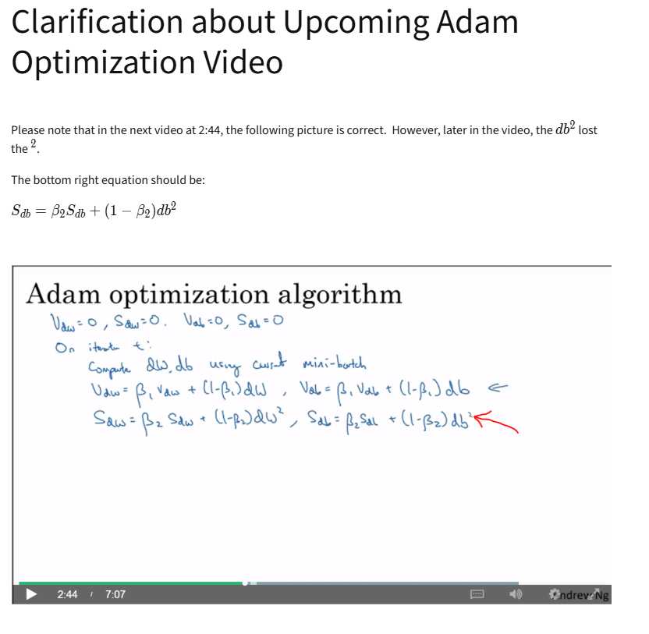
Adam Optimization Algorithm
The content focuses on the Adam optimization algorithm, which combines momentum and RMSprop techniques to improve the training of neural networks.

Adam Optimization Algorithm

- Adam stands for Adaptive Moment Estimation, utilizing two hyperparameters: Beta_1 for momentum and Beta_2 for RMSprop.
- It initializes variables for momentum (V_dw, V_db) and RMSprop (S_dw, S_db) to zero before computing updates during training.
Implementation Steps

- The algorithm computes derivatives using mini-batch gradient descent and updates momentum and RMSprop values with exponential decay.
- Bias correction is applied to the momentum and RMSprop values to ensure accurate updates.
Hyperparameters and Tuning

- Key hyperparameters include the learning rate (Alpha), Beta_1 (default 0.9), and Beta_2 (default 0.999), with Epsilon typically set to 10^-8.
- While Alpha often requires tuning, Beta_1 and Beta_2 are usually left at default values.
Overall Significance

- The Adam algorithm is widely recommended due to its effectiveness across various neural network architectures, making it a valuable tool for training deep learning models.

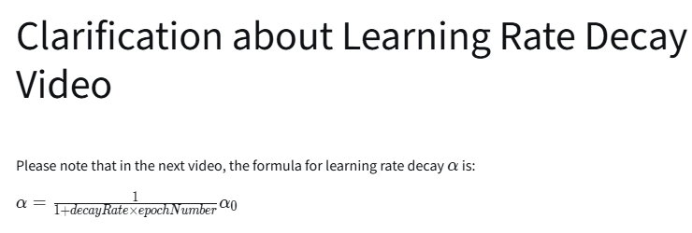
Learning Rate Decay
The content focuses on the concept of learning rate decay in the context of training neural networks.

Learning Rate Decay

- Learning rate decay helps improve convergence by gradually reducing the learning rate over time.
- A larger learning rate allows for faster learning initially, while a smaller learning rate helps fine-tune the model as it approaches convergence.
Implementation of Learning Rate Decay

- The learning rate can be adjusted using a formula: Alpha = 1 / (1 + decay rate epoch number) Alpha0.
- Different methods for decay include exponential decay and discrete decay, where the learning rate is halved after certain steps.
Hyperparameter Tuning

- Selecting the right hyperparameters, including the initial learning rate and decay rate, is crucial for effective training.
- The content suggests that while learning rate decay is beneficial, it is often lower on the priority list compared to other tuning methods.
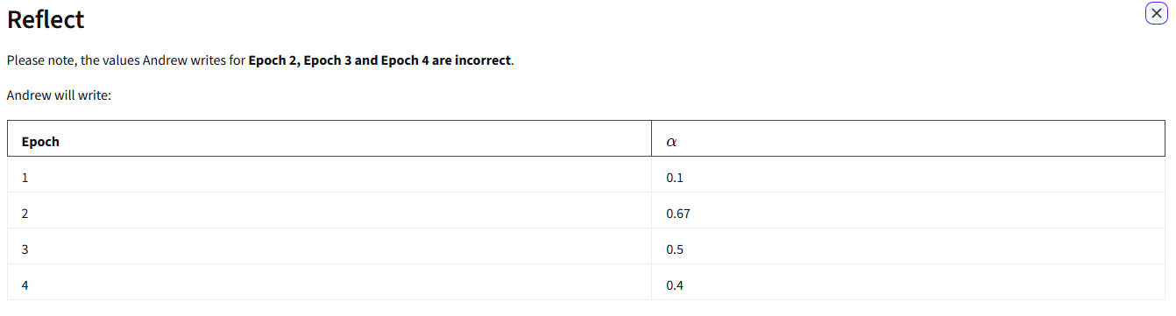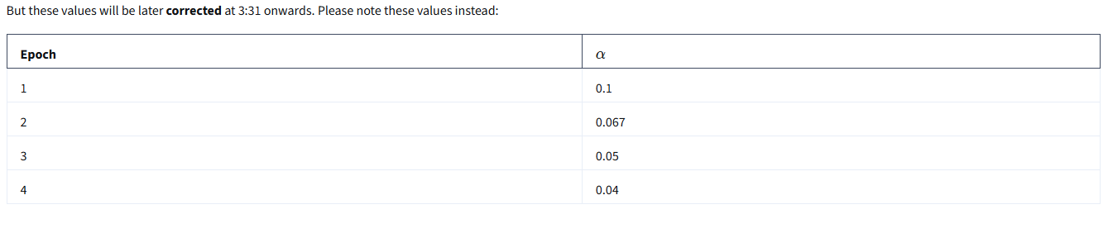

The problem of Local Optima
This content discusses the challenges of optimization in deep learning, particularly focusing on local optima and saddle points.

Understanding Local Optima

- Early concerns in deep learning were about optimization algorithms getting stuck in local optima.
- In high-dimensional spaces, most points of zero gradient are saddle points rather than local optima.
Saddle Points vs. Local Optima

- Saddle points are more common in high-dimensional spaces, making it unlikely to be stuck in local optima.
- A saddle point resembles a horse saddle, where the gradient is zero but can curve up in some directions and down in others.
Plateaus in Optimization

- Plateaus, where the gradient is close to zero for extended periods, can slow down learning.
- Advanced algorithms like momentum, RMSprop, and Adam can help navigate through plateaus more efficiently.
Overall, the content emphasizes that while local optima are less of a concern in high-dimensional spaces, plateaus can significantly hinder the learning process.

