Using an Appropriate scale to pick Hyperparameter
This content focuses on the importance of selecting the appropriate scale for sampling hyperparameters in deep learning models.

Understanding Hyperparameter Sampling

- Random sampling can be inefficient if not done uniformly across the valid range of hyperparameters.
- Different hyperparameters may require different sampling strategies, such as linear or logarithmic scales.
Examples of Hyperparameter Sampling

- For hidden units in a layer, uniform random sampling within a specified range (e.g., 50 to 100) is reasonable.
- For learning rates, a logarithmic scale is more effective, as it allows for better resource allocation across the range (e.g., 0.0001 to 1).
Implementing Logarithmic Sampling

- To sample on a logarithmic scale, calculate the logarithm of the lower and upper bounds to determine the range for sampling.
- Use a random number generator to sample uniformly within this logarithmic range.
Special Cases in Hyperparameter Sampling

- For hyperparameters like beta, which affect exponentially weighted averages, sampling should also consider the sensitivity of results to small changes.
- Exploring the range of values for 1 - beta can lead to more efficient sampling and better model performance.

Hyperparameter Tuning in Practice: Pandas vs Caviar
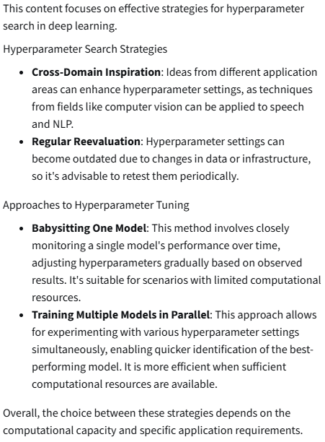

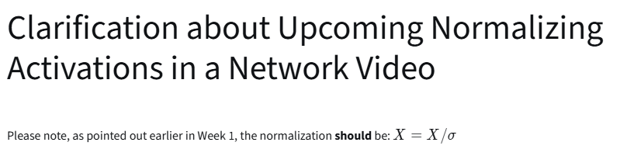

Normalizing Activations in a Network
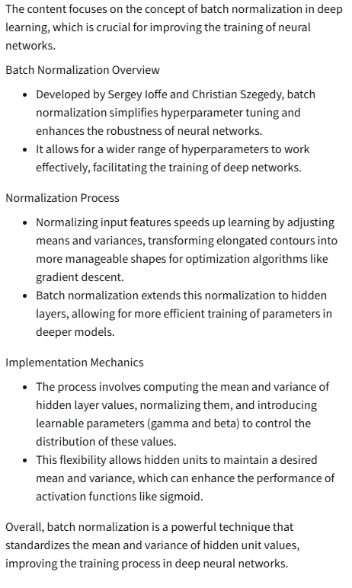

Fitting Batch Norm into a Neural Network
The content focuses on the implementation and significance of Batch Normalization (Batch Norm) in training deep neural networks.

Understanding Batch Normalization

- Batch Norm is applied between the computation of Z (linear transformation) and A (activation function) in each layer of a neural network.
- It normalizes the input to the activation function, which helps stabilize and accelerate training.
Parameters and Computation

- Each layer has additional parameters (Beta and Gamma) introduced by Batch Norm, which are distinct from other hyperparameters like momentum.
- -The computation involves adjusting the mean and variance of the inputs using these parameters, allowing for more effective learning.
Mini-Batch Gradient Descent

- Batch Norm is typically applied using mini-batches rather than the entire training set, computing mean and variance for each mini-batch.
- This process helps in maintaining the benefits of normalization while training on smaller subsets of data.
Parameterization Adjustments

- The bias parameter (B) can be eliminated when using Batch Norm, as its effect is negated during normalization.
- The new parameterization focuses on scaling and shifting the normalized values using Beta and Gamma.
Gradient Descent Implementation

- The implementation of gradient descent with Batch Norm involves forward propagation through mini-batches, followed by backpropagation to update parameters.
- Various optimization algorithms (like Adam or RMSprop) can be used to update the new parameters introduced by Batch Norm.
Overall, Batch Norm enhances the training process of deep networks by normalizing inputs, which leads to faster convergence and improved performance.

Batch Norm at Test Time
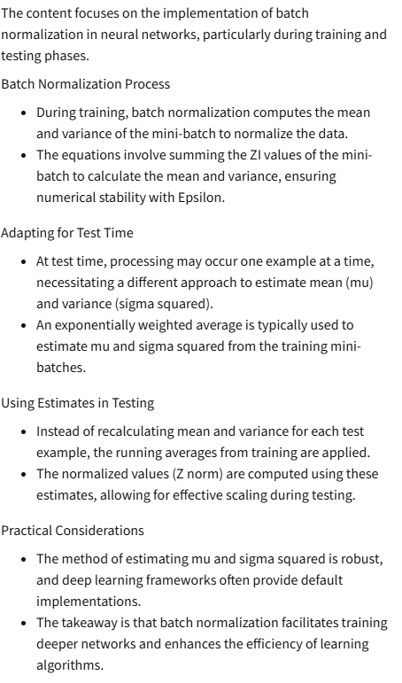

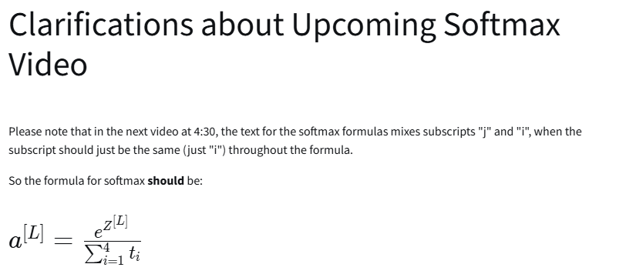
Softmax Regression
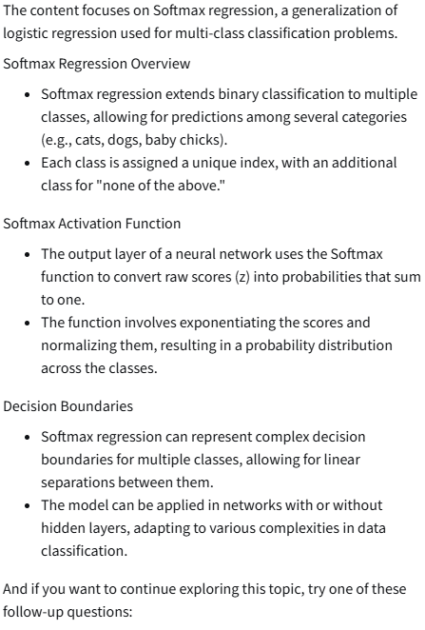

Training a Softmax Classifier
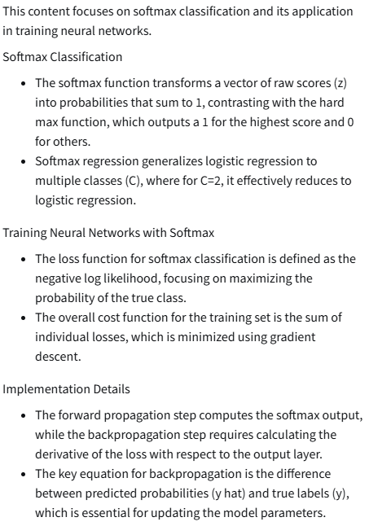

Deep Learning Frameworks – TensorFlow
This content provides an overview of using TensorFlow for implementing deep learning algorithms, particularly focusing on minimizing a cost function.

Understanding TensorFlow Basics

- TensorFlow is a framework that helps in developing and using deep learning algorithms efficiently.
- The example cost function used is ( J(w) = w^2 - 10w + 25 ), which simplifies to ( (w - 5)^2 ), with the minimum at ( w = 5 ).
Implementing a Simple Optimization

- The program starts by importing necessary libraries and defining the variable ( w ) as a TensorFlow variable initialized to zero.
- The Adam optimization algorithm is set up with a learning rate of 0.1, and the cost function is defined.
- TensorFlow uses a gradient tape to automatically compute gradients during backpropagation, simplifying the implementation process.
Training the Model

- A training step function is defined to compute gradients and apply them using the optimizer.
- After running multiple iterations, the value of ( w ) approaches the minimum of the cost function, demonstrating TensorFlow's efficiency in optimization.
Extending to More Complex Functions

- The content also discusses how to incorporate training data into the cost function, allowing for more complex models.
- The optimizer can be easily changed, showcasing TensorFlow's flexibility in experimenting with different optimization algorithms.
Overall, the lecture emphasizes the simplicity and power of TensorFlow in building and training neural networks by focusing on defining the cost function and letting TensorFlow handle the optimization process.
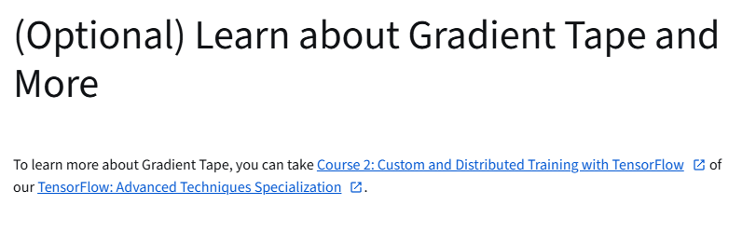

https://www.coursera.org/learn/custom-distributed-training-with-tensorflow
https://www.coursera.org/specializations/tensorflow-advanced-techniques

