Image-to-Image Translation
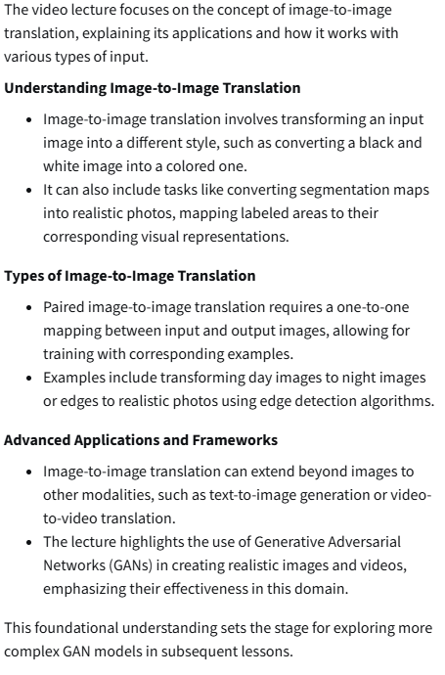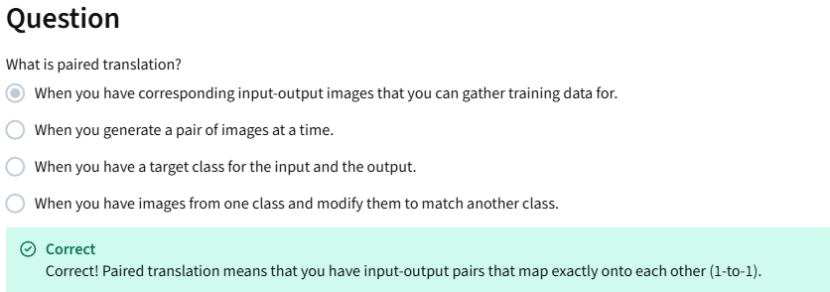
Pix2Pix Overview
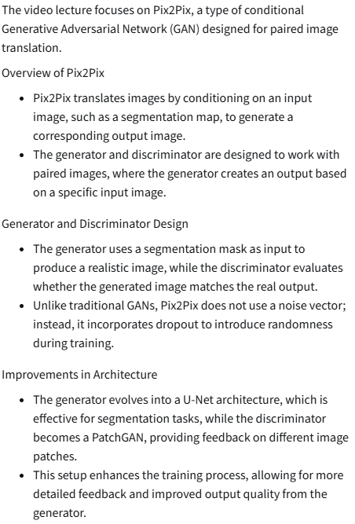
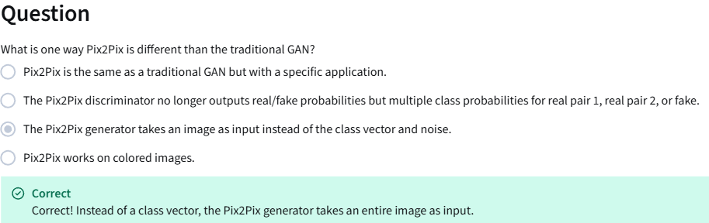
Pix2Pix: PatchGAN
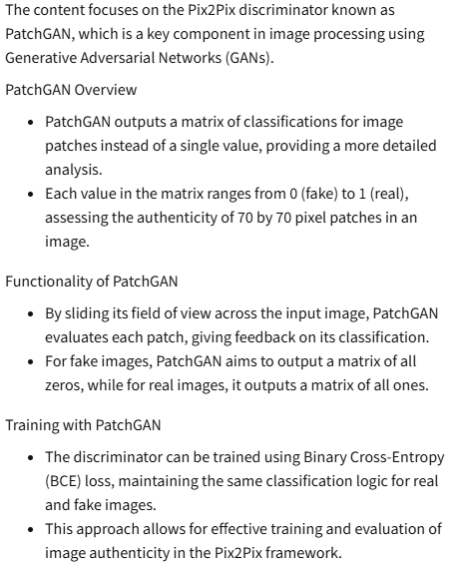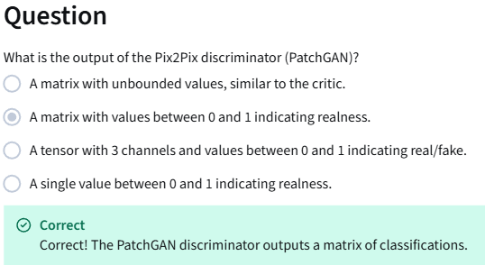

Pix2Pix: U-Net
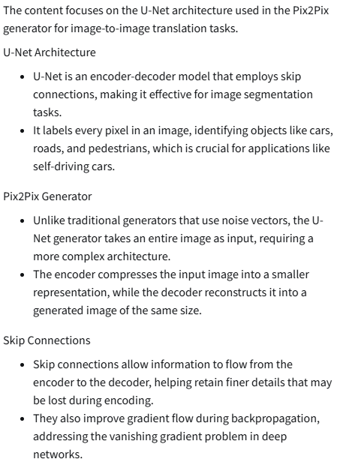
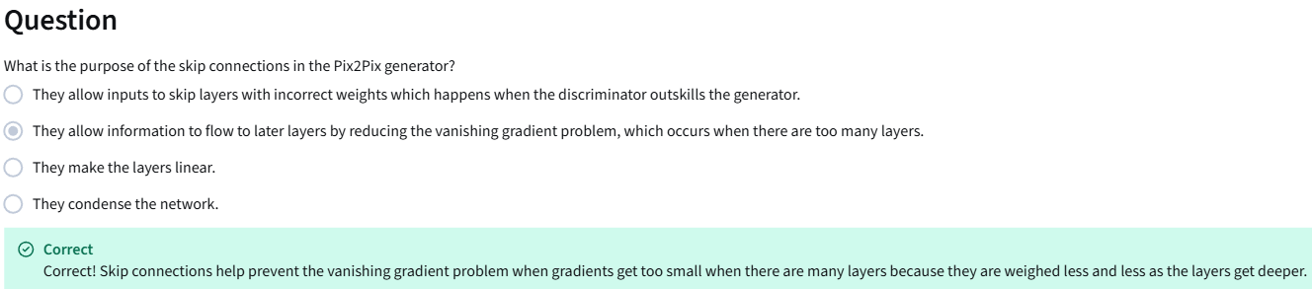

Pix2Pix: Pixel Distance Loss Term
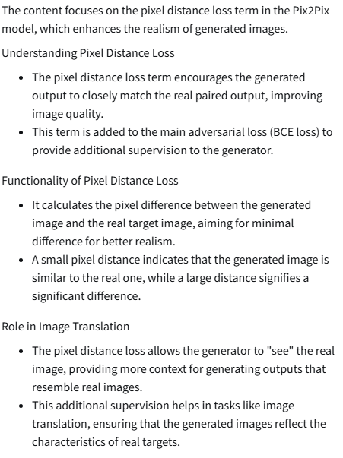
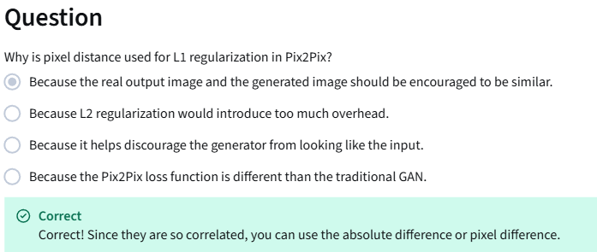
Pix2Pix: Putting It All Together
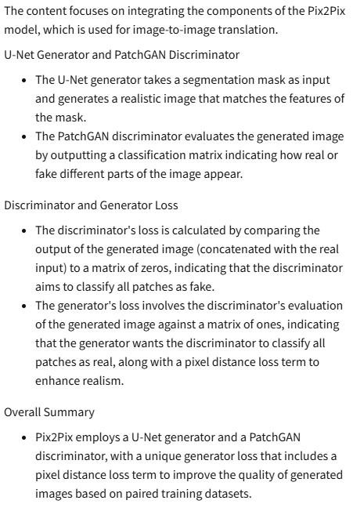

Pix2Pix Advancements
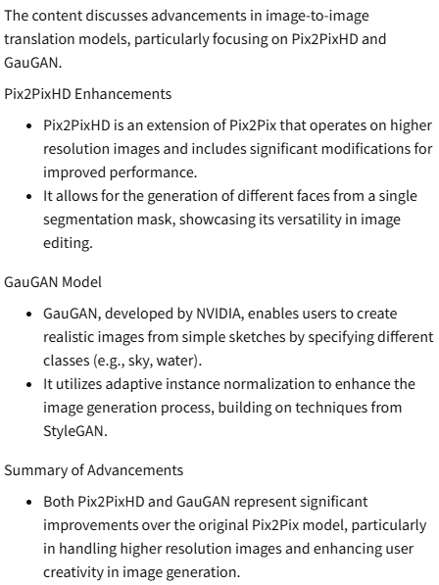

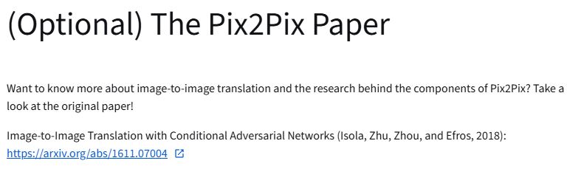
https://arxiv.org/abs/1611.07004

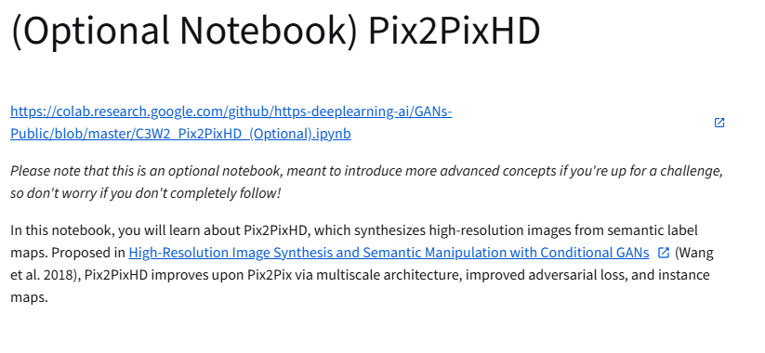
https://colab.research.google.com/github/https-deeplearning-ai/GANs-Public/blob/master/C3W2_Pix2PixHD_(Optional).ipynb
https://arxiv.org/abs/1711.11585

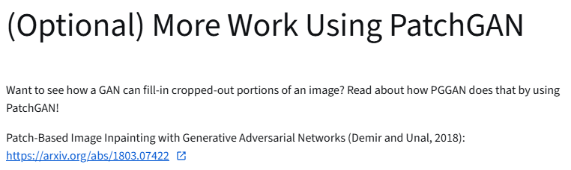
https://arxiv.org/abs/1803.07422

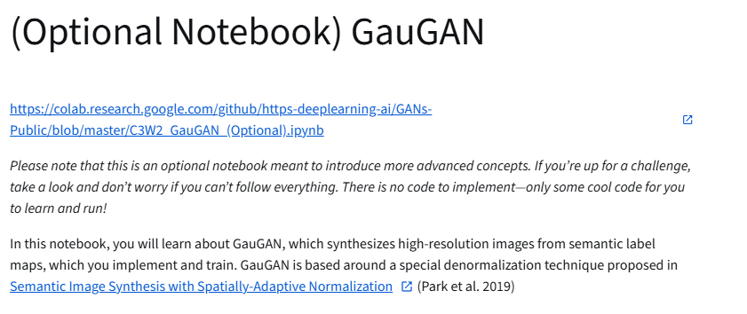
https://colab.research.google.com/github/https-deeplearning-ai/GANs-Public/blob/master/C3W2_GauGAN_(Optional).ipynb
https://arxiv.org/abs/1903.07291

