Unpaired Image-to-Image Translation
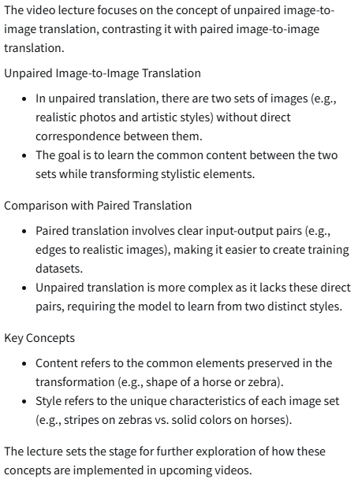
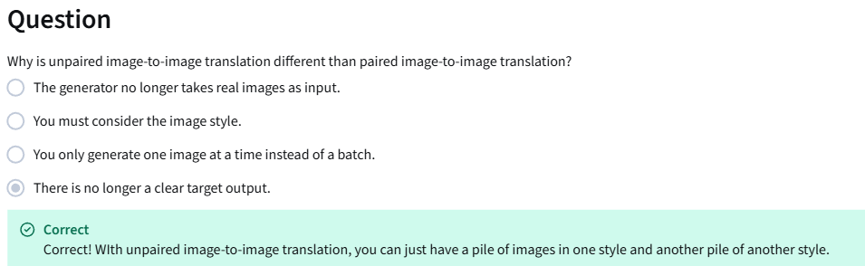

CycleGAN Overview
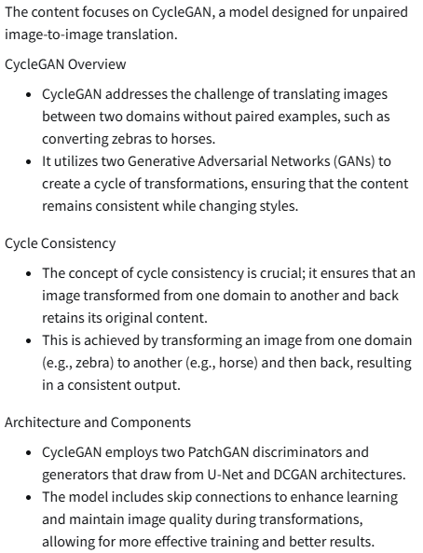

CycleGAN: Two GANs
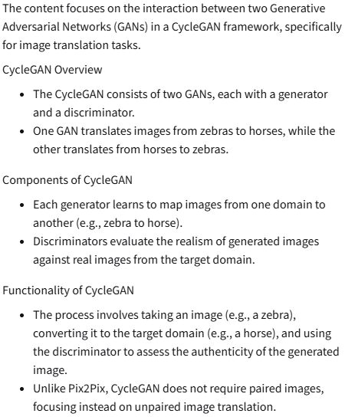

CycleGAN: Cycle Consistency
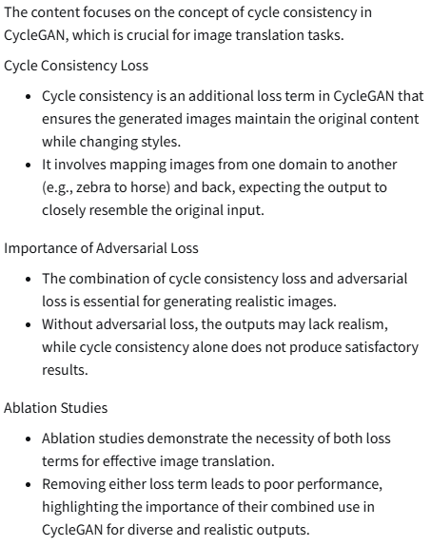
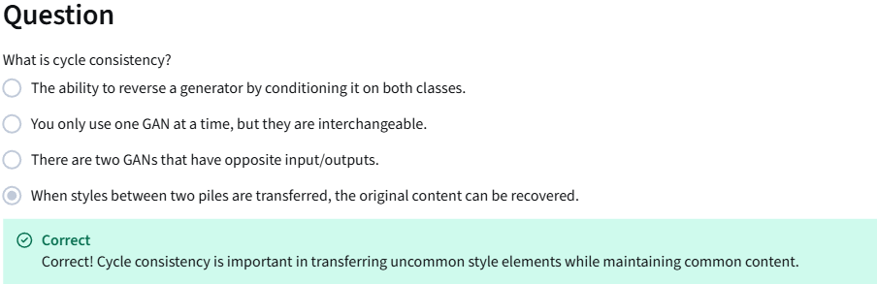

CycleGAN: Least Squares Loss
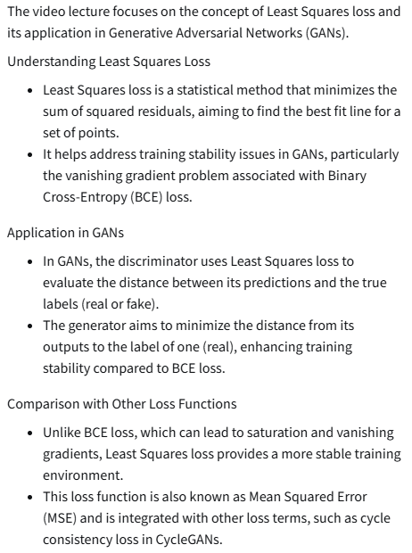
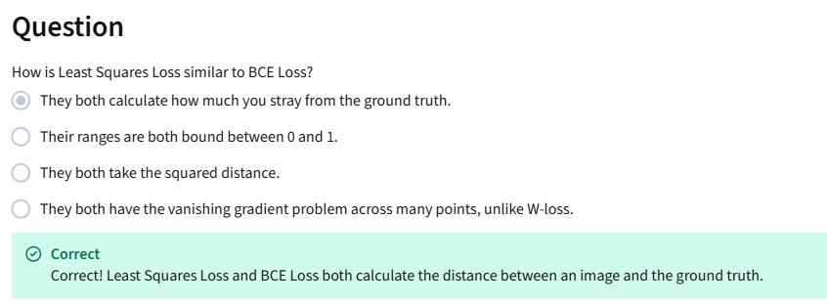

CycleGAN: Identity Loss
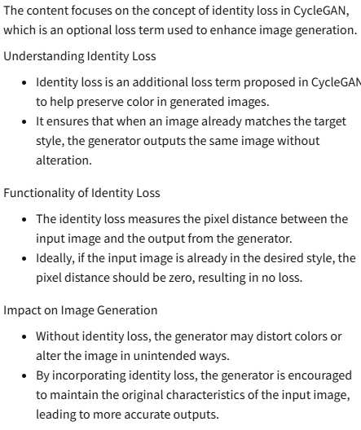
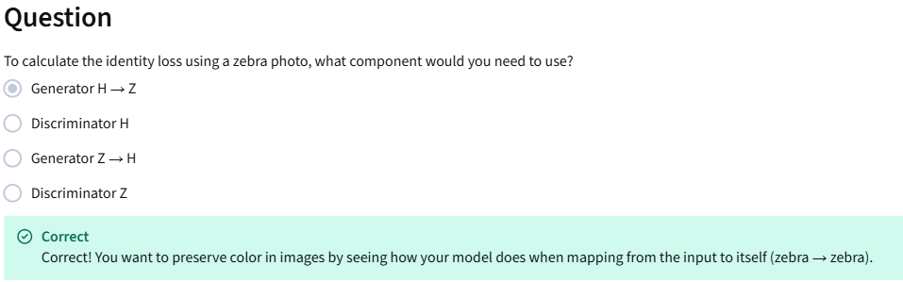

Cycle GAN Applications & Variants
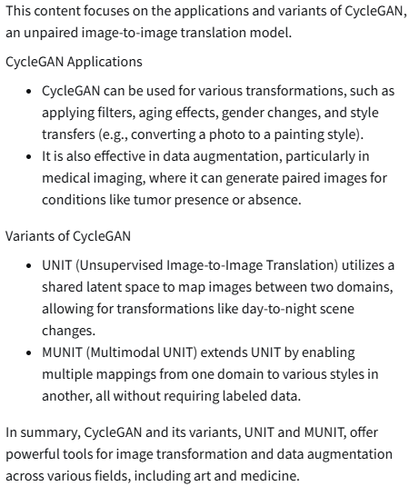

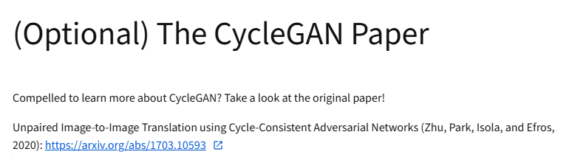
https://arxiv.org/abs/1703.10593

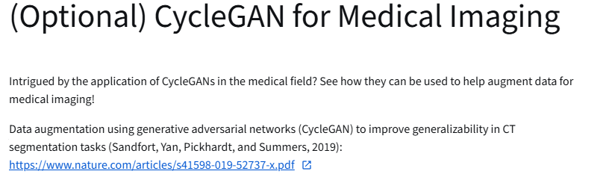
https://www.nature.com/articles/s41598-019-52737-x.pdf
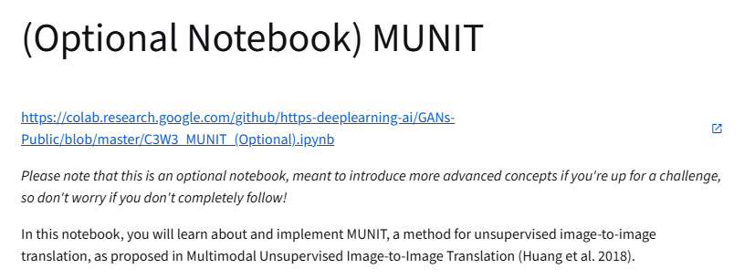
https://colab.research.google.com/github/https-deeplearning-ai/GANs-Public/blob/master/C3W3_MUNIT_(Optional).ipynb

