Carrying Out Error Analysis
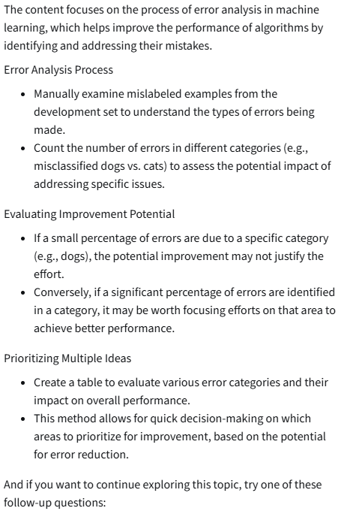

Cleaning Up Incorrectly Labeled Data
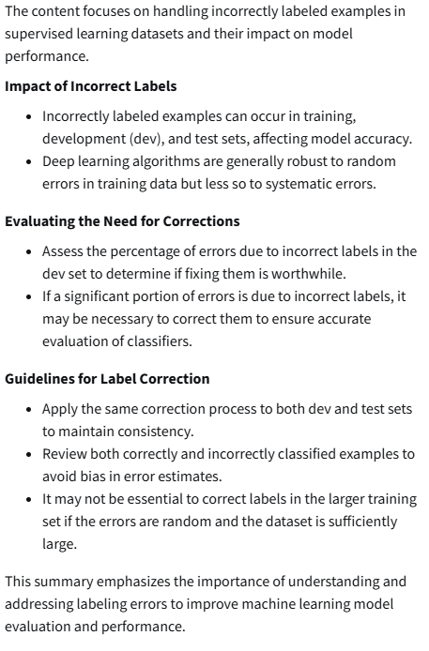

Training and Testing on Different Distributions
The content discusses the challenges and strategies involved in training machine learning models when the training data comes from a different distribution than the development (dev) and test data.

Training Data Distribution Challenges

- Deep learning algorithms require large amounts of labeled training data, often leading teams to use data from various sources, which may not match the desired distribution.
- Using data from different distributions can lead to suboptimal performance if the model is not trained on the data it will encounter in real-world applications.
Example 1: Mobile App Image Classification

- A mobile app collects user-uploaded images, which may be of lower quality compared to professionally taken images available online.
- Combining both datasets can lead to a dev set that does not represent the target distribution, potentially misguiding model optimization.
Recommended Approach

- Instead of mixing datasets, use a larger training set from the web while keeping the dev and test sets focused on the mobile app images to ensure the model is optimized for the intended use case.
Example 2: Speech Recognition for a Rearview Mirror

- A speech recognition system for a rearview mirror can utilize existing speech data from other applications for training, while the dev and test sets should consist of data specific to the rearview mirror's use case.
- This approach allows for a larger training set while ensuring the model is evaluated on relevant data.
Conclusion

- The content emphasizes the importance of aligning training, dev, and test data distributions to improve model performance, while also hinting at future discussions on techniques for handling mismatched distributions.

Bias and Variance with Mismatched Data Distributions
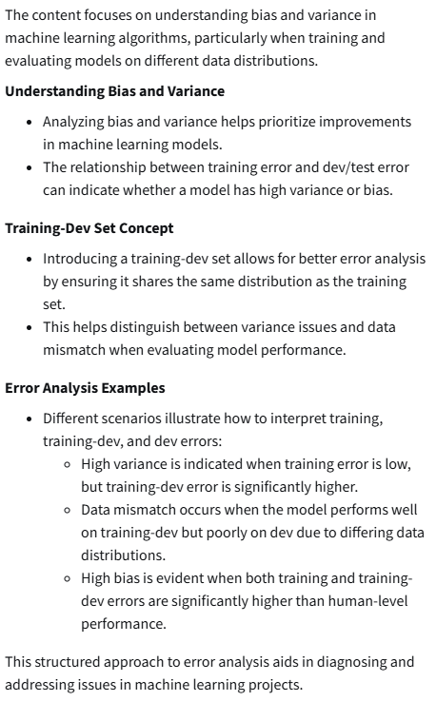
Addressing Data Mismatch
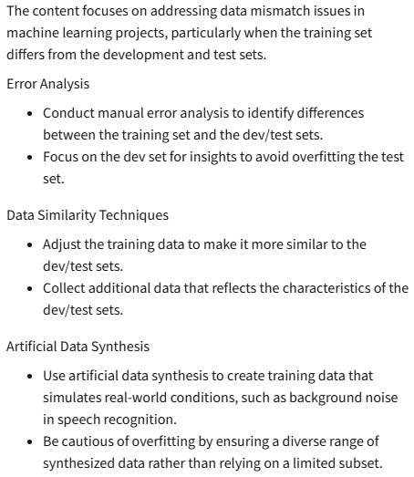

Transfer Learning
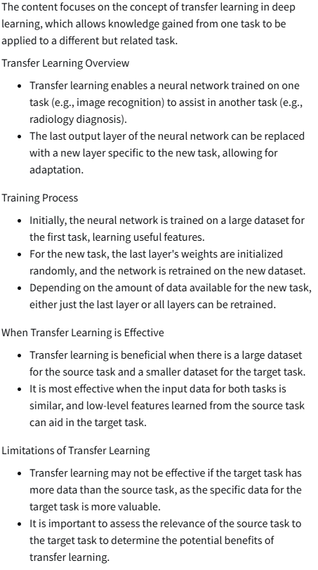

Multi-task Learning
