1. **Introduction**

It was a cloudy day, dark cloud beginning to show. You are ill and think about your career, your life like a storm and don’t know what to day. Go with me and TOGETHER we will become BETTER with five steps.

1. **Story**

So let’s begin with my story:

Story 1

I learn a course in Coursera with instructor Andrew Ng, he is one of the best teacher I have ever met, he is my inspiration, he helps me understand and do complex, abstract things step by step with a practical way and so fun to learn. And then I learn how a model works on a specific problem. And it works like this:

- Define what is the input, like if you want to classify an image so input is image

- To classify an image effectively model should use artificial neural network (So what is an artificial neural network, like its name, it mimics our real neural networks on computer but much more simple, and why we use it because we are so good at recognize things).

- Build model using artificial neural network

- Evaluate it good a not by some norms

- And then update, build again to become better

Story 2

Another story is that. I am a math tutor and my student. Her name is Bao Han a very beautiful name), she is my inspiration, my innovation, she is pretty, approachable and so energetic. She helps me to think, to do, how to explain complex abstract concept in math step by step make it easy to understand, so she, I and we can become BETTER TOGETHER. And there was a day when I teach her, this happened she learned about perpendicular bisector of a line and she confused in what the difference between perpendicular bisector of a line and median line. So how can I explain this to her:

- So okay I need to show the difference between perpendicular bisector of a line and median line and I will do it by teach her what makes a line become perpendicular bisector of a line

- This how I do, I teach her. I show what is the condition to make a line become perpendicular bisector of the line we want and it need to satisfy two conditions:

+ That line needs to ***cross the middle point*** of the line we want

+ That line needs to ***perpendicular*** of the line we want

- And she will do an example and with the solution is the two things I highlight in bold and italic above.

- When she done, she, I, we will review

- And then she do it again to make what she has presented about that example BETTER and then she and I will review, she do again get BETTER and finish until it’s okay.

1. **Model**

So what you can see in two story above is that to achieve a goal it is a process of 5 steps:

First: define the problem

Second: find a solution

Third: do it, practice it

Fourth: take a review, like is that correct or what is the point in scale 10, what need to improve

Fifth: update from the review and do again

So this is the process:

Problem -> Solution -> Do -> Review -> Update

^ |

|____________________|

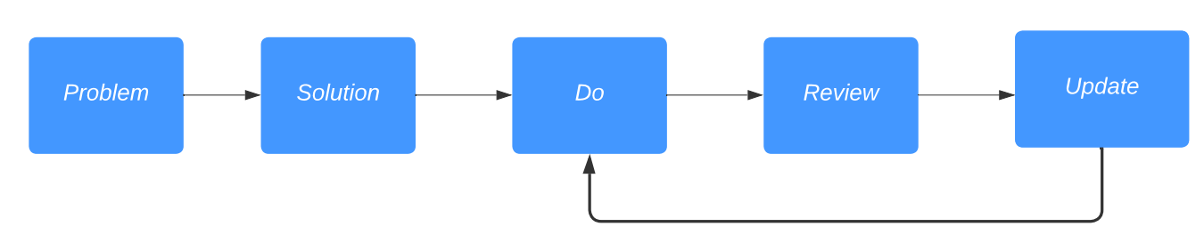

(Image 1)

Okay, it sounds make sense but you will wonder how can you do it effective and we become BETTER version TOGETHER

So what you need to do

in the first step (define the problem): you, me and we need to define it RIGHT

In the second step (find a solution): you, me and we need to find a PRACTICAL solution

In the third step (do it): you, me and we need to HARDWORKING

In the fourth step (reviewing): you, me and we need to NETWORKING (because besides the tools evaluate only your result and then look again what need to fix, it’s so boring. So you need at least a person and you always have a person already, ITS YOURSELF and BETTER if many people with positive energy review TOGETHER and when you do that you and your reviewers TOGETHER can see a lot of things NEED and CAN develop, for examples the knowledge you are vague or don’t understand quite clearly, and so on. And the things I think great about that is that TOGETHER is more FUN).

In the fifth steps (update): you, me and we need to LISTEN to the reviews and then do it again and see how it goes.

And do you recognize somethings:

Again, it a process of 5 step:

Problem: how can you do the process effective

Solution: is above

And then: Do -> Review -> Update

And this how it looks likes:

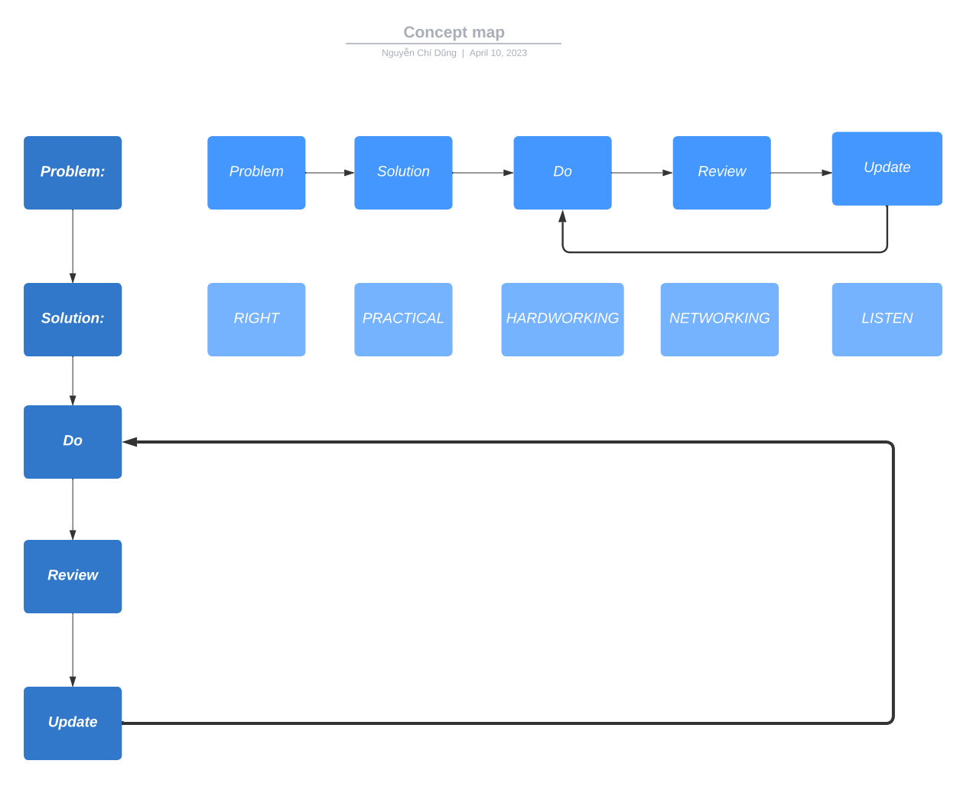

(image 2)

1. Apply model to real life and my life

Example1: How to become a bilingual.

Problem: need to good at a new language

Solution: Find an online course about the language you want to learn with a lot of students enrollment, review with high star, and ask your close friends to learn with you

Do: Learn the course, practice with your friends

Review: Your close friends and you, remember REVIEW INCLUDE YOU

Update: Listen to your friend’s opinion, and practice what you still need to improve

But do you think about a scenario that you don’t have some close friends yet. What should you do. So again

Example 2: How to have a close friend.

Problem: need to have a close friend

Solution: Find an online course about socializing or networking with a lot of student’s enrollment and review with high star

Do: Learn the course and then talk to friends in your class

Review: Friends in your class and YOU

Update: Listen to their response, their emotions, their opinions and then do, practice again.

So I think you can see why NETWORKING is so important and we needs it to become BETTER version of ourselves TOGETHER.

And there is a question I usually ask my close friends when talk with them and that is “IF I NEED TO CHANGE ONE THING, WHAT IS IT?” – I have this question when I read “How to be a power connector” (author: Judy Robinett – the best speaker I have ever heard). Sometimes, you may get some answers but unfortunately, I don’t. But that UNFORTUNATELY lead to my LUCKILY, I **HAVE THE FIRST TIME REVIEW MYSELF BY MYSELF ABOUT WHAT I HAVE DONE**. And that the key reason how I can write this story. And finally I figure out the answers. And my problem is that I am too subjective. I do then I rarely take reviews so I don’t UPDATE to become BETTER and also can not BETTER TOGETHER with people around me. It likes: ***My goal*** is to finish the 100m race in 20s. I ran 50ms in 8s and I stop, I ***chill***, I ***sleep*** and then I’m ***late***. But if I ask my friends that I’m tired how long should I rest and then they said 2s ,1s, 3s. So after relax with the same speed again I will ***achieve*** my goal. That’s why I think me, you and we should take a review and I take a review about myself in the day I said from the beginning. And the idea, the answer I have is after I teach Bao Han and think about the model I learn in course teach by Andrew. The day I do this story is so great, it is sunny, I have a test I nailed it, I review my friend science poster I understand clearer about a machine learning model that I have learned by review with them and my health is recovering quickly.

And some tips I want to share with you after I apply that model to have a better result at my school

When I do a school project by groups, ***when we finished the process before the deadlines two to three weeks I send to my teacher and ask for a review***. Because your teacher can give you so many things to make your products better and so do me, my group members, we become BETTER TOGETHER. So if you have some people that so good at the things you are working, ask their review is so fantastic but again how can you know them, close to them. It’s NETWORKING

And so do like internship program. You have a problem and solution from your mentors. Ask them carefully don’t be scared if you don’t understand so you can define RIGHT problem, and key points in the solution your mentors give you. You do it and then report to your mentors ***before the deadlines two to three weeks so your mentor can give you a review. And when doing that, I believe you can show that you are seriously learn, hardworking and responsibility.***

***So after REVIEW MYSELF and write this story, I use this model more often now with people around me to BECOME BETTER TOGETHER EVERYDAY. And I think you, we did it before but maybe just without notice.***

1. Review my model

So I want to build a model that we can have a specific path for us to achieve our dreams. And to do that first I need my model and also my first layer (image 2) be accurate. And to do that, I need you. I, you, we TOGETHER can make my model become BETTER. My model I think just like a seat right now and that seat need to sprout, and have body, branch. So let’s finish our first layer and then many other layers so TOGETHER grow a tree BETTER, and each of the branch is a job in different fields with fresh, positive energy.

And don’t hesitate to contact me because I also need to

DO LISTEN UPDATE to become BETTER and REVIEW TOGETHER.

And,

IT’S ALWAYS BETTER WHEN WE ARE TOGETHER.

Contact me at:

Linkedin: [linkedin/chidung](https://www.linkedin.com/in/d%C5%A9ng-nguy%E1%BB%85n-8b92b8200/) , facebook: [fb.com/chidung](https://www.facebook.com/goodnight2k2/), instagram: [ins.com/chidung](https://www.instagram.com/chidzung_ql/)

Github: [github.com/chidung](https://github.com/quanly01), Youtube: [youtube.com/chidung](https://www.youtube.com/channel/UC103ztUFon5r0V_X-kN9JlQ) Tiktok: [tiktok/chidung](https://www.tiktok.com/@user27856010969332?lang=vi-VN)

Gmail: [alwaysbettertogether2023@gmail.com](mailto:alwaysbettertogether2023@gmail.com)

The last thing I want to say is

Thank you for spending time on my story.

If you want to thank, send your positive energy and spread this positive story because it makes me x **∞** power than coffee.

Link of this story:

Linkedin:

Facebook:

Instagram:

Github:

Youtube:

Tiktok: