1. **Introduction**

It was a cloudy day, dark clouds began to show. You are ill and think about your career, your life like a storm and don’t know what to do. Go with me and TOGETHER we will become BETTER with five steps.

1. **Story**

So let’s begin with my story:

Story 1

I learn a course in Coursera with instructor Andrew Ng. He is one of the best teachers I have ever met. He is my inspiration, he helps me understand and do complex, abstract things step by step in a practical way and so fun to learn. And then I learn how a model works on a specific problem. And it works like this:

- Define what is the input, like if you want to classify an image so input is image.

- To classify an image effectively, model should use an artificial neural network (So what is an artificial neural network, like its name, it mimics our real neural networks on computers but much more simple, and why we use it because we are so good at recognizing things).

- Build a model using an artificial neural network.

- Evaluate it’s good or not by some norms.

- And then update, build again to become better.

Story 2

Another story is that. I am a math tutor and my student. Her name is Bao Han a very beautiful name). She is smart, approachable and so energetic. She inspires me to think deeper so I can explain abstract math concepts in easier ways, so she, I and we can become BETTER TOGETHER. And there was a day when I taught her, this happened. She learned about the perpendicular bisector of a line and she was confused about the difference between the perpendicular bisector of a line and the median line. So how can I explain this to her:

- So okay I need to show the difference between the perpendicular bisector of a line and median line and I will do it by teaching her what makes a line become the perpendicular bisector of a line.

- This is how I do, I teach her. I show what is the condition to make a line become perpendicular bisector of the line we want and it need to satisfy two conditions:

+ That line needs to ***cross the middle point*** of the line we want.

+ That line needs to be perpendicular to the line we want.

- And she will do an example and with the solution are the two things I highlight in bold and italic above.

- When she’s done, she, I, we will review.

- And then she does it again to make what she has presented about that example BETTER and then she and I will review, she does again get BETTER and finish until it’s okay.

1. **Model**

So what you can see in two story above is that to achieve a goal it is a process of 5 steps:

First: define the problem.

Second: find a solution.

Third: do it, practice it.

Fourth: take a review, like is that correct or what is the point in scale 10, what needs to improve.

Fifth: update from the review and do it again.

So this is the process:

Problem -> Solution -> Do -> Review -> Update

^ |

|____________________|

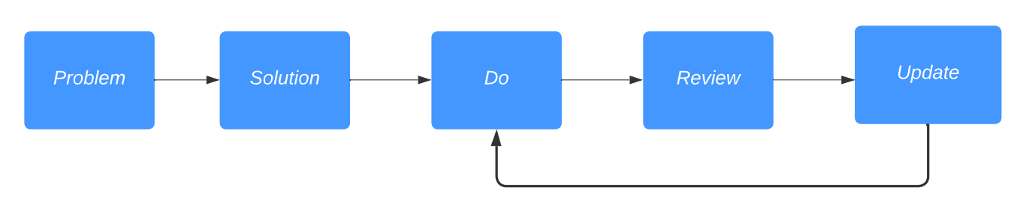

(Image 1)

Okay, it sounds make sense but you will wonder: how can you do it effectively and we become BETTER TOGETHER.

So what you need to do:

in the first step (define the problem): you, me, we need to define it RIGHT.

In the second step (find a solution): you, me, we need to find a PRACTICAL solution.

In the third step (do it): you, me, we need to HARDWORKING.

In the fourth step (review): you, me, we need to NETWORKING (because besides the tools evaluate only your result and then look again at what needs to be fixed, it’s so boring. So you need at least a person and you always have a person already, IT'S YOURSELF and BETTER if many people with POSITIVE energy review TOGETHER. And when you do that you and your reviewers TOGETHER can see a lot of things NEED and CAN develop. For example, the knowledge you, they are vague or don’t understand quite clearly, and so on. And the thing I think great about this is that TOGETHER is more FUN).

In the fifth step (update): you, me, we need to LISTEN to the reviews and then do it again and see how it goes.

And do you recognize somethings:

Again, it a process of 5 steps:

Problem: Do the process effectively.

Solution: Is above.

And then: Do -> Review -> Update.

And this how it looks like:

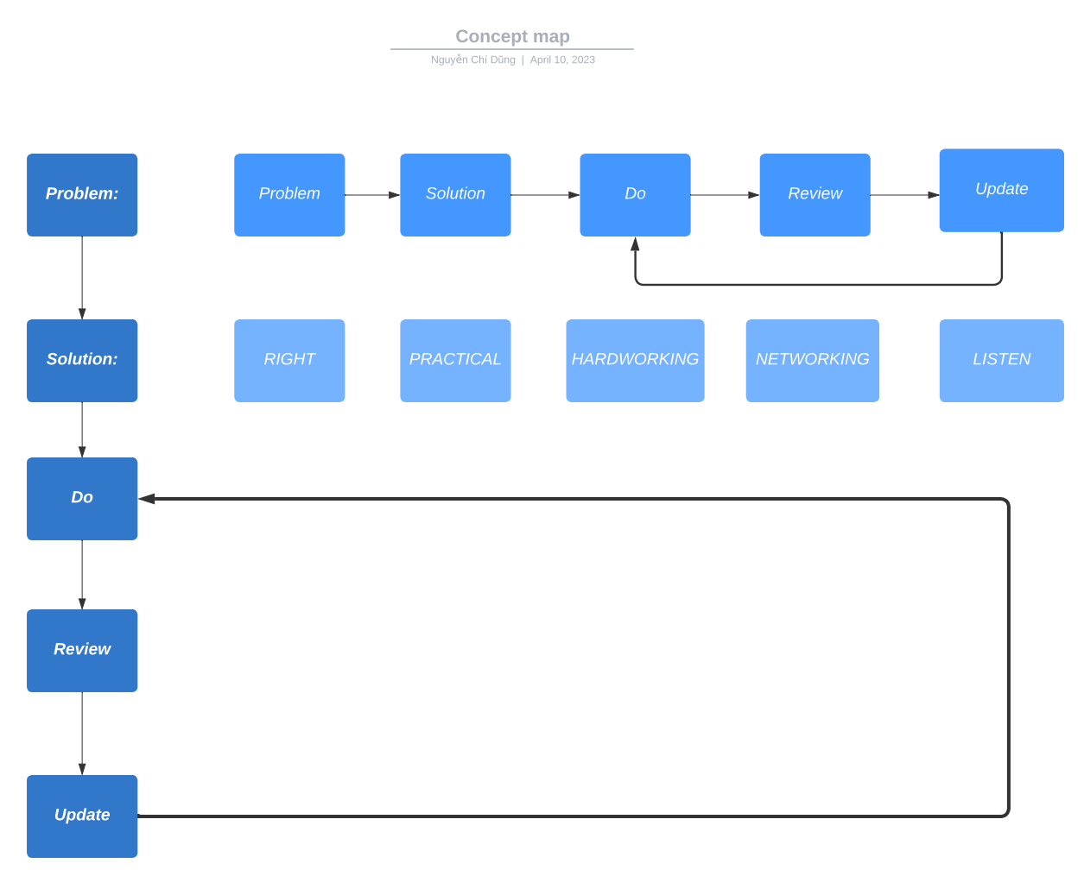

(image 2)

1. Apply model to real life and my life

Example1: How to become bilingual.

Problem: Need to be good at a new language.

Solution: Find a course about the language you want to learn with a lot of student’s enrollment, review with high stars, and ask your close friends to learn with you.

Do: Learn the course, practice with your friends.

Review: Your friends and you, remember REVIEW INCLUDE YOU.

Update: Listen to your friend’s opinion, and practice what you need to improve.

But do you think about a scenario where you don’t have some close friends yet. What should you do. So again:

Example 2: How to have a close friend.

Problem: Need to have a close friend.

Solution: Find a course about socializing or networking with a lot of student’s enrollment and review with high stars.

Do: Learn the course and then talk to friends in your class.

Review: Friends in your class and YOU.

Update: Listen to their response, their emotions, their opinions and then do, practice again.

So I think you can see why NETWORKING is so important and we need it to become a BETTER version of ourselves TOGETHER.

And there is a question I usually ask my close friends when I talk with them and that is “**IF I NEED TO CHANGE ONE THING, WHAT IS IT?**” – I have this question when I read “How to be a power connector” (author: Judy Robinett – the best speaker I have ever heard). Sometimes, you may get some answers but unfortunately, I don’t. But that UNFORTUNATELY led to my LUCKILY, I **HAVE THE FIRST TIME REVIEW MYSELF BY MYSELF ABOUT WHAT I HAVE DONE**. And that is the key reason why I started writing this story. And finally I figured out the answers. And my problem is that I am too **SUBJECTIVE**. I do then I rarely take reviews so I don’t UPDATE to become BETTER and also can not BETTER TOGETHER with people around me. It likes: ***My goal*** is to finish the 100 meters race in 20s. I ran 50 meters in 8s and I stop, I ***chilled***, I ***slept*** and then I’m ***late***. I do a pretty good job at the beginning but why I ***stop***, is because I’m tired. I just ran ***alone*** in that race but no one forced me to run alone, I can have my teammates run with me and my friends - the audience who encourage me. So when I go alone, I have many doubts about myself like I don’t know do I run in the right way, why when I go further it just gets darker and darker. And there is a light shine my way and that is from my best friends. He asks me to hang out. When we play, we go cafe, we eat, he sees the sadness and tiredness in my eyes and he said: How are you doing, my buddy, is there anything new, you look so tired. I shared with him about my problem and he smiled and said: ***I believe you are doing great, I always believe in you so you need to believe in yourself and why don’t do that with some people who are awesome like me*** :)). That compliment and advice shine my light, I continue to run with confidence, with more teammates around who can support each other and audiences who can encourage me. That's how I ***achieve*** my goal.

And do you ever run in the **WRONG WAY**? I do :)). I do that when I and two of my friends do a project on a subject which was teached by a teacher who gave us so many enjoyable lessons. He gave us a topic: **An application of Math in real life**. And we do about the prisoner's dilemma. It’s really fun and applies to so many fields based on math, especially in psychology. So what we do is all about **psychology** in real life **without giving any data about math**. At that point, my teams are all the best talented people in my class. The first member, she studied in a gifted high school and achieved many awards in Maths. The way she explains, teaches us about math theory is so energetic and passionate. The second member is a co-leader in our school social media page, she designs beautiful powerpoint for presentation, well-structured google doc for us to edit and spectacular latex for the report. And me, I am the one who will control the flow, handle when we conflict in opinions. I listen to their opinions, gently say my opinion when they finish, ask other member’s opinions and ***just don’t force them say wrong to prove I’m right***, give them time to think and do in a better way. I strongly believe that we are doing great and we take our FIRST REVIEW before the presentation just **3 HOURS.** So no one of us can see that we are going in the wrong ways. And what happens will happen, our presentation is a disaster, everything falls apart, it is like a cacophony that makes the audience listen in confusion**.** But luckily because my team listens and answers a lot of questions that my teacher asks when teaching so he remembers us, likes us. And we volunteer to be the first group present so he gives us a **second chance**. At that second chance, in 8 weeks, every week we REVIEW at least a time and work so hard. And when we finish our presentation, the audiences give us a big round of applause, and a big round of applause again after our teacher’s compliment. So in the beginning my team went like this:

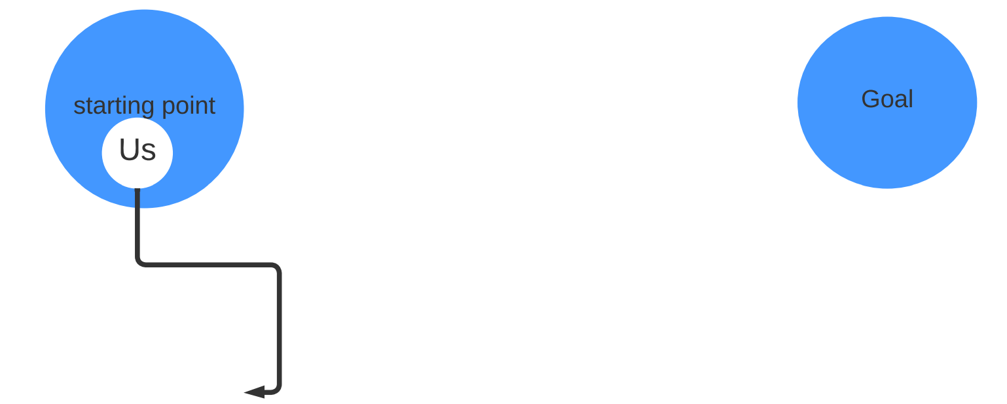

And at our second chance we go like this:

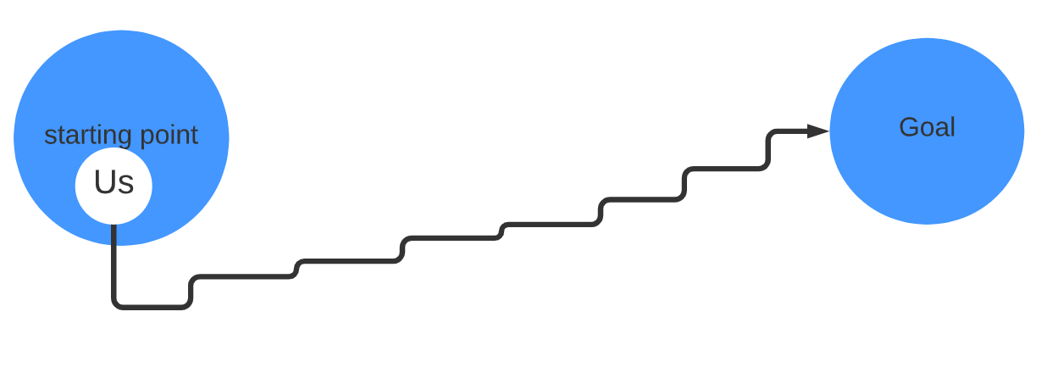

That’s why I think me, you, we should take a review and I take a review about myself in the day I said from the beginning. And the idea, the answer I have is after I teach Bao Han and think about the model I learn in the course taught by Andrew. The day I did this story was so great. It was sunny, I had a test, I nailed it, and I reviewed my friend's science poster. I understand clearer about a machine learning model that I have learned by reviewing with them TOGETHER and my health is recovering quickly.

And some tips I want to share with you after I apply this model to have a better result at my school.

When I do a school project in groups, ***when we finish the project before the deadlines two or three weeks, I send it to my teacher and ask for a review***. Because your teacher can give you so many things to make your products better and so do me, my group members, we become BETTER TOGETHER. So if you have some people that are good at the things you are working on, ask their review is so fantastic but again how can you know them, close to them. It’s NETWORKING

And so does the internship program. You have a problem and solution from your mentors. Ask them carefully, don't be scared if you don’t understand so you can define RIGHT problem, and key points in the solution your mentors give you. You do it and then report to your mentors ***before the deadlines two to three weeks so your mentor can give you a review. And when doing that, I believe you can show that you are seriously learning, hardworking and responsible.***

***So after REVIEW MYSELF and write this story, I use this model more often now with people around me to BECOME BETTER TOGETHER EVERYDAY. And I think you, we did it before but maybe just without notice.***

1. Review my model

So I want to build a model so that we can have a specific path for us to achieve our dreams. And to do that first I need my model and also my first layer (image 2) to be accurate. And to do that, I need you. I, you, we TOGETHER can make my model become BETTER. My model I think is just like a seed right now and that seed needs to sprout, and have a body, branch, leaf. So let’s finish our first layer and then many other layers so TOGETHER grow a tree BETTER, and each of the branches is a dream in different fields with fresh, positive energy.

And don’t hesitate to contact me because I also need to

DO LISTEN UPDATE to become BETTER and REVIEW TOGETHER.

And,

IT’S ALWAYS BETTER WHEN WE’RE TOGETHER.

Contact me at:

Linkedin: [linkedin/chidung](https://www.linkedin.com/in/d%C5%A9ng-nguy%E1%BB%85n-8b92b8200/) , Facebook: [fb.com/chidung](https://www.facebook.com/goodnight2k2/), Instagram: [ins.com/chidung](https://www.instagram.com/chidzung_ql/)

Twitter: [twitter.com/chidung](https://twitter.com/chidungql) Spotify: [spotify.com/chidung](https://open.spotify.com/user/31dtmnbbpgdo2im3j3tt3qhysuu4?si=c9db28fe22d8498f) Github: [github.com/chidung](https://github.com/quanly01), Youtube: [youtube.com/chidung](https://www.youtube.com/channel/UC103ztUFon5r0V_X-kN9JlQ) Tiktok: [tiktok/chidung](https://www.tiktok.com/@user27856010969332?lang=vi-VN)

Gmail: [alwaysbettertogether2023@gmail.com](mailto:alwaysbettertogether2023@gmail.com)

The last thing I want to say is

Thank you for spending time on my story.

If you want to thank, send your positive energy and spread this positive story because it makes me x **∞** power than coffee.

Link of this story:

Linkedin:

Facebook:

Instagram:

Twitter

Github: <https://github.com/quanly01/better-together>

Spotify:

Youtube:

Tiktok: