**Exercise 1** (1 mark) : Explain outputs:

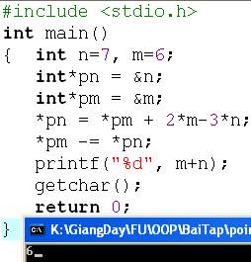

In this program, we have n = 7 and m = 6, pointer variable of n is pn, pointer of m is pm.

*pn = *pm + 2*m - 3*n

=> *pn( = n) = *pm( = m) + 2*m - 3 * n = 6 + 2 * 6 + 3 *7 = 39

After this equation n = 39.

*pm -= *pn;

=> *pm( = m) -= *pn( = n) = 6 - 39 = -33

After this equation m = -33

Therefore, the result of: m + n = 39 + (-33) = 6

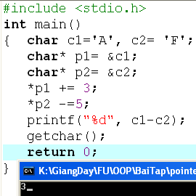

We have c1 = ‘A’, c2 = ‘F’, pointer to c1 is p1, pointer to c2 is p2.

In ASCII table: the number representation of character ‘A’ is 65 and character ‘F’ is 70.

=> *p1( = c1) += 3 = 65 + 3 = 68

After this equation: ( int)c1 = 68;

=>*p2( = c2) -= 5 = 70 - 5 = 65

After this equation: (int)c2 = 65

So, the sesult of: (int) c1 - (int) c2 = 68 - 65 = 3

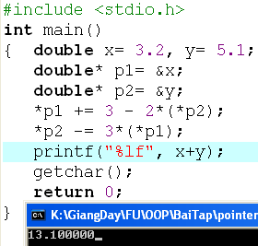

After declaring variable, we have x =3.2, y = 5.1, pointer to x is p1, pointer to y is p2

=> *p1 += 3 - 2 * (*p2) = 3.2 + 3 - 2 * 5.1 = 13.4

After this equation x = -4

=> *p2 -= 3*(*p1) = 5.1 - 3*(-4) = 17.1

After this equation y = 17.1

Hence, x + y = (-4) + 17.1 = 13.1

**Exercise 2: (1 marks) What are outputs**

Output: 8

Output: 8

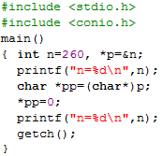

Output:

n=260

n=256

**Exercise 3: (2 marks) Walkthroughs**

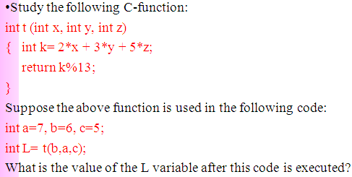

When this code is executed:

x= b = 6 (Copy)

y= a = 7 (Copy)

z= c = 5 (Copy)

k= 2 *x + 3 *y + 5*z = 2*6 + 3*7 + 5*5 = 58

After that k%13 = 6

So, L = 6.

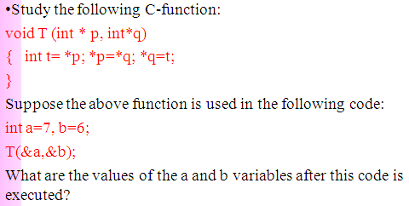

The swapping process will occur, so the result after this program is executed:

a= 6

b=7

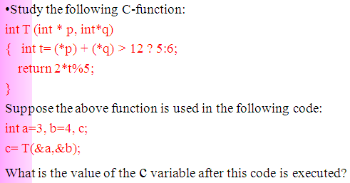

Because the addresses of two variable a and b are arguments of this process. After this code is executed, the result: c = 2