|  |
| --- |
|  |
| Vending Machine Control |
| Application Prototype |
|  |
| **Quan Nguyen** |
| **5/1/2018** |

Table of Contents

1. Pages 3

Page Tree 01 - Login 02 - Forgot_Password_Screen 03 - Dashboard 04 - Employee_Screen 05 - Manage Account ResetPass Lock Acc 06 - Putins - TakeOver 3

01 - Login 4

1.1.1. User Interface 4

1.1.2. Widget Table 4

1.2. 02 - Forgot_Password_Screen 5

1.2.1. User Interface 5

1.2.2. Widget Table 5

1.3. 03 - Dashboard 7

1.3.1. User Interface 7

1.3.2. Widget Table 8

1.4. 04 - Employee_Screen 9

1.4.1. User Interface 9

1.4.2. Widget Table 9

1.5. 05 - Manage Account 12

1.5.1. User Interface 12

1.5.2. Widget Table 12

1.6. ResetPass 13

1.6.1. User Interface 13

1.6.2. Widget Table 13

1.7. Lock Acc 15

1.7.1. User Interface 15

1.7.2. Widget Table 15

1.8. 06 - Putins - TakeOver 17

1.8.1. User Interface 17

1.8.2. Widget Table 17

1. Pages

Page Tree  
 01 - Login  
 02 - Forgot_Password_Screen  
 03 - Dashboard  
 04 - Employee_Screen  
 05 - Manage Account  
 ResetPass  
 Lock Acc  
 06 - Putins - TakeOver

01 - Login

* + 1. User Interface

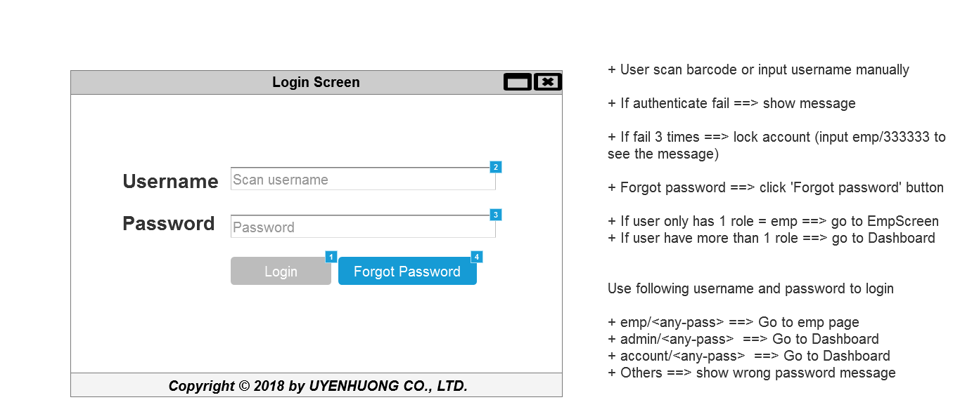

* + 1. Widget Table

|  |  |  |
| --- | --- | --- |
| Footnote | Name | Interactions |
| 1 | LoginButton | OnClick:  Authenticate user with username and password |
| 2 | UserName | OnTextChange:  Case 1  (If text on This does not equal """" and length of value of widget Password is greater than or equals "6"):  Set value of UserName equal to text on UserName  Enable LoginButton OnLostFocus:  Case 1  (If text on UserName equals ""):  Set text on Hint Username equal to "Username can not be blank"  Show Hint Username  Case 2  (Else If text on UserName does not equal ""):  Hide Hint Username |
| 3 | Password | OnTextChange:  Case 1  (If length of value of widget This is greater than or equals "6" and text on UserName does not equal """"):  Enable LoginButton OnLostFocus:  Case 1  (If length of value of widget Password is less than "6"):  Set text on Hint Pass equal to "Pwd length must greater than 6 chars"  Show Hint Pass  Case 2  (Else If text on Password does not equal ""):  Hide Hint Pass |
| 4 | ForgotPass | OnClick:  Case 1:  Open 02 - Forgot_Password_Screen in Current Window |

* 1. 02 - Forgot_Password_Screen
     1. User Interface

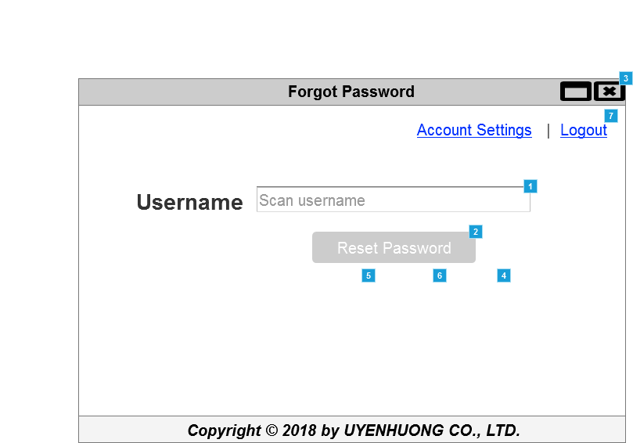

* + 1. Widget Table

|  |  |  |
| --- | --- | --- |
| Footnote | Name | Interactions |
| 1 | UserName | OnTextChange:  Case 2  (If text on This equals ""):  Disable Reset pass button  Case 1  (Else If True):  Set value of UserName equal to text on UserName  Enable Reset pass button OnLoad:  Case 1  (If text on UserName equals ""):  Disable Reset pass button |
| 2 | Reset pass button | OnClick:  Case 1:  Set text on ConfirmMesage equal to "Do you want to reset password of [[UserName]]?"  Show (Group), Confirm, ConfirmMesage bring to front, Cancel, Confirm  Enable Confirm  Enable Cancel |
| 3 |  | OnShow:  Case 1  (If text on UserName equals ""):  Disable Reset pass button |
| 4 | Cancel | OnClick:  Case 1:  Hide (Group), Confirm, ConfirmMesage, Cancel, Confirm |
| 5 | Confirm | OnClick:  Case 1:  Set text on ResultMessage equal to "Request has been sent to admin."  Hide (Group), Confirm, ConfirmMesage, Cancel, Confirm  Show Notify, (Group), ResultMessage, OK  Enable OK |
| 6 | OK | OnClick:  Case 1:  Hide (Group), Notify, Confirm, (Group), ResultMessage, ConfirmMesage, OK, Cancel, Confirm  Open 01 - Login in Current Window |
| 7 |  | OnClick:  Case 1:  Open 01 - Login in Current Window |

* 1. 03 - Dashboard

OnPageLoad:  
 Case 1  
 (If value of UserName contains "acc"):  
 Disable AccountManagement,  
UnlockMachines,  
GetTools  
 Set value of Function equal to ""  
 Case 2  
 (Else If value of UserName contains "admin"):  
 Disable TakeOvers,  
PutsIns,  
GetTools  
 Case 3  
 (Else If True):  
 Disable AccountManagement,  
PutsIns,  
TakeOvers,  
GetTools

* + 1. User Interface

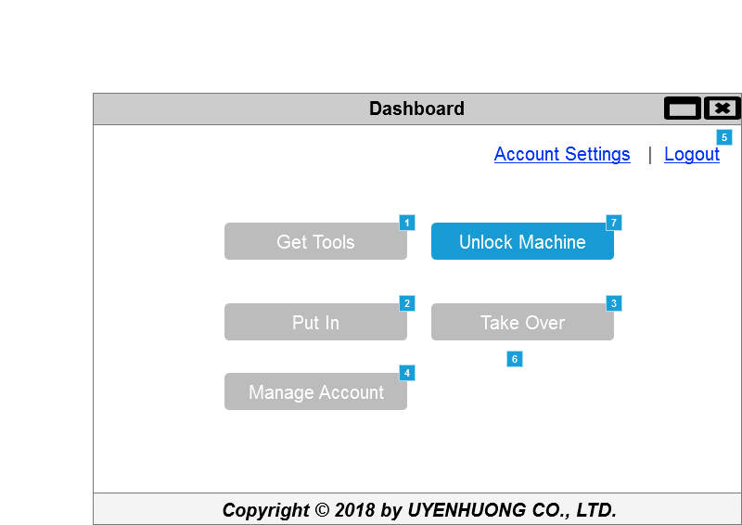

* + 1. Widget Table

|  |  |  |
| --- | --- | --- |
| Footnote | Name | Interactions |
| 1 | GetTools | OnClick:  Case 1:  Open 04 - Employee_Screen in Current Window |
| 2 | PutsIns | OnClick:  Case 1:  Set value of Function equal to "Putins"  Open 06 - Putins - TakeOver in Current Window |
| 3 | TakeOvers | OnClick:  Case 1:  Set value of Function equal to "TakeOver"  Open 06 - Putins - TakeOver in Current Window |
| 4 | AccountManagement | OnClick:  Case 1:  Open 05 - Manage Account in Current Window |
| 5 |  | OnClick:  Case 1:  Open 01 - Login in Current Window |
| 6 | OK | OnClick:  Case 1:  Open 03 - Dashboard in Current Window |
| 7 | UnlockMachines | OnClick:  Case 1:  Set text on ResultMessage equal to "Unlock machine successfully!"  Show Notify Result, ResultMessage, OK  Enable OK |

* 1. 04 - Employee_Screen

OnPageLoad:  
 Case 1:  
 Hide Waiting result,  
Notify Result,  
OK,  
Confirm,  
ConfirmMesage,  
Cancel,  
Confirm,  
Advise,  
ResultMessage,  
OK,  
WaitingClock,  
Loading

* + 1. User Interface

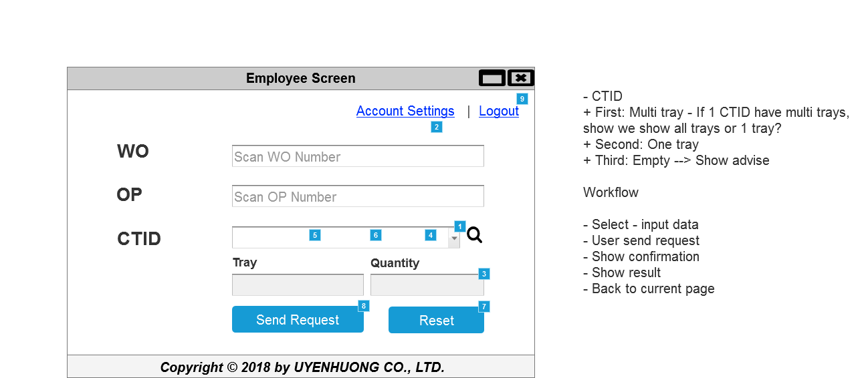

* + 1. Widget Table

|  |  |  |
| --- | --- | --- |
| Footnote | Name | Interactions |
| 1 | CTID | OnSelectionChange:  Case 1  (If selected option of This equals CSDML213455):  Set text on Quantity equal to "5"  Set text on Tray equal to "2, 16"  Set value of CTID equal to text on focused widget   Case 2  (Else If selected option of This equals LSDM33456FDS):  Set text on Quantity equal to "2", and  text on Tray equal to "58"  Set value of CTID equal to text on focused widget   Case 3  (Else If selected option of This equals 56EGRDSF):  Set value of CTID equal to text on focused widget   Set text on Quantity equal to "0", and  text on Tray equal to ""  Case 4  (Else If True):  Set text on Quantity equal to "1", and  text on Tray equal to "1"  Set value of CTID equal to text on focused widget |
| 2 | Advise | OnClick:  Case 1:  Hide Advise, ResultMessage, OK OnLoad:  Case 1:  Hide Advise, ResultMessage, OK |
| 3 | Quantity | OnTextChange:  Case 1  (If text on This equals "0"):  Wait 1000 ms  Set text on ResultMessage equal to "Quantity of [[CTID]] = 0. Please check MAC01 (34,52,18), MAC03 (12)"  Show Advise, ResultMessage, OK  Case 2  (Else If True):  Hide Advise, ResultMessage, OK |
| 4 | Cancel | OnClick:  Case 1:  Hide Confirm, ConfirmMesage, Cancel, Confirm |
| 5 | Confirm | OnClick:  Case 1:  Show WaitingClock bring to front, Waiting result, Loading bring to front, WaitingGroup  Wait 3000 ms  Set text on ResultMessage equal to "Complete successfully!"  Hide Confirm, ConfirmMesage, Cancel, Confirm  Hide Waiting result, WaitingGroup, Loading, WaitingClock  Show Notify Result, ResultMessage, OK  Enable OK |
| 6 | OK | OnClick:  Case 1:  Open 04 - Employee_Screen in Current Window |
| 7 | Reset | OnClick:  Case 1:  Set text on Quantity equal to "", and  text on Tray equal to "", and  text on Send Request equal to "Send Request", and  text on Reset equal to "Reset", and  text on WU Text equal to "", and  text on WO Text equal to "" |
| 8 | Send Request | OnClick:  Case 1:  Set value of WO equal to text on WO Text, and  value of WU equal to text on WU Text, and  value of TRAY equal to text on Tray  Set text on ConfirmMesage equal to "WO: [[WO]] - WU: [[WU]] - CTID: [[CTID]] - Tray: [[TRAY]] - Do you want to continue?"  Set Variable  Show Confirm, ConfirmMesage, Cancel, Confirm |
| 9 |  | OnClick:  Case 1:  Open 01 - Login in Current Window |

* 1. 05 - Manage Account
     1. User Interface

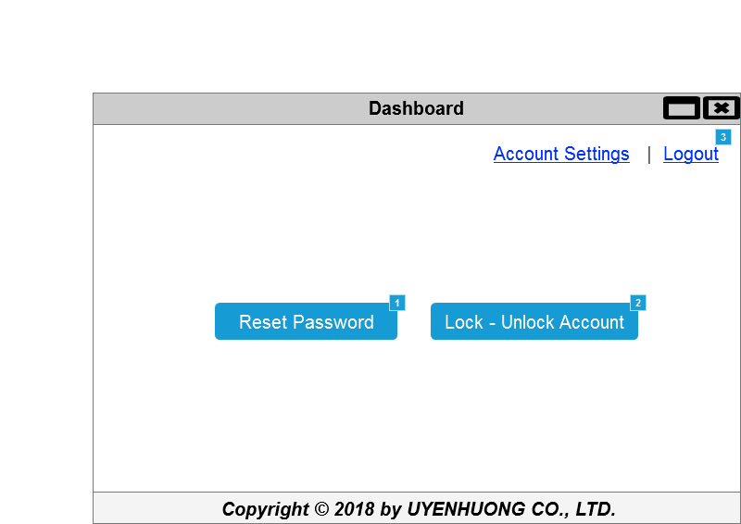

* + 1. Widget Table

|  |  |  |
| --- | --- | --- |
| Footnote | Name | Interactions |
| 1 | PutsIns | OnClick:  Case 1:  Open ResetPass in Current Window |
| 2 | TakeOvers | OnClick:  Case 1:  Open Lock Acc in Current Window |
| 3 |  | OnClick:  Case 1:  Open 01 - Login in Current Window |

* 1. ResetPass

OnPageLoad:  
 Case 1:  
 Hide Confirm,  
ConfirmMesage,  
Cancel,  
Confirm,  
Notify Result,  
ResultMessage,  
OK

* + 1. User Interface

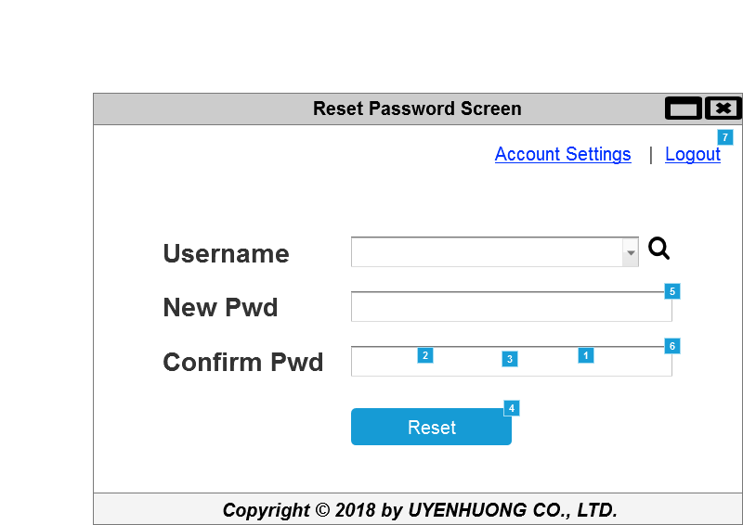

* + 1. Widget Table

|  |  |  |
| --- | --- | --- |
| Footnote | Name | Interactions |
| 1 | Cancel | OnClick:  Case 1:  Hide Confirm, ConfirmMesage, Cancel, Confirm |
| 2 | Confirm | OnClick:  Case 1:  Hide Confirm, Cancel, ConfirmMesage, Confirm  Set text on ResultMessage equal to "Complete successfully!"  Show OK, ResultMessage, Notify Result  Enable OK |
| 3 | OK | OnClick:  Case 1:  Open 05 - Manage Account in Current Window |
| 4 | Send Request | OnClick:  Case 2  (If text on Newpass does not equal text on ConfirmPass):  Set text on Not match pass equal to "Password not match"  Case 1  (Else If True):  Set text on Not match pass equal to ""  Set value of NewUsername equal to selected option of Username, and  value of NewPass equal to text on Newpass  Set text on ConfirmMesage equal to "Reset password of user [[NewUsername]]- Do you want to continue?"  Show Confirm, ConfirmMesage, Cancel, Confirm |
| 5 | Newpass | OnTextChange:  Case 1:  Set value of UserName equal to text on Newpass OnLostFocus:  Case 1  (If text on Newpass equals ""):  Set text on Unidentified equal to "Username can not be blank"  Show/Hide Widget  Case 2  (Else If text on Newpass does not equal ""):  Show/Hide Widget |
| 6 | ConfirmPass | OnTextChange:  Case 1:  Set value of UserName equal to text on ConfirmPass OnLostFocus:  Case 1  (If text on ConfirmPass equals ""):  Set text on Unidentified equal to "Username can not be blank"  Show/Hide Widget  Case 2  (Else If text on ConfirmPass does not equal ""):  Show/Hide Widget |
| 7 |  | OnClick:  Case 1:  Open 01 - Login in Current Window |

* 1. Lock Acc

OnPageLoad:  
 Case 1:  
 Hide Confirm,  
ConfirmMesage,  
Cancel,  
Confirm,  
Notify Result,  
ResultMessage,  
OK  
 Disable Lock,  
Unlock

* + 1. User Interface

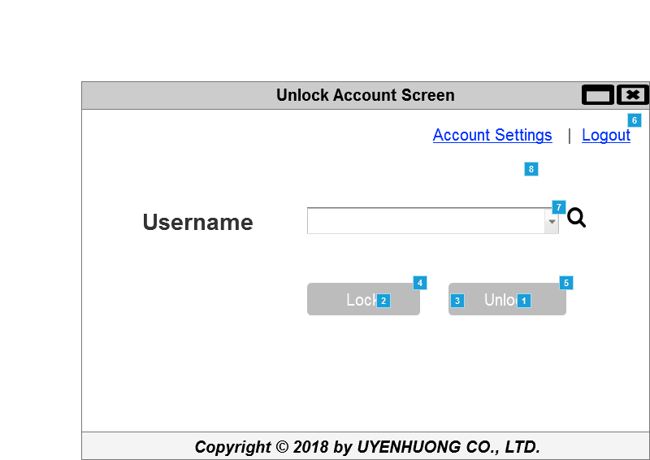

* + 1. Widget Table

|  |  |  |
| --- | --- | --- |
| Footnote | Name | Interactions |
| 1 | Cancel | OnClick:  Case 1:  Hide Confirm, ConfirmMesage, Cancel, Confirm |
| 2 | Confirm | OnClick:  Case 1:  Hide Confirm, Cancel, ConfirmMesage, Confirm  Set text on ResultMessage equal to "Complete successfully!"  Show OK, ResultMessage, Notify Result  Enable OK |
| 3 | OK | OnClick:  Case 1:  Open 05 - Manage Account in Current Window |
| 4 | Lock | OnClick:  Case 1:  Set value of Function equal to "Lock account"  Set text on ConfirmMesage equal to "[[Function]] user [[NewUsername]] - Do you want to continue?"  Show Confirm, ConfirmMesage, Cancel, Confirm |
| 5 | Unlock | OnClick:  Case 1:  Set value of Function equal to "Unlock account"  Set text on ConfirmMesage equal to "[[Function]] user [[NewUsername]] - Do you want to continue?"  Show Confirm, ConfirmMesage, Cancel, Confirm |
| 6 |  | OnClick:  Case 1:  Open 01 - Login in Current Window |
| 7 | Username | OnSelectionChange:  Case 1:  Enable Unlock, Lock  Set value of NewUsername equal to selected option of Username |
| 8 | Confirm | OnClick:  Case 1:  Disable Unlock, Lock |

* 1. 06 - Putins - TakeOver

OnPageLoad:  
 Case 1:  
 Set text on Action equal to value of Function  
 Show Action,  
Hide Notify Result,  
ResultMessage,  
OK,  
Confirm,  
ConfirmMesage,  
Cancel,  
Confirm  
 Set value of UserName equal to "acc"

* + 1. User Interface

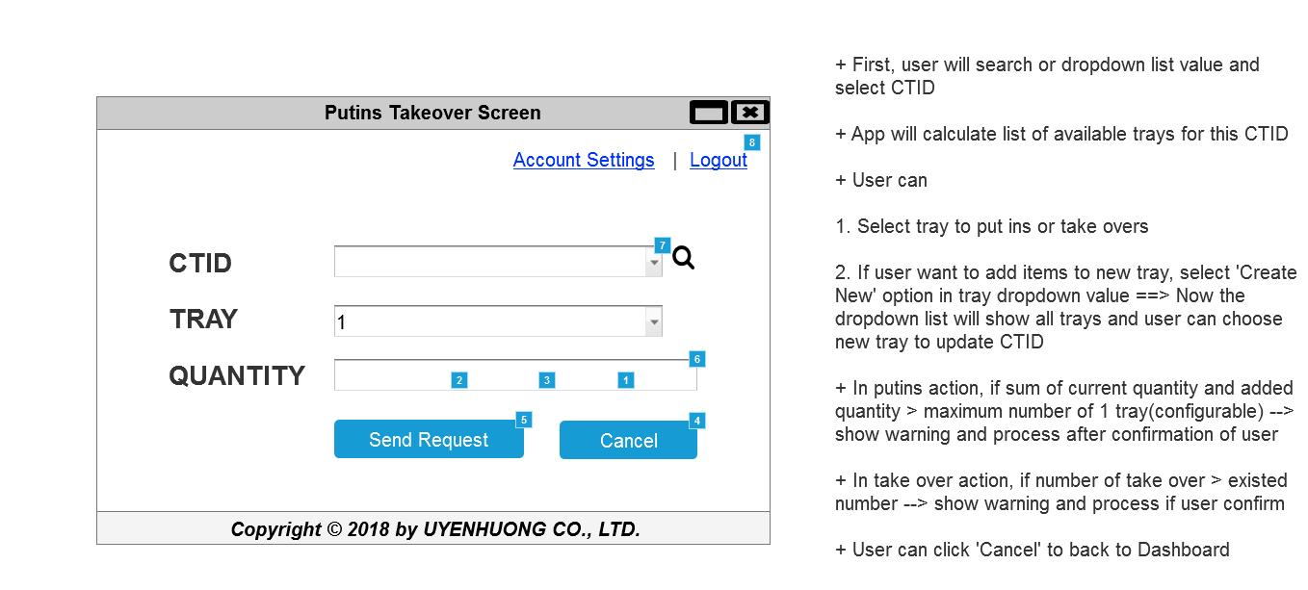

* + 1. Widget Table

|  |  |  |
| --- | --- | --- |
| Footnote | Name | Interactions |
| 1 | Cancel | OnClick:  Case 1:  Hide Confirm, ConfirmMesage, Cancel, Confirm |
| 2 | Confirm | OnClick:  Case 1:  Hide Confirm, Cancel, ConfirmMesage, Confirm  Set text on ResultMessage equal to "Complete successfully!"  Show OK, ResultMessage, Notify Result  Enable OK |
| 3 | OK | OnClick:  Case 1:  Open 06 - Putins - TakeOver in Current Window |
| 4 | Reset | OnClick:  Case 1:  Open 03 - Dashboard in Current Window  Set value of UserName equal to "acc" |
| 5 | Send Request | OnClick:  Case 1:  Set value of CTID equal to text on focused widget , and  value of TRAY equal to selected option of TrayID, and  value of Quantity equal to text on Quantity  Set text on ConfirmMesage equal to "[[Function]] action CTID: [[CTID]] - Tray: [[TRAY]] - Quantity: [[Quantity]] - Do you want to continue?"  Show Confirm, ConfirmMesage, Cancel, Confirm |
| 6 | Quantity | OnTextChange:  Case 1:  Set value of UserName equal to text on Quantity OnLostFocus:  Case 1  (If text on Quantity equals ""):  Set text on Unidentified equal to "Username can not be blank"  Show/Hide Widget  Case 2  (Else If text on Quantity does not equal ""):  Show/Hide Widget |
| 7 | CTID | OnSelectionChange:  Case 1  (If selected option of CTID equals CSDML213455):  Set text on Quantity equal to "3", and  text on Unidentified equal to "34"  Case 2  (Else If True):  Set text on Quantity equal to "1", and  text on Unidentified equal to "14" |
| 8 |  | OnClick:  Case 1:  Open 01 - Login in Current Window |