|  |
| --- |
| iTools |
| User Guide |

|  |  |  |
| --- | --- | --- |
|  | ***Last updated by:*** | *Quan Nguyen* |
|  | ***Effective date:*** | Aug 14, 2018 |
|  | ***Version:*** | *1.0* |

# Document Control

|  |  |  |  |  |  |
| --- | --- | --- | --- | --- | --- |
| Version | Change description | Changed by | Date | Approved by | Date |
| 0.1 | Initiate and draf | Quan Nguyen | 16-Aug-2018 |  |  |
| 1.0 | Modify and finalize the document | Quan Nguyen | 16-Aug-2018 | Quan Nguyen | 16-Aug-2018 |
|  |  |  |  |  |  |
|  |  |  |  |  |  |
|  |  |  |  |  |  |

# Table of Contents

1. Overview 5

1.1. Requirement 5

1.2. Approach 5

2. Installation 5

2.1. Java 5

2.2. MySQL 5

2.3. iTools 5

3. Configuration 6

4. User Guide 7

4.1. Common Feature 7

4.1.1. Login 7

4.1.2. Forgot Password 8

4.1.3. Change Password 11

4.2. Company Admin 12

4.2.1. Reset Password 12

4.2.2. Lock - Unlock Account 14

4.2.3. Sync manually 14

4.3. Accounting 15

4.3.1. Lock/Unlock machine 15

4.3.2. Putin 19

4.3.3. TakeOver 24

4.4. Normal User 25

4.4.1. Get Tool 25

5. Error Message 27

6. Troubleshoot 27

7. Portrait page style 27

# Index of Tables

**No table of figures entries found.**

# Index of Figure

Figure 1: Configuration 6

Figure 2: Login Page 7

Figure 3: Forgot Password Page1 8

Figure 4: Forgot Password Page2 9

Figure 5: Forgot Password 3 10

Figure 6: Change Password 11

Figure 7: Dashboard 12

Figure 8: Reset Password 13

Figure 9: Lock – Unlock Account 14

Figure 10: Login by accounting account 15

Figure 11: Show Dashboard 16

Figure 12: Wait for result 17

Figure 13: Enable Putins and TakeOver button after unlock 18

Figure 14: Putins Page 19

Figure 15: Select Tools 20

Figure 16: Select Trays 21

Figure 17: Edit quantity and process 22

Figure 18: Review result 23

Figure 19: Review result 24

Figure 20: Get Tool Page 25

Figure 21: Processing 26

Figure 22: Review result 27

# Overview

TBD

## Requirement

TBD

## Approach

* TBD

# Installation

## Java

* Version: JRE 1.8 - jre-8u172-windows-i586.exe (<http://download.oracle.com/otn-pub/java/jdk/8u181-b13/96a7b8442fe848ef90c96a2fad6ed6d1/jre-8u181-windows-i586.exe> )

## MySQL

* MySQL server 5.7: <https://dev.mysql.com/downloads/file/?id=479142>
* MySQL Workbench: <https://dev.mysql.com/downloads/file/?id=474210>
* Configuration user to logon: admin/<password>

## iTools

* Provide basic information of Industry PC (IPC)
  + Database configuration
  + Board ID + VendorID – will provide the tool to get information later.
  + Machine Code
  + Company Code
* Copy iTools_<version>.jar to IPC and run

# Configuration

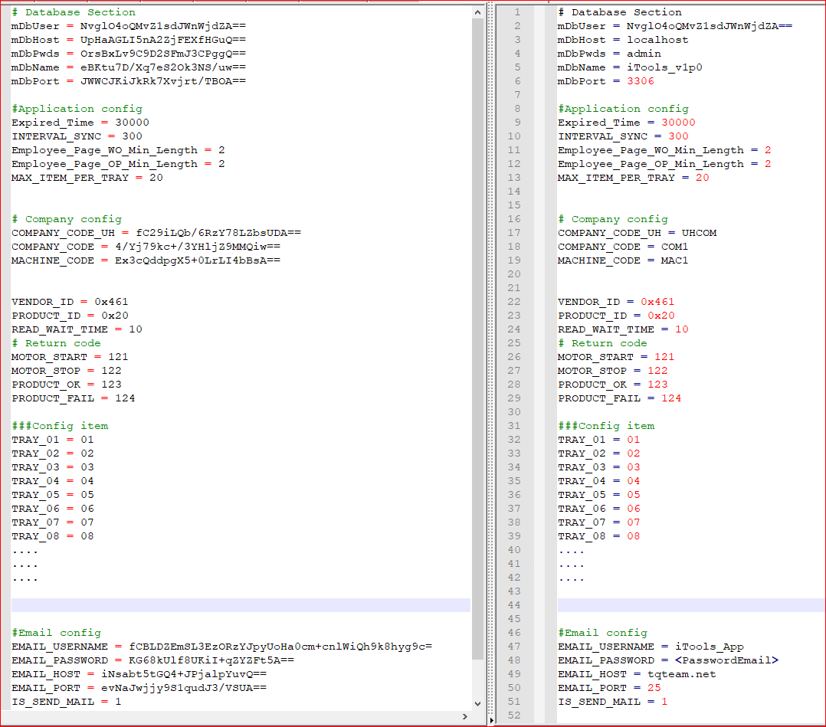

Figure : Configuration

# User Guide

## Common Feature

### Login

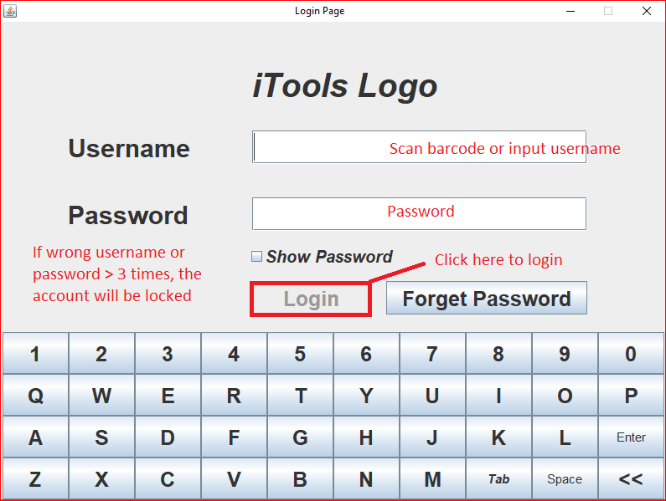

Figure 2: Login Page

Illustration 1: Login Page

## Forgot Password

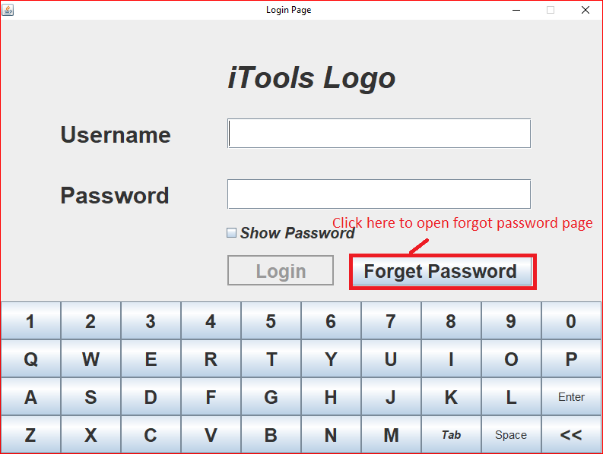

Figure 3: Forgot Password Page1

Illustration 2: Forgot Password Page1

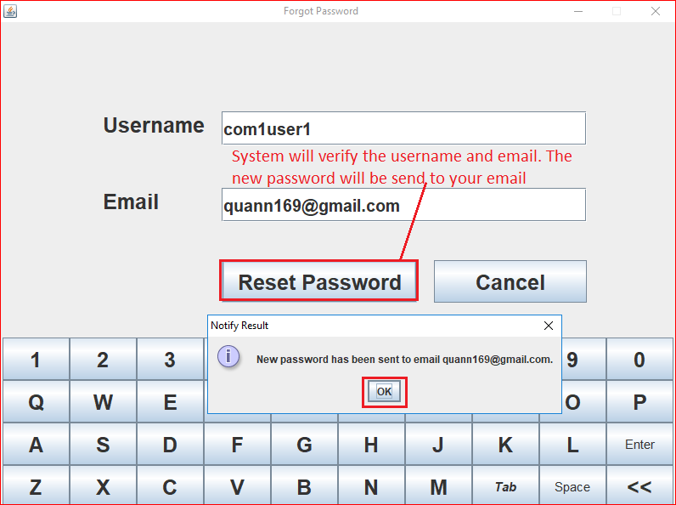

Figure 4: Forgot Password Page2

Illustration 3: Forgot Password Page2

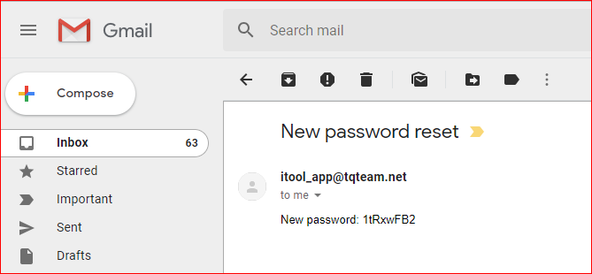

Figure 5: Forgot Password 3

## Change Password

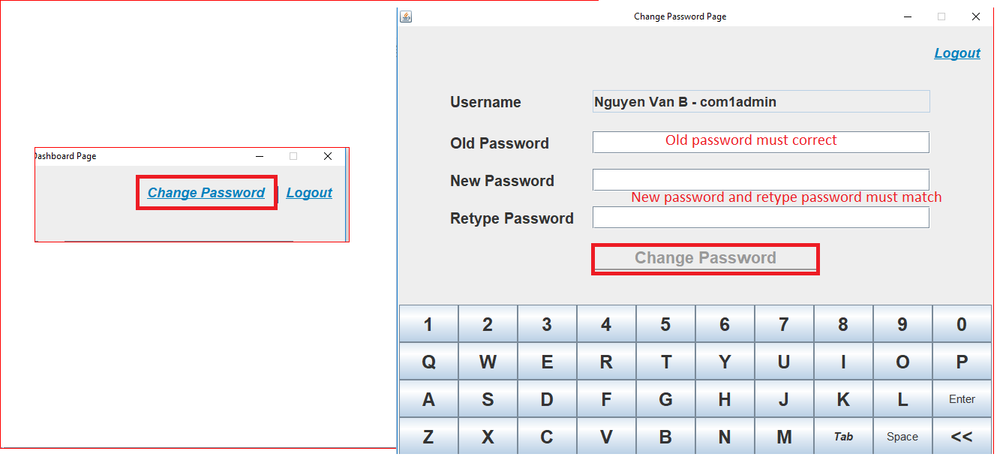

Figure : Change Password

## Company Admin

## Reset Password

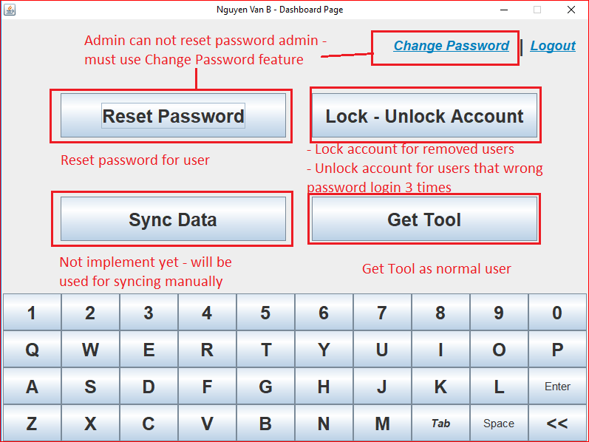

Figure : Dashboard

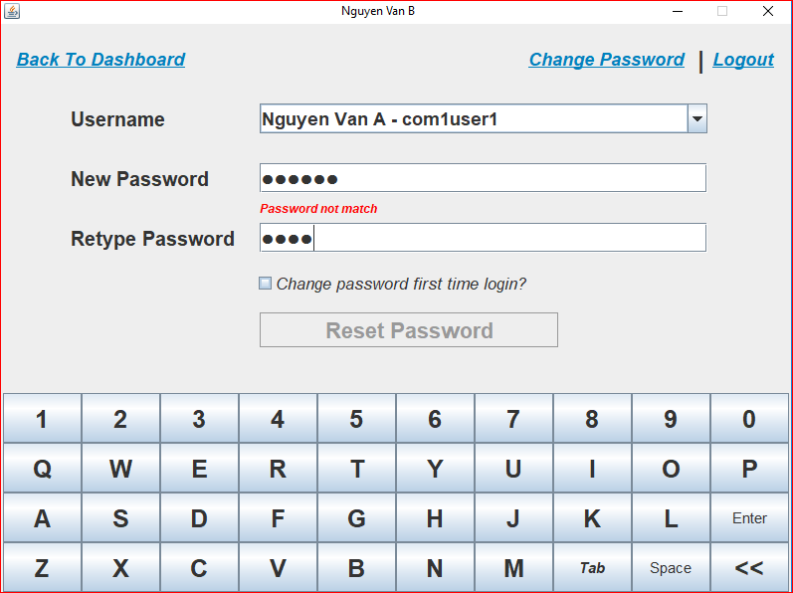

Figure : Reset Password

## Lock - Unlock Account

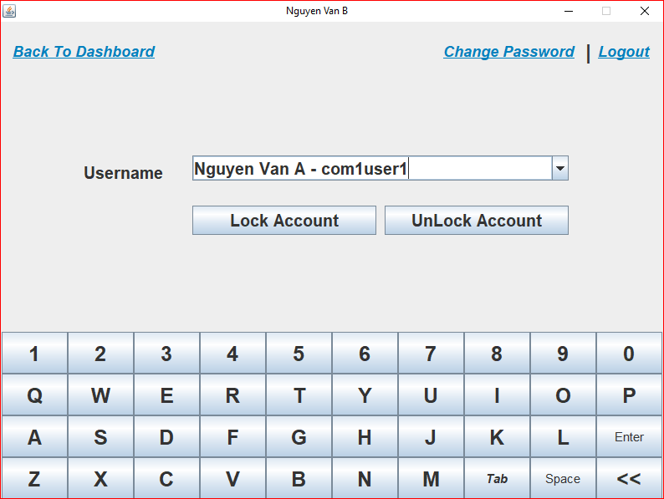

Figure : Lock – Unlock Account

## Sync manually

TBD

## Accounting

## Lock/Unlock machine

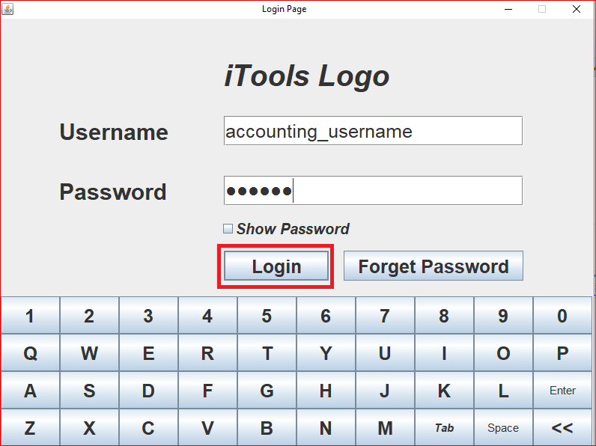

Figure : Login by accounting account

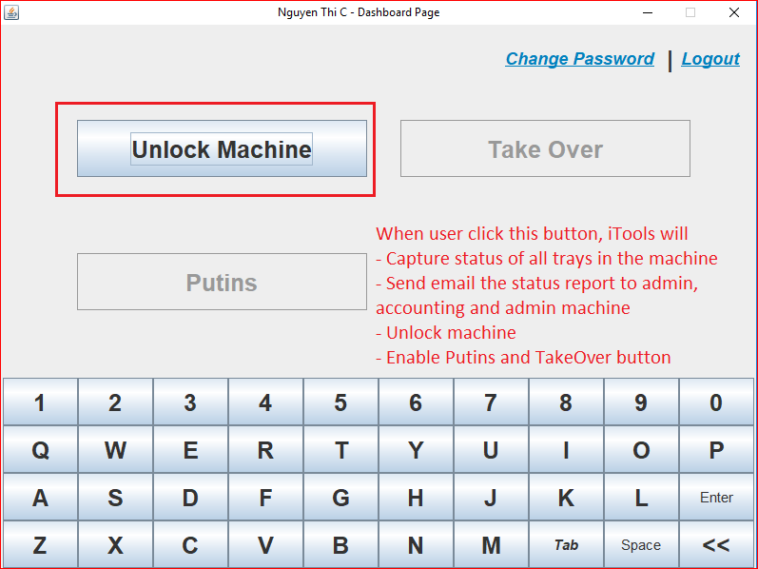

Figure : Show Dashboard

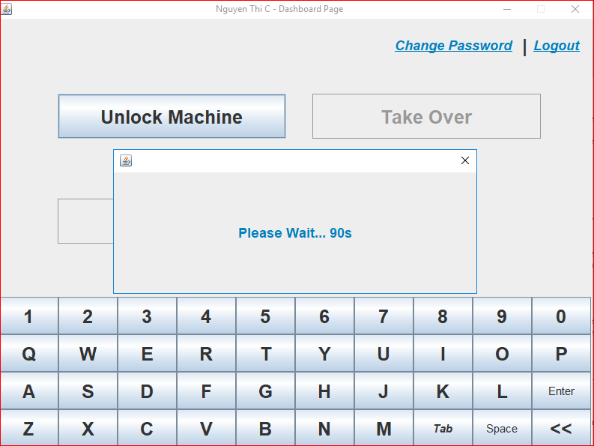

Figure : Wait for result

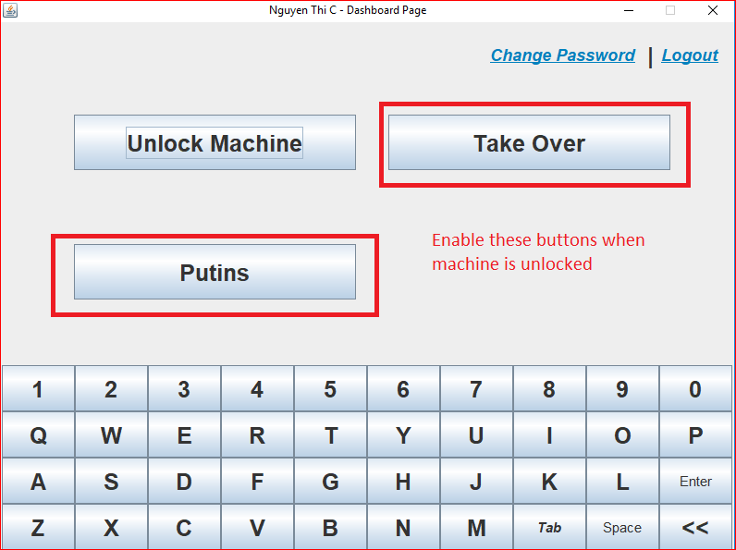

Figure : Enable Putins and TakeOver button after unlock

## Putin

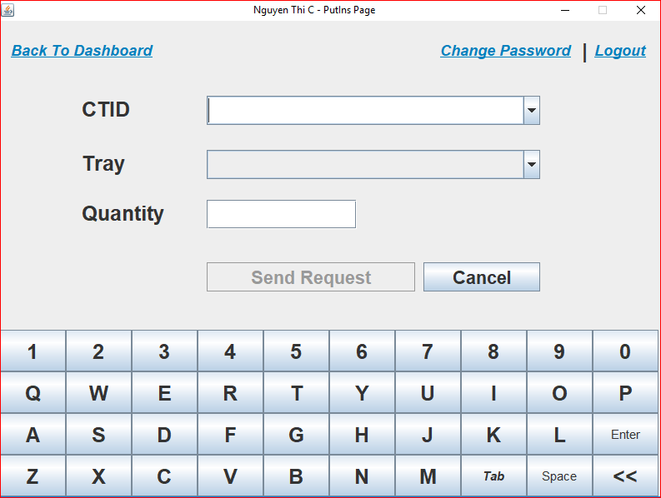

Figure : Putins Page

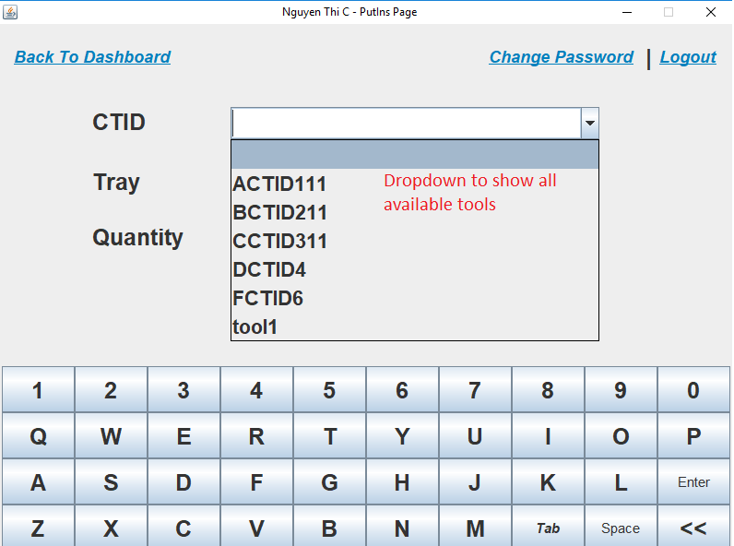

Figure : Select Tools

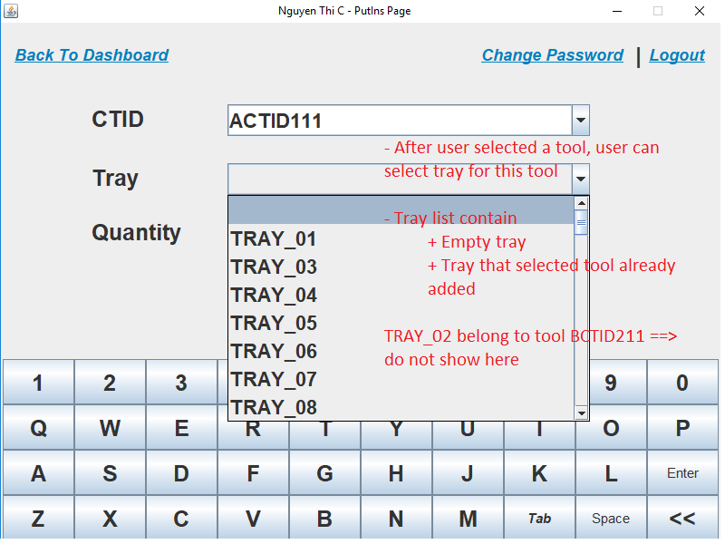

Figure : Select Trays

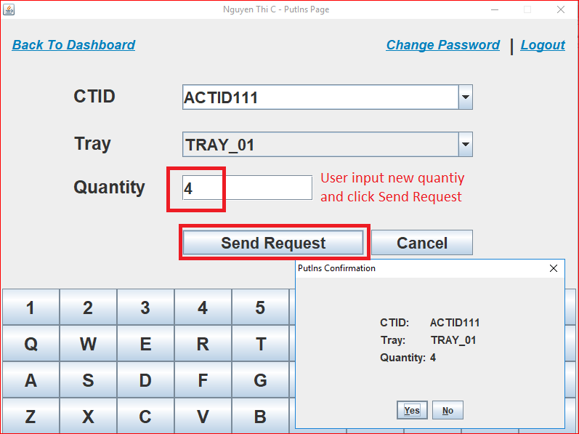

Figure : Edit quantity and process

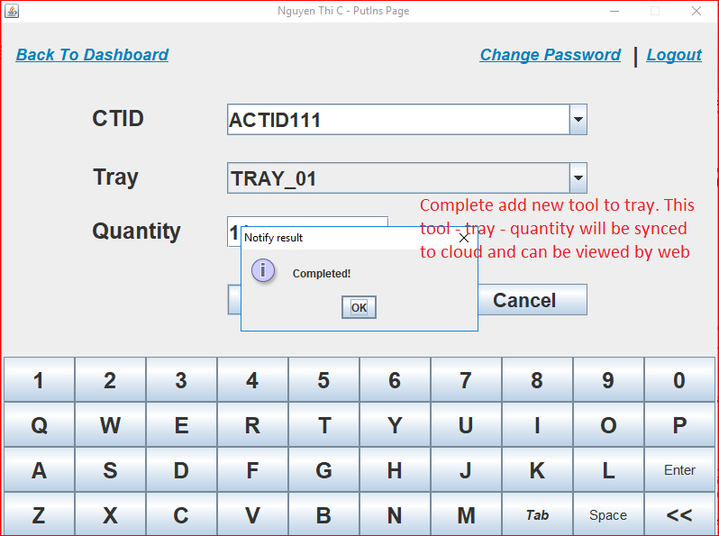

Figure : Review result

## TakeOver

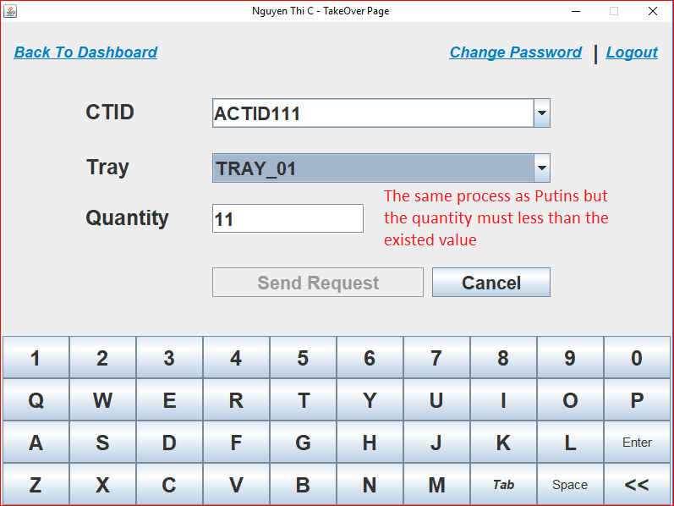

Figure : Review result

## Normal User

## Get Tool

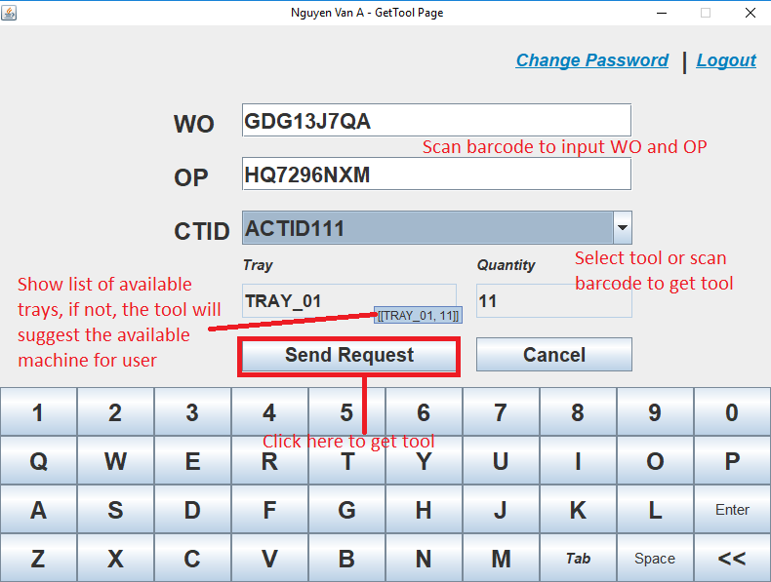

Figure : Get Tool Page

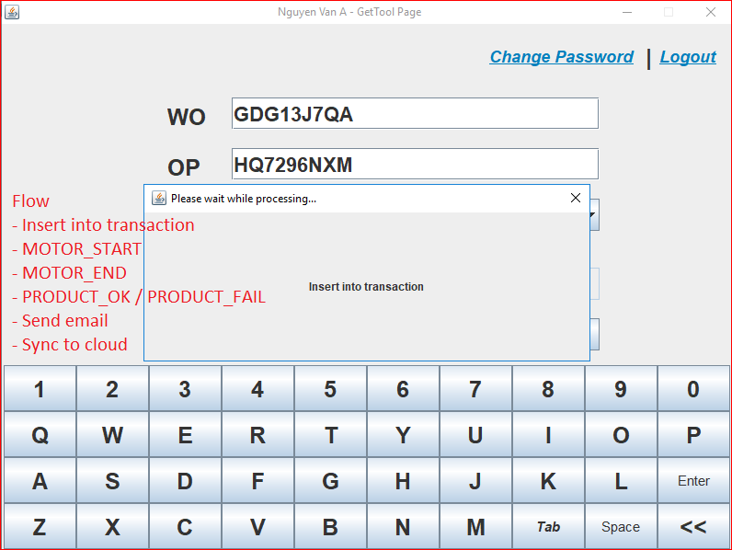

Figure : Processing

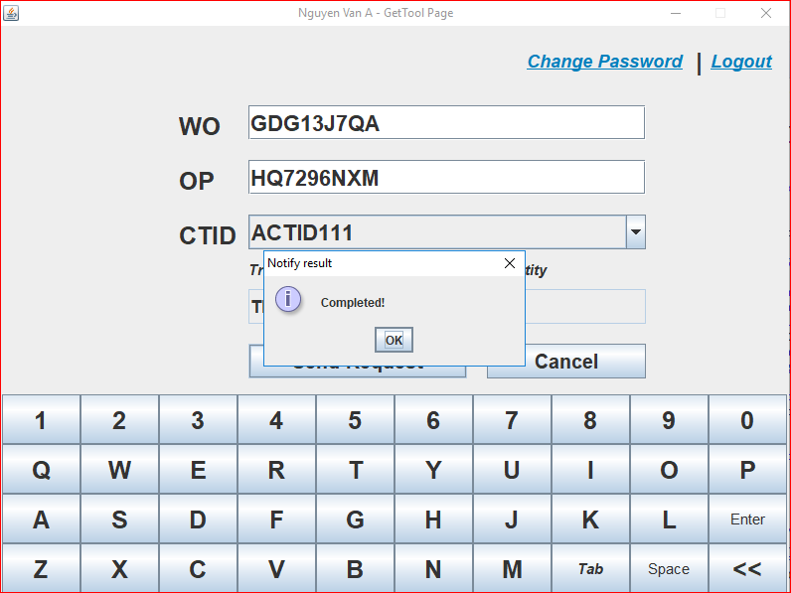

Figure : Review result

# Error Message

# Troubleshoot

# Portrait page style