|  |
| --- |
| iTools |
| Deployment Guide |

|  |  |  |
| --- | --- | --- |
|  | ***Last updated by:*** | *Quan Nguyen* |
|  | ***Effective date:*** | May 14, 2019 |
|  | ***Version:*** | *1.0* |

# Document Control

|  |  |  |  |  |  |
| --- | --- | --- | --- | --- | --- |
| Version | Change description | Changed by | Date | Approved by | Date |
| 0.1 | Initiate and draft | Quan Nguyen | May 14, 2019 |  |  |
| 1.0 | Modify and finalize the document | Quan Nguyen | May 24, 2019 | Quan Nguyen | May 24, 2019 |
|  |  |  |  |  |  |
|  |  |  |  |  |  |
|  |  |  |  |  |  |

# Table of Contents

1. Overview 5

1.1. Requirement 5

1.2. Approach 5

2. Installation 5

2.1. Installation checklist 5

2.2. Java 6

2.3. Simulation PC connect board via USB port 6

2.4. MySQL 7

2.5. Create database 11

2.6. Verify iTools 16

2.7. How to build iTools for new PC 17

3. Troubleshoot 19

# Index of Tables

**No table of figures entries found.**

# Index of Figure

# Overview

TBD

## Requirement

TBD

## Approach

* TBD

# Installation

All needed software has been uploaded to GoogleDrive as below link

<https://drive.google.com/drive/folders/1lEzXBppFtIE5FTJrVOuUWWg6JOc4x3zt?usp=sharing>

## Installation checklist

|  |  |  |  |  |  |  |  |  |  |
| --- | --- | --- | --- | --- | --- | --- | --- | --- | --- |
|  |  |  |  | VM-1 | VM-2 | VM-3 | VM-4 | VM-5 | VM-6 |
| # | Category | Task | Note | VINAMOIL  TOOLS | MFC | MFC | VINAMOIL  TOOLS | MFC | VINAMOIL  TOOLS |
| 1 | Support software | 7 Zip |  | x | x | x | x | x |  |
| 2 | Notepad++ |  | x | x | x | x | x |  |
| 3 | Team Viewer |  | x | x | x | x | x |  |
| 4 | Minimum requirement for mysql server and workbench | vc_redist.x86 | Microsoft Visual C++ 2015 | x | x | x | x | x |  |
| 5 | vcredist_x86 | Microsoft Visual C++ 2013 | x | x | x | x | x |  |
| 6 | NDP452-KB2901907-x86-x64-AllOS-ENU | Microsoft.Net Framework 4.5.2 | x | x | x | x | x |  |
| 7 | Mysql | mysql-installer-community-5.7.23.0 | Mysql Server | x | x | x | x | x |  |
| 8 | mysql-workbench-community-6.3.8-win32 | Workbench | x | x | x | x | x |  |
| 9 | Config Mysql | Config Mysqlserver |  | x | x | x | x | x |  |
| 10 | Edit my.ini |  | x | x | x | x | x |  |
| 11 | Restart Mysql server |  | x | x | x | x | x |  |
| 12 | Java | jre-8u211-windows-i586 |  | x | x | x | x | x |  |
| 13 | Simulation PC connect board via USB port | Copy dll toJRE |  | x | x | x | x | x |  |
| 14 | Check HDMI simulation |  | x | x | x | x | x |  |
| 15 | Tool verification | Create database |  | x | x | x | x | x |  |
| 16 | Open iTools |  | x | x | x | x | x |  |

## Java

* Run jre-8u211-windows-i586.exe from Soft folder

## Simulation PC connect board via USB port

* Copy hidapi.dll into **C:\Program Files (x86)\Java\jre<version>\bin** folder
* Extract the folder **HIDSimulation.zip** and run **HID.jar**
* In case the PC does not connect the board, we will see the message as below. If the PC connect to the board, it will send the message to board and get the message return

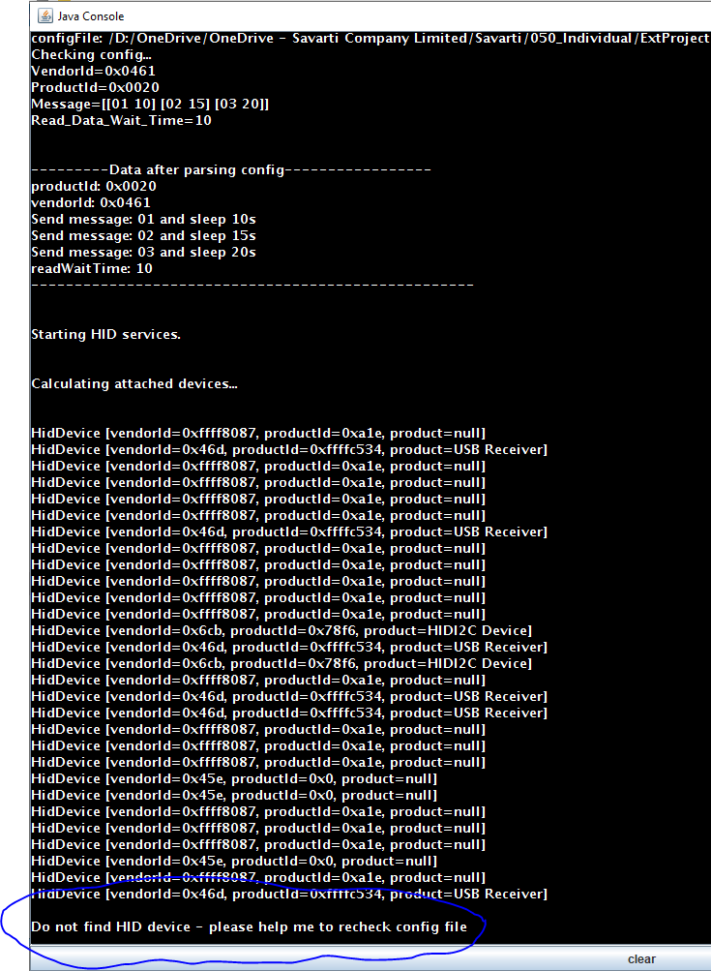

## MySQL

* Install support software: [4], [5], [6]
* Install mysqlserver

|  |  |
| --- | --- |
|  |  |
| A screenshot of a cell phone  Description automatically generatedJust add MySQL server 5.6.23 only | A screenshot of a cell phone  Description automatically generatedInstall successfully |
| A screenshot of a cell phone  Description automatically generatedConfigure for MySQL server |  |
| A screenshot of a social media post  Description automatically generatedWe will have 3 account: root, admin@% and admin@localhost  All account will have the same password 1qazxsw2 |  |
|  | A screenshot of a cell phone  Description automatically generatedStart MySQL Server successfully |
| A screenshot of a social media post  Description automatically generatedWe need to change the MySQL server configuration to support federated mode  This configuration located on Program Data folder. This folder will be hidden by default in C:\ so we have to show all hidden folder to change the configuration | A screenshot of a computer  Description automatically generatedNow the Program Data folder has been shown |
| A screenshot of a social media post  Description automatically generatedUpdate my.ini to add federated text at the end of configuration file |  |
|  | A screenshot of a social media post  Description automatically generatedFind the MySQL5.7 service to restart and apply the new federated configuration |
|  |  |

* Configure mysqlserver
* Install Workbench
* Install Workbench: Run mysql-workbench-community-6.3.8-win32 and follow the wizard

## Simulation PC connect board via USB port

## Create database

* Open Workbench and create new connection
  + Create new connection if not existed – **DO NOT SAVE THE PASSWORD TO KEEP THE SECURITY**

* Create database
  + Run the script Soft\iTools_v1p0_clean.sql

* Verify the database is ok or not
  + Verify the database log

* + Verify the tables

* + Verify the store procedure

* + Verify the basic data: select * from itools_v1p0.roles;

* + Verify the federated data: select * from itools_v1p0.federated_assessor;

## Verify iTools

* Open [www.tqteam.net/itools](http://www.tqteam.net/itools)
  + Create new company if needed
  + Create new machine if needed
  + Assign machine to company
  + Edit user to assign login permission to machine
* Check the configuration of jar file
  + **COMPANY_CODE** 
    - MFC
      * COMPANY_CODE = HEujRkVVDZU1CcJiMNmONQ==
    - VINAMOILTOOLS
      * COMPANY_CODE = hUTB9SpP67JNtA/h0R2XXw==
  + **MACHINE_CODE**
    - VM-1
      * MACHINE_CODE = SUON6OYqdkwqnGwssvrm2w==
    - VM-2
      * MACHINE_CODE = A4C0+dIdml+sMfrMgyJW7A==
    - VM-3
      * MACHINE_CODE = fZk/IXEklxkKpbEEquyTmg==
    - VM-4
      * MACHINE_CODE = iidX3Wv3FjeKpQmze3xzSQ==
    - VM-5
      * MACHINE_CODE = 2jnB+XZQ78pai0Dp9xgV7A==
    - VM-6
      * MACHINE_CODE = 9K1OYnAESRs2iZyoUTt2Mg==
    - VM-7
      * MACHINE_CODE = HGHryVlEXhq1bQk7DTm7BQ==
    - VM-8
      * MACHINE_CODE = nSVeUrKDqAY9molU+xo8VA==
* Run the iTools and check the log file from log folder

* Test the database again with below tables
  + Assessors
  + Company
  + Machine
  + RoleAssessor
  + …
* Test other features

## How to build iTools for new laptopPC

* Copy the current tool to new name with naming convention as below

<MACHINE_CODE>_<COMPANY_CODE>__iTool_v1p2.jar

* + For example:

VM-1_VINAMOILTOOLS__iTool_v1p2.jar

VM-2_MFC__iTool_v1p2.jar

VM-3_MFC__iTool_v1p2.jar

VM-4_VINAMOILTOOLS__iTool_v1p2.jar

VM-5_MFC__iTool_v1p2.jar

* Edit file config.properties inside the jar

# Troubleshoot

TBD

# 