WORKSHOP 1

Create the HTML file, named Workshop11.html and servlet file execute the requests from HTML file.
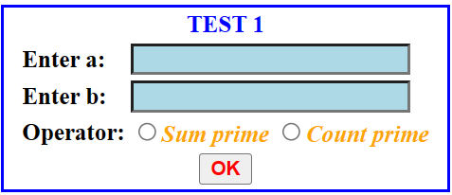
When pressing the OK button, call the servlet to execute and output the following requests:
- Check input: empty and integer number for each number.
- Select any operator option to process that operator from a to b.

