|  |
| --- |
| Software design |
| Music Store system |
| Version 1.0 |
| Prepared by class SE1316, Group 4  Nguyen Duc Quan  Dao Van Tam  Pham Van Quy  Phuong Dinh Anh  Ta Vu Anh Duc  April 3, 2020 |

Contents

Revision history 2

1. Document description 2

2. SRS overview 3

2.1. List of system users 3

2.2. List of use cases 3

2.3. Use case diagram 5

2.3.1. Preliminary use case diagram 5

2.3.2. Use case detail diagrams 6

2.4. Activity diagrams of use case scenarios 7

2.4.1. Activity diagram for use case “Buy Album” 7

3. Data model 9

3.1. Entity Relationship Diagram 9

3.2. Table details/Chi tiết các bảng 9

3.2.1. Table name: Album 9

3.2.2. Table name: Artist 9

3.2.3. Table name: Genre 10

3.2.4. Table name: OrderDetail 10

3.2.5. Table name: Order 10

3.2.6. Table name: User…………………………………………………………………………………………………………10

4. Class diagram (p.61 – p70) 11

4.1. List of classes in the Layers 11

4.2. Modeling the Class Behaviors - sequence diagrams ( p. 66, 77) 11

4.2.1. Sequence diagram for use case “Buy Album” 11

5. User Interface Model Design (p. 70 – p.74) 13

5.1. User interface model design 13

5.2. Interface Flow Diagrams (p. 51) 13

# Revision history

|  |  |  |  |
| --- | --- | --- | --- |
| **Date** | **Authors** | **Modifications** | **Version** |
|  |  |  |  |
|  |  |  |  |
|  |  |  |  |
|  |  |  |  |
|  |  |  |  |

# Document description

This document describes OO solution version 1.0 for Music Store system. It is divided into the following sections:

* In the section 2 an overview of the Music Store system’s requirements will be provided, including list of system users, use cases, use case diagram, and activity diagrams that describes the most important use case scenarios.
* In the section 3 an E-R diagram and all tables of the Music Store system in detail will be presented.
* In the section 4 all classes organized in the layers and their behaviors (sequence diagrams) for the most important use cases will be presented.
* In the section 5 the most screen prototypes will be presented.

# SRS overview

## 2.1. List of system users

1. Administrator: The person can Create, Edit, and Delete albums.

2. Visitors: The person can view album, add to cart, review, remove item in cart, browse album

## 2.2. List of use cases

1. Browse Album(s) by Genre

2. Add Album(s) to cart 6. Edit Album

3. Remove Album(s) in cart 7. Delete Album

4. Register Album 8. Checkout carts

5. Register Visitors 9. Login/Logout

## 2.3. Use case diagram

### 2.3.1. Preliminary use case diagram

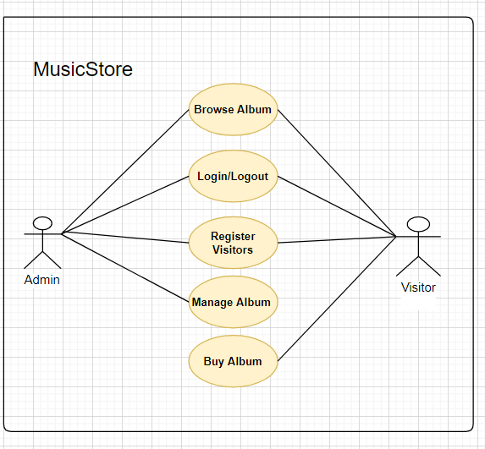

### 

### 

## 2.4. Activity diagrams of use case scenarios

### 2.4.1. Activity diagram for use case “Buy Album”

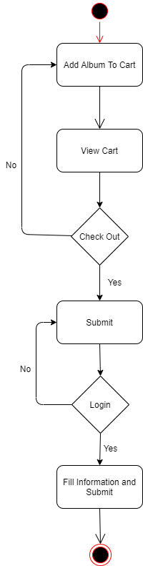

### 2.4.2. Data model

## Entity Relationship Diagram

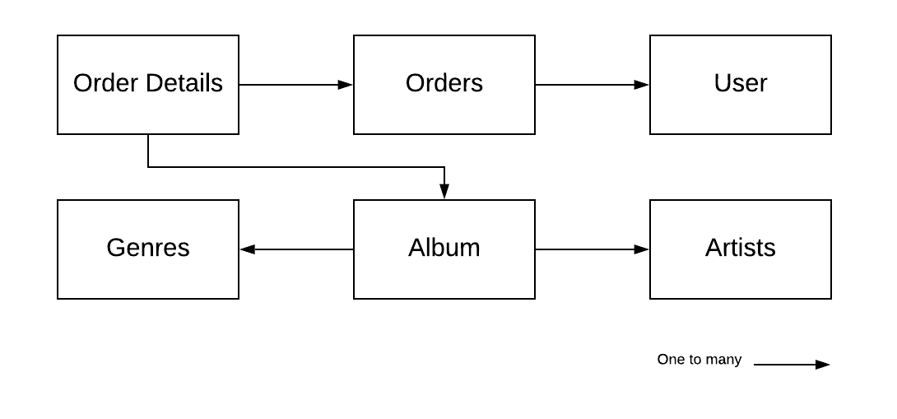

## Table details/Chi tiết các bảng

Note: Attribute with underline is Primary key

### Table name: Album

|  |  |  |  |
| --- | --- | --- | --- |
| **Field name** | **Type** | **Size** | **Note** |
| Albumid | Integer |  | Primary key |
| Genreid | Integer |  | Foreign key, refers to Genre table |
| Artistid | Integer |  | Foreign key, refers to Artist table |
| Title | String | Max | Not null |
| Price | Float |  | Not null |
| Album | String | Max | Not null |

### Table name: Artist

|  |  |  |  |
| --- | --- | --- | --- |
| **Field name** | **Type** | **Size** | **Note** |
| Artistid | Integer |  | Primary key |
| Name | String | Max | Not null |

### Table name: Genres

|  |  |  |  |
| --- | --- | --- | --- |
| **Field name** | **Type** | **Size** | **Note** |
| Genreid | Integer |  | Primary key |
| Name | String | Max | Not null |
| Description | String | Max | Not null |

### 3.1.4 Table name: OrderDetails

|  |  |  |  |
| --- | --- | --- | --- |
| **Field name** | **Type** | **Size** | **Note** |
| OrderDetailid | Integer |  | Primary key |
| Orderid | Integer |  | Foreign key, refers to Order table |
| Albumid | Integer |  | Foreign key, refers to Album table |
| Quantity | Integer |  | Not null |
| UnitPrice | Float |  | Not null |

### 3.1.5 Table name: Orders

|  |  |  |  |
| --- | --- | --- | --- |
| **Field name** | **Type** | **Size** | **Note** |
| OrderId | Integer |  | Primary key |
| OrderDate | Datetime |  | Not null |
| FirstName | String | Max | Not null |
| LastName | String | Max | Not null |
| Address | String | Max | Allow null |
| City | String | Max | Allow null |
| State | String | Max | Allow null |
| Country | String | Max | Allow null |
| Phone | String | Max | Allow null |
| Email | String | Max | Not null |
| Total | Integer |  | Not null |
| Userid | Integer |  | Foreign key, refers to User table |

### 3.1.6. Table name: User

|  |  |  |  |
| --- | --- | --- | --- |
| **Field name** | **Type** | **Size** | **Note** |
| Id | Integer |  | Primary key |
| UserName | String |  | Not null |
| Password | String | Max | Not null |
| FirstName | String | Max | Not null |
| LastName | String | Max | Not null |
| Address | String | Max | Allow null |
| City | String | Max | Allow null |
| State | String | Max | Allow null |
| Country | String | Max | Allow null |
| Phone | String | Max | Allow null |
| Email | String |  | Not null |
| Type | Bit |  | Not null |

# Class diagram (p.61 – p70)

## List of classes in the Layers

Layer GUI

Layer DT

InformationGUI

HistoryGUI

Add/Edit AlbumGUI

Album

AlbumGUI

My Cart GUI

My Account GUI

MainGUI



LoginGUI

AboutGUI

GUI

NewArtistGUI

Account

RegisterGUI

OrderDetailGUI

NewGenreGUI

Artists

Genres

Layer DA

AlbumDAO

Order

OrderDetailDAO

OrderDAO

GenreDAO

ArtistDAO

AccountDAO

Order Detail

Note: Allow to use

BL: Business logic DT: Data transfer

DA: Data access

MusicStore Database

## Modeling the Class Behaviors - sequence diagrams ( p. 66, 77)

### Sequence diagram for use case “Buy Album”

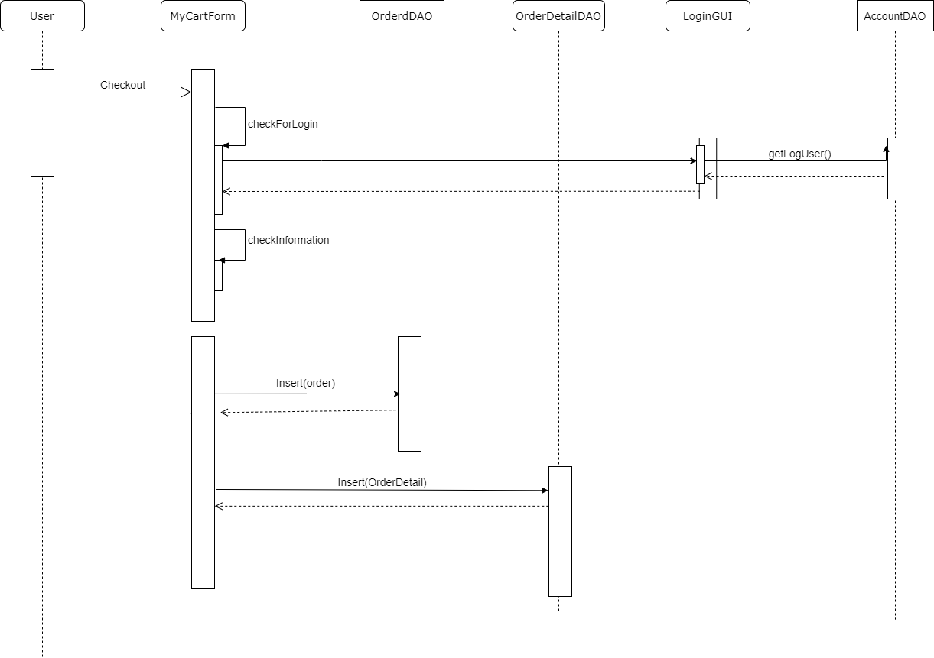

# User Interface Model Design (p. 70 – p.74)

## User interface model design

### 5.1.1. Screen “Register Albums”

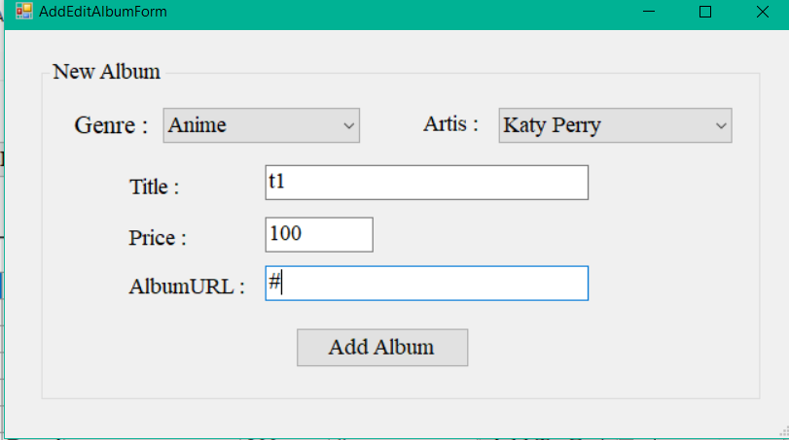

### 5.1.2. Screen “Register Visitors”

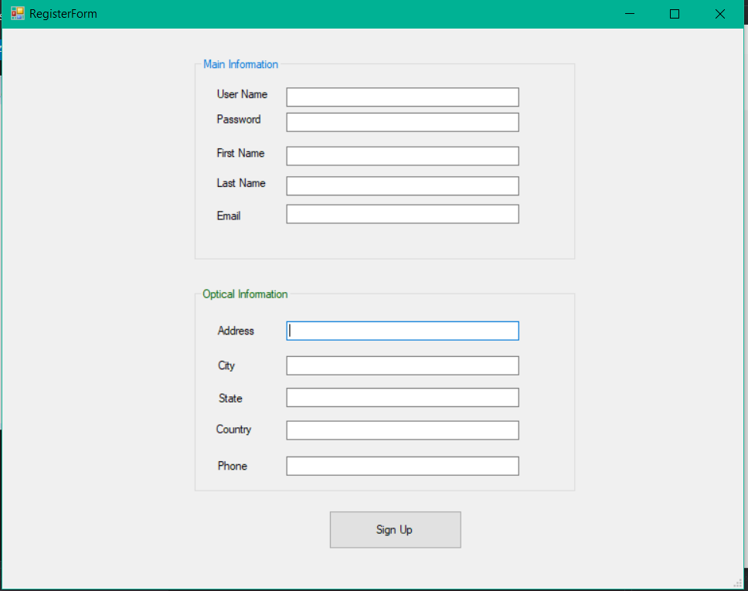

### 51.3. Screen “Browse Albums”

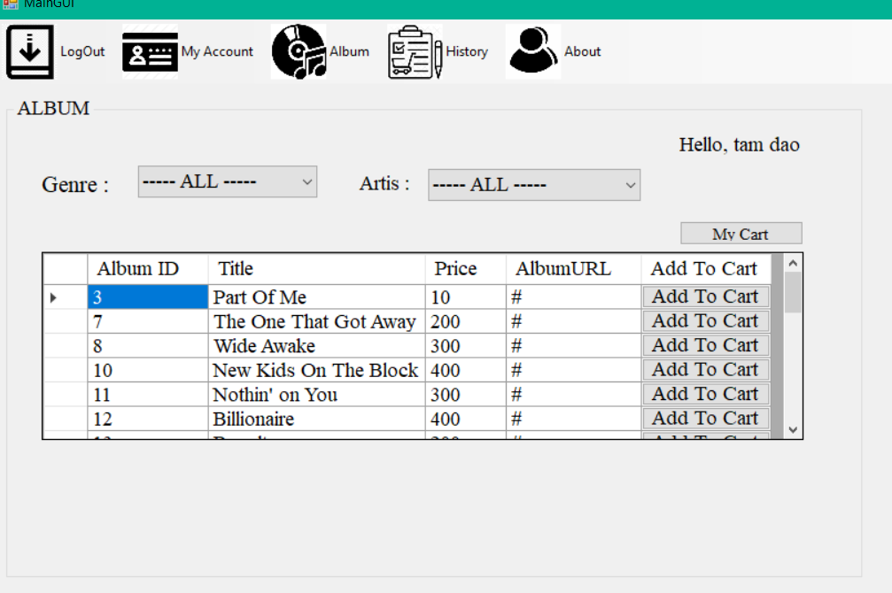

### 5.1.4. Screen “My Cart”

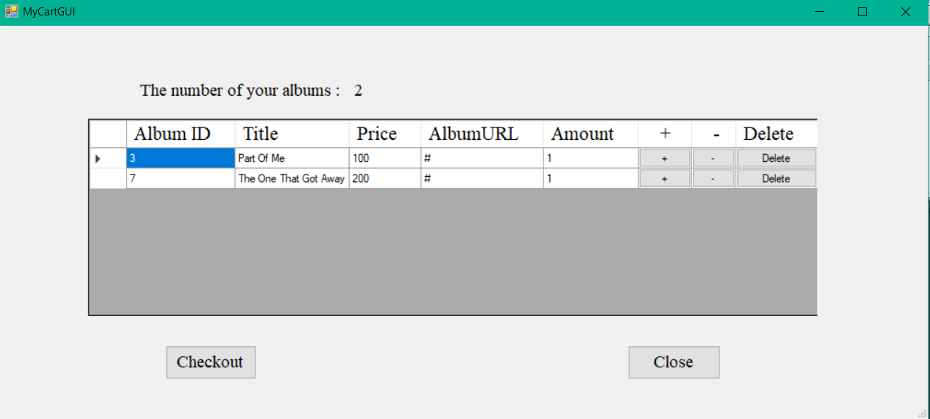

### 5.1.5. Screen “Checkout”

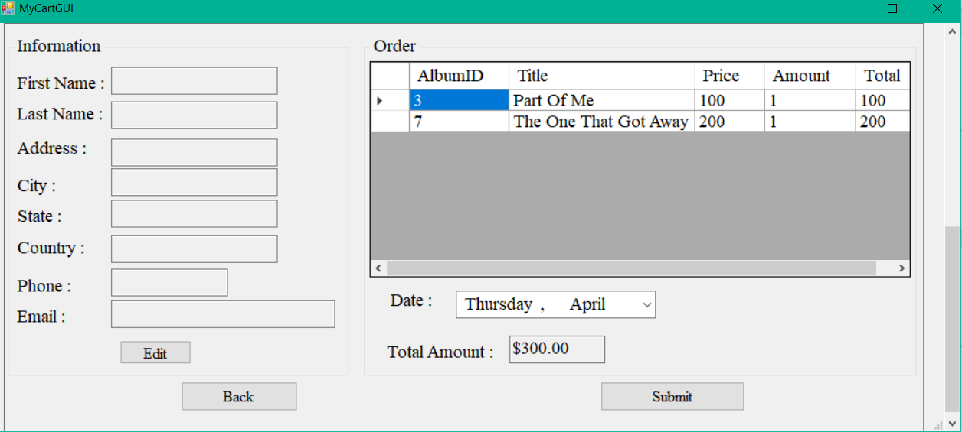

## 5.1.6.Scren”History”

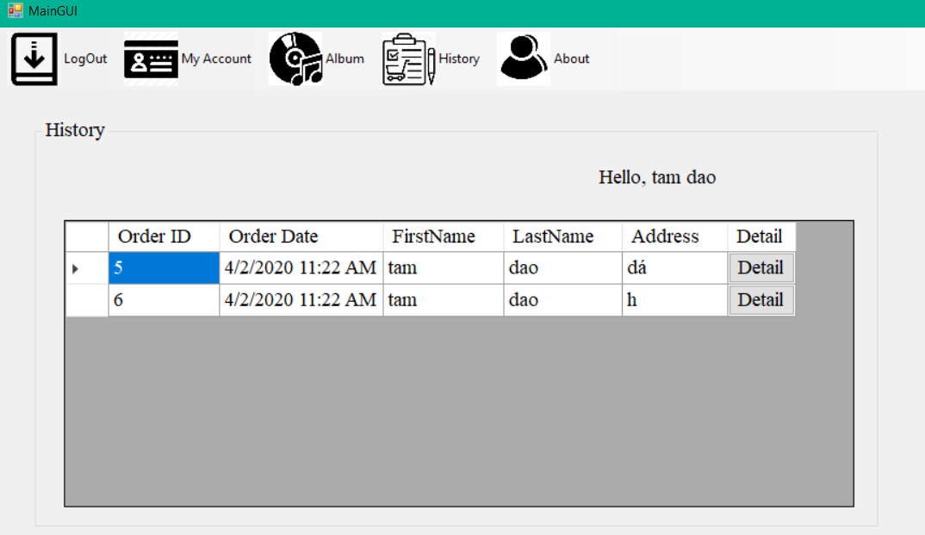

## Interface Flow Diagrams (p. 51)

Main form (main menu)

History

Group About

Detail Account

Browse Albums

Login/Logout

[Click Album]

[Click Login/Logout

u]

[Click About]

[Click Account]

[Click History]