Function Details
Preconditions
- The Admin is logged in to BPMS.
- The Admin's role has the "audit_log:view" permission with scope All.
- Audit records exist, written automatically whenever business data is created, updated, deleted or soft-deleted.
Process
1. Access Audit Log Screen:
- The Admin opens System administration > Audit log, or follows an "View audit log" link from another screen, which pre-fills the entity, entity ID, actor, action and date filters.
2. Load Audit Log List:
- The system sends a request to GET /audit-logs with page 1, page size 20, the current filters and the sort order "Newest first".
3. Retrieve Audit Records:
- The server retrieves matching audit records from the database, including time, actor, action, entity name, entity ID, IP address and changed columns, together with the total record count.
4. Display Audit Log Table:
- The system displays the records in a table with the columns Time, Actor, Action, Entity, Entity ID, IP address and Changed columns, and shows the total number of records and the current page (e.g. "Page 1/5"). Changes made by background jobs show "System" as the actor.
5. Filter and Sort Records:
- The Admin can search by entity, ID or actor, enter an entity name, choose an action (Create, Update, Delete, Soft delete), choose a From date and To date, and select "Newest first" or "Oldest first", then click "Apply". "Clear filters" resets all filters and reloads the list from page 1.
6. Navigate Pages:
- The Admin clicks "Previous page" or "Next page" to move between pages of 20 records.
7. View Audit Log Details:
- The Admin clicks a row or "View details". The system sends a request to GET /audit-logs/{id} and opens the details drawer with three sections: General (time, actor, account ID, entity, entity ID, action), HTTP request (IP address, method, path, browser/client, trace ID) and Data changes (column, old value, new value).
8. Close Details:
- The Admin clicks the close button or presses Esc to close the drawer and return to the list.
Postconditions
- The Admin views the audit records that match the selected filters, sorted and paged as requested.
- If the Admin opens a record, the system displays its full details, including the old and new values of each changed column.
- No audit record is created, changed or deleted by this screen; it is read-only.
Error Handling
- No Matching Records: Display the message "No matching audit records." in the table.
- Invalid Date Range: When the From date is after the To date, display "The start date must be on or before the end date." and disable the "Apply" button.
- Audit Log Could Not Be Loaded: Display "Could not load the audit log." with a "Retry" button that reloads the list.
- Record No Longer Exists: When the details request returns 404, display "This audit record no longer exists." in the drawer.
- Details Could Not Be Loaded: Display "Could not load the audit log details." in the drawer.
- Unauthorized or Forbidden Access: If the session has expired (401) the user is redirected to sign in; if the user lacks the "audit_log:view" permission (403) the request is rejected.
Security Measures
- Both endpoints require authentication and the "audit_log:view" permission with scope All, enforced on the server.
- The audit log is read-only: no API exists to edit or delete audit records.
- Sensitive values such as passwords, tokens and secrets are masked as "***" in old and new values.
- Filtering, paging and sorting are performed on the server, and page size is limited so the client cannot request unbounded data.

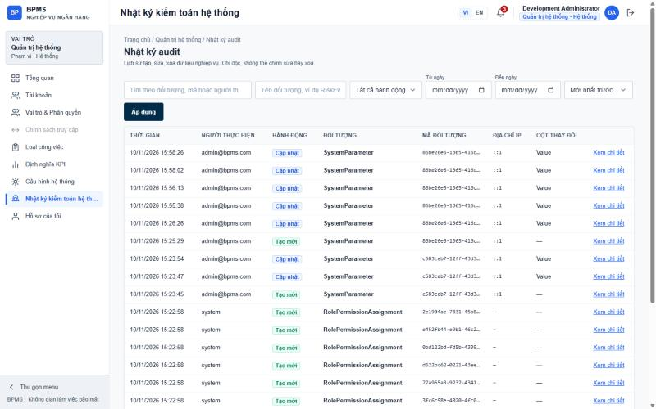
Figure: Audit Log List (SCR-ADM-05) and Audit Log Details (SCR-ADM-05-D1)

