# Lab Guide

**LIDAR Point Cloud**

Content Description

The following document describes a LiDAR point cloud implementation in either python or MATLAB software environments.

Lab Guide 1

Running the example 2

Details 3

Running the Example 4

Details 4

MATLAB

In this example, we will capture LIDAR data from the RP LIDAR A2 on the QCar platform, send the data to a polar plot, and generate a point cloud map. The process is shown in Figure 1.

|  |
| --- |
| Generate Point Cloud  Capture LIDAR data  Display Map |
| Figure 1. Component diagram |

In addition, a timing module will be monitoring the entire application’s performance. The Simulink implementation is displayed in Figure 2 below.

Figure 2. Simulink implementation of Lidar Point Cloud

## Running the example

To run examples for virtual QCar please go to the **SIMULATION** tab in the ribbon interface and click on the Run icon.

As your room size may vary, change the maximumDistance (m) parameter within the pointCloud subsystem accordingly, up to a maximum of 4m (corresponding to an 8 x 8 m room). Figure 3 shows the typical output expected when running this example.

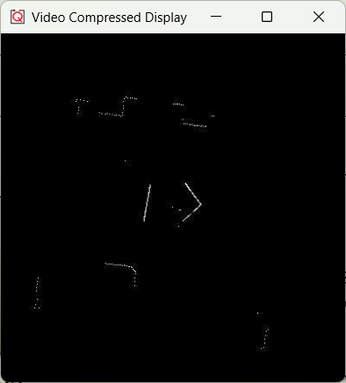

Figure 3. Point cloud map generated in a room.

## Details

1. Capturing LIDAR data   
     
   The RP LIDAR A2 reads data in a clockwise manner, starting from a position opposite to the data cable attached to it. On the QCar platform, this corresponds to the +y axis. To correct this, the **captureLIDAR** subsystem corrects the order of the data to start at the front and orient counterclockwise to follow standard convention in the **bodyFrameAdjustmentOnCapture** function.   
   Logo

   Description automatically generated with medium confidence
2. Saturating the distances data meaningfully  
     
   To limit the scope of the data to a range, the **distances** data is dynamically saturated using the **maximumDistance** parameter. The **findXYContour** function then converts the **distance**/**heading** data pairs to **X** **Y** pairs. However, we would like the **X** **Y** points corresponding to the **maximumDistance** to not show up within the point cloud itself, as they simply correspond to a maximum range and not physical obstacles. To do so, the **findXYContour** also drops data points that are equal to the **maximumDistance** parameter.   
   Diagram

   Description automatically generatedDiagram, schematic

   Description automatically generated
3. Generating the point cloud  
     
   This function first decays the existing map to 90%, thereby slowly erasing older data. The **X** **Y** data points in meters are converted to pixel scale **pX** and **pY** using a **gain** of 50 px/m for a map of size **dim** up to 400 pixels wide and tall (or 8m x 8m). Check out the documentation of MATLAB’s **sub2ind** for information on how the (row, col) pairs in (**pX**, **pY**) are converted to indices where the point cloud map will be set to **1**. Adjust the **decay** parameter to change the rate of update of the map. Note that you can do this online while the application is deployed.
4. Performance considerations  
     
   To improve performance, we only create a blank map on the first call by the use of persistent MATLAB variables. The variable map_internal holds its value at any given iteration into the next call. At the end of the function, the mapOut is updated and then displayed.

Python

In this example, we will capture LIDAR data from the RP LIDAR A2 on the QCar 2 and generate a point cloud map. The process is shown in Figure 4.

|  |
| --- |
| Generate Point Cloud  Capture LIDAR data  Display Map |
| Figure 4. Component diagram |

## Running the Example

Run the **lidar_point_cloud.py** example on your local machine. As your environment may vary in size, change the parameters **dim** and **gain** as you see fit. Figure 5 shows the typical output expected.

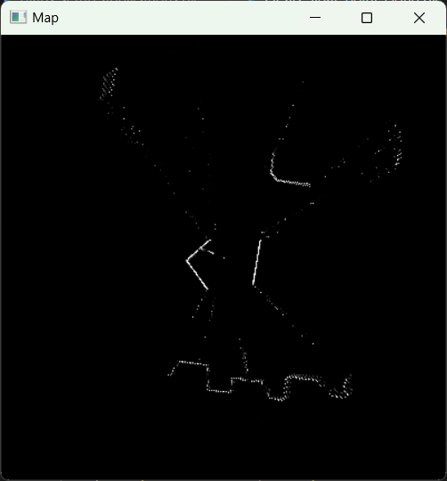

Figure 5. Point cloud map generated in a room.

## Details

1. Capturing LIDAR data   
     
   The data available using the LIDAR class is already adjusted to be presented counterclockwise starting at the positive X axis of the lidar frame (right direction). The LIDAR class object has two attributes, distances, and angles, which correspond to the data. The first line below shows the initialization step, and the second shows how to read the data.

myLidar = Lidar(

    type='RPLidar',

    numMeasurements=numMeasurements,

    rangingDistanceMode=lidarMeasurementMode,

    interpolationMode=lidarInterpolationMode)

myLidar.read()

1. Converting distances/angles to x y  
     
   After heading angles are converted from lidar frame to QCar body frame, the **distance**/**heading** data pairs are converted to **x** **y** pairs (in meters) using the lines below, and then to **pX, pY** pairs (in pixels) for the image.

x = myLidar.distances[idx]*np.cos(anglesInBodyFrame[idx])

y = myLidar.distances[idx]*np.sin(anglesInBodyFrame[idx])

pX = (sideLengthScale/2 - x*pixelsPerMeter).astype(np.uint16)

pY = (sideLengthScale/2 - y*pixelsPerMeter).astype(np.uint16)

1. Generating the point cloud  
     
   Note that the **map** is set to zeros at the beginning.

map = np.zeros((dim, dim), dtype=np.float32)

It then decays slowly based on the **decay** parameter at the start of the loop.

map = decay*map

A line below updates the **map** at the locations **pX,** **pY** near the end of the loop.

map[pX, pY] = 1

1. Performance considerations  
     
   To improve performance, we only create a blank map when initializing the code. Within the main loop, older map data slowly decays. The module **opencv** provides the **waitKey()** method for pausing in this case. See User Manual – Software Python for more information on timing.