**15.455x – Mathematical Methods for Quantitative Finance**

# Recitation Notes

The common probability distributions occur on their own and frequently as building blocks of other random variables. That helps in finding new results and modeling new processes.

For example, consider a binomial random variable *X* that takes values 1 or 0 with probabilities *p* or *q* = 1−*p*, respectively. If we draw *n* independent variables from the same distribution, and we ask how many 1’s (“successes”) there are, independent of their order, what is the distribution? Since the ordering doesn’t matter, we can figure out the probability of one case, then count up the number of different arrangements, and multiply by that number.

We get the binomial distribution

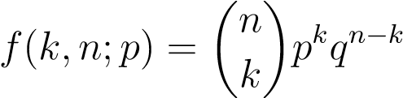*.*

The combinatorial part  represents how many ways there are to place *k* 1’s in a string of *n* results. Each string, regardless of order, has *k* factors of *p* and *n* − *k* factors of *q* because the probabilities multiply when the events are independent.

But what if we don’t know *n* in advance? Or what if the orderings are not all equivalent? In these cases, we don’t rush to group things together. We identify the cases of interest, one-by-one if necessary, and assign probabilities. Then we’re ready to compute any quantity of interest.

Example: mean waiting time in a Bernoulli trial. Suppose we keep doing new trials and drawing new random variables until we succeed. That is, we are interested in finding the *n* that corresponds to having one “success” after a string of *n* − 1 consecutive “failures.” How long does it take, on average, to roll a seven (*p* = 6*/*36) with a pair of dice? How many hands of Texas Hold’em does it take to get dealt a pair of aces (*p* = 12*/*2652)?

Let *T* be the waiting time, a random variable that takes values 0*,*1*,*2*,...*. Then Prob(*T* =

*n*) = *qn*−1*p*. Therefore

∞

E[*T*] = X*nqn*−1*p*

!

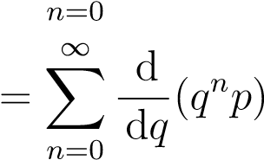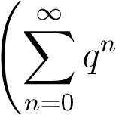d

= *p*

d*q*

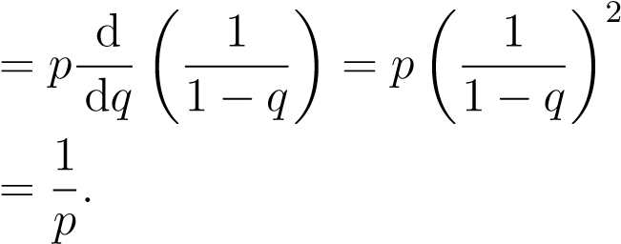

That means that you’ll need to wait, on average, about 6 turns to roll a seven with the dice, and about 221 hands of poker to get dealt pocket aces, or any other specific pair.

There are two tricks I used here. The first was to recognize *nqn*−1 as the derivative of something simpler. The second was to interchange the order of the summation and the differentiation, which is justified here because the infinite series converge as long as *q <* 1.

Notice that there is no memory of previous events. Whether you have been waiting 2 hands or 220, the expected waiting time from that point forward remains the same. This is known as the Markov property: the future expectations depend only on the current state, not on what happened in the past to get us there.

Sometimes history does matter. It depends on the question asked. The probability of observing an equal number of heads and tails of a fair coin after two flips is 1/2. But if you got two of the same outcome in the first two flips, then the probability that two additional flips brings you even is only 1/4.

Let’s return to our Bernoulli problem and compute the variance of the waiting time.

We can use the general result that

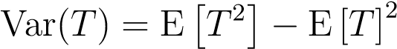

and compute directly

E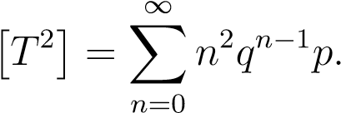

The previous trick still works if we generalize it a bit. For the *r*-th moment, there will be a factor of *nr* in the sum. So we can write

E[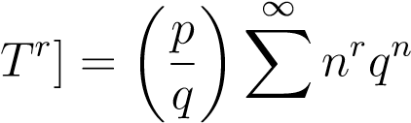

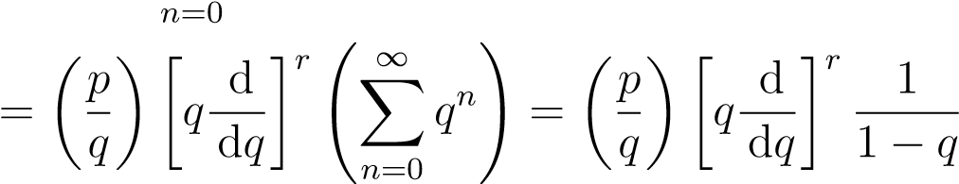*.*

Evaluating for *r* = 2, subtracting off the square of the mean, and letting *q* = 1 − *p*, we have

