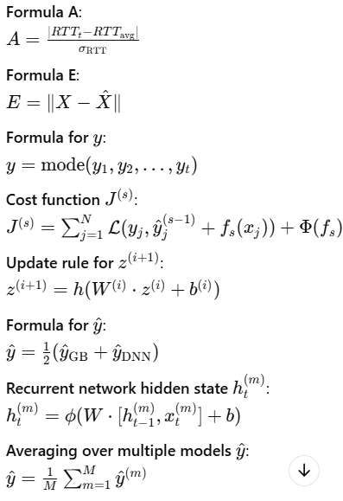
$$H\left(X\right)=-\sum{p\left(x_{i}\right).\log_{2}(p\left(x_{i}\right))}$$
$$A=\frac{|{RTT}_{t}-{RTT}_{avg}|}{σ_{RTT}}$$
$$E=||X-\hat{X}||$$
$$y=mode(y_{1},y_{2},….,y_{t})$$
$$J^{(s)}=\sum_{j=1}^{N}{L\left(y_{j,}{\hat{y}}_{j}^{\left(s-1\right)}+f_{s}\left(x_{j}\right)\right)+Φ(f_{s})}$$
$$z^{(i+1)}=h(W^{\left(i\right)}.z^{\left(i\right)}+b^{(i)})$$
$$\hat{y}=\frac{1}{2}({\hat{y}}_{GB}+{\hat{y}}_{DNN})$$
$$h_{t}^{(m)}=ϕ(W.\left[h_{t-1}^{\left(m\right)},x_{t}^{\left(m\right)}\right]+b)$$
$$\hat{y}=\frac{1}{M}\sum_{m=1}^{M}{{\hat{y}}^{(m)}}$$

