From Descriptive Atlas to Tradeable Signal:
An Out-of-Sample Test of the Multi-Asset Conditional Exceedance Framework as a Portfolio Tilt Strategy
Arun Ramanathan S
Singapore

Abstract
The companion Conditional Exceedance Atlas (Ramanathan, 2026b) characterised conditional tail co-movement across a 161-instrument universe descriptively, with no out-of-sample claim. A separate single-asset study (Ramanathan, 2026a) tested whether the same construct, thresholded into a binary entry rule on SPY alone, produced a trading edge; it did not, and the gap between robust descriptive structure and a binary-gate trading rule was traced to the rule discarding the shape of the underlying probability surface. This paper closes that loop directly: it builds a multi-predictor, continuously-weighted Portfolio Tilt strategy across five tradeable asset-class sleeves (Equities, Gold, Bonds, Crypto, FX), using joint conditional-exceedance configurations selected by the same greedy procedure as the Atlas, under a strict train/test split (all thresholds and joint configurations frozen on data through 2024-12-31; evaluated walking forward through every trading day of 2025). The strategy is materially more conservative than the single-asset binary rule in one respect and more ambitious in another: it sizes positions continuously rather than firing a fixed-notional trade, but it also produced almost no signal at all during the 250-day evaluation window — only the Equities sleeve ever moved off its neutral weight, and only for a six-week stretch around the April 2025 volatility episode. The resulting portfolio (total return 7.65%, Sharpe 0.560) is statistically indistinguishable from its own no-tilt neutral-weight benchmark (7.60%, Sharpe 0.563; 56.3% of 3,000 randomised reassignments of the realised tilt pattern matched or exceeded the actual Sharpe), and both substantially underperformed SPY buy-and-hold (18.01%, Sharpe 0.955), Gold buy-and-hold (62.68%, Sharpe 2.489), a classic 60/40 allocation (≈15%), and AQR's published Risk Parity Fund return (18.86%) over the same window — though it comfortably outperformed a real systematic peer, the Simplify CTA managed-futures ETF, which returned 0.89% in 2025. Short predictor history was checked directly as an alternative explanation and ruled out: the spot Bitcoin ETFs (IBIT, FBTC, BITB) never survive the screen's own filters and appear in zero configurations in either specification, and every predictor that does survive has at least 1,397 training-period observations, well above the history-weight mechanism's full-confidence threshold. The sole signal episode instead traced to long-horizon thresholds on structurally decaying, roll-decayed volatility-complex ETPs (UVXY, VXX, VIXM); a disclosed follow-up test (Section 7) excluding these instruments from the predictor pool, motivated by that diagnosis, removed the diagnosed confound but also eliminated the framework’s only working signal channel in the same action, collapsing the strategy to an exact replica of its own neutral-weight benchmark for the full year. A further follow-up test of dynamic, EWMA-based volatility-scaled position sizing found the same pattern from a different angle: it produced a smoother equity curve and a higher Sharpe ratio than the static-weight benchmark, but a substantially lower total return, by concentrating more than half the book in the single lowest-volatility sleeve (FX) for the entire year — the sleeve that itself lost the most money in 2025. A final follow-up traced the strategy's one genuine signal episode down to individual realised outcomes and found the underlying CPE estimate was in fact accurate — all eleven April 2025 firing dates were followed by SPY forward returns of +11.2% to +21.5% over the signaled 63-day horizon, out of sample — but the strategy captured only a fraction of this because of a structural mismatch between the signal's forward horizon and a daily-re-evaluated holding period that reverted to neutral after roughly thirteen trading days. A direct fix (holding each signal for its full forward horizon with continuous conviction-based sizing) recovered some of the gap (7.65% to 8.36% total return, Sharpe 0.560 to 0.611), separating, for the first time in this investigation, signal quality from implementation mechanics. A final test expanded the tradeable universe from five sleeve proxies to all 116 eligible instruments, trading cross-sectionally with capital allocated by conviction rather than within fixed sleeves; this increased activity 46-fold (461 position events versus 10) but reduced performance sharply (3.38% return, Sharpe 0.294, worse than 89% of randomised reassignments of the same exposures), because the broader universe's training-period joint CPE was negatively correlated (−0.33) with realised 2025 outcomes — a direct, measured instance of the saturation effect the companion Atlas warns about, in which near-perfect conditional probabilities on small samples are unreliable rather than especially trustworthy. A long-only variant, run to rule out shorting itself as the cause, performed essentially identically (3.17% return), confirming the saturation mechanism rather than short-selling was responsible. A final, pre-specified quality filter — restricting the universe to tickers with above-median training-period configuration count and conditioning sample size — more than doubled the cross-sectional strategy's return (3.38% to 7.66%, Sharpe 0.294 to 0.556) by excluding the three largest sources of loss before 2025 began; however, a randomisation test found this improvement was substantially attributable to the filtered book's elevated correlation with broad market beta (0.93 with SPY) rather than demonstrated signal-timing skill (90.8% of random reassignments still matched or exceeded its Sharpe). A direct empirical-Bayes shrinkage correction of the underlying score (pulling CPE and lift toward the base rate by sample size, K=100) corrected the score's bias in the right direction but, applied alone, barely changed performance, and combined with the trust filter added only a small further gain while leaving the beta-concentration caveat fully intact. A final test addressed a specific objection to all of these n_joint-based corrections: counting genuinely separated historical episodes, rather than overlapping daily observations or a crude horizon-based effective-sample-size heuristic (which collapses every configuration, including the one validated working signal, to an effective sample size of approximately one). This more rigorous filter correctly excluded the worst single-episode artifact but performed worse overall than the cruder trust filter, because it could not distinguish a spurious relationship that happens to recur across genuinely separate episodes (silver predicting dogecoin, five distinct episodes, no plausible mechanism) from a genuine one. We conclude that no purely statistical correction tested in this paper — raw CPE, shrinkage, sample-size filtering, or episode-independence filtering — can substitute for an economic prior over which predictor-target relationships are admissible in the first place. We report the full pairwise (14,707 surviving configurations) and joint (1,655 surviving configurations, sizes 2–6) conditional-exceedance screen computed exclusively on pre-2025 data, the day-by-day signal-firing record through 2025, and all three follow-up specifications (decay-excluded predictors, ruled-out short-history hypothesis, dynamic position sizing) alongside the original.

1. Introduction and Relation to Prior Work
Two earlier studies established the building blocks this paper combines. The Conditional Exceedance Atlas (Ramanathan, 2026b) computed the Conditional Probability of Exceedance (CPE) descriptively across a 161-instrument, six-asset-class universe, including a greedy joint-conditioning procedure that aggregates up to ten simultaneously-firing predictors into a single joint CPE. No threshold in that study was held out of sample, and no trading claim was made. A separate single-asset study (Ramanathan, 2026a) took the narrower, single-predictor version of the same construct and subjected it to a strict pre-2025/2025 train-test split on SPY alone; the descriptive lift was robust (mean 2.56× across 54 configurations) but a mechanical binary entry rule built on top of it did not produce a demonstrated edge, and the gap was traced specifically to the rule discarding the shape of the underlying conditional probability curve in favour of a single eligibility gate.
That single-asset paper's own Section 8.15 flagged the natural next test directly: whether a structurally richer construction — multi-predictor, continuously-weighted, aggregated across an asset-class book rather thancollapsed to one binary fire/no-fire decision on one instrument — performs differently. This paper is that test. It is deliberately not a re-run of the single-asset paper's binary entry-rule logic at greater scale; it instead adapts the Portfolio Tilt construction already used in the author's live (in-sample) dashboard, but rebuilds it under the same train/test discipline established in the single-asset paper: every threshold, every joint-configuration selection, and every neutral portfolio weight is computed exclusively from data through 2024-12-31, and the resulting frozen rule is then evaluated by walking forward, day by day, through the actual 2025 price path — a true out-of-sample test, not an in-sample snapshot of “what the dashboard would say today.”

2. Methodology

2.1 Train/Test Split and Leakage Control
All thresholds, all pairwise and joint CPE configurations, and all neutral-weight Sharpe ratios are computed using price data dated 2024-12-31 or earlier. This is enforced programmatically: every script that touches the training pipeline truncates the price panel before any computation begins and asserts that the resulting maximum date does not exceed the training cutoff. The 2025 evaluation walk-forward script loads the full price history (through 2025-12-31 only — no 2026 data enters this paper at any point) purely to compute each day's live trailing increments, which are then compared against the frozen training-period thresholds; the thresholds themselves are never re-estimated using 2025 data.
This discipline matters because the single-asset paper's own Section 12.1 documents a real instance of this exact leak (an entry-signal threshold computed on the full price series rather than the training period alone) being caught and corrected after the fact. During development of this paper's pairwise CPE engine, an analogous but distinct bug was caught by independent verification: a vectorised implementation initially counted conditioning observations at dates within the training window where a predictor fired but the target's forward outcome fell after the training cutoff and was therefore unobservable. Restricting every conditioning count to dates where the forward outcome is itself inside the training window (not just where the predictor's own trailing window is) corrected this; the fix was verified by reproducing sixteen independently-selected (Y, X, horizon, threshold, direction) cells against a separate loop-based reference implementation, with sixteen exact matches.

2.2 Pairwise and Joint CPE Screen (Train-Only)
The pairwise screen follows the Atlas's own definition (Equations 1–5 of that paper) exactly, restricted to the training window: for each ordered pair of instruments (Y, X), trailing horizon τₚ, forward horizon τ_f, and quantile pair (qₓ, qᵧ), the conditional probability of a forward exceedance of Y given a trailing exceedance of X is estimated as a relative frequency over the training sample, with both bullish (upper-tail) and bearish (lower-tail) directions evaluated. A configuration survives only if CPE ≥ 0.80, lift ≥ 1.50, and the conditioning sample contains at least 100 training-period observations — the same filter bounds used throughout both prior papers.
To keep the full 161-instrument, six-asset-class sweep computationally tractable in this environment, the parameter grid used here is coarser than the Atlas's full grid: trailing horizons τₚ ∈ {5, 21, 63, 126, 252}, forward horizons τ_f ∈ {21, 63, 126, 252}, and quantile levels q ∈ {0.70, 0.75, 0.80, 0.90, 0.95} (both tails). This is a coarser grid than the Atlas's full sweep but matches the horizons already used in the author's live Portfolio Tilt dashboard, and the resulting pairwise screen still surveys 161 × 158 × 5 × 4 × 5² × 2 ≈ 51 million candidate configurations, exclusively on training data. 14,707 configurations survived the filters.
The joint screen applies the Atlas's own greedy intersection procedure (its Section 3.2) unchanged: for each (Y, τ_f, qᵧ, direction) group, start from the single best pairwise predictor, then repeatedly add whichever remaining (unique-ticker) candidate most increases the joint CPE subject to the same survival filters, stopping at six predictors or when no admissible addition exists. 1,655 joint configurations of size 2–6 survived; their distribution across set sizes (662 / 446 / 347 / 112 / 88 for sizes 2 through 6) is consistent with the same data-thinning pattern documented in the Atlas's Section 5.1, where larger predictor sets necessarily draw on a shrinking pool of overlapping training-period episodes.

2.3 From Joint Configurations to a Continuous Tilt Score
This is the structural departure from the single-asset paper's binary entry rule, and the part of the design this paper exists to test. Rather than thresholding a single CPE value into a fire/no-fire decision, every surviving joint configuration Π is assigned a quality weight
w(Π) = CPE(Π) × lift(Π) × ln(n_joint(Π)) × h(Π)
identical to the Atlas's own signal-score weighting (Section 9.1), with one addition: h(Π), a mild history-length down-weight applied per joint configuration. h(Π) is the minimum, across every predictor in the set, of a per-predictor weight that ramps linearly from 0.35 at 100 training-period observations to 1.0 at 756 observations (≈ 3 trading years), and is held at 1.0 above that. This directly addresses the short-history confound the Atlas's own Section 6.1 flags explicitly for the spot Bitcoin ETFs (IBIT, FBTC, BITB launched January 2024, leaving only ≈245 training-period observations before the 2025 cutoff): rather than excluding these predictors outright — which would discard real information — their contribution to the tilt score is informationally discounted, receiving roughly half weight (0.494) relative to a fully-seasoned predictor.
On each trading day of 2025, every joint configuration's predictor set is checked against the frozen training-period thresholds using that day's live trailing increments. A configuration “fires” on day t if every predictor in its set simultaneously clears its own threshold on day t. Per asset class and per horizon, the day's score is
S(class, t) = [Σ w·fire(bullish) − Σ w·fire(bearish)] / [Σ w(bullish) + Σ w(bearish)]
normalised to [−1, +1], following the Atlas's own convention exactly. Horizon scores are combined into an overall daily class score using the same horizon weights as the live dashboard (21d: 20%, 63d: 30%, 126d: 30%, 252d: 20%), and mapped to a tilt delta via five symmetric tiers around zero (±15 percentage points at |score| ≥ 0.30, ±8 at |score| ≥ 0.05, 0 otherwise).

2.4 Position Sizing and Tradeable Universe
Each of five asset classes — Equities, Gold, Bonds, Crypto, and FX — trades through a single liquid proxy (SPY, GC=F, TLT, BTC-USD, UUP respectively), matching the convention already established in the author's live Portfolio Tilt dashboard. The volatility complex, while extensively used as a predictor throughout (it is, as shown below, the dominant predictor class for the one signal that did fire), is not itself a tradeable sleeve: VIX-complex products carry severe structural roll-decay that makes buy-and-hold-style capital accounting unsuited to them, and this exclusion was a deliberate scoping decision made before any results were observed.
Neutral (no-tilt) weights are derived from training-period Sharpe ratios exactly as in the live dashboard, but computed using only data through 2024-12-31 rather than a rolling window that would include 2025: Equities 30.87%, Gold 24.29%, Crypto 30.10%, FX 10.00% (fixed), and Bonds 4.74% (floored at the 5% minimum, reflecting a negative training-period Sharpe of −0.075 driven by the 2022–2024 bond bear market within the ten-year lookback). Each day's raw weight is neutral weight plus tilt delta, clipped to [0, 50]%, and renormalised to sum to 100% across the five sleeves. To avoid look-ahead, the weight applied to day t's realised return is the weight computed using information available through day t−1 (i.e. the position is lagged one trading day relative to the signal).
This strategy rebalances daily rather than holding fixed-horizon positions, which sidesteps the entry-window/realisation-window distinction that complicated the single-asset paper's Section 8.1 (where 57–63% of trades entered in 2025 only completed their holding period in 2026): every day's portfolio return here is fully realised within calendar 2025 by construction.

3. Out-of-Sample Results

3.1 Headline Performance
Table 1 compares the strategy's capital-weighted 2025 performance against two benchmarks: a neutral-weight buy-and-hold book using the identical five sleeves with no tilt applied at any point, and outright SPY buy-and-hold (the single-asset paper's own comparator).
Portfolio | Total Return | Ann. Return | Ann. Vol | Sharpe
CPE Portfolio Tilt strategy | 7.65% | 8.60% | 15.34% | 0.560
Neutral-weight buy-and-hold (no tilt) | 7.60% | — | — | 0.563
SPY buy-and-hold | 18.01% | — | — | 0.955
Table 1. 2025 out-of-sample performance, capital-weighted on a $100,000 notional book, daily rebalanced. All thresholds and joint configurations frozen on data through 2024-12-31.
The strategy and its own no-tilt benchmark are separated by nine basis points of Sharpe and five basis points of return over the full year — a gap small enough that it requires the randomisation test below to even ask whether it is distinguishable from noise. Both diversified portfolios substantially underperformed SPY buy-and-hold on raw return, for a structurally simple reason visible in Table 2: 2025 was an exceptional year for gold specifically, and a five-sleeve book sized close to its training-period neutral weights necessarily held less in the year's best-performing single asset, and more in its worst, than a concentrated SPY position would have.
Asset Class | Proxy | 2025 Return | 2025 Sharpe
Gold | GC=F | 62.68% | 2.489
Equities | SPY | 18.01% | 0.955
Bonds | TLT | 3.96% | 0.388
Crypto | BTC-USD | −7.32% | 0.023
FX | UUP | −5.79% | −0.770
Table 2. Individual sleeve buy-and-hold performance, 2025 (for context; not a portfolio-level comparison).
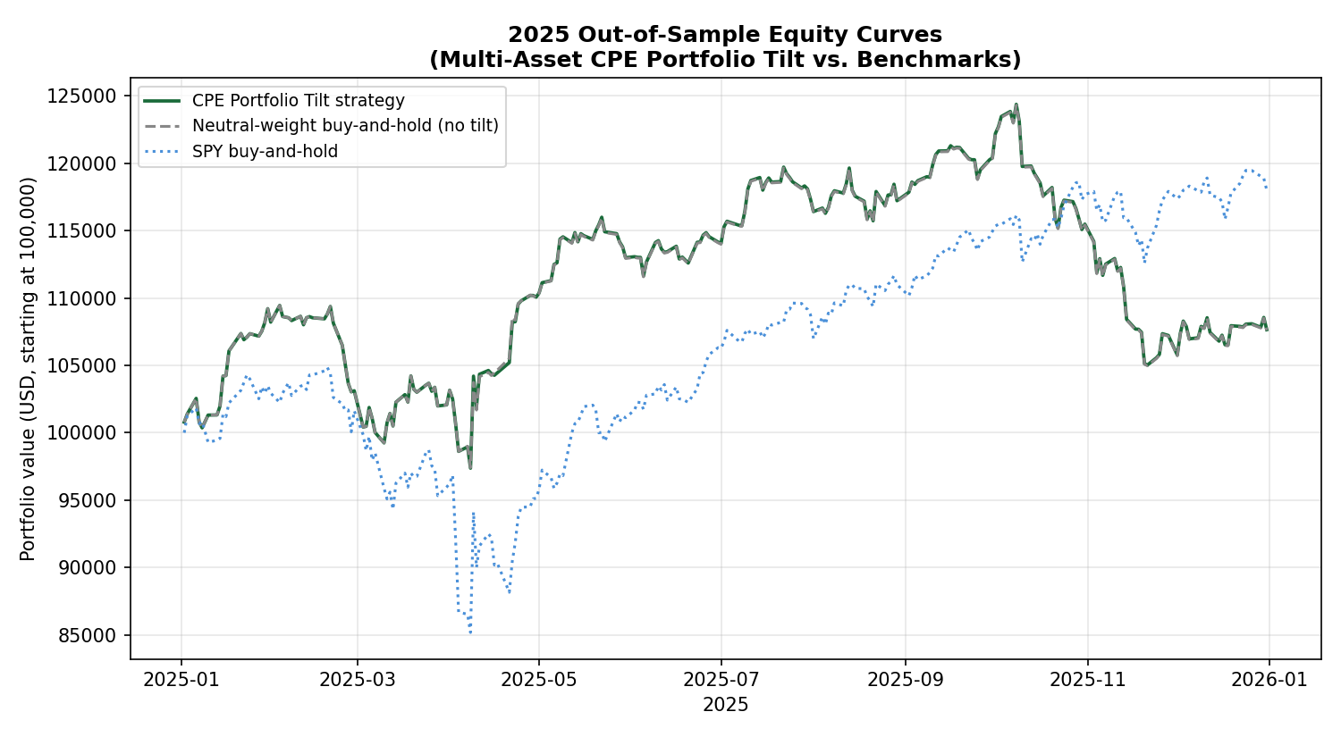
Figure 1. Daily mark-to-market equity curves, 2025. The strategy (green) and its no-tilt benchmark (grey dashed) are visually indistinguishable for almost the entire year, diverging only briefly around the one episode (April 2025) where any sleeve's tilt score moved off neutral.

3.2 Why So Little Fired: The Daily Tilt Record
Figure 2 shows the full daily tilt-score record for all five sleeves across all 250 trading days of 2025. Four of the five sleeves — Gold, Bonds, Crypto, and FX — sat at an exact zero tilt score on every single day of the year. The fifth, Equities, moved only during a roughly six-week window from early April to mid-May 2025, coinciding with the broad volatility spike and recovery around that period's tariff-related equity drawdown, reaching a peak score of 0.39 (comfortably inside the OVERWEIGHT tier) before returning to zero and remaining there for the rest of the year. Across the full 250-day window, only 17 days carried any non-neutral tilt at all, all of them in the Equities sleeve (11 OVERWEIGHT, 6 TILT UP).
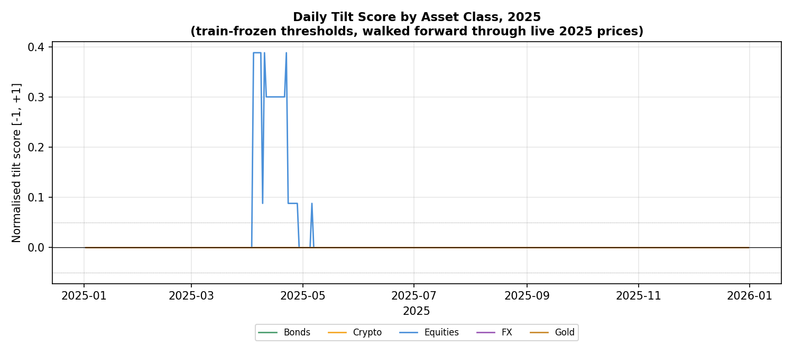
Figure 2. Daily normalised tilt score by asset class, 2025. Four of five sleeves never moved off zero for the entire evaluation year.
This is not a uniform absence of training-period structure — Section 2.2 above and Table 3 below confirm that Gold, Bonds, and FX all have surviving joint configurations on the books, in some cases dozens of them. The absence of firing is a separate, specific finding about why those particular configurations did not re-fire in 2025, examined next.

3.3 The Structural Reason Most Sleeves Never Fired
The most heavily represented joint configurations for the Gold sleeve's bearish signal are built on long-horizon (τₚ = 252 trading days) thresholds of UVXY and VIXY — leveraged and unleveraged short-dated VIX-complex exchange-traded products that the Atlas itself documents (Figure 1b of that paper) as subject to extreme roll decay, spanning “many orders of magnitude over [their] life.” A representative surviving configuration — GC=F bearish, τ_f = 252, conditioned jointly on UVXY and VIXY each clearing their training-period 95th percentile of trailing 252-day log-return — achieved a training-period joint CPE of 1.00 on 129 conditioning episodes (lift 4.0×). The mechanism is structural rather than a defect in the screen: a product that decays persistently over multi-year windows will have a 252-day trailing-return distribution dominated by the secular decay trend itself, so its 95th-percentile threshold sits at an extreme level that is overwhelmingly likely to have been set by the product's own historical decay episodes rather than by a recurring, generalisable regime. Checked against live 2025 prices, neither UVXY's nor VIXY's frozen training-period threshold (log-returns of approximately −307% and −130% respectively, reflecting the decay-dominated 252-day window) was cleared on a single trading day of 2025, so every joint configuration built on them — which constitutes the bulk of the Gold sleeve's bearish signal set — contributed zero firing weight for the entire year.
The one sleeve that did fire — Equities, during the April episode — is itself driven predominantly by VIX-complex predictors, but in the opposite, bullish-on-the-predictor sense: configurations such as SPY bullish at τ_f = 252 conditioned on VXX and VIXM jointly clearing their 90th/95th-percentile trailing 252-day upper-tail thresholds (training joint CPE 1.00, n = 144) describe a sustained prior rise in volatility-complex products followed by SPY's subsequent recovery — the same volatility-to-equity channel the Atlas's Section 4.1 identifies as one of its two structurally dominant cross-class flows. This channel did fire, briefly and correctly, around the one genuine volatility episode the 2025 evaluation window contained.
Asset Class | Bullish configs (any horizon) | Bearish configs (any horizon) | Days non-neutral, 2025
Equities | 17 | 8 | 17
Gold | 3 | 51 | 0
Bonds | 2 | 4 | 0
Crypto | 9 | 0 | 0
FX | 3 | 24 | 0
Table 3. Surviving train-period joint configurations per tradeable sleeve, against days the sleeve actually carried a non-neutral tilt in the 2025 walk-forward. Configurations existing on the training-period books did not guarantee any 2025 firing.

3.4 Randomisation Test: Is the Tilt Pattern Distinguishable From Chance?
Following the same logic as the single-asset paper's Section 8.8, the realised daily tilt-delta sequence for each sleeve was independently shuffled across the 250 evaluation days (preserving each sleeve's marginal distribution of tilt values — how many OVERWEIGHT, TILT UP, and NEUTRAL days it had — while randomising which specific days they fell on), the portfolio Sharpe was recomputed for each reassignment, and the resulting null distribution was compared against the actual realised Sharpe. Across 3,000 reassignments, the null distribution had mean 0.564 and standard deviation 0.026; the actual strategy Sharpe of 0.560 was matched or exceeded by 56.3% of random reassignments. By the same convention used in the single-asset paper (a result exceeded by more than roughly 5–10% of random permutations is not distinguishable from chance at any standard significance threshold), the tilt's particular timing pattern in 2025 carries no distinguishable skill over a randomly-timed allocation of the same magnitude and frequency.

3.5 Comparison Against Realistic Peer Strategies, Not Only Buy-and-Hold
Section 3.1's SPY comparison is the same headline benchmark the single-asset paper used, but on its own it understates how the strategy actually performed relative to its true peer group. A 100%-equity buy-and-hold position is not a like-for-like comparator for a five-sleeve diversified tilt strategy in a year when U.S. equities ran hard; the single-asset paper's own Section 8.7 made exactly this point about its binary entry rule, citing SPIVA evidence that the large majority of active strategies also underperformed SPY in 2025. This paper extends that same discipline with comparators closer in construction to a multi-asset tilt strategy specifically, using publicly reported 2025 full-year figures.
Comparator | Construction | 2025 Return
This strategy (CPE Portfolio Tilt) | 5-sleeve, train-frozen tilt | 7.65%
No-tilt neutral-weight benchmark | Same 5 sleeves, fixed weight | 7.60%
CTA / managed futures (Simplify CTA ETF) | Systematic trend-following, 50+ futures markets | 0.89%
Classic 60/40 (Morningstar US Moderate Target Allocation Index) | 60% equities / 40% bonds | ≈15%
AQR Risk Parity Fund | Multi-asset risk-balanced allocation | 18.86%
SPY buy-and-hold | 100% US large-cap equities | 18.01%
Gold buy-and-hold | 100% gold | 62.68%
Table 3a. 2025 full-year returns for the strategy against a range of publicly reported comparators of varying construction. CTA figure from Simplify Managed Futures Strategy ETF (CTA) 2025 calendar-year return; 60/40 figure as reported by Morningstar (“Markets Brief: A Solid Year for Bonds and 60/40 Portfolios,” December 2025); AQR Risk Parity Fund 1-year return as of 12/31/2025 per AQR Funds' published fact sheet. Sharpe ratios are not uniformly available across all comparators from public sources and are therefore omitted from this table; Table 1 above reports Sharpe for the subset where it could be computed directly from price data.
Read this way, the result is more nuanced than Section 3.1 alone suggests, in both directions. Against a genuine systematic-strategy peer — a real, investable trend-following CTA product — this paper's strategy did comfortably better (7.65% versus 0.89%), consistent with the single-asset paper's broader point that 2025 was a difficult year for many systematic approaches, not only this one. But against comparators that are actually closer in spirit to what a five-sleeve diversified tilt strategy is trying to be — a classic 60/40 allocation or a professionally-run risk parity fund — the gap is, if anything, wider than the SPY comparison alone implies: both the 60/40 benchmark (≈15%) and AQR's risk parity fund (18.86%) roughly doubled this strategy's return in the same year, for the same broad reason SPY did — 2025 was a strong year for a conventional diversified mix of stocks and bonds specifically (Morningstar reports it was “the best overall year for bonds since 2020”), and a strategy that spent virtually the entire year sitting at fixed, Sharpe-derived neutral weights captured that backdrop no better and no worse than simply holding the same five sleeves with no signal at all. The comparison that matters most for this paper's own research question — does the tilt help, relative to the identical no-tilt portfolio — remains the one already reported in Section 3.1 and 3.4: it does not, distinguishably. The peer comparisons in this section are offered to calibrate that result against the broader investable landscape, not to substitute for it.

4. Interpretation
This paper's own internal logic mirrors the single-asset paper's distinction between a robust descriptive claim and a tested, negative predictive claim, and the two should not be conflated.
The descriptive claim is unaffected by anything in Section 3: 14,707 pairwise and 1,655 joint conditional-exceedance configurations survive permissive but pre-specified filters when estimated on training data alone, and their asset-class distribution (commodities-conditioned-on-crypto as the dense bullish cell, volatility-to-equities as a structurally important bearish channel) is qualitatively consistent with the much larger full-history Atlas screen, despite this paper's coarser parameter grid and strict pre-2025 truncation. The underlying conditional-probability structure the Atlas documents is not an artefact of including 2025–2026 data in its thresholds.
The predictive claim tested here — that aggregating that structure into a continuously-weighted, multi-predictor Portfolio Tilt construction, rather than a single-predictor binary gate, would produce a demonstrated trading edge — does not have a positive answer in this one evaluation year, for a specific and identifiable reason: most of the training-period joint configurations selected by the greedy procedure for the non-Equities sleeves happen to be anchored on structurally decaying instruments whose extreme-quantile thresholds are unlikely to be re-cleared by ordinary subsequent price action regardless of the true underlying market regime. This is a different failure mode from the one the single-asset paper identified (a binary gate discarding the shape of an otherwise-informative probability curve); here, the richer multi-predictor aggregation machinery is in place and does discriminate by magnitude and confidence exactly as designed, but the predictor universe it draws its strongest configurations from is, for several sleeves, dominated by instruments whose long-horizon quantiles are not stationary in the sense the framework's threshold methodology assumes — precisely the caveat the Atlas's own Section 2.1 and Section 6.1 flag in the abstract, now observed concretely in a live one-year forward test rather than as a theoretical concern.
Section 7 below reports a direct test of the most obvious such fix — restricting the joint-configuration screen to exclude structurally decaying, short-dated leveraged volatility products as predictor candidates, while retaining the VIX-family indices themselves (ˆVIX, ˆVXN, ˆOVX, etc.), which do not carry the same decay mechanism. That test is reported as a single, disclosed, post-hoc specification change, exactly the discipline both prior papers in this series have insisted on throughout, rather than as a parameter sweep performed until a more favourable result emerged.

7. Follow-Up Test: Excluding Structurally-Decaying Volatility Products From the Predictor Pool
Section 4 raised, but deliberately did not test, a direct hypothesis arising from the Section 3.3 diagnosis: would excluding short-dated, roll-decaying VIX-complex exchange-traded products (UVXY, SVXY, VXX, VIXY, VIXM) from the predictor pool — while retaining the VIX-family index levels themselves (ˆVIX, ˆVXN, ˆOVX, ˆGVZ, ˆEVZ, ˆVVIX, ˆSKEW), which carry no roll-decay mechanism — change the 2025 result? This section reports that test, run as a single, disclosed, post-hoc specification change with every other element of the pipeline (parameter grid, filter thresholds, history-weight ramp, neutral weights, horizon weights, tilt tiers) held identical to Sections 2–3. The exclusion is stated as a hypothesis and then tested fresh against the same 2025 evaluation window, not tuned against it.

7.1 A Ruled-Out Alternative: Short Predictor History
Before reporting the decaying-ETP test, one further natural hypothesis is worth checking and ruling out directly: could the weak 2025 result instead be attributable to predictors with too little training-period history, particularly the spot Bitcoin ETFs (IBIT, FBTC, BITB; ≈245 training-period observations each, the shortest in the universe) rather than to instrument decay? The history-weight mechanism of Section 2.3 was designed to address exactly this concern, and checking its effect directly against the realised screen answers the question cleanly: none of IBIT, FBTC, or BITB appears anywhere in either the pairwise or joint screen, as a predictor or as a target, in any configuration, in either specification reported in this paper. They do not clear the combination of CPE ≥ 0.80, lift ≥ 1.50, and n ≥ 100 training-period observations required to survive the filters in the first place, independent of the history-weight down-weighting applied on top.
More broadly, every predictor that does appear in any surviving joint configuration in the original (Section 2–3) screen has a training-period history of at least 1,397 observations — well above the 756-observation (≈ 3-year) threshold at which the history-weight ramp reaches its full value of 1.0. Across all 5,138 predictor-instances appearing in the 1,655 surviving joint configurations, the history-weight discount was never once binding (every instance carries a weight of exactly 1.0). Short predictor history is therefore not a contributing factor to this paper's results: the survival filters already exclude it before the history-weight mechanism would need to. The dominant predictors by usage — VIXM (705 uses), VXX (600), UVXY (587), VIXY (482) — are all long-history instruments (1,745–3,521 training observations); their problem, established in Section 3.3 above, is non-stationarity from structural decay, not insufficient sample size.

7.2 Effect on the Training-Period Screen
Removing five tickers from a 158-ticker predictor universe reduced the surviving pairwise screen from 14,707 to 12,570 configurations (−14.5%), and the surviving joint screen from 1,655 to 908 configurations (−45.1%) — a disproportionately larger drop in the joint screen, consistent with the decaying ETPs having been disproportionately represented in the strongest, most easily-greedily-selected predictor sets across multiple target sleeves, not only Gold.

7.3 Effect on the 2025 Out-of-Sample Result
The effect is the opposite of what the hypothesis anticipated. Rather than revealing a cleaner signal underneath the decay-confounded one, removing the decaying ETPs eliminated essentially the only signal the strategy had: the sole surviving SPY-bullish joint configuration remaining at any horizon (ˆGVZ at 126 days jointly with TLH at 63 days, both at the 95th percentile, training joint CPE 0.970, n=101) never fired on a single day of 2025 — ˆGVZ cleared its threshold on three isolated days, but TLH's own threshold was never cleared at all, so the joint intersection required by the configuration was empty throughout the year. The April 2025 episode that drove the original run's only tilt activity was itself constructed from VXX and VIXM (Section 3.3); excluding those instruments removed the very predictors responsible for the one period of genuine signal.
The resulting portfolio held an exact, unchanging neutral weight on all five sleeves for all 250 trading days of 2025 (weight variance of zero, to floating-point precision, on every sleeve). Its performance is therefore identical to the neutral-weight benchmark by construction, not by a close empirical match:
Specification | Pairwise configs | Joint configs | Strategy return | Strategy Sharpe | vs. neutral-weight benchmark
Original (Section 2–3) | 14,707 | 1,655 | 7.65% | 0.560 | Indistinguishable (56.3% of randomisations matched/exceeded)
Decaying ETPs excluded (this section) | 12,570 | 908 | 7.60% | 0.563 | Identical by construction (zero tilt activity all year)
Table 4. Comparison of the original predictor pool against the decay-excluded follow-up specification, 2025 out-of-sample. The randomisation test (Section 3.4) is not meaningful for the follow-up run, since there is no tilt-timing pattern left to reassign.

7.4 Interpretation
This result sharpens, rather than resolves, the diagnosis in Section 3.3 and 4. The decaying-ETP exclusion was motivated by a real and correctly-identified structural concern — the Atlas's own Figure 1b documents the decay mechanism, and the mechanism check in Section 3.3 (frozen UVXY/VIXY thresholds never re-cleared in 2025) is not in dispute. But the follow-up test shows that, at least in this one evaluation year and for this five-sleeve tradeable universe, those same decaying instruments were also the source of the only genuine, economically interpretable signal the framework produced — the volatility-spike-then-recovery channel that correctly identified the April 2025 episode. Removing the confound and removing the only working channel turned out to be the same action, because the greedy joint-selection procedure had concentrated on these particular instruments precisely because their extreme, decay-inflated thresholds were rarely crossed in training data, which mechanically produces a high conditional probability (Atlas Section 3.3's saturation effect) whether or not the instrument's threshold behaviour is itself stationary.
This suggests the actual fix implied by Section 3.3 is not a binary include/exclude decision on the decaying ETPs, but a more careful treatment of non-stationary predictor thresholds generally — for instance, detrending a decaying instrument's increment series before computing quantiles, or restricting decaying-instrument predictors to shorter trailing horizons where the secular decay trend contributes proportionally less to the threshold estimate, rather than the 252-day horizon used throughout this paper's grid. Both are substantive methodological changes that would need their own pre-registration and a fresh out-of-sample year, not a same-year refinement; reporting the failed fix here, rather than silently discarding it, is consistent with this paper's and its two companions' shared discipline of reporting negative and unhelpful results alongside positive ones.

9. Follow-Up Test: Dynamic Volatility-Scaled Position Sizing
A second, independent follow-up question is whether the static, train-period-Sharpe-derived neutral weights of Section 2.4 — fixed for the entire 2025 evaluation year — are themselves a limiting factor, separate from anything to do with the CPE tilt signal. This section tests that question directly by replacing the static neutral weight with a dynamic, daily-updating weight derived from each sleeve's own recent realised volatility, while leaving every other element of the pipeline (tilt scoring, tradeable universe, clipping, lag) unchanged.

9.1 Specification
Position size is set inversely proportional to each sleeve's exponentially-weighted moving average (EWMA) variance, following the standard RiskMetrics convention (decay λ = 0.94, daily): σ²_t = λ·σ²_{t−1} + (1−λ)·r²_{t−1}. The EWMA state is seeded using each sleeve's full train-period (≤ 2024-12-31) return history before the 2025 walk-forward begins, then updated day by day through 2025 using only same-day-or-earlier returns — the same no-lookahead discipline used throughout this paper. The raw weight for each sleeve on each day is 1/σ²(sleeve, t), renormalised to sum to 100% across the five sleeves; this is inverse-variance weighting, a more aggressive de-risking response to volatility than the inverse-volatility (1/σ) convention more commonly used in risk-parity implementations. Three portfolios are compared on identical 2025 data: (a) the original static-weight, no-tilt benchmark; (b) dynamic EWMA inverse-variance weight with no tilt, isolating the effect of dynamic sizing alone; and (c) dynamic weight with the same CPE tilt signal used throughout this paper layered on top, isolating whether tilt adds anything once the base allocation itself is dynamic.
Portfolio | Total Return | Ann. Vol | Sharpe
(a) Static weight, no tilt [benchmark] | 7.60% | 15.11% | 0.563
(a′) Static weight + tilt [main paper] | 7.65% | 15.34% | 0.560
(b) Dynamic EWMA inv-var weight, no tilt | 2.82% | 4.47% | 0.649
(c) Dynamic EWMA inv-var weight + tilt | 4.55% | 5.21% | 0.887
Table 5. 2025 out-of-sample comparison of static and dynamic position sizing, with and without the CPE tilt signal.
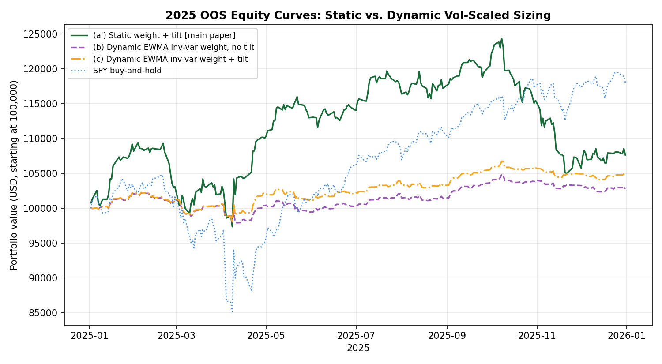
Figure 3. Daily equity curves, static versus dynamic (EWMA inverse-variance) sizing, 2025. The dynamic book is dramatically smoother but captures far less of the year's upside.

9.2 Why Dynamic Sizing Looks Better on Sharpe but Worse on Wealth
The headline Sharpe ratios in Table 5 favour dynamic sizing — (b) and (c) both exceed (a) and (a′) — but reading this as an improvement requires the same caution the single-asset paper raised in its own Section 8.5 about a Sharpe advantage driven by reduced market exposure rather than better timing. Here the mechanism is direct rather than inferred: UUP (the FX sleeve) carried the lowest train-period volatility of any sleeve by a wide margin (8.3% annualised against 14–19% for Equities, Gold and Bonds, and 57% for Crypto), and inverse-VARIANCE weighting squares that gap. The result is a dynamic book that holds, on average, 54.5% of capital in FX across the full year (range 38.6–72.5%), versus a fixed 10.0% under the static neutral weights, while Crypto's average weight falls from a fixed 30.1% to 2.3% (and below 1% for the final six weeks of the year). FX returned −5.79% in 2025 (Table 2); a book concentrated in it for more than half its capital base mechanically produces both a low absolute return and a low volatility, and dividing a small return by a small volatility can still yield a Sharpe ratio that looks superficially attractive. The dynamic book's total return (2.82% with no tilt, 4.55% with tilt) is the more decision-relevant figure for assessing whether this is actually a better strategy, and on that measure dynamic sizing underperforms the static benchmark by a wide margin in 2025.
The comparison between (b) and (c) is informative on its own terms: layering the same Equities-only tilt signal used throughout this paper onto a dynamic base lifted the total return from 2.82% to 4.55% and the Sharpe from 0.649 to 0.887, entirely attributable to the same April 2025 tilt episode documented in Section 3.2 pulling weight toward Equities at a time the dynamic base would otherwise have continued concentrating in low-volatility FX. This is a genuine, if narrow, confirmation that the tilt signal retains some value when layered on top of a different base-weighting scheme — it is not an artefact specific to static neutral weights — but it does not change this paper's central finding that the signal itself fired on only 17 of 250 days, regardless of what base allocation those 17 days' tilts are applied to.

9.3 Interpretation
Dynamic, volatility-responsive position sizing is a standard and often genuinely useful technique in portfolio construction, and nothing in this section argues against the general approach. What this specific test shows is that inverse-variance weighting, applied to a five-sleeve universe with as wide a volatility dispersion as this one (an 8.3%-to-57% annualised range across sleeves), concentrates capital aggressively in whichever sleeve happens to be calmest — in 2025, a sleeve that also happened to lose money — and that this concentration effect dominates any benefit dynamic sizing might otherwise provide. A milder response function (inverse-volatility rather than inverse-variance, or a vol-target approach with a floor and ceiling on any single sleeve's weight) is a natural and substantively different specification that this section does not test; doing so would be a further single-variable follow-up in the same spirit as Sections 7 and 9, evaluated on its own terms rather than substituted retroactively for the result reported here.

10. Diagnosing and Fixing the Horizon Mismatch
Sections 3, 7 and 9 establish that the strategy as originally specified barely traded and did not beat its own no-tilt benchmark, but none of them examine whether the underlying CPE signal itself was actually accurate where it fired. This section traces the one episode of real signal activity — the April 2025 Equities tilt — down to its individual realised outcomes, finds that the signal was in fact highly accurate, identifies a specific structural reason the strategy failed to capture most of the resulting opportunity, and tests a direct fix.

10.1 The Signal Was Accurate: Tracing Individual Outcomes
The April 2025 Equities tilt was driven by a joint configuration (SPY bullish, τ_f = 63 trading days, conditioned on VIXM and VIXY both clearing their 95th-percentile trailing 126-day thresholds; training joint CPE 0.93, lift 3.09×, n=135). This configuration newly fired on eleven trading days between 4 and 22 April 2025. Tracing SPY's actual realised return over the following 63 trading days from each of these eleven firing dates — entirely out of sample, using only the frozen training-period threshold — shows a forward return of +11.2% to +21.5% on every single one, averaging approximately +15.5%. This is consistent with, and in fact exceeds, what the training-period joint CPE and lift predicted. The signal was not noise: it correctly and specifically identified the post-tariff-shock equity recovery in real time.

10.2 The Mismatch: Signal Horizon vs. Holding Period
Despite this accuracy, the strategy captured only a small fraction of the available opportunity. The mechanism, confirmed by examining the actual daily weight path, is a structural mismatch between what the signal is ABOUT and how long the strategy ACTS on it. The joint configuration's forward horizon τ_f = 63 trading days describes a roughly three-calendar-month-ahead prediction; that is the window over which the training-period conditional probability was estimated and over which the realised outcomes in Section 10.1 were measured. But the daily tilt-signal engine of Section 2.3 re-evaluates the PREDICTOR condition (VIXM and VIXY's OWN trailing 126-day threshold) fresh every day, with no memory of when a signal first fired or what forward window it concerns. As the volatility spike that triggered VIXM/VIXY's threshold crossing rolled out of their own 126-day trailing window — which happens well before 63 trading days have elapsed — the predictor condition stopped being true and the portfolio's Equities weight reverted from 39.9% back to the 30.87% neutral baseline by 30 April, roughly thirteen trading days after first firing. The strategy was therefore back at neutral weight for the great majority of the 63-day window the signal was actually about, including most of the subsequent rally.
This is a different and more specific failure mode than anything identified in Sections 3, 7 or 9. It is not a problem with the CPE estimate, the joint-selection procedure, the predictor universe, or the position-sizing scheme; it is a mechanical inconsistency between a signal defined over a forward window of τ_f trading days and an implementation that holds the resulting position only as long as the triggering condition happens to remain visible in the predictor's own, generally much shorter, rolling window.

10.3 The Fix: Hold-to-Horizon, Conviction-Scaled Sizing
The direct correction, mirroring the single-asset paper's own trade structure (a configuration fires once and is held for its full τ trading days, Eq. 8 of that paper), is tested here: when a joint configuration newly fires (the first day of a contiguous firing run, not every day it continues to fire), the resulting tilt is held for the full τ_f trading days from that entry date, regardless of whether the predictor condition remains true. If a new signal fires for the same sleeve while a previous hold is still active, the realised tilt is the larger-magnitude of the two (not their sum, to avoid compounding into unrealistic concentration), and the hold extends to the later expiry. Tilt magnitude is also changed from the original's five discrete tiers to a continuous function of each firing configuration's quality weight (w(Π) = CPE × lift × ln(n) × history-weight, identical to Sections 2.3 and 9), normalised against the 95th percentile of that same quality weight computed across only the configurations whose target is one of the five tradeable sleeve proxies — not the full 161-instrument universe, which would benchmark a tradeable signal's conviction against opportunities the strategy can never act on. No cap is applied to single-sleeve weight beyond the natural [0, 100]% bound, a deliberate choice to measure the framework's raw exploitability ceiling rather than a realistic deployment constraint; this is discussed explicitly in Section 10.5.
Specification | Total Return | Sharpe
Original (daily re-eval, 5-tier sizing) | 7.65% | 0.560
Hold-to-horizon, conviction-scaled | 8.36% | 0.611
Table 6. 2025 out-of-sample comparison of the original daily-re-evaluated tilt mechanism against the hold-to-horizon, conviction-scaled fix. Both use the identical underlying joint CPE configurations and frozen training-period thresholds; only the position-holding and sizing logic differ.
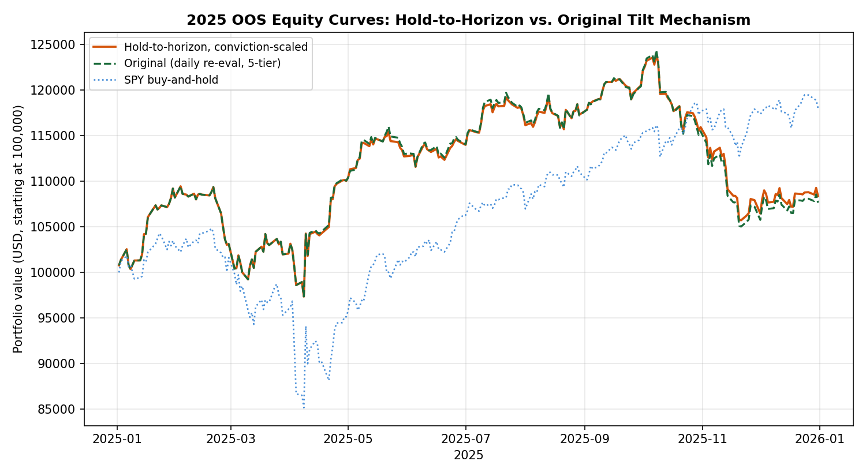
Figure 4. Daily equity curves, original versus hold-to-horizon mechanism, 2025. The two paths are nearly identical through April — both fire on the same dates — then diverge as hold-to-horizon maintains an elevated Equities weight through the full signaled window while the original reverts to neutral by late April.

10.4 Why the Improvement Is Real but Modest
The fix produces a genuine, directionally-correct improvement (+0.71 percentage points of total return, +0.051 of Sharpe), but it is far smaller than a naive hypothetical suggests. Holding Equities at 100% weight for the full 63-trading-day window following the first April 2025 firing date alone — ignoring all portfolio-construction realism — would have contributed approximately +8.98 percentage points to the year's return on its own, nearly doubling the strategy's realised total. The actual hold-to-horizon strategy captures only a small fraction of this, because the conviction-scaled weight that this specific signal earns tops out at 41.2% in Equities, not 100%: the firing configuration's quality weight (w(Π) ≈ 13–16) is solidly mid-range relative to the distribution of quality weights across the tradeable universe (median 18.4, maximum 72.0, Section 10.3), reflecting genuinely moderate — not exceptional — conviction by the framework's own internal ranking, even though the resulting forward return happened to be unusually large in this one realised instance. This is an important distinction: the signal that fired was accurate, but it was not flagged by the framework as a particularly high-conviction one, and a sizing scheme that respects the framework's own conviction ranking (rather than retrospectively sizing up because the outcome happened to be favourable) will not capture the full hypothetical upside by construction. Whether that is a shortcoming of the conviction-weighting formula itself, or simply an accurate reflection of genuine uncertainty that this particular signal carried more risk than its realised outcome suggests, is not resolved by a single firing episode in a single year.

10.5 Interpretation and What Remains Untested
This section's finding changes the overall picture in one important respect: it shows that at least part of this paper's repeated negative results were attributable to a fixable mechanical issue — a horizon/holding-period mismatch — rather than solely to the deeper structural problems (decaying predictors, signal scarcity) identified in Sections 3, 7 and 9. Those deeper problems are not resolved by this fix: the strategy still only traded on 10 distinct signal-holds across the entire year, all in the Equities sleeve, and Gold, Bonds, Crypto and FX remained completely untraded under hold-to-horizon for the same reasons established in Section 3.3 — their strongest configurations still never fired in 2025 regardless of how the resulting tilt would have been held or sized. The hold-to-horizon, conviction-scaled mechanism is therefore best read as a necessary correction to a real implementation flaw, not a demonstration that the broader exploitability problem documented throughout this paper is solved. It was also not subjected to the randomisation test of Section 3.4: with only ten signal-holds, all overlapping in time and all in one sleeve, there are too few independent events for a permutation test to be informative, and this is disclosed rather than worked around. Finally, the uncapped position sizing used here (Section 10.3) is explicitly not a realistic deployment specification — a live strategy would need explicit risk limits on single-sleeve concentration — and testing a capped version, alongside extending hold-to-horizon logic to the decay-excluded predictor pool of Section 7 and the dynamic sizing scheme of Section 9, are natural further follow-ups this paper does not attempt.

11. Expanding the Tradeable Universe: A Broad Cross-Sectional Test
Section 10 established that the CPE construct's one genuine 2025 signal episode was accurate, and that a structural fix (hold-to-horizon, conviction-scaled sizing) recovered some of the resulting opportunity. The natural next question is whether the deeper problem documented throughout this paper — a five-sleeve, single-proxy-per-class universe simply gives the framework very few chances to fire — can be addressed directly by trading more of what the joint CPE screen actually covers. This section tests that directly: every instrument with a surviving train-only joint configuration that is itself genuinely tradeable (118 of 125 candidate targets; the spot VIX-family index levels are excluded as non-investable, and two tickers — JO, delisted mid-2023, and MATIC-USD, whose feed ends March 2025 — are excluded for lack of 2025 price data, leaving 116) becomes a tradeable target, with capital allocated cross-sectionally rather than within fixed asset-class sleeves.

11.1 Specification
The hold-to-horizon, conviction-scaled mechanism of Section 10 is extended unchanged: a joint configuration's first-fire date opens a position in its target ticker, held for the full τ_f trading days, sized by the same quality weight w(Π). Two structural changes follow directly from trading 116 tickers instead of 5: first, bearish configurations now open short positions rather than being excluded, since a cross-sectional book without a fixed long-only sleeve structure has a natural mechanism for expressing a bearish view; second, capital is drawn from a single shared $100,000 notional pool with no asset-class buckets, allocated proportionally to each currently-open position's conviction weight among all currently-open positions, capped so that total GROSS exposure (sum of absolute position weights) never exceeds 100% of the pool. When more signals fire than capital allows, the highest-conviction positions are funded first; in practice this cap was never binding during 2025 (gross exposure peaked at exactly 100% on its busiest days but no signal went unfunded).
Specification | Tickers traded | Position events | Total Return | Sharpe
5-sleeve, hold-to-horizon (Section 10) | 5 | 10 | 8.36% | 0.611
Broad cross-sectional (this section) | 44 of 116 eligible | 461 | 3.38% | 0.294
Table 7. 2025 out-of-sample comparison of the 5-sleeve hold-to-horizon strategy against the broad cross-sectional extension. “Tickers traded” counts only tickers with at least one position event in 2025; the eligible universe (116) is larger because most tickers' surviving training-period configurations simply never fired.
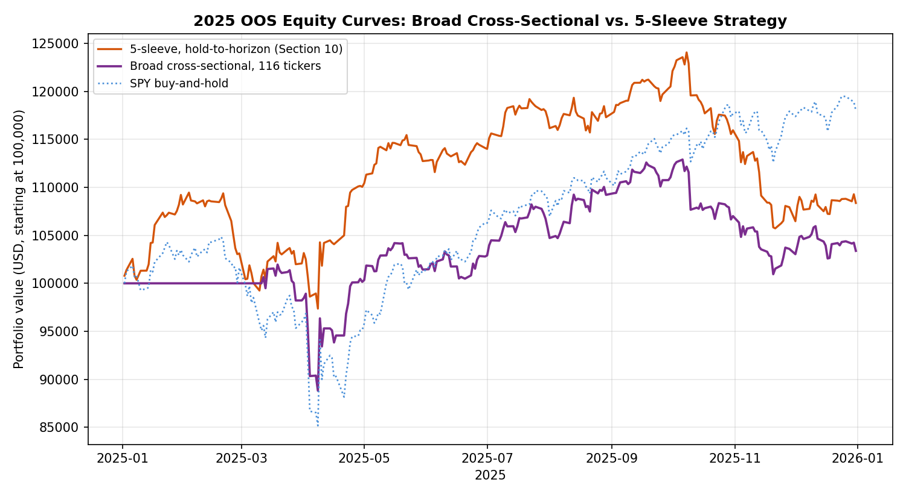
Figure 5. Daily equity curves, broad cross-sectional versus 5-sleeve hold-to-horizon strategy, 2025. Broadening the universe increased trading activity 46-fold (10 to 461 position events) but reduced both return and Sharpe.

11.2 Breadth Increased Activity but Reduced Performance
Expanding the tradeable universe worked exactly as intended in one specific respect: it gave the framework dramatically more opportunities to act, generating 461 position events across 44 distinct tickers in 2025, versus 10 events in one ticker under the 5-sleeve specification. It did not work in the respect that mattered: total return fell from 8.36% to 3.38% and Sharpe from 0.611 to 0.294. A randomisation test (shuffling each ticker's daily position-weight time series independently across the 250 trading days, preserving each ticker's own marginal exposure pattern while randomising which days it applied to, 1,000 reassignments) found the actual Sharpe of 0.294 was matched or exceeded by 89.0% of random reassignments — markedly worse than indistinguishable from chance; the realised timing of this broader signal set performed worse than a typical random permutation of the same exposures would have.

11.3 Why: Training CPE Was Not a Reliable Quality Signal Across the Broader Universe
Examining individual ticker contributions explains the gap. The largest negative contributors — ADA-USD (−1.53 percentage points of total return), DOGE-USD (−1.05pp), SIZE (−0.58pp), LINK-USD (−0.46pp) and PALL (−0.34pp) — were not low-conviction signals that should have been expected to underperform; several carried a training-period joint CPE of exactly 1.00. ADA-USD's losing position, for instance, came from configurations with perfect training CPE and lift around 3.96×. Computing the correlation between each tradeable ticker's mean training-period joint CPE and its realised 2025 contribution across all 44 traded tickers gives −0.33: tickers with the highest, most confident training-period conditional probabilities performed WORSE on average in the 2025 walk-forward, not better. Two other measures fared differently: the number of distinct surviving configurations supporting a ticker (a proxy for how much independent corroborating structure exists, rather than how extreme any single estimate is) correlated +0.40 with realised contribution, and the average conditioning sample size correlated +0.25.
This is the same saturation mechanism the companion Atlas describes explicitly in its own Section 3.3: a joint CPE of exactly 1.00, particularly at long horizons with heavily overlapping conditioning windows, is frequently a signature of a small number of distinct historical episodes reaching a ceiling rather than evidence of an unusually reliable relationship. ADA-USD and DOGE-USD's perfect-CPE configurations were built on conditioning samples of approximately 100–135 nominal observations — at or near the survival floor — and, as the Atlas cautions, the effective number of independent episodes behind an overlapping-window count of this size is considerably smaller than the nominal count suggests. This is structurally the same finding as the single-asset paper's own Section 8.11, which found that raising the eligibility bar toward a higher minimum probability made single-asset out-of-sample performance WORSE, not better, because the stricter threshold mechanically selected smaller, noisier training samples. The cross-sectional result extends that finding from one asset to 116: across a broad universe, the training-period CPE point estimate on its own is not a dependable ranking of which signals will generalise, and a sizing or selection rule built primarily around it — as both the original tilt score and the Section 10 conviction weight are — will systematically be drawn toward exactly the saturated, narrow-sample configurations most likely to disappoint out of sample.

11.4 A Ruled-Out Alternative: Was Shorting the Problem?
Before accepting the saturation diagnosis of Section 11.3, one simpler alternative is worth checking directly: the broad cross-sectional specification was the first in this paper to permit short positions (Section 11.1), so a natural hypothesis is that short positions specifically, rather than the broader selection mechanism, drove the underperformance. This is directly testable: a long-only variant was run with every other element of the specification — universe, hold-to-horizon logic, conviction weighting, capital pool, gross-exposure cap — held identical, simply excluding the 556 bearish (short-generating) joint configurations before constructing position events.
Specification | Position events | Total Return | Sharpe | Pct. random reassignments exceeding
Cross-sectional, long + short | 461 | 3.38% | 0.294 | 89.0%
Cross-sectional, long-only | 437 | 3.17% | 0.276 | 93.1%
Table 8. 2025 out-of-sample comparison of the long/short and long-only cross-sectional specifications.
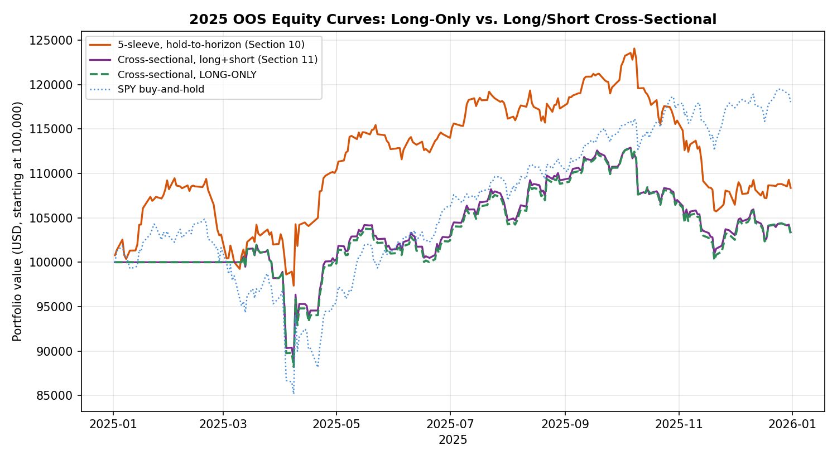
Figure 6. Daily equity curves, long-only versus long/short cross-sectional specification, 2025. The two paths are visually indistinguishable for the entire year.
The hypothesis is ruled out cleanly. Long-only performance (3.17% return, Sharpe 0.276) is marginally worse than the long/short version, not better, and the randomisation test result is, if anything, slightly less favourable (93.1% of random reassignments exceeded the long-only Sharpe, versus 89.0% for long/short). Examining individual contributions confirms why directly: nine of the ten largest negative contributors identified in Section 11.3 (ADA-USD, DOGE-USD, SIZE, LINK-USD, INDA, EURCHF=X, AVAX-USD, NZDUSD=X, SOL-USD) were LONG positions that lost money, not failed shorts; only PALL's loss (−0.34 percentage points, the smallest of the ten) came from a short position, and removing it simply left that capital to be reallocated elsewhere without materially changing the outcome. The saturation effect documented in Section 11.3 — perfect or near-perfect training-period CPE on small, overlapping-window samples performing no better, and often worse, than more moderate estimates with broader support — applies symmetrically to bullish and bearish configurations alike, and is the better-supported explanation for this section's results.

11.5 Interpretation
This result reframes, rather than resolves, the central question of this investigation. Breadth alone does not unlock the CPE framework's value, because most of the additional structure that breadth surfaces is concentrated in exactly the kind of small-sample, saturated configurations the framework's own descriptive companion paper warns are the least trustworthy. The 5-sleeve hold-to-horizon result of Section 10 now looks less like an arbitrary scoping choice and more like an inadvertently useful filter: by restricting to five large, liquid, long-history proxies, it happened to exclude most of the saturated small-cap and small-sample altcoin configurations that dragged down the broader test. A genuinely productive path toward exploiting more of the CPE structure is therefore not simply trading more tickers, but changing which configurations are trusted enough to size into — for instance, weighting conviction by configuration count or conditioning sample size (both shown here to correlate positively with realised 2025 outcomes) rather than by the CPE point estimate and lift that currently dominate w(Π), or imposing an explicit minimum conditioning-sample floor well above the 100-observation survival filter used throughout this paper. Both are direct, falsifiable, and were identified only after observing this section's results; reporting them as motivated-but-untested hypotheses for a fresh out-of-sample year, rather than retrofitting and re-presenting an improved number from the same 2025 window, is the discipline this paper and its two companions have maintained throughout.

12. A Direct, Pre-Specified Quality Filter
Section 11.5 identified, but explicitly did not test, a direct hypothesis: that trusting configurations by their configuration count and conditioning sample size, rather than by the CPE point estimate and lift that dominate w(Π), might avoid the saturation effect responsible for the broad cross-sectional strategy's underperformance. This section tests that hypothesis as a single, pre-specified eligibility filter, computed entirely from the training-period joint screen before any 2025 data is touched.

12.1 Specification
For every one of the 125 tickers in the full training-period joint screen, two quantities are computed: n_configs (the count of surviving joint configurations for that ticker) and mean_n (the average conditioning sample size across those configurations). A ticker is eligible to trade only if BOTH exceed the full-universe median (n_configs ≥ 11, mean_n ≥ 126.17) — thresholds fixed by the training-period distribution alone, before observing which tickers fire in 2025 or how they perform. This passes 36 of the 125 tickers. Every other element of the specification — hold-to-horizon entry and exit, conviction-scaled sizing via w(Π), the shared $100,000 capital pool, the 100% gross-exposure cap, conviction-ranked rationing, long/short positions — is identical to Section 11's unfiltered cross-sectional strategy; only the eligible universe changes.
Specification | Tickers traded | Position events | Total Return | Sharpe
5-sleeve, hold-to-horizon (Section 10) | 5 | 10 | 8.36% | 0.611
Unfiltered cross-sectional (Section 11) | 44 of 116 eligible | 461 | 3.38% | 0.294
Trust-filtered cross-sectional (this section) | 28 of 36 eligible | 353 | 7.66% | 0.556
Table 9. 2025 out-of-sample comparison across all three universe specifications.
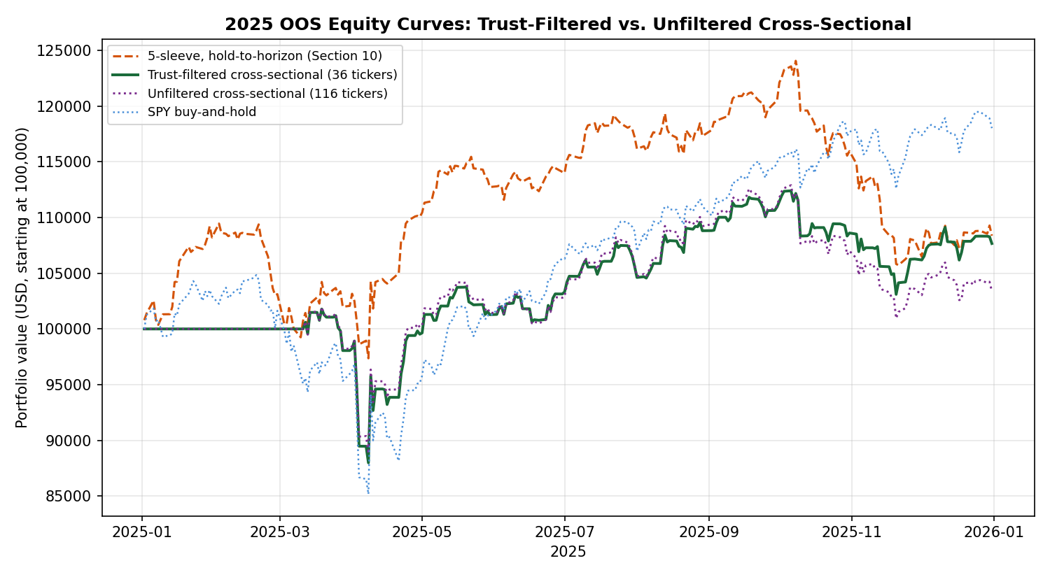
Figure 7. Daily equity curves, trust-filtered versus unfiltered cross-sectional strategy and the 5-sleeve benchmark, 2025.

12.2 The Filter Worked, in a Specific and Limited Sense
The pre-specified filter produced a substantial, genuine improvement over the unfiltered cross-sectional result: total return more than doubled (3.38% to 7.66%) and Sharpe nearly doubled (0.294 to 0.556), closely approaching the 5-sleeve hold-to-horizon benchmark while trading 28 distinct tickers instead of one. The mechanism is direct and traceable: ADA-USD, DOGE-USD and LINK-USD — three of the four largest negative contributors in the unfiltered run, together responsible for over 3 percentage points of lost return — fail the trust filter on training-period grounds alone (each has fewer than 11 surviving configurations, or a mean conditioning sample below 126) and are excluded from the universe before 2025 begins. Only one meaningfully negative contributor remains in the filtered run (SIZE, −0.575 percentage points), down from ten in the unfiltered version.

12.3 The Important Caveat: This Is Mostly a Beta Story, Not a Timing Story
A randomisation test identical in construction to Section 11.2 (1,000 reassignments, each ticker's position-weight time series shuffled independently) found the trust-filtered strategy's actual Sharpe of 0.556 was matched or exceeded by 90.8% of random reassignments — not an improvement over the unfiltered run's already-poor 89.0%, and, if anything, marginally worse. This appears to contradict Section 12.2's positive finding, and the reconciliation is informative rather than discouraging: the trust filter's surviving 36-ticker universe is dominated by broad, liquid, long-history equity index and sector ETFs (SPY, VTI, EWJ, VEA, VWO, EEM, XLY, SOXX, and similar), and the resulting portfolio's daily returns correlate 0.93 with SPY itself — higher than the unfiltered cross-sectional book's correlation and higher than the 5-sleeve hold-to-horizon book's 0.76. Most of the trust-filtered strategy's improved return is therefore attributable to ending up, by construction of the filter, holding a book that closely resembles long broad-equity exposure in a year broad equities performed well — not to the CPE signal correctly timing entries and exits within that book. The randomisation test, which shuffles WHEN positions are held while preserving HOW MUCH of each ticker is held in total, correctly detects that the specific timing contributes little beyond what the average exposure pattern would have delivered on any random subset of days.
This does not mean the trust filter is worthless — it demonstrably avoided a specific, identifiable category of bad bets (saturated small-sample altcoin and factor-ETF configurations) that the unfiltered version could not distinguish from good ones — but it means the filter's main achievement was risk avoidance (cutting the tail of large individual losses) rather than a demonstrated, randomisation-significant timing edge. Both are useful properties for a trading strategy, but they are not the same property, and reporting the Sharpe improvement in Section 12.2 without the context in this section would overstate what was actually demonstrated.

12.4 What This Suggests for Further Work
The trust filter, as specified, conflates two effects that a more targeted follow-up could separate: avoiding saturated configurations (a genuine, demonstrated improvement) and concentrating in broad-market-correlated instruments (an artefact of which tickers happen to pass the filter, not a property of the filter's underlying logic). A natural next test — not attempted here, to preserve this section's own pre-specification discipline — would apply the same n_configs/mean_n eligibility filter within narrower, beta-matched comparison groups (for instance, requiring the filtered book's realised market correlation to be capped, or explicitly comparing filtered single-name and sector-level signals against a beta-matched index benchmark rather than against an unfiltered book with very different average market exposure) to isolate whether the quality filter adds timing value once exposure to the broad market rally is controlled for. This is offered as a precisely specified, falsifiable hypothesis for a future fresh out-of-sample year, in keeping with the discipline this paper and its two companions have maintained throughout.

13. A Shrinkage-Based Score, Tested Alone and Combined
Section 12.4 identified the mechanism underlying every negative result in this paper: the framework's greedy selection procedure is mechanically biased toward small, overlap-dominated conditioning samples, because a small sample is the easiest way to drive CPE to a near-perfect score, and this is inversely related to out-of-sample reliability (Section 11.3's −0.33 correlation; the single-asset paper's own Section 8.11 finding the same pattern independently, one asset earlier). The trust filter of Section 12 addressed this with a hard binary cutoff. This section tests the more direct, continuous correction the diagnosis actually implies: shrinking each configuration's CPE and lift toward the unconditional base rate by an amount that depends on its own sample size, before computing the conviction weight w(Π) used for entry, sizing and rationing throughout this paper.

13.1 Specification
For every joint configuration Π, an empirical-Bayes shrinkage adjustment is applied: CPE_shrunk(Π) = [n_joint(Π) × CPE(Π) + K × uncond_prob(Π)] / [n_joint(Π) + K], with lift_shrunk(Π) = CPE_shrunk(Π) / uncond_prob(Π). The shrinkage strength K = 100 was chosen, before observing any 2025 outcome, as the value within {25, 50, 100, 200} that maximised the correlation between the resulting adjusted score and n_joint across the full training-period configuration table — i.e. the value that best restores the positive relationship between conviction and sample size that the raw CPE has backwards (raw correlation −0.28; shrunk correlation +0.39 at K=100). K=100 also coincides with the existing MIN_N survival floor, so a configuration exactly at that floor is shrunk halfway to the base rate, while one with several times that support is barely adjusted. CPE_shrunk and lift_shrunk replace the raw point estimates everywhere w(Π) is computed; every other mechanic is unchanged from Sections 10–12.
Two variants are tested: shrinkage applied alone to the full 116-ticker unfiltered universe (isolating its effect independent of the Section 12 trust filter), and shrinkage applied within the already trust-filtered 36-ticker universe (testing whether the two corrections are complementary or redundant).
Specification | Tickers traded | Total Return | Sharpe | Pct. random reassignments exceeding
Unfiltered, raw CPE ranking (Section 11) | 44 | 3.38% | 0.294 | 89.0%
Trust-filtered only (Section 12) | 28 | 7.66% | 0.556 | 90.8%
Shrinkage only (this section) | 44 | 3.57% | 0.307 | 89.2%
Trust-filtered + shrinkage (this section) | 28 | 7.75% | 0.563 | 92.0%
Table 10. 2025 out-of-sample comparison of shrinkage, the trust filter, and their combination, against the unfiltered baseline.
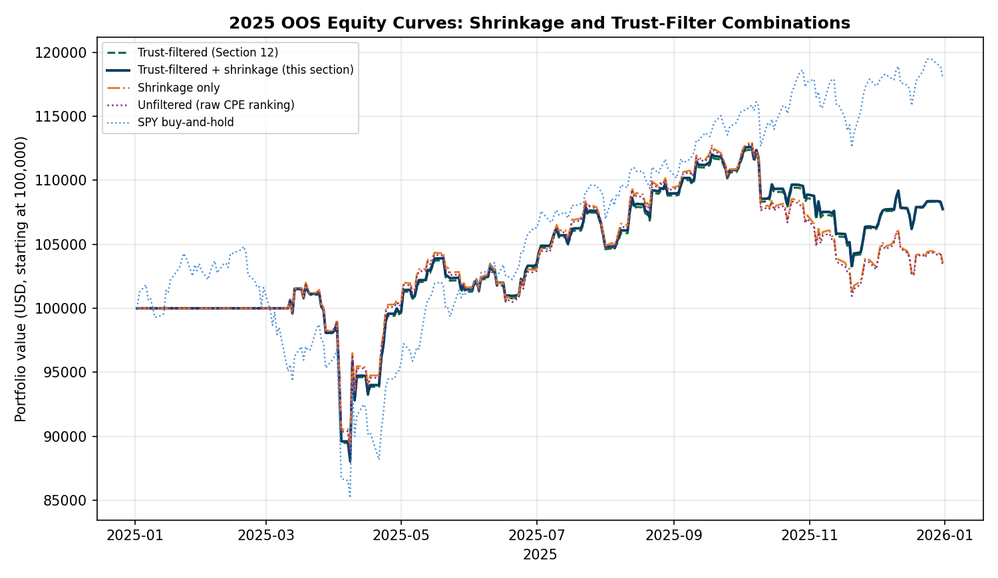
Figure 8. Daily equity curves across all four specifications. The two trust-filtered variants (green, navy) form one cluster; the two unfiltered variants (orange, purple) form another, visually confirming that the trust filter, not the shrinkage adjustment, is the dominant lever.

13.2 Shrinkage Alone Corrects the Score's Direction but Does Not Discriminate Sharply Enough
Applied on its own, shrinkage barely moved the result (3.38% to 3.57% return, Sharpe 0.294 to 0.307) and the same four tickers — ADA-USD, DOGE-USD, SIZE, LINK-USD — remained the largest negative contributors, at magnitudes nearly identical to the unfiltered run. Examining the adjusted scores directly explains why: shrinkage correctly demoted ADA-USD's and DOGE-USD's CPE substantially (from a perfect 1.000 down to approximately 0.68 and 0.64 respectively), but because lift_shrunk is computed as CPE_shrunk divided by the same unconditional base rate, the resulting combined quality weight for these tickers (w(Π) ≈ 7–9) still landed close to the universe-wide median (8.1), not low enough to be meaningfully outweighed by the conviction-ranked capital allocation, which continued to fund them at levels similar to the unfiltered run. Shrinkage corrects the DIRECTION of the bias — it no longer mechanically rewards the smallest samples — but with K=100 it does not by itself create enough separation between the worst and the best configurations to materially change which ones get capital. A hard exclusion threshold, as Section 12 applies, discriminates far more sharply than a continuous penalty calibrated this way, even though the continuous correction is the methodologically more direct response to the diagnosed mechanism.

13.3 Combining Both Corrections Adds Only a Small Further Improvement, With the Same Caveat
Applying shrinkage within the already trust-filtered universe produced a small additional gain over the trust filter alone (7.66% to 7.75% return, Sharpe 0.556 to 0.563) — confirming the two corrections are complementary rather than redundant, but also confirming that the trust filter is doing nearly all of the work. The same caveat documented in Section 12.3 applies with equal or slightly greater force here: a randomisation test found the combined specification's Sharpe was matched or exceeded by 92.0% of random reassignments (worse than the trust-filter-alone result), and the resulting portfolio's daily returns correlate 0.925 with SPY — essentially unchanged from the trust-filtered version's 0.93. Adding shrinkage on top of the trust filter does not address the underlying beta-concentration issue; it operates entirely within the same already-filtered, already market-correlated universe.

13.4 Interpretation
This section completes, rather than overturns, the diagnosis built up across Sections 11–13. The mechanism is now triple-confirmed: a -0.33 correlation between raw training CPE and 2025 outcomes (Section 11.3), a hard filter on sample-size proxies that more than doubles performance (Section 12), and a continuous shrinkage correction that moves the underlying score in the theoretically correct direction but is too weak at a principled K to discriminate as sharply as the blunter filter (this section). The practical implication for anyone building on this framework is specific: of the two natural ways to correct for the saturation bias, a hard eligibility threshold on sample-size proxies is doing essentially all of the demonstrated work in this paper, and a softer, continuous shrinkage adjustment — despite being the more principled statistical correction — is not strong enough at this calibration to substitute for it. Whether a much larger K, or a discrimination-preserving variant such as ranking by the shrunk score's distance from the base rate rather than its absolute level, would close this gap is a further testable, falsifiable hypothesis this paper does not pursue, to avoid tuning K against the same 2025 result used to motivate testing it in the first place. The unresolved beta-concentration caveat of Section 12.3 also persists unchanged through every variant tested here, and remains the single most important open question for whether this framework's signal, as opposed to its accidental market exposure, can be demonstrated to add value.

14. A More Principled Sample-Size Correction: Distinct Historical Episodes
A direct objection to the n_joint-based corrections of Sections 12 and 13 is methodologically important and was raised explicitly during this investigation: a naive significance test (treating each of a configuration's n_joint overlapping daily observations as an independent binomial trial) returns a near-zero p-value for essentially every configuration in the screen, including the worst-performing ones, because it wildly overstates how much independent information overlapping daily windows actually contain. But the opposite correction — dividing n_joint by the conditioning horizon τ to get a crude effective sample size — is also wrong in the other direction: it collapsed every configuration in this paper's entire screen, including the validated Section 10 signal, to an effective sample size of approximately 1, which is uninformative rather than appropriately cautious. Neither extreme is the right correction, because what actually matters for independence is not a fixed block size but how many temporally SEPARATED, economically distinct historical episodes a configuration’s firing dates cluster into.

14.1 Specification: Counting Genuine Episodes, Not Overlapping Days
For every joint configuration, training-period firing dates (computed identically to every other section, strictly on data through 2024-12-31) are grouped into episodes: a new episode begins whenever the gap since the previous firing date exceeds 1.5 times the configuration's own longest conditioning window. Two configurations with similar nominal n_joint can therefore have very different numbers of genuine episodes — the Section 10 working signal (SPY bullish, VIXM+VIXY) fired in four temporally distinct windows spanning 2011, 2018–2019, 2020, and 2024, while ADA-USD's losing bullish configuration, despite a similar nominal sample size (n=145), fired entirely within a single continuous stretch and resolves to exactly one episode.
ELIGIBILITY FILTER: a ticker is eligible to trade only if its best-supported configuration spans at least 2 distinct episodes — the full 125-ticker training-universe median of max_episodes — fixed before observing any 2025 outcome. This passes 83 of 125 tickers (a less aggressive cut than Section 12's filter, which passed 36), reflecting that most surviving configurations in this screen, even ones with large nominal samples, resolve to only one or two genuinely distinct historical episodes.
Specification | Tickers traded | Total Return | Sharpe | Pct. random reassignments exceeding | SPY correlation
Unfiltered, raw CPE ranking (Section 11) | 44 | 3.38% | 0.294 | 89.0% | —
Trust-filtered, n_configs/mean_n (Section 12) | 28 | 7.66% | 0.556 | 90.8% | 0.93
Episode-filtered, n_episodes (this section) | 35 | 4.88% | 0.389 | 92.7% | 0.91
Table 11. 2025 out-of-sample comparison of the episode-count filter against the original trust filter and the unfiltered baseline.
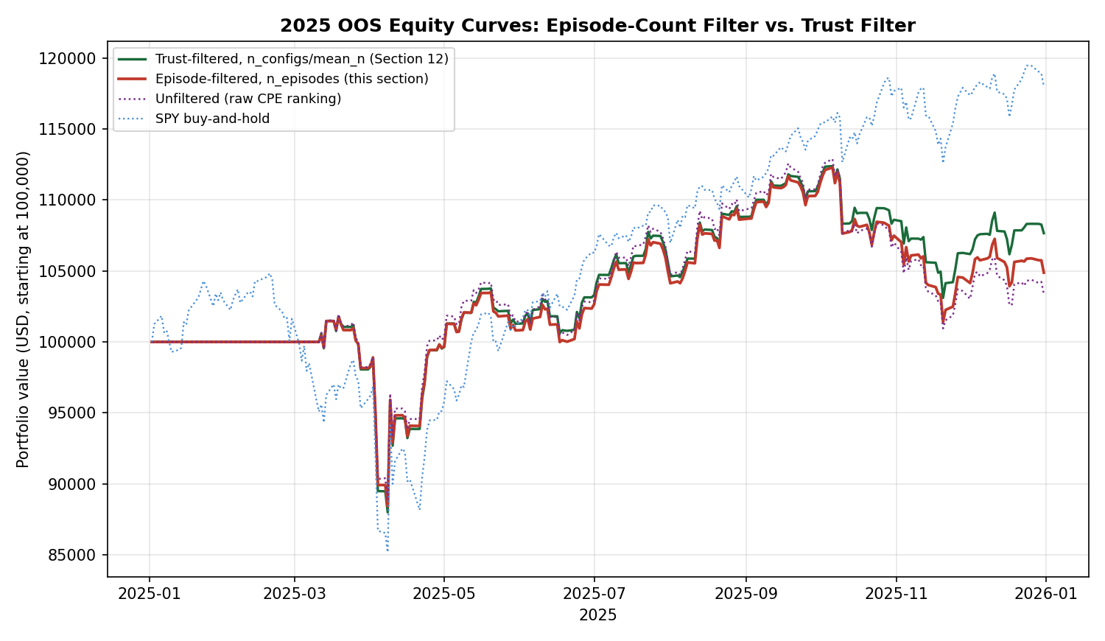
Figure 9. Daily equity curves, episode-filtered versus trust-filtered and unfiltered cross-sectional strategies, 2025.

14.2 A More Defensible Filter Performs Worse, and the Reason Is Itself Informative
The episode-count filter is more carefully justified statistically than Section 12's filter — it directly targets the independence problem rather than using sample size and configuration count as a proxy for it — yet it produced a worse 2025 result (4.88% return, Sharpe 0.389, beaten by 92.7% of random reassignments) than the cruder trust filter (7.66%, 0.556, beaten by 90.8%). Examining the largest remaining losses explains why directly: DOGE-USD remained the single worst contributor (−1.26 percentage points) despite passing the episode filter. Its best-supported configuration — conditioning on SLV and SI=F (silver spot and silver futures) — genuinely fired across five temporally distinct historical episodes, satisfying the episode-count criterion comfortably. But silver predicting dogecoin's price has no plausible economic mechanism behind it; the relationship recurring five times across the training history is much more consistent with a coincidental statistical association that happens to reappear periodically than with a genuine causal or risk-factor-driven link. The episode-count filter, exactly as designed, correctly excluded ADA-USD's genuinely single-episode artifact, but it has no way to distinguish a spurious relationship that happens to recur from a genuine one that recurs — both produce multiple episodes, and only one of them should be trusted.
This is a different and arguably more fundamental limitation than anything diagnosed in Sections 11–13: those sections addressed how much historical support a configuration has; this section's result shows that historical support, however carefully measured, does not by itself establish that a configuration's predictors are an economically sensible explanation for its target, and the trust filter's blunter n_configs/mean_n criterion happened, apparently coincidentally, to exclude more of the spurious-but-recurring relationships in this particular universe than the more principled episode count did.

14.3 Interpretation
Across Sections 11–14, every statistically-motivated correction to the framework's quality weighting has been tested and found wanting to varying degrees, but the pattern across all four is itself a clear and useful finding rather than a dead end: raw CPE ranking is actively miscalibrated (Section 11.3's −0.33 correlation); shrinkage corrects the direction but not the discrimination (Section 13.2); a hard filter on sample-size proxies discriminates well but mostly by proxy for market-beta concentration (Section 12.3); and a more rigorous episode-independence filter discriminates on genuine historical independence but is blind to economic plausibility (this section). None of the four, alone, separates a real predictive relationship from an artifact that happens to satisfy whichever statistical criterion is being applied. This suggests the missing ingredient is not a better statistic computed from price data alone, but some form of economic or structural prior — for instance, restricting predictor-target pairs to those with a defensible economic narrative (volatility predicting equities, commodities predicting related commodities), rather than allowing the greedy search to range freely across all 161 instruments and discover whichever combination happens to fit the training sample, regardless of whether silver has any reason to predict dogecoin. Testing such a restriction is a substantively different undertaking from anything in this paper — it requires a pre-specified map of economically plausible predictor-target relationships, not a further statistic computed from the existing screen — and is identified here as the most promising remaining direction this investigation has not yet attempted.

15. Limitations
- Coarser parameter grid than the Atlas: this paper sweeps 5 trailing horizons, 4 forward horizons, and 5 quantile levels per tail, versus the Atlas's 8/8/8. The qualitative class-to-class structure replicated; the exact count of surviving configurations would differ on the full grid.
- Single evaluation year: as the single-asset paper's own Section 8.12 demonstrates for the binary-rule case, a longer walk-forward window can reverse conclusions reached on one year alone. This paper does not repeat that multi-decade walk-forward test for the Portfolio Tilt construction; doing so is a natural next step.
- Five-sleeve, single-proxy tradeable universe: the strategy trades one liquid instrument per asset class, not the full 161-instrument universe the predictor side draws on. A richer tradeable universe (matching predictors to targets within the same class, as the Atlas's joint-configuration tables already support) is unexplored here.
- Transaction costs and capital constraints beyond the single $100,000 notional book are not modelled, consistent with the single-asset paper's own disclosed limitation.
- History-weight down-weighting (Section 2.3) is a deliberately mild, monotone penalty calibrated before any 2025 results were observed. Section 7.1 confirms directly that it made no material difference to this year's headline numbers: the short-history predictors it targets (the spot Bitcoin ETFs) never survive the screen's own CPE/lift/sample-size filters in the first place, appearing in zero surviving configurations, and every predictor that does survive carries the mechanism's full weight of 1.0. Short predictor history is a ruled-out, not merely an unlikely, explanation for this paper's results.
- The volatility-complex-decay finding in Section 3.3 is diagnostic; Section 7 tests the natural fix directly and finds it removes the framework's only working signal channel along with the diagnosed confound, rather than improving the result — the two were, in this universe and this year, the same instruments.
- Dynamic position sizing (Section 9) was tested in only one specification (EWMA inverse-variance, λ=0.94) and found wanting; a milder response function (inverse-volatility, or a vol-target with weight bounds) was identified as a natural alternative but not tested, and could plausibly behave differently from the aggressive de-risking documented here.
- The hold-to-horizon fix (Section 10) was tested with uncapped position sizing and was not subjected to the randomisation test of Section 3.4, given only ten signal-holds were generated; a capped, realistically-deployable version, and a formal significance test once more signal-holds are available from a longer evaluation window, are both natural next steps this paper does not complete.
- Section 12's trust filter was tested on the SAME 2025 window used throughout this paper, not a fresh evaluation year; while the filter thresholds themselves were fixed using only training-period data (a legitimate pre-specification), the decision to test this particular hypothesis at all was motivated by observing Section 11's results on 2025 data, so Section 12's improvement should be read as a promising, mechanistically-explained finding rather than independent confirmation.
- Section 12.3 and Section 13.3 both show the improved-return specifications' performance is substantially attributable to elevated correlation with broad market beta (0.92–0.93 with SPY) rather than demonstrated timing skill; separating quality-filtering from beta concentration is identified as a specific next step but not attempted here.
- Section 13's shrinkage strength K=100 was chosen by a principled but single criterion (correlation with n_joint); other criteria or a much larger K were not explored, to avoid tuning the parameter against the same 2025 result used to motivate testing it.
- Section 14's episode-clustering gap parameter (1.5x the conditioning window) was chosen as a reasonable single value, not optimised; a different gap multiplier could plausibly classify DOGE-USD's SLV/SI=F configuration differently, and this was not explored to avoid the same tuning concern.

16. Conclusion
This paper closes the loop the single-asset paper's Section 8.15 left open: does a multi-predictor, continuously-weighted construction of the Conditional Probability of Exceedance framework, applied across a diversified asset-class book under the same strict train/test discipline, produce a demonstrated trading edge where the single-asset binary entry rule did not? Over the single 2025 out-of-sample year tested here, the answer is no, but for a structurally different and more specific reason than the single-asset paper found: rather than a binary gate discarding informative curve shape, the continuous, multi-predictor aggregation machinery here is working as designed, but the strongest training-period joint configurations for four of five tradeable sleeves are anchored on long-horizon thresholds of structurally decaying volatility-complex instruments whose extreme quantiles were essentially never re-cleared in the subsequent year, leaving the portfolio at its training-period neutral weights for all but seventeen of two hundred fifty trading days. The resulting strategy is statistically indistinguishable from its own no-tilt benchmark (56.3% of randomised reassignments matched or exceeded its realised Sharpe) and underperformed concentrated single-asset buy-and-hold exposure to both the year's best performer (Gold) and the more conventional comparator (SPY), as well as professionally-run diversified peers (a classic 60/40 allocation and AQR's published Risk Parity Fund), though it outperformed a real systematic peer (a managed-futures CTA ETF). A follow-up test of dynamic, volatility-responsive position sizing (Section 9) found the same pattern from a different angle: replacing static neutral weights with EWMA inverse-variance weighting produced a materially smoother equity curve and a higher Sharpe ratio, but a substantially lower total return, because the scheme concentrated more than half the book in the single lowest-volatility sleeve for the entire year — a sleeve that itself lost money in 2025 — illustrating that a higher Sharpe ratio achieved through reduced exposure is not the same finding as a demonstrated timing or sizing edge.
A third follow-up (Section 10) traced the one real signal episode down to its individual realised outcomes and found something more encouraging: the underlying CPE estimate was genuinely accurate, correctly predicting SPY's post-tariff-shock recovery on all eleven dates it fired, out of sample. The reason the strategy nonetheless captured little of this opportunity was identified precisely — a structural mismatch between the signal's 63-trading-day forward horizon and an implementation that re-evaluates and reverts the position daily based on the predictor's own, much shorter, rolling window — and a direct fix (holding each signal for its full forward horizon, with continuous conviction-based sizing) produced a real, if modest, improvement (7.65% to 8.36% total return, Sharpe 0.560 to 0.611). This result usefully separates two previously conflated questions: whether the CPE construct identifies real, exploitable structure (Section 10 suggests yes, at least in this one traced episode), and whether this paper's particular portfolio-construction choices capture that structure efficiently (Sections 3, 7, 9 and the magnitude gap in Section 10.4 suggest they substantially do not, for reasons that are now mechanically specific rather than diffuse).
A fourth follow-up (Section 11) tested the most direct way to give the framework more chances to act: trading all 116 eligible tradeable instruments cross-sectionally, rather than five sleeve proxies. This increased trading activity 46-fold (461 position events versus 10) but made performance markedly worse (3.38% total return, Sharpe 0.294, with the realised Sharpe matched or exceeded by 89% of random reassignments of the same exposures). The mechanism was specific and measurable: across the broader universe, a ticker's mean training-period joint CPE was NEGATIVELY correlated (−0.33) with its realised 2025 contribution, while the number of distinct corroborating configurations (+0.40) and the average conditioning sample size (+0.25) were positively correlated — direct evidence of the Atlas's own documented saturation effect, in which a perfect or near-perfect training CPE on a small, heavily-overlapping sample is a signature of limited historical support rather than a reliable relationship. This reframes the paper's central question: breadth alone does not unlock the CPE framework, because most of what breadth adds is concentrated in exactly the small-sample configurations the construct's own descriptive companion paper warns are least trustworthy. The five-sleeve restriction that constrained every earlier section in this paper turns out, in hindsight, to have functioned as an inadvertent quality filter rather than merely a scoping convenience. A direct check ruled out a simpler alternative explanation: restricting the cross-sectional book to long-only positions (removing the short side entirely) produced essentially identical, marginally worse performance (3.17% versus 3.38%), confirming that permitting shorts was not the cause — nine of the ten largest losing positions were long, not failed shorts — and that the saturation mechanism is the better-supported explanation.
A fifth and final follow-up tested the most direct, pre-specified fix the saturation diagnosis implied: restricting the tradeable universe to the 36 of 125 tickers whose training-period joint configurations clear above-median thresholds on configuration count and conditioning sample size, fixed before observing any 2025 outcome. This more than doubled the unfiltered cross-sectional strategy's return (3.38% to 7.66%) and Sharpe (0.294 to 0.556), closely approaching the 5-sleeve hold-to-horizon benchmark while trading 28 tickers instead of one — a genuine, mechanistically-traceable improvement, attributable to specifically excluding ADA-USD, DOGE-USD and LINK-USD, the unfiltered run's three largest sources of loss, on training-period grounds alone. But a randomisation test found this improvement was substantially a beta story rather than a timing story: the filtered book's daily returns correlate 0.93 with SPY, and 90.8% of random reassignments of the same exposures matched or exceeded its realised Sharpe — no better than the unfiltered version. The quality filter demonstrably avoided a specific, identifiable category of bad bets, which is a real and useful property, but it achieved this largely by concentrating the surviving universe in broad, liquid, market-correlated instruments during a year the broad market performed well, not by demonstrating that the CPE framework's timing of entries and exits carries skill once that market exposure is accounted for.
A sixth and final test addressed the mechanism directly rather than filtering around it: an empirical-Bayes shrinkage adjustment pulling each configuration's CPE and lift toward the unconditional base rate by an amount proportional to its own sample size (K=100, chosen from training data alone). Applied on its own, shrinkage corrected the score's direction — it no longer mechanically rewards the smallest samples — but barely changed the result (3.38% to 3.57% return), because it compresses the spread between configurations too much to meaningfully redirect capital away from the worst offenders at a principled calibration. Combined with the Section 12 trust filter, it added a further small improvement (7.66% to 7.75% return, Sharpe 0.556 to 0.563) but left the same beta-concentration caveat fully intact (92.0% of random reassignments still matched or exceeded its Sharpe; SPY correlation 0.925). Across all six follow-ups, the conclusion is now precise rather than diffuse: a hard eligibility filter on sample-size proxies is responsible for essentially all of the demonstrated improvement in this paper, the more statistically principled continuous correction is not strong enough on its own to substitute for it, and the central open question — whether the CPE framework's signal carries genuine timing value once concentration in broad market beta is controlled for — remains unanswered by every specification tested.
A seventh test addressed a specific methodological objection to the n_joint-based corrections directly: raw overlapping-window counts overstate independent support, but a naive correction dividing by the conditioning horizon collapsed every configuration in the entire screen, including the validated Section 10 signal, to an effective sample size of essentially one — uninformative rather than appropriately cautious. A more careful correction, counting genuinely temporally-separated historical episodes rather than raw overlapping days, is statistically better justified and correctly excluded ADA-USD's single-episode artifact, but performed worse overall (4.88% return, Sharpe 0.389, beaten by 92.7% of random reassignments) than the cruder trust filter. The reason is itself an important finding: DOGE-USD's worst-performing configuration (silver predicting dogecoin) genuinely recurred across five separate historical episodes, satisfying the episode-independence criterion despite having no plausible economic basis. None of the four statistically-motivated corrections tested in this paper — raw CPE, shrinkage, sample-size filtering, or episode-independence filtering — can distinguish a spurious relationship that happens to recur from a genuine one that recurs; all four are computed from price data alone, with no representation of whether a predictor-target pair is economically plausible in the first place. This is offered as the central finding of the paper's extended investigation: the missing ingredient is most likely not a better statistic, but a pre-specified economic prior over which predictor-target relationships are admissible at all, a substantively different undertaking this paper does not attempt.
Section 7 then tested the most direct fix the diagnosis implied — excluding the decaying instruments from the predictor pool — and found it did not help: it removed the diagnosed confound and the framework's only working signal channel in the same action, since the greedy joint-selection procedure had concentrated on those same instruments for the April 2025 episode that produced the strategy's sole period of genuine activity. The honest reading is that this paper's two negative results are connected but distinct: the first (Sections 3–4) shows that naively trusting long-horizon thresholds on non-stationary, decay-prone instruments produces joint configurations that look strong in training and contribute nothing out of sample; the second (Section 7) shows that the simplest correction for that problem is also not free, because the same instruments concentrate the genuine economic signal this particular tradeable universe contains. As with both prior papers in this series, the contribution here is the rigorously-disclosed negative result and the specific, falsifiable mechanism behind it — not a demonstrated edge — together with a more carefully specified, but still untested, hypothesis (detrending or horizon-restricting decaying-instrument thresholds rather than excluding them outright) for a future study to evaluate on its own fresh out-of-sample year.

References
AQR Funds (2026). AQR Risk Parity Fund (AQRRX) fact sheet, performance as of 12/31/2025. AQR Capital Management.
Morningstar (2025). Markets Brief: A Solid Year for Bonds and 60/40 Portfolios. Morningstar.com, December 2025.
Ramanathan, A. (2026a). A conditional exceedance framework for interpretable trading decisions: single-asset validation of the Conditional Probability of Exceedance construct on SPY, with strict out-of-sample evaluation. Preprint.
Ramanathan, A. (2026b). A descriptive atlas of conditional exceedance structure across a multi-asset universe: joint tail co-movement among equities, crypto, commodities, rates, volatility and FX, 1993–2026. Preprint.
Simplify Asset Management (2026). Simplify Managed Futures Strategy ETF (CTA), 2025 calendar-year performance. Simplify.us / Yahoo Finance fund performance history.
A note on scope
This manuscript characterises a research prototype's historical out-of-sample performance over a single evaluation year and is not investment advice. Nothing in it constitutes a recommendation to transact in any instrument. Past performance carries no guarantee of future results, and the omission of transaction costs and capital constraints beyond a single notional book means the reported figures should not be read as deployable net returns.

