A Descriptive Atlas of Conditional Exceedance Structure Across a Multi-Asset Universe
Joint Tail Co-Movement Among Equities, Crypto, Commodities, Rates, Volatility and FX, 1960–2026
Arun Ramanathan
Preprint — this version compiled June 2026
Abstract
We present a large-scale descriptive study of conditional tail co-movement across a universe of 161 financial instruments spanning equities, cryptocurrencies, commodities, fixed income, volatility, and foreign exchange, using daily data whose earliest series begin in 1960 and which extend to June 2026. Our central object is the Conditional Probability of Exceedance (CPE): the empirical frequency with which a target asset's forward log-increment over a horizon breaches a chosen quantile threshold, conditional on a predictor asset's trailing log-increment having breached its own threshold. We compute this quantity exhaustively over a grid of trailing and forward horizons spanning one to three hundred trading days and over a grid of quantile thresholds from the median to the 99th percentile, in both bullish (upper-tail) and bearish (lower-tail) directions, retaining roughly 169,000 pairwise configurations that exceed pre-set support and lift filters. We then extend the analysis to joint conditioning sets of up to ten predictors via a greedy intersection procedure. The study is explicitly descriptive rather than predictive: every threshold is an in-sample quantile and no out-of-sample or forecasting claim is made or implied. Read at the level of asset-class structure rather than individual ranked pairs, the atlas reveals coherent and interpretable regions of strong conditional co-exceedance — within-complex metal linkages, a pronounced volatility-to-equity lower-tail channel, dense intra-crypto coupling, and a recurring crypto-to-commodity association mediated by the post-2024 spot Bitcoin ETFs. We document these structures, characterise their dependence on horizon and threshold, and discuss the important interpretive limits imposed by overlapping observation windows and heterogeneous sample start dates.
Contents

1. Introduction
Dependence between financial assets is famously unstable in its tails. Correlations estimated over calm periods routinely understate the degree to which assets move together during stress, and a large literature on contagion, flight-to-quality, and tail dependence has grown up precisely because the linear, second-moment view of co-movement misses the behaviour that matters most when it matters most. The copula and extreme-value-theory traditions address this by modelling the dependence structure of joint extremes directly. Those approaches are powerful but parametric: they require a model of the marginal tails, a model of the dependence function, and a set of assumptions about stationarity that are difficult to defend across a universe as heterogeneous as the modern cross-asset landscape.
This paper takes a deliberately non-parametric and descriptive stance. Rather than fit a dependence model, we ask a simpler empirical question and ask it exhaustively. For an ordered pair of assets, and for a given pair of time horizons and quantile thresholds, what fraction of the historical episodes in which the predictor breached its threshold were followed by the target breaching its own? We call this fraction the Conditional Probability of Exceedance. It is nothing more than a conditional relative frequency — a sample statistic — but computed across the full Cartesian product of a large asset universe, a horizon grid, a threshold grid, and both tail directions, it yields a detailed map of where in the cross-asset space strong conditional co-exceedance has historically occurred.
We stress at the outset what this study is and is not. It is a characterisation of realised joint behaviour over a fixed historical sample. Because every threshold used to define an exceedance is an in-sample quantile of the full record, the CPE is a descriptive statistic of that record and nothing more. We make no forecasting claim, we perform no out-of-sample validation, and the word “predictor” throughout should be read as “conditioning variable,” not as a claim of predictive power. This is not a limitation we apologise for; it is the design. The value of an atlas is in faithfully depicting the terrain, and the terrain here is the historical geometry of joint exceedance.
Our contribution is therefore threefold. First, we assemble and document a broad, six-class instrument universe and a reproducible pipeline for computing pairwise and joint CPE across it. Second, and centrally, we show that when the results are read at the level of asset-class structure — which regions of the target-by-predictor space light up — a small number of coherent and economically interpretable channels dominate, rather than the idiosyncratic individual pairs that a naive ranked-table reading would emphasise. Third, we are explicit and quantitative about the interpretive limits of the construction, in particular the role of overlapping observation windows in inflating apparent support and saturating the conditional frequency near unity, and the role of heterogeneous and in several cases very short sample histories.

2. Data and Universe Construction
The instrument universe comprises 161 daily price series retrieved from public market-data sources and organised into six asset classes. The class composition is summarised in Table 1. Equities (50 instruments) include broad U.S. and international index ETFs, the eleven GICS sector ETFs, factor and style ETFs, a set of thematic and leveraged vehicles, and a handful of mega-capitalisation single names. Commodities (30) span precious and base metals, energy, and agricultural exposures in both ETF and front-month futures form. Fixed income and rates (27) cover the Treasury maturity ladder, TIPS, investment-grade and high-yield credit, municipals, and the constant-maturity Treasury yield indices. Foreign exchange (22) covers G7 majors, a set of emerging-market crosses, the dollar-index ETFs, and several cross rates. Cryptocurrency (20) covers major coins, a set of alternative coins, and the spot Bitcoin and Ethereum exchange-traded products. Volatility (12) covers the VIX family of indices together with the principal listed volatility exchange-traded products.
Asset class | Instruments | Representative members
Equities | 50 | SPY, QQQ, sector XLs, factor ETFs, AAPL…NVDA
Commodities | 30 | GLD, SLV, PPLT, PALL, USO, UNG, CORN, GC=F…
Rates / credit | 27 | SHY…TLT, TIP, LQD, HYG, ^TNX, ^IRX…
FX | 22 | EURUSD=X…, UUP, UDN, EURJPY=X…
Crypto | 20 | BTC, ETH, SOL…, IBIT, FBTC, GBTC, BITB
Volatility | 12 | ^VIX, ^VVIX, ^SKEW, UVXY, SVXY, VIXM…
Table 1. Composition of the 161-instrument universe by asset class.
The series are deeply heterogeneous in length. The constant-maturity Treasury yield indices extend back to 1960; the S&P 500 ETF begins in 1993; most sector and factor ETFs begin between 1998 and 2006; the major cryptocurrencies begin between 2014 and 2018; and — a point we return to repeatedly — the spot Bitcoin ETFs (IBIT, FBTC, BITB) begin only in January 2024, giving them barely two years of history as of this writing. This heterogeneity is intrinsic to a realistic cross-asset universe and cannot be engineered away, but it bears directly on the interpretation of any conditioning event that involves a short-history instrument, because the conditioning sample for such an event is necessarily drawn from a narrow and possibly unrepresentative window.
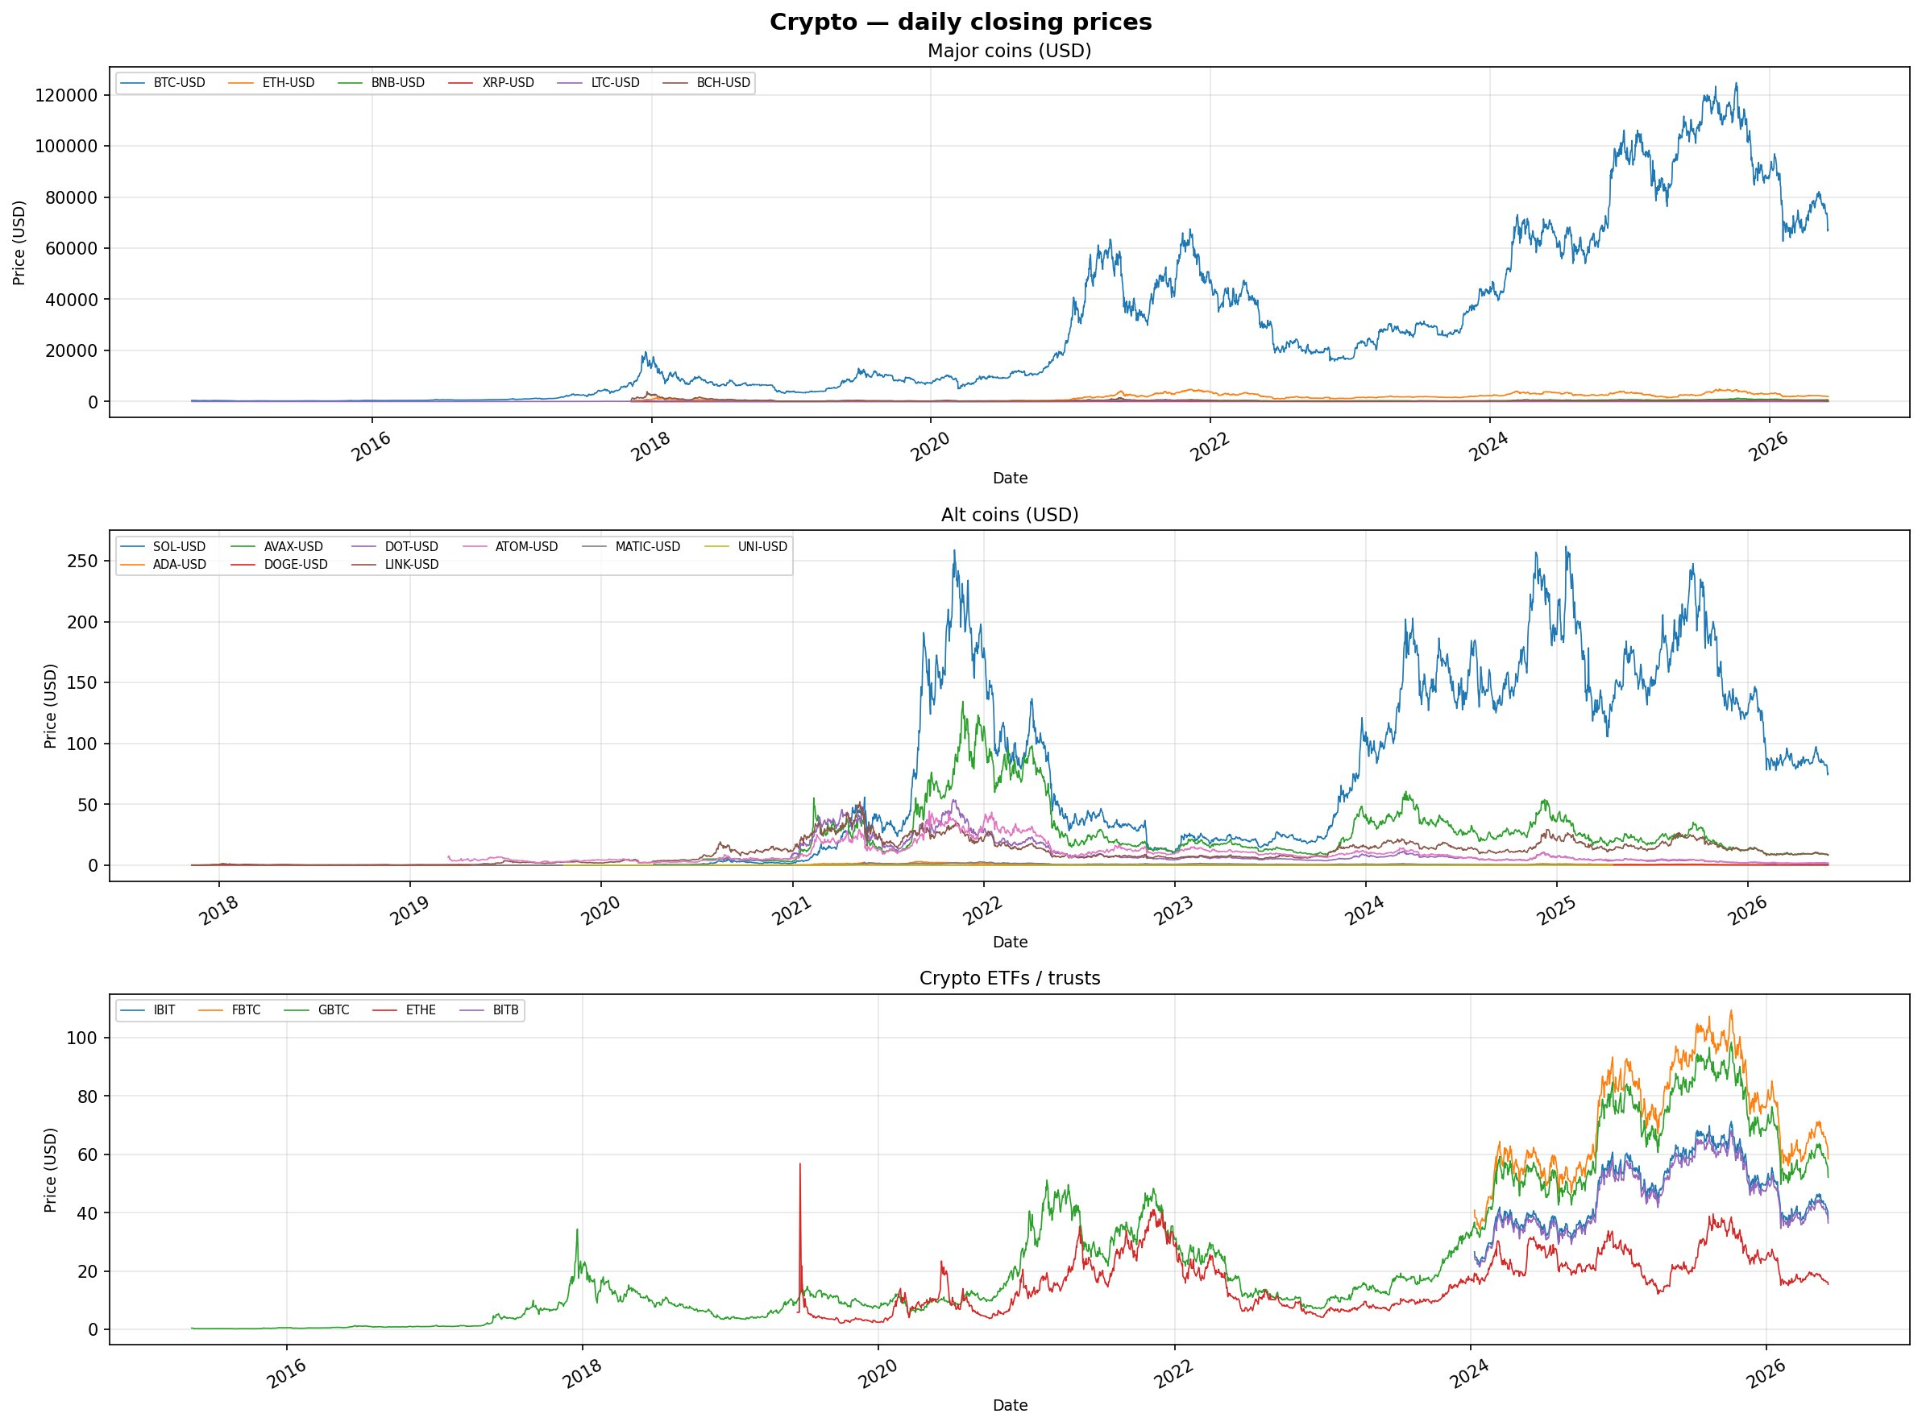
Figure 1. Daily closing levels for the cryptocurrency block: major coins (top), alternative coins (middle), and the crypto ETFs and trusts (bottom). The January 2024 inception of the spot Bitcoin ETFs is visible in the bottom panel and constrains the conditioning history available for any signal involving IBIT, FBTC, or BITB.
The volatility complex (Figure 1b) presents a different sampling challenge. The VIX-family indices extend back to 1990 and exhibit the familiar spike-and-decay pattern, but the listed volatility products are short-dated and subject to extreme roll decay, with one series spanning many orders of magnitude over its life. The rate complex (Figure 1c) combines the very long yield-index histories from 1960 with much shorter ETF histories beginning in the 2000s. These panels make concrete why the conditioning history available for a configuration depends sharply on which instruments it involves, and why we annotate the short-history channels so carefully in Section 6.
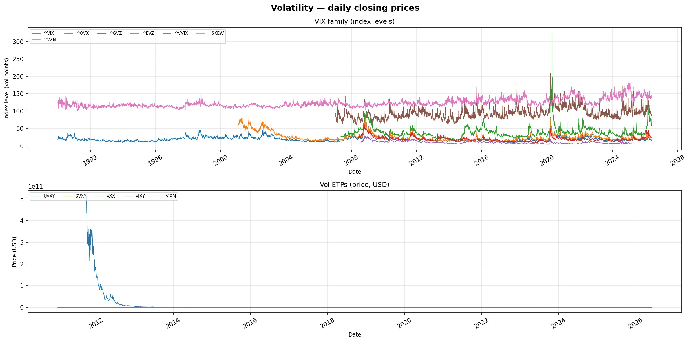
Figure 1b. The volatility complex: VIX-family index levels (top) and listed volatility ETPs (bottom). The ETPs are short-dated and roll-decayed, and are excluded from the target side of the analysis.
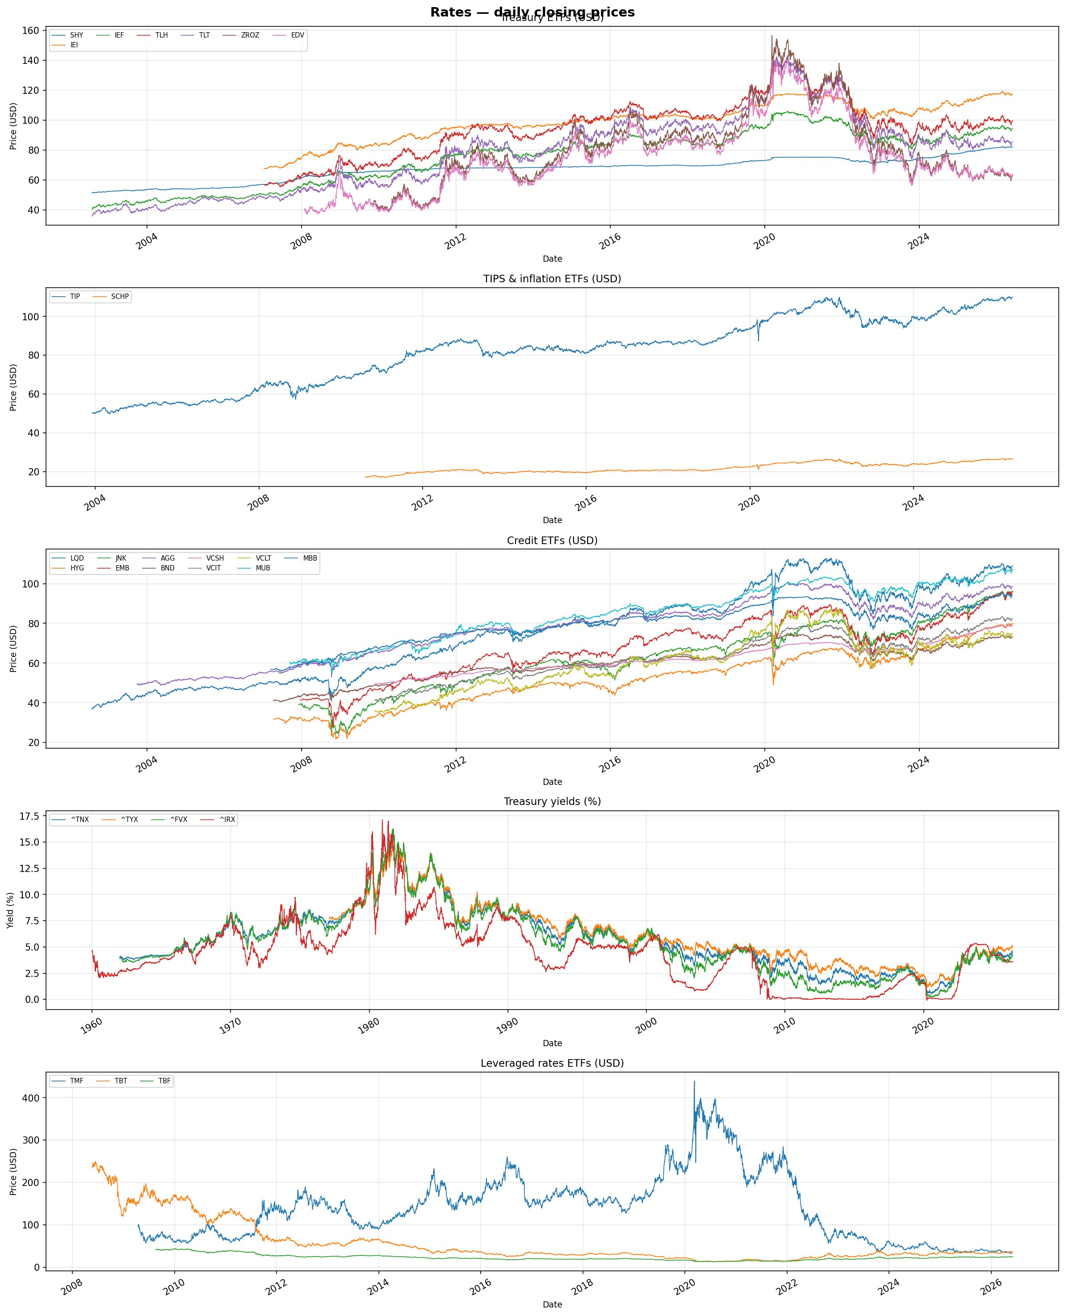
Figure 1c. The rates and credit complex: Treasury and credit ETF prices, constant-maturity yield indices extending to 1960, and leveraged rate ETFs. Sample lengths within this single class span more than six decades.

2.1 Increments and thresholds
For each instrument we construct overlapping log-increments at trailing horizons τ ∈ {1, 5, 10, 21, 63, 126, 252, 300} trading days. For price-like series the increment at horizon τ on date t is rt,τ = log(Pt / Pt−τ); for the four constant-maturity yield indices, which are already expressed in yield points, we use arithmetic differences rather than log-ratios. Thresholds are defined as unconditional empirical quantiles of each instrument's increment distribution at each horizon, over the full available history of that instrument, on a grid q ∈ {0.50, 0.60, 0.70, 0.75, 0.80, 0.90, 0.95, 0.99} together with the complementary lower-tail quantiles. Because these quantiles are computed over the entire sample, they are descriptive sample quantiles and the entire construction is a within-sample characterisation.

3. The Conditional Probability of Exceedance

3.1 Pairwise definition
Fix an ordered pair of instruments (Y, X), a trailing horizon τp for the predictor, a forward horizon τf for the target, predictor and target quantile levels qX and qY, and a direction. In the bullish (upper-tail) direction we define the conditioning event on date t as the predictor's trailing increment exceeding its upper threshold, and the target event as the target's forward increment over the next τf days exceeding its own upper threshold. The bearish direction uses the corresponding lower thresholds. The CPE is then the fraction of conditioning dates on which the target event also occurred:
CPE = #{ t : predictor breached AND target subsequently breached } / #{ t : predictor breached }
The unconditional probability of the target event is by construction 1 − qY, and we define the lift as the ratio of the CPE to this unconditional baseline. A lift above one indicates that conditioning on the predictor's exceedance raised the realised frequency of the target's exceedance relative to its base rate over the sample. We retain a configuration only if its conditioning sample contains at least 100 observations, its CPE is at least 0.80, and its lift is at least 1.5; these filters are deliberately permissive and serve to discard configurations too sparse or too weak to be informative, not to perform any inferential selection.
The full pairwise computation evaluates every target against every eligible predictor across all horizon and threshold combinations in both directions, a space of order ten to the eighth in size, and is parallelised across instruments. Leveraged and inverse products, together with three managed-peg currencies, are excluded from the target side because their mechanical construction would generate trivially implied co-exceedances; the managed-peg currencies are additionally excluded from the predictor side. After filtering, 169,357 pairwise configurations survive, of which 107,846 are bullish and 61,511 bearish, involving 136 distinct targets and 158 distinct predictors.

3.2 Joint conditioning
The natural extension of pairwise conditioning is to condition on several predictors simultaneously. For each target, horizon, threshold and direction, we begin from the strongest surviving single predictor and greedily add further predictors, at each step intersecting the conditioning masks and retaining the addition that most increases the joint CPE, subject to the same support, CPE and lift filters and to a constraint that no instrument appears twice in a set. The procedure terminates when no admissible addition remains or when ten predictors have been selected, and every intermediate set of size two or greater that passes the filters is recorded. This yields 4,545 joint configurations, 2,956 bullish and 1,589 bearish, ranging from two to ten predictors.
The greedy construction is a deliberate simplification. It does not search the full combinatorial space of predictor subsets, which would be infeasible at this universe size, and it is therefore not guaranteed to find the globally strongest set of a given size. For a descriptive atlas this is acceptable: the aim is not to certify optimal predictor sets but to establish which targets admit coherent multi-predictor conditioning at all and from which asset classes the constituent predictors are drawn. The greedy path is a representative, reproducible traversal of the joint space rather than an exhaustive optimisation, and its outputs are interpreted accordingly.

3.3 On ranking and the meaning of saturation
A substantial fraction of surviving configurations sit at or very near a CPE of unity: about 6.4 percent of pairwise configurations have a CPE of at least 0.99 and roughly 4.7 percent are exactly one. This saturation is the single most important feature to interpret correctly, and it has a mechanical rather than an economic origin. When a conditioning event is rare — a joint breach of high quantiles over a long trailing window — the conditioning sample reduces to a small number of historical episodes. Because the trailing and forward windows are overlapping and stepped daily, consecutive conditioning dates share almost all of their underlying window; a nominal conditioning count of, say, 150 daily observations at a 252-day horizon corresponds to only a handful of genuinely distinct episodes. A conditional frequency computed over a few distinct episodes can readily equal one, and many such configurations do.
We therefore caution explicitly against over-reading the ordering of configurations within the saturated region. Where many configurations report a CPE of exactly one, the point estimate cannot separate them, and the conditioning count — which we use as a secondary sort key after CPE and lift — should be read as a rough indication of how much historical support stands behind a configuration, not as an independent-sample size suitable for inference. We deliberately do not attach confidence intervals to the CPE: the standard interval constructions assume independent Bernoulli trials, an assumption that overlapping windows violate, and presenting such intervals would import a false precision. The honest reading of a saturated configuration is qualitative — “across the small number of historical episodes in which this conditioning held, the target almost always subsequently breached” — and the value of the atlas lies not in the fine ranking of these episodes but in the asset-class structure they collectively trace out, to which we now turn.

4. The Asset-Class Structure of Conditional Co-Exceedance
The organising finding of this study is that the surviving conditional co-exceedances are not scattered uniformly across the cross-asset space. They concentrate in a small number of target-by-predictor regions that are stable across the horizon and threshold grid and that admit straightforward economic readings. We make this concrete first at the level of asset-class flows and then through the threshold-resolved heatmaps.

4.1 Class-to-class flows
Table 2 aggregates the surviving bullish pairwise configurations by the asset class of the target (rows) and of the predictor (columns). The counts are not uniform. In the upper-tail direction the densest single cell is commodities conditioned on crypto, with over sixteen thousand surviving configurations, followed by commodities conditioned on equities and by equities conditioned on the volatility complex. The bearish flows, in Table 3, redistribute markedly: the volatility-to-equity channel strengthens in relative terms, rates-conditioned-on-crypto and equities-conditioned-on-crypto become prominent, and the within-commodity and rates-on-rates cells fill in. The asymmetry between the two directions is itself informative, and is invisible at the level of any single pair.
Table 2. Surviving bullish (upper-tail) pairwise configuration counts by target class (rows) and predictor class (columns).
Target \ Predictor | Comm | Crypto | Equity | FX | Rates | Vol
Commodities | 4927 | 16729 | 11655 | 1762 | 2833 | 3065
Crypto | 1280 | 1276 | 6743 | 2144 | 2277 | 1994
Equities | 1653 | 2854 | 7678 | 1674 | 6707 | 8617
FX | 1014 | 2008 | 2270 | 432 | 1974 | 1591
Rates | 2531 | 1843 | 2616 | 2257 | 2663 | 779

Table 3. Surviving bearish (lower-tail) pairwise configuration counts by target and predictor class.
Target \ Predictor | Comm | Crypto | Equity | FX | Rates | Vol
Commodities | 3032 | 4017 | 4794 | 1737 | 4937 | 3042
Crypto | 262 | 1229 | 1946 | 780 | 972 | 190
Equities | 1287 | 5189 | 2882 | 1627 | 2236 | 934
FX | 1416 | 1262 | 1073 | 716 | 465 | 1312
Rates | 1519 | 6060 | 2344 | 536 | 1327 | 2388

Two cross-cutting channels deserve emphasis because they recur throughout the threshold-resolved results below. The first is the volatility-to-equity lower-tail channel: conditioning on a prior surge in the volatility complex is associated, across many sector and factor equity targets, with subsequent lower-tail equity exceedance. This is the empirical shadow of the well-known leverage and risk-off dynamic, and it appears here without any modelling assumption, simply as a dense region of the target-by-predictor map. The second is the crypto-to-commodity upper-tail channel, which is numerically the largest single cell in the bullish table and which, on inspection of the individual configurations, is mediated substantially by the spot Bitcoin ETFs acting as conditioning variables on precious-metal targets — a structure we examine critically in Section 6 because of the short-history caveat it carries.

4.2 Threshold-resolved structure
The aggregate flows conceal the within-region geometry, which the heatmaps recover. Figure 2 shows the bullish CPE map at a moderately directional setting (a 63-day trailing and forward horizon, predictor threshold at the 90th percentile and target at the 60th). The brightest band is the upper-left block in which the major coins and the alternative coins predict one another: intra-crypto upper-tail coupling is dense, strong, and essentially uniform across the block, consistent with the single common risk factor that the cryptocurrency complex is widely understood to share. Outside that block the map is sparse and the surviving cells are scattered, which is exactly the visual signature one should expect when a genuinely strong and homogeneous dependence region coexists with a background of weak idiosyncratic associations.
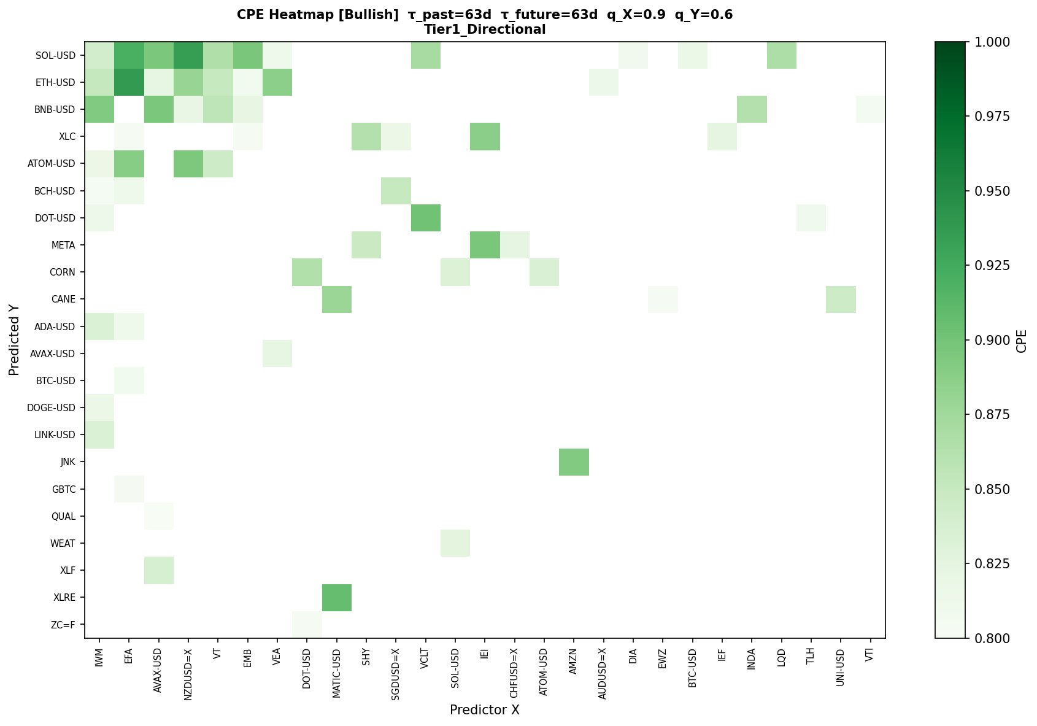
Figure 2. Bullish CPE heatmap at τ_past = τ_future = 63 days, q_X = 0.90, q_Y = 0.60 (Tier 1, directional). Rows are targets, columns predictors; colour encodes CPE on a floor of 0.80. The dense upper-left block is the intra-crypto coupling region.
Figure 3 moves to a longer horizon and a more symmetric, moderately extreme threshold (252-day trailing and forward windows, both thresholds at the 75th percentile). Here a different region dominates: the precious-metal and gold-proxy targets (PPLT, GC=F, GLD, IAU, SLV) conditioned on the crypto ETFs form a bright vertical band, and a broad-based association between a wide set of targets and the JO and AVAX columns appears in the top rows. The metal-on-crypto-ETF band is the long-horizon, higher-threshold manifestation of the crypto-to-commodity channel identified in the aggregate flows. Its strength is real within the sample, but its sample is short, and we defer the interpretation to Section 6.
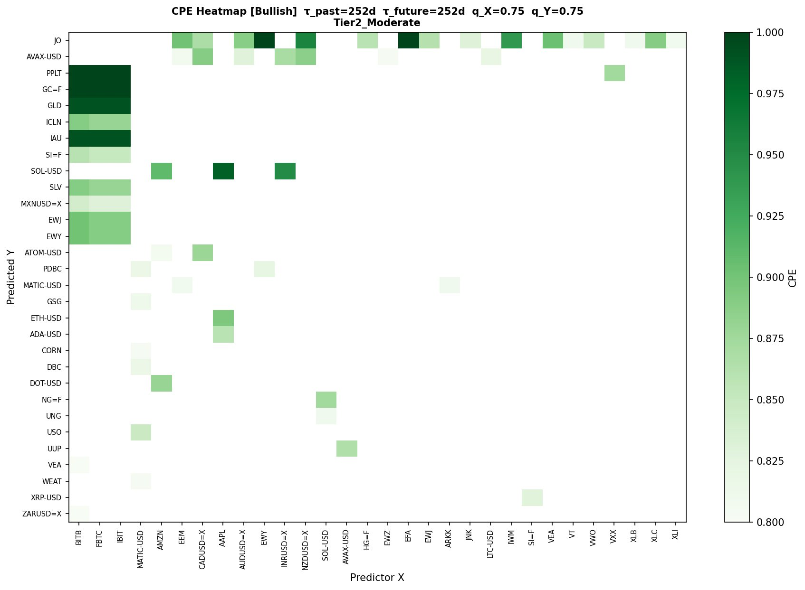
Figure 3. Bullish CPE heatmap at τ_past = τ_future = 252 days, q_X = q_Y = 0.75 (Tier 2, moderate). The bright vertical band over the BITB / FBTC / IBIT columns against precious-metal targets is the long-horizon crypto-to-commodity association.

4.3 The bearish geometry
The lower-tail maps are not simply mirror images of the upper-tail maps, and the difference is one of the more interesting structural findings. Figure 4 shows the bearish CPE map at the same moderately directional setting used for Figure 2. Two features stand out. First, the conditioning structure is sparser and more localised than in the bullish case: lower-tail co-exceedance is concentrated in particular target-predictor cells rather than spread across a homogeneous block. Second, the predictor columns that light up are dominated by the volatility and equity complexes acting on rate and commodity targets, rather than by the intra-crypto coupling that dominated the bullish picture. The economic reading is that joint downside exceedance is mediated more by broad risk-off dynamics — volatility spikes coinciding with weakness across rate-sensitive and cyclical targets — than by the within-complex momentum that characterises the upside.
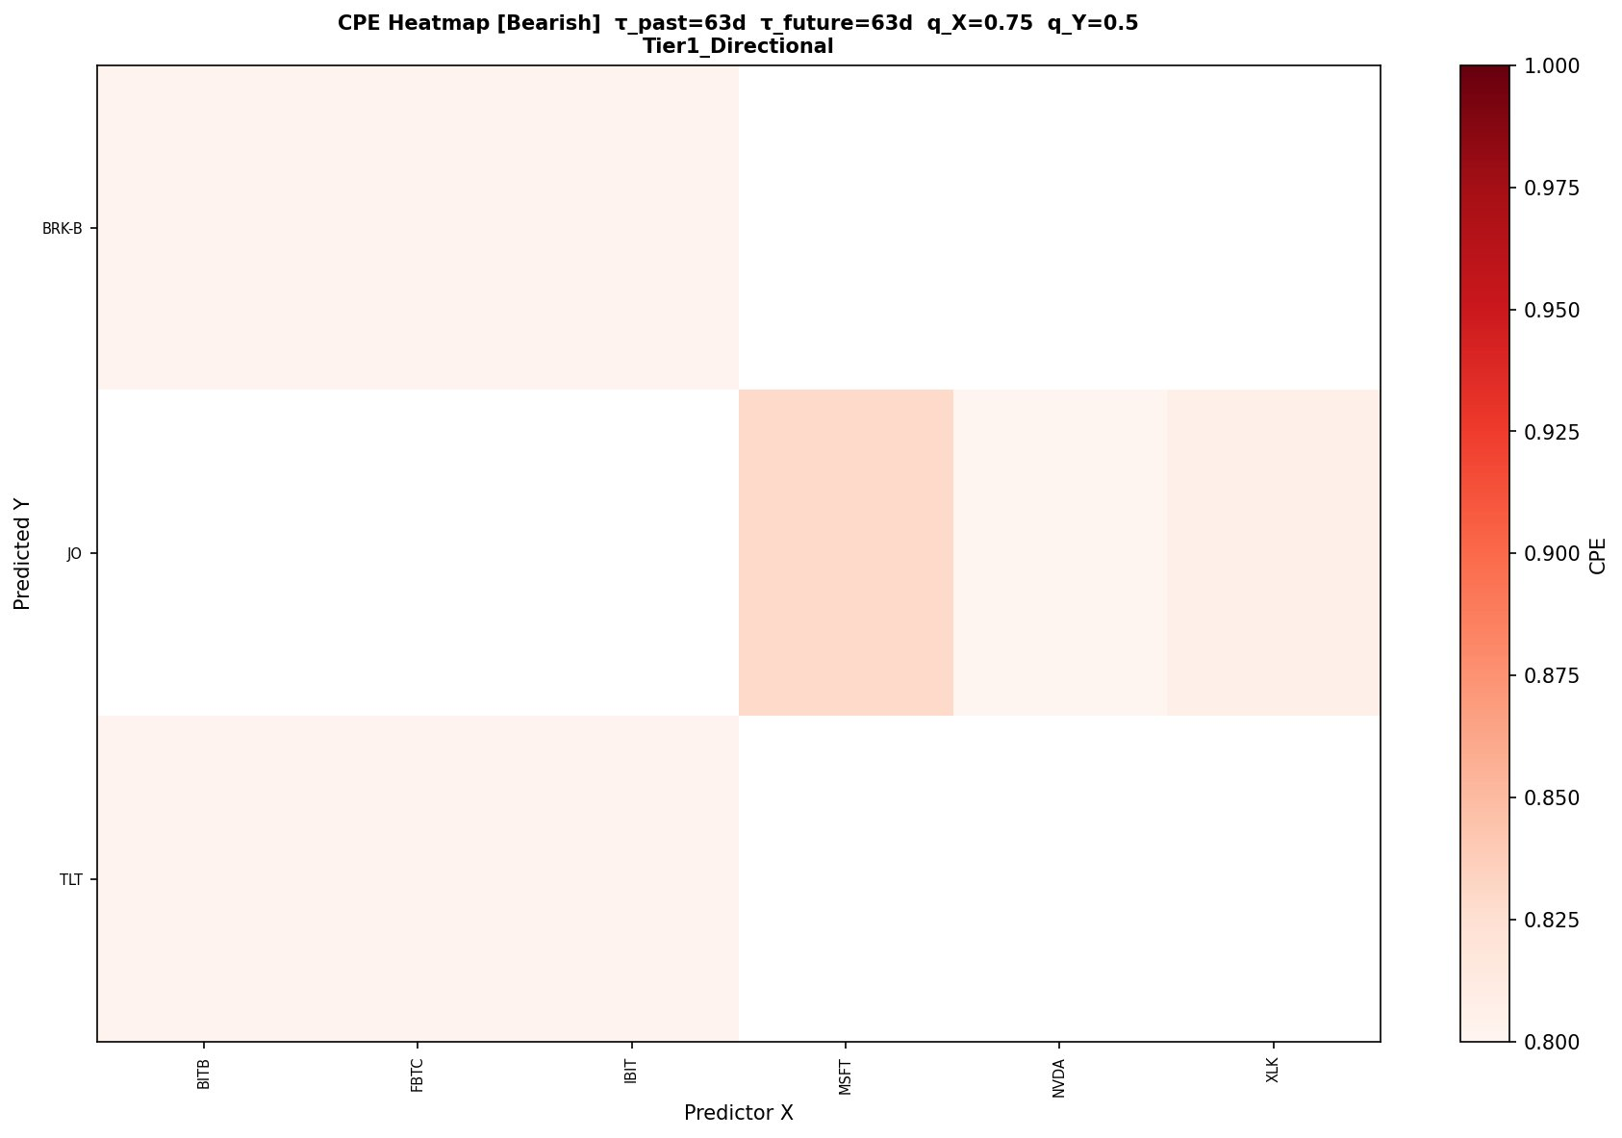
Figure 4. Bearish CPE heatmap at τ_past = τ_future = 63 days, q_X = 0.75, q_Y = 0.50 (Tier 1, directional). Lower-tail co-exceedance is sparser and more localised than the bullish analogue, with volatility and equity predictors prominent against rate and cyclical targets.
At the longer, more symmetric moderate-tier setting the bearish map (Figure 5) develops a small number of intense cells — notably palladium conditioned on the alternative coins, and natural-gas and wheat targets conditioned on the same — against an otherwise sparse field. These intense isolated cells are the bearish counterpart of the saturation discussed in Section 3.3: they rest on a small number of distinct episodes in which a sharp crypto drawdown coincided with subsequent weakness in a specific commodity, and they should be read as descriptions of those particular episodes rather than as evidence of a structural lower-tail link between an alternative coin and a metal.
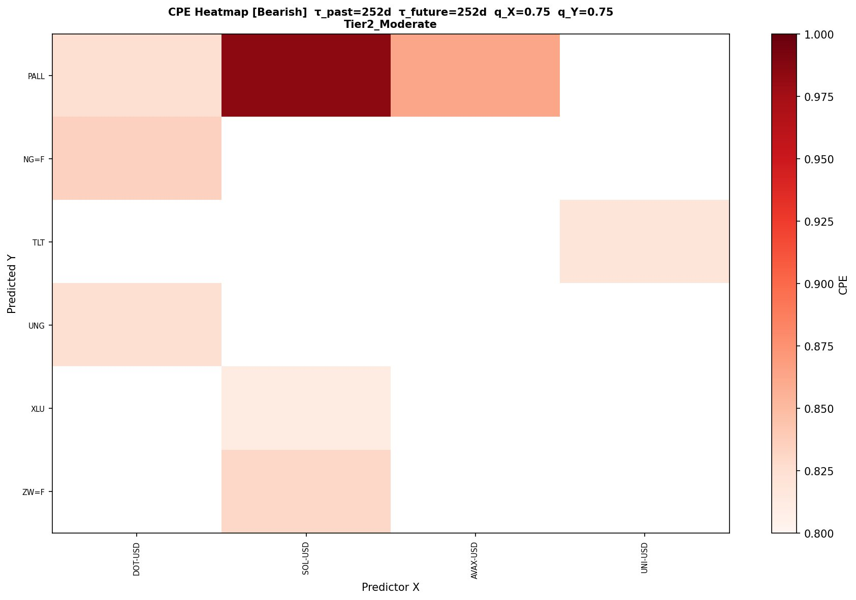
Figure 5. Bearish CPE heatmap at τ_past = τ_future = 252 days, q_X = q_Y = 0.75 (Tier 2, moderate). Intense isolated cells (e.g. PALL conditioned on crypto) rest on few distinct episodes and are read episodically rather than structurally.

5. Dependence on Horizon and Threshold
We organise the threshold grid into three tiers: a directional tier (target quantiles of 0.50 and 0.60), a moderate tier (0.70 through 0.80), and an extreme tier (0.90 through 0.99). The tiers correspond to progressively rarer target events and therefore to progressively smaller and more overlap-dominated conditioning samples. Reading across the tiers makes the saturation mechanism of Section 3.3 visible as a systematic effect rather than an isolated curiosity.
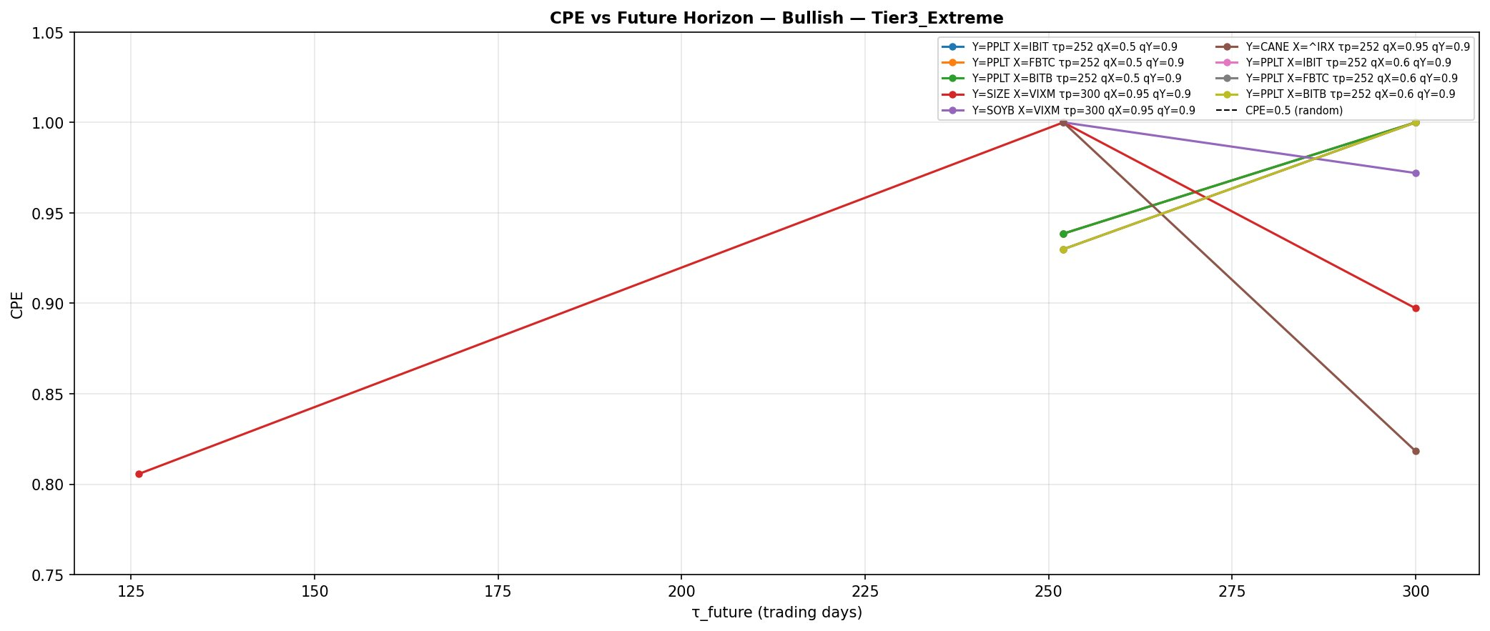
Figure 6. CPE as a function of the forward horizon for the strongest bullish configurations in the extreme tier. The curves rise toward unity as the horizon lengthens, which co-occurs with the collapse of the effective number of distinct conditioning episodes.
Figure 6 plots the CPE against the forward horizon for the strongest extreme-tier bullish configurations. The curves trend upward with horizon, approaching unity at the longest horizons. This is the expected joint consequence of two forces acting together: at longer horizons the target's directional event becomes more probable under a drifting series, and simultaneously the overlapping-window redundancy grows, so that the conditional frequency is computed over fewer and fewer distinct episodes. The upward drift of these curves should therefore be read as a property of the estimator under the tier's sampling regime, not as evidence that longer-horizon co-exceedance is economically stronger.
The bearish extreme-tier curves (Figure 7) behave differently and instructively. Several do not rise monotonically toward unity; some decline with horizon, reflecting that a sharp conditioning event in the volatility or rate complex is followed by lower-tail target exceedance over intermediate horizons but not uniformly over the longest ones. The contrast with the bullish curves underscores that the upper-tail saturation is partly a drift phenomenon: remove the persistent positive drift that characterises most price series and the approach to unity weakens, as it does on the downside.
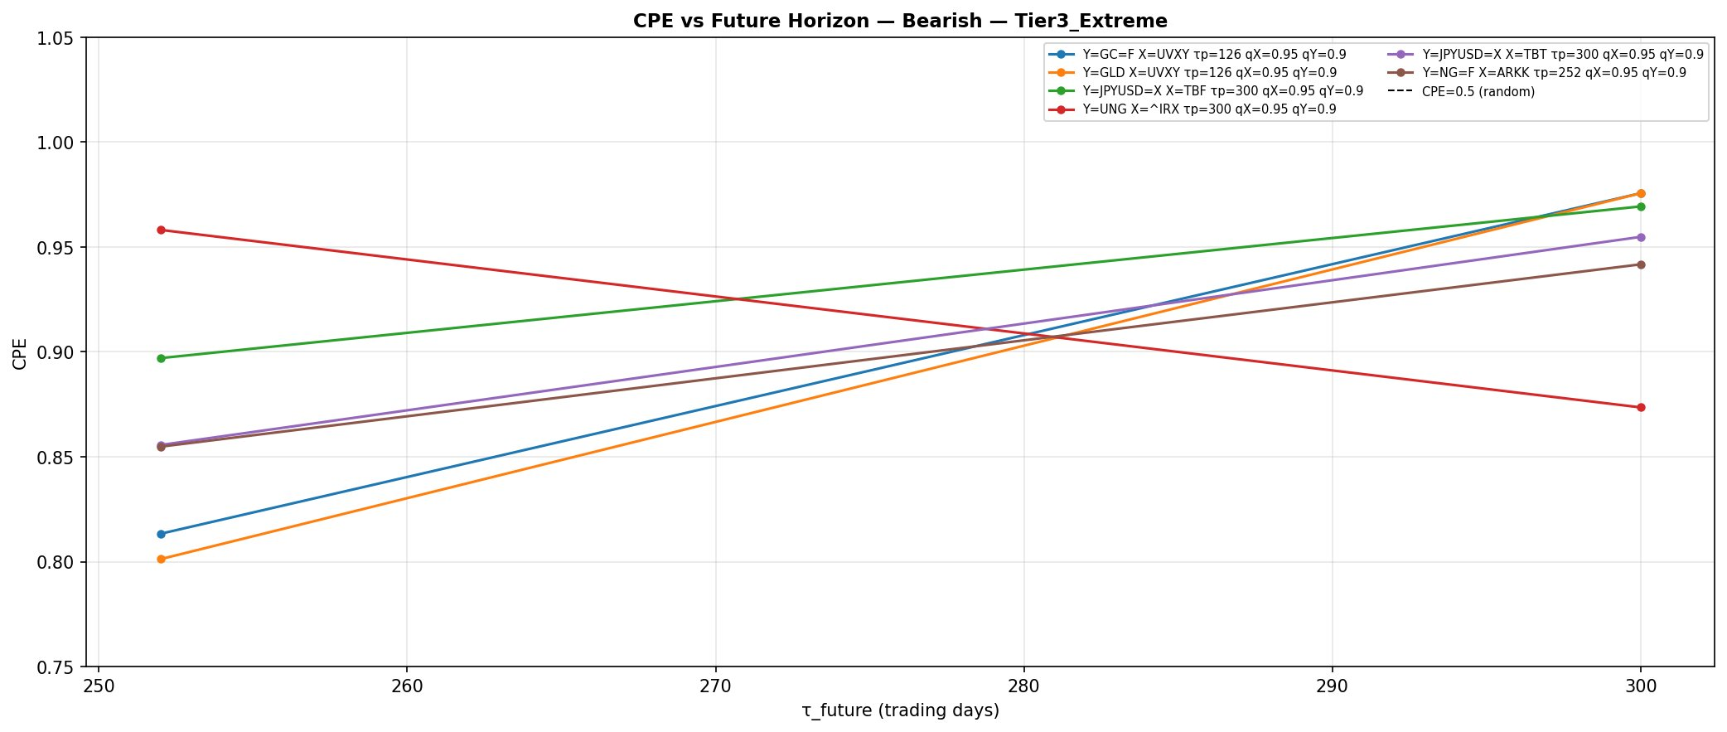
Figure 7. CPE against forward horizon for the strongest bearish extreme-tier configurations. Unlike the bullish analogue several curves are non-monotone or declining, consistent with the upper-tail saturation being partly attributable to positive price drift.

5.1 Joint conditioning and the approach to unity
The joint analysis sharpens the same point. Figure 5 shows the mean joint CPE as a function of the number of conditioning predictors, separately for the two directions; Figure 6 shows the corresponding conditioning sample size. As predictors are added, the mean joint CPE rises monotonically — from about 0.979 at two predictors to about 0.998 at eight in the bullish direction, and from about 0.968 to about 0.993 in the bearish direction — while the conditioning sample size falls toward and then sits just above the imposed floor of 100 observations. The two figures must be read together: the apparent improvement in joint CPE with set size is inseparable from the contraction of the conditioning sample, since the greedy intersection necessarily shrinks the conditioning set at each step and the floor of 100 overlapping observations is reached quickly.
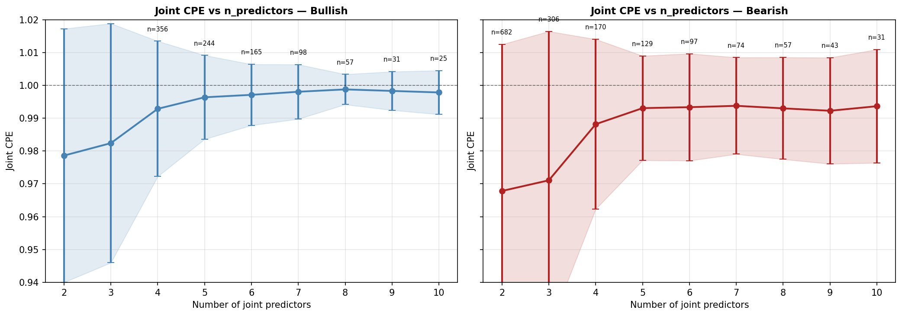
Figure 8. Mean joint CPE against the number of conditioning predictors, bullish (left) and bearish (right). Error bars are dispersion across configurations, not inferential intervals. Annotations give the number of configurations at each set size.
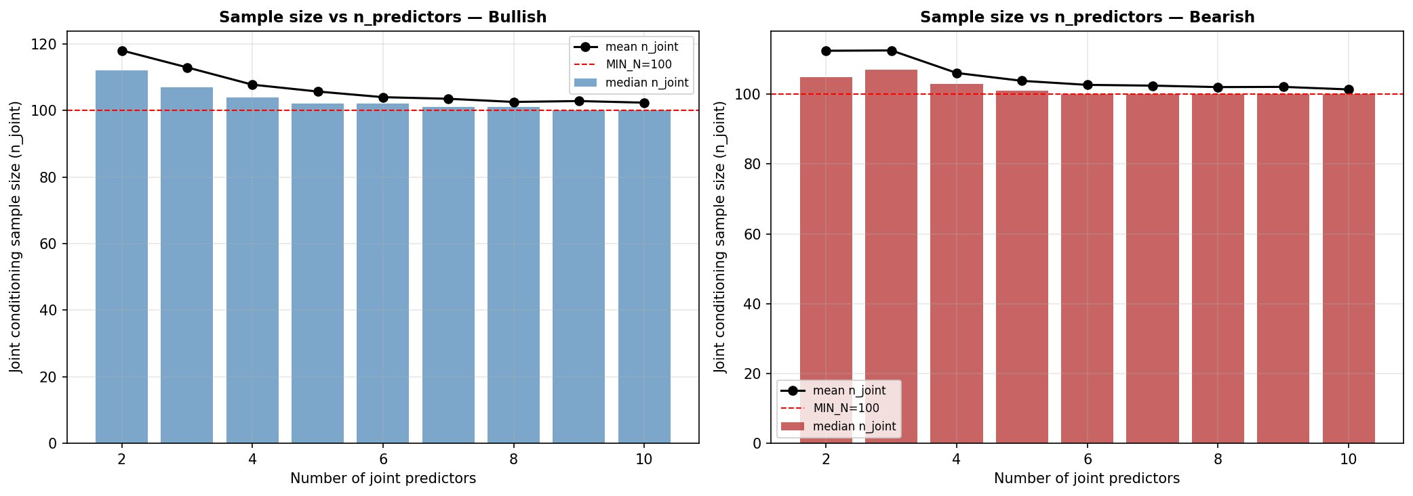
Figure 9. Joint conditioning sample size (bars: median; line: mean) against the number of predictors. The sample contracts toward the imposed floor of 100 overlapping observations as predictors are added.
This is precisely why we frame the joint results structurally rather than as a ladder of ever-stronger signals. The monotone rise in Figure 5 is not evidence that ten-predictor sets capture stronger dependence than two-predictor sets; it is the mechanical result of selecting, at each greedy step, the addition that most increases an already-high conditional frequency over a shrinking overlapping sample. The informative content of the joint analysis is in which targets admit large coherent predictor sets at all — and these are dominated by the same precious-metal and intra-crypto regions identified in the pairwise structure — not in the numerical value of the joint CPE at large set sizes.
Table 4 lists representative two-predictor joint configurations to make the structure concrete. Their character reinforces the pairwise reading: precious metals conditioned on pairs of crypto ETFs, short-rate proxies conditioned on pairs of crypto ETFs, and gold proxies conditioned on the same. These are not ten independent discoveries; they are repeated expressions of two or three underlying class-level channels.
Table 4. Representative two-predictor bullish joint configurations (descriptive; CPE saturated at unity, ordered by conditioning support).
Target | τ_f | q_Y | Predictor set | Joint CPE | n_joint
PPLT | 252 | 0.50 | FBTC ∩ BITB | 1.0000 | 195
SHY | 63 | 0.50 | BITB ∩ IBIT | 1.0000 | 191
BNO | 252 | 0.50 | ETH-USD ∩ ADA-USD | 1.0000 | 179
FXI | 252 | 0.50 | AAPL ∩ XLU | 1.0000 | 178
GLD | 252 | 0.50 | IBIT ∩ FBTC | 1.0000 | 167
IAU | 252 | 0.50 | IBIT ∩ FBTC | 1.0000 | 167

The dispersion of joint configurations is shown in Figure 10, which plots each configuration's joint CPE against its conditioning sample size, coloured by target class and sized by predictor-set cardinality. The mass of configurations sits in the upper-left, at high CPE and conditioning counts close to the floor, in both directions; the few configurations with substantially larger conditioning samples are concentrated in the equity and commodity target classes, which have the longest and most continuous histories. The figure is a compact visual summary of the saturation-versus-support trade-off that runs through the entire study.
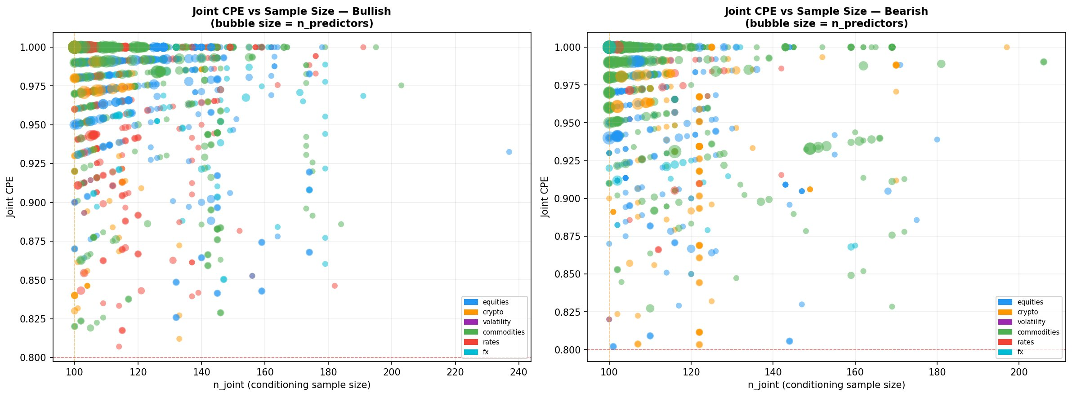
Figure 10. Joint CPE against conditioning sample size for all joint configurations, coloured by target asset class, sized by number of predictors; bullish (left), bearish (right). The dashed lines mark the CPE floor of 0.80 and the sample-size floor of 100.

6. Interpretation and Caveats

6.1 The short-history channels
The crypto-to-commodity channel, and in particular the precious-metal-on-Bitcoin-ETF configurations that populate the strongest bullish tables, demand a specific caveat. The spot Bitcoin ETFs began trading in January 2024. Any conditioning event defined on IBIT, FBTC or BITB is therefore drawn entirely from a window of roughly two years, and at a 252- or 300-day trailing horizon the number of genuinely distinct conditioning episodes available is very small. A conditional frequency of unity computed over such a window says only that, in the short and particular period since these products launched, the relevant metal target happened to be in a sustained upper-tail regime on every one of the few distinct episodes when the ETFs were also in such a regime. Both Bitcoin and gold did in fact appreciate strongly and concurrently over this window, so the co-exceedance is real as a description of 2024–2026; it carries essentially no information about a stable structural relationship, and the atlas should not be read as asserting one.
The same caution applies in attenuated form to all configurations involving the younger cryptocurrencies and, to a lesser degree, to any long-horizon configuration. We have chosen not to suppress these configurations, because doing so would misrepresent what the in-sample computation actually returns and because the heterogeneity of sample lengths is a genuine feature of the cross-asset universe. Instead we flag them explicitly and rely on the structural reading to keep them in proportion: a single short-history band on a heatmap is visually unmistakable and is naturally discounted by the reader, whereas a single highly-ranked row in a table invites exactly the over-interpretation we wish to avoid — which is, again, why the structural framing is primary.

6.2 The overlapping-window limit on inference
We restate the central interpretive limit in its strongest form so that it cannot be mistaken. The conditioning counts reported throughout are counts of overlapping daily observations. Because trailing and forward windows of up to 300 days are stepped one day at a time, adjacent observations are almost perfectly redundant, and the effective number of independent episodes underlying any reported count is smaller than the count by roughly the window length in the worst case. This has no bearing on the validity of the CPE as a description of the sample — a relative frequency over a defined set of dates is exactly what it is regardless of dependence among those dates — but it forecloses the usual machinery of statistical inference. We do not report standard errors or confidence intervals, we do not test hypotheses, and we do not rank saturated configurations against one another as though small differences in conditioning count carried inferential weight. Readers seeking to build a predictive or tradeable claim on any structure visible in this atlas would need to address the effective-sample-size problem directly, for instance through non-overlapping sampling or an explicit block-resampling scheme, and would additionally need to confront the multiplicity inherent in a screen of this size.

6.3 Multiplicity
The pairwise screen evaluates a configuration space of order ten to the eighth and retains roughly 169,000 survivors under permissive filters. No multiple-comparison control is applied, and none is appropriate to the descriptive aim: we are not claiming that any individual surviving configuration is a discovery against a null. The aggregate structure documented in Section 4 is robust to this concern precisely because it is aggregate — a dense, spatially-coherent block of thousands of surviving cells in the same target-by-predictor region is not plausibly an artefact of multiplicity in the way that a single high-ranked row might be. This is a further reason to anchor the reading in the class-level structure rather than in individual configurations.

7. Relation to Existing Approaches
The CPE is closely related to several established constructs without coinciding with any of them. It is a finite-sample, fixed-threshold cousin of the tail-dependence coefficient of extreme-value theory, which is defined as a limiting conditional exceedance probability as the threshold approaches the support boundary; our quantity fixes the threshold at a finite quantile and does not take the limit, trading the asymptotic interpretation for direct sample interpretability. It is related to the conditional exceedance probabilities that appear in the systemic-risk literature, but it is computed exhaustively and descriptively across a universe rather than estimated for a small set of designated institutions under a model. And it is a directed, asymmetric quantity — the CPE of Y given X is not the CPE of X given Y — which distinguishes it from symmetric dependence measures such as rank correlation or the symmetric tail-dependence coefficient. The asymmetry is deliberate and is exploited in the class-flow tables, where the off-diagonal asymmetries between Tables 2 and 3 carry the directional information.
The parametric copula literature offers the natural route to a generative model of the dependence structure we describe. We regard such modelling as complementary future work rather than as a competitor: an atlas of where strong conditional co-exceedance has historically occurred is a useful input to the specification of such a model, indicating which regions of the cross-asset space a parametric dependence function would need to capture. The present contribution is the map, not the model.

8. Conclusion
We have computed the Conditional Probability of Exceedance exhaustively across a 161-instrument, six-class financial universe, in both tail directions, over wide horizon and threshold grids, and have extended the analysis to joint conditioning sets of up to ten predictors. The exercise is descriptive by design: it characterises realised joint exceedance over a fixed historical sample using in-sample thresholds, and makes no predictive claim. Read at the level of asset-class structure, the atlas is interpretable and coherent. A small number of channels dominate the surviving configurations — dense intra-crypto upper-tail coupling, a volatility-to-equity lower-tail channel, within-complex metal linkages, and a crypto-to-commodity association mediated by the recently-launched spot Bitcoin ETFs. The near-unity saturation that characterises much of the surviving space is a mechanical consequence of rare conditioning events over heavily overlapping windows and short histories, not a measure of economic strength, and we have been explicit about the limits this places on interpretation: the atlas supports qualitative structural reading, not the fine ranking of individual configurations and not statistical inference. We offer it as a map of the historical geometry of joint tail co-movement, and as a descriptive foundation on which parametric dependence modelling and properly out-of-sample predictive work might subsequently build.
Data and code availability
The pairwise and joint CPE engines, the analysis and plotting scripts, and the assembled price, return and metadata files underlying every figure and table in this paper are retained by the author and available on reasonable request. All figures are generated directly from the computed result files without manual adjustment.
A note on scope
This manuscript characterises historical joint behaviour and is not investment advice. Nothing in it constitutes a recommendation to transact in any instrument, and the descriptive statistics reported here carry no out-of-sample or forward-looking guarantee.

References
Aas, K., Czado, C., Frigessi, A., and Bakken, H. (2009). Pair-copula constructions of multiple dependence. Insurance: Mathematics and Economics, 44(2):182–198.
Adrian, T. and Brunnermeier, M. K. (2016). CoVaR. American Economic Review, 106(7):1705–1741.
Ang, A. and Bekaert, G. (2002). International asset allocation with regime shifts. Review of Financial Studies, 15(4):1137–1187.
Ang, A. and Chen, J. (2002). Asymmetric correlations of equity portfolios. Journal of Financial Economics, 63(3):443–494.
Baur, D. G. and Lucey, B. M. (2010). Is gold a hedge or a safe haven? An analysis of stocks, bonds and gold. Financial Review, 45(2):217–229.
Bekaert, G., Harvey, C. R., and Ng, A. (2005). Market integration and contagion. Journal of Business, 78(1):39–69.
Bouri, E., Molnar, P., Azzi, G., Roubaud, D., and Hagfors, L. I. (2017). On the hedge and safe haven properties of Bitcoin: Is it really more than a diversifier? Finance Research Letters, 20:192–198.
Brunnermeier, M. K. and Pedersen, L. H. (2009). Market liquidity and funding liquidity. Review of Financial Studies, 22(6):2201–2238.
Coles, S., Heffernan, J., and Tawn, J. (1999). Dependence measures for extreme value analyses. Extremes, 2(4):339–365.
De Jonghe, O. (2010). Back to the basics in banking? A micro-analysis of banking system stability. Journal of Financial Intermediation, 19(3):387–417.
Embrechts, P., McNeil, A., and Straumann, D. (2002). Correlation and dependence in risk management: Properties and pitfalls. In Dempster, M. A. H., editor, Risk Management: Value at Risk and Beyond, pages 176–223. Cambridge University Press.
Engle, R. F. (2002). Dynamic conditional correlation: A simple class of multivariate generalized autoregressive conditional heteroskedasticity models. Journal of Business and Economic Statistics, 20(3):339–350.
Forbes, K. J. and Rigobon, R. (2002). No contagion, only interdependence: Measuring stock market comovements. Journal of Finance, 57(5):2223–2261.
Glosten, L. R., Jagannathan, R., and Runkle, D. E. (1993). On the relation between the expected value and the volatility of the nominal excess return on stocks. Journal of Finance, 48(5):1779–1801.
Hansen, B. E. (1994). Autoregressive conditional density estimation. International Economic Review, 35(3):705–730.
Hong, Y., Liu, Y., and Wang, S. (2009). Granger causality in risk and detection of extreme risk spillover between financial markets. Journal of Econometrics, 150(2):271–287.
Jondeau, E. and Rockinger, M. (2006). The copula-GARCH model of conditional dependencies: An international stock market application. Journal of International Money and Finance, 25(5):827–853.
Junker, M. and May, A. (2005). Measurement of aggregate risk with copulas. Econometrics Journal, 8(3):428–454.
Lettau, M. and Ludvigson, S. C. (2010). Measuring and modeling variation in the risk-return trade-off. In Ait-Sahalia, Y. and Hansen, L. P., editors, Handbook of Financial Econometrics, volume 1, pages 617–690. Elsevier.
Longin, F. and Solnik, B. (2001). Extreme correlation of international equity markets. Journal of Finance, 56(2):649–676.
Malevergne, Y. and Sornette, D. (2004). Investigating extreme dependences: Concepts and tools. In Malevergne, Y. and Sornette, D., editors, Extreme Financial Risks: From Dependence to Risk Management, pages 1–54. Springer.
McNeil, A. J., Frey, R., and Embrechts, P. (2015). Quantitative Risk Management: Concepts, Techniques and Tools. Revised edition. Princeton University Press.
Nelsen, R. B. (2006). An Introduction to Copulas. Second edition. Springer.
Pagan, A. R. and Sossounov, K. A. (2003). A simple framework for analysing bull and bear markets. Journal of Applied Econometrics, 18(1):23–46.
Politis, D. N. and Romano, J. P. (1994). The stationary bootstrap. Journal of the American Statistical Association, 89(428):1303–1313.
Reboredo, J. C. (2013). Is gold a safe haven or a hedge for the US dollar? Implications for risk management. Journal of Banking and Finance, 37(8):2665–2676.
Rodriguez, J. C. (2007). Measuring financial contagion: A copula approach. Journal of Empirical Finance, 14(3):401–423.
Sklar, M. (1959). Fonctions de répartition à n dimensions et leurs marges. Publications de l’Institut de Statistique de l’Université de Paris, 8:229–231.
Tang, K. and Xiong, W. (2012). Index investment and the financialization of commodities. Financial Analysts Journal, 68(6):54–74.
Whaley, R. E. (2009). Understanding the VIX. Journal of Portfolio Management, 35(3):98–105.
Wwuthrich, M. V. and Merz, M. (2023). Statistical Foundations of Actuarial Learning and Its Applications. Springer Open.
Zhang, W., Wang, P., Li, X., and Shen, D. (2018). Some stylized facts of the cryptocurrency market. Applied Economics, 50(55):5950–5965.

