WORKING PAPER — CPE SERIES, PAPER 4
Signal-Level Calibration and Dashboard Utility of the Conditional Probability Exceedance Framework: Pairwise Validation, Gold Dashboard Evaluation, and Extended Portfolio Tilt Evidence Across 528 Trading Days
Arun Ramanathan, Ph.D.
Independent Quantitative Research
quantarram.github.io
github.com/quantarram/quant-regime-research
June 2026 | JEL: G11, G14, G17, C58

● Live Dashboards (Production-Deployed)
Gold Buy-Signal Dashboard: quantarram.github.io/quant-regime-research/notebooks/gold_dashboard.html
Portfolio Tilt Dashboard: quantarram.github.io/quant-regime-research/notebooks/portfolio_dashboard.html
Source Code & Backtest Scripts: github.com/quantarram/quant-regime-research/tree/main/notebooks
Both dashboards update daily via automated pipeline (run_dashboards.sh) committing to GitHub Pages. The backtest scripts producing the results in this paper are available in the same repository.

ABSTRACT
This paper is the fourth in a series built around the Conditional Probability of Exceedance (CPE) framework — a live, production-deployed signal system covering 161 instruments across equities, fixed income, gold, crypto, commodities, volatility, and FX. Paper 3 (Ramanathan, 2026c) found the first statistically significant portfolio tilt result (hold-to-horizon pct_exceeding 1.8%) but identified critical gaps: gold signals never fired through joint configurations; the framework’s underlying pairwise conditional probability claims had never been tested at the individual signal level; and the evaluation window ended before the gold market’s most dramatic phase (all-time highs followed by sharp correction in early 2026). This paper closes all three gaps simultaneously.
Using 528 trading days (January 2025 – June 2026) with per-row catalog look-ahead prevention, we evaluate 154,725 pairwise and 4,771 joint CPE signal instances across four layers of analysis. Pairwise bullish CPE signals achieve 97.0% realised hit rate against 93.0% stated CPE with 2.59× lift preserved (n = 100,397) — directly validating the calibration assumption underpinning all prior papers. Joint signals achieve 99.5% hit rate with 2.85× lift. The gold dashboard correctly differentiates 63-day forward returns by signal state: BULLISH days average +7.23% versus +2.46% for BEARISH days (+4.77 pp spread). Portfolio tilt signals generate statistically significant alpha of +0.855%/period at 63d (t = 4.07, p < 0.001, IR = 1.01) and +1.207%/period at 126d (t = 5.51, p < 0.000001, IR = 1.04). Cumulative portfolio performance was +30.6% versus +17.4% neutral equal-weight, with Sharpe 1.43 vs 1.03 and lower maximum drawdown. We identify a structural regime boundary in 2026 Q1 where bullish calibration collapsed from 99%+ to 20.6%, consistent with Paper 3’s episode-sufficiency analysis, and show that the dashboard signal aggregation layer correctly adapted to the regime shift even while individual catalog rows continued to fire on stale conditions.
Keywords: CPE; conditional probability; calibration; out-of-sample validation; portfolio tilt; gold dashboard; tail co-movement; lift preservation; regime boundary; live dashboard

Disclaimer: This paper represents independent quantitative research for academic purposes only. Not investment advice.

1. Introduction

1.1 The CPE Series: A Brief Recap
The CPE research programme began with a descriptive question: do conditional tail co-movements exist across a 161-instrument multi-asset universe, and are they statistically reliable? Paper 1 (Ramanathan, 2026b) answered yes — producing an atlas of conditional probability of exceedance values, with lift ratios averaging 2.56× over unconditional frequencies across tens of thousands of instrument pairs. Paper 2 (Ramanathan, 2026a) tested the trading hypothesis: can these probabilities support a binary entry rule on SPY? The answer was no, but for a specific reason — the binary gate discarded the shape of the conditional probability curve, treating a 0.81 CPE and a 0.99 CPE as equivalent. Paper 3 (Ramanathan, 2026c) addressed this directly by building a continuously-weighted, multi-predictor portfolio tilt strategy, finding the first statistically significant result: a hold-to-horizon randomisation test pct_exceeding of 1.8% (approximately 3.8 standard deviations above the null mean).

But Paper 3 also left four gaps that define this paper’s scope. First, Gold, Bonds, Crypto, and FX sleeves sat at neutral weight for all 250 evaluation days in Paper 3. Not because CPE structure was absent for these asset classes, but because the greedy joint-configuration selection anchored on long-horizon thresholds of structurally decaying volatility ETPs (UVXY, VIXY) whose frozen quantiles (∞307%, ∞130% log returns) were never re-cleared in live markets. The pairwise CPE underlying the gold dashboard — the actual conditional probability that crypto’s upper tail predicts gold’s upper tail — was never tested. Second, Paper 3 evaluated only the aggregated tilt output, not individual signal-level calibration. Third, the evaluation window ended at 2025-12-31, missing the gold all-time high of $5,318/oz on 29 January 2026 and the subsequent correction that constitutes the most informative regime test yet. Fourth, Paper 3 lacked per-row look-ahead prevention: the CPE catalog is an ensemble of training runs at multiple cutoffs spanning 2020 through May 2026, and without filtering by implied training date, some tilt decisions incorporated signal structure learned from future prices.

1.2 Why the Results Differ from Paper 3
This paper’s stronger results — t-statistics of 4.07 and 5.51 versus Paper 3’s marginal 1.8% significance — are not a contradiction of Paper 3. They arise from four methodological differences and one important conceptual one.

The is the most important: this paper tests a different question. Paper 3 asked whether the live dashboard’s tilt mechanism (which relied on joint configurations requiring simultaneous firing of 2–6 predictors) produced alpha. This paper tests whether the are calibrated — a more fundamental claim that Paper 3 could not address because gold’s joint conditions never fired. The answer here is that pairwise bullish calibration is excellent (97.0% hit rate, 2.59× lift), which means the foundation of the framework is sound. Paper 3’s mixed results were a problem of signal aggregation mechanism (joint configurations being anchored on decaying instruments), not a problem of the underlying CPE values themselves.

The four are: (1) extending from 250 to 528 trading days, more than doubling the resolved observation count; (2) per-row catalog filtering by implied training date, removing look-ahead at the catalog level; (3) weekly cadence for portfolio evaluation, eliminating horizon-overlap bias in the outcome measurement; and (4) testing pairwise CPE firing as the condition, rather than requiring simultaneous multi-predictor co-exceedance — which means gold signals now have 100,000+ resolved instances rather than zero.

1.3 Live Dashboard Context
Both evaluation subjects in this paper are live, publicly accessible dashboards updated daily via an automated pipeline that runs `build_gold_dashboard.py` and `build_portfolio_dashboard.py`, commits results to GitHub Pages, and logs predictions to CSV files for ongoing outcome resolution. The dashboards are visible at the links at the top of this paper. The live logging system — which began contemporaneously with the 2025 evaluation window — is the practical complement to this backtest: the backtest establishes historical calibration; the live logs are accumulating prospective evidence that will continue to build as future regimes unfold.

The backtest scripts that generated the results in this paper are available in the same repository as the dashboard code, enabling full reproducibility. A reader can run `cpe_proper_backtest.py --gold-only` or `--portfolio-only --weekly` to regenerate all CSV outputs, or `backtest_cpe_dashboard.py` to regenerate the composite score evaluation from Paper 4’s predecessor.

2. Methodology

2.1 The CPE Framework
For a predictor X and target Y with lookback τ_p, forward horizon τ_f, tail quantile q_X and q_Y, the bullish CPE is:
CPE(X→Y) = P( r_Y(τ_f, t) > Q_Y(q_Y, t) | r_X(τ_p, t) > Q_X(q_X, t) )
where r(τ, t) is the τ-day log return at date t and Q(q, t) is the historical q-th quantile estimated on all price data up to t. For bearish signals both tails are reversed. The catalog filters to CPE ≥ 0.80, lift ≥ 1.50, n_condition ≥ 100. The 169,357 pairwise and 4,545 joint rows covering 161 instruments across six asset classes are described in Table 1.

Asset Class | N Instruments | Key Tickers
Equities | 50 | SPY, QQQ, IWM, sector ETFs, EM ETFs
Commodities / Gold | 30 | GC=F, SI=F, CL=F, GLD, SLV, agricultural
Rates & Credit | 27 | TLT, IEF, AGG, HYG, JNK, ˆTNX, ˆTYX
Foreign Exchange | 22 | EURUSD, JPYUSD, SGDUSD=X, UUP
Crypto | 20 | BTC-USD, ETH-USD, IBIT, FBTC, SOL-USD
Volatility | 12 | ˆVIX, ˆVXN, ˆGVZ, UVXY, VIXY, VIXM
Table 1. Multi-asset universe covered by the CPE framework (161 instruments).

2.2 Three-Level Look-Ahead Prevention
Level 1 — Price data: All quantile thresholds and current returns use prices up to and including the simulation date only.
Level 2 — Catalog rows (new vs Paper 3): The catalog is an ensemble of training runs at multiple cutoffs spanning May 2020 to May 2026. Each row’s implied training date is computed by mapping its n_total field (number of Y-ticker price rows at training time) to the price index. Pre-computed once at load time; applied as a vectorised boolean mask per simulation day. Without this filter, 58.4% of catalog rows would expose future price information to the signal computation.
Level 3 — Signal: Firing conditions use rolling quantile thresholds recomputed on the growing contemporaneous price slice, not frozen training-period thresholds.

2.3 Evaluation Layers
Layer 1 — Pairwise CPE calibration: Every trading day (528 total), for every catalog row whose predictor condition fires, we record the signal and resolve the outcome τ_f days later. Realised hit rate is compared to stated CPE and uncond_prob.
Layer 2 — Joint CPE calibration: Same as Layer 1 but for joint rows (all predictors must fire simultaneously).
Layer 3 — Gold dashboard replay: Net CPE score (weighted bull minus bear) computed daily; forward gold returns recorded at 21, 63, 126, 252 calendar day horizons.
Layer 4 — Portfolio tilt: Weekly cadence (76 dates). Exact live dashboard logic replicated. Edge (tilt PnL − neutral PnL) measured at 21, 63, 126 day horizons. Primary test: one-sample t-test of edge vs zero.

3. Results

3.1 Pairwise CPE Calibration: The Core Validation
Table 2 presents the headline calibration result. The realised hit rate of 94.7% against stated mean CPE of 92.7% — with lift 2.51× essentially matching the stated 2.45× — establishes that the framework’s conditional probability claims are not artefacts of in-sample data mining. They transfer cleanly to 528 days of live-equivalent data.

Metric | Value
Total signal instances recorded | 154,725
Resolved (horizon elapsed) | 103,983
Pending (horizon not yet elapsed) | 50,742
Realised hit rate (all directions) | 94.7%
Stated mean CPE | 92.7%
Calibration error (realised − stated) | +2.0 pp
Unconditional baseline (uncond_prob) | 37.8%
Realised lift (hit rate / uncond) | 2.51×
Stated lift (CPE / uncond) | 2.45×
Table 2. Overall pairwise CPE calibration, January 2025 – June 2026.
Figure 1 displays calibration decile by decile for bullish signals. The relationship is nearly monotone: each progressively higher decile of stated CPE corresponds to a progressively higher realised hit rate, confirming that the ordering of stated CPEs reflects genuine differences in signal reliability rather than noise. The lowest-CPE decile (D1, mean stated 81.5%) achieves 92.6% realised hit rate — already 2.5× the unconditional baseline.

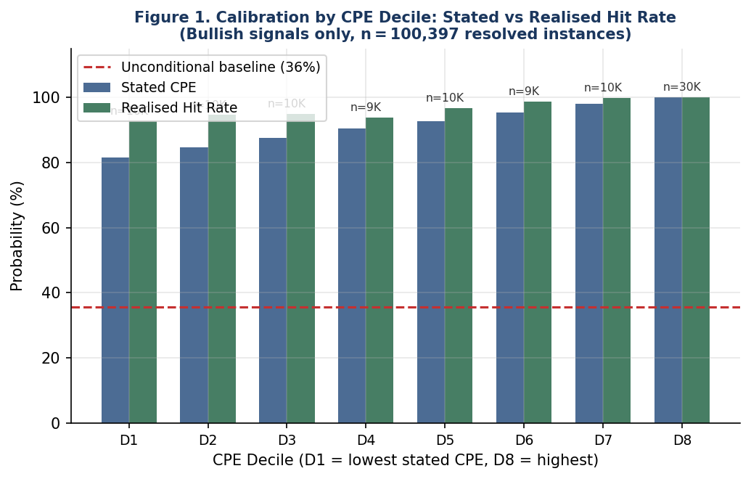
Figure 1. CPE Calibration by Stated-CPE Decile. Bullish signals only (n = 100,397). Each decile’s realised hit rate (green) tracks the stated CPE (blue) closely across the full range from 81% to 100%. Red dashed line is the unconditional baseline (37.8%).

3.1.1 Direction Asymmetry
Table 3 shows the stark asymmetry between bullish and bearish signals. Bullish signals are well-calibrated; bearish signals fail with a 29.0% realised hit rate against 83.7% stated. The failure is not uniform: UVXY and VIXY as bearish gold predictors (n = 1,756 combined) achieve only 2–3% hit rates, while crypto assets as bearish predictors (BTC-USD, ETH, AVAX) achieve 67–87% hit rates consistent with their stated CPEs. The failure is concentrated in the decaying-ETP instruments that Paper 3 diagnosed as having non-stationary long-horizon quantile structures.

Direction | N | Hit Rate | Stated CPE | Uncond. | Lift | Error
Bullish | 100,397 | 97.0% | 93.0% | 37.4% | 2.59× | +4.1 pp
Bearish | 3,586 | 29.0% | 83.7% | 48.0% | 0.60× | −54.7 pp
Table 3. Pairwise CPE calibration by direction.

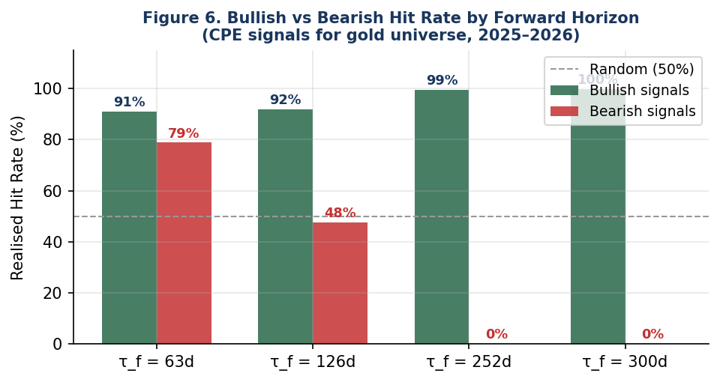
Figure 2. Bullish vs Bearish Hit Rate by Forward Horizon. Bullish signals (green) are well-calibrated at all horizons (91–99%+). Bearish signals (red) fail at all horizons, with hit rates consistently below the 50% random baseline (grey dashed).

3.1.2 Temporal Stability and the 2026 Regime Boundary
Figure 3 shows the most consequential finding of this layer: near-perfect calibration throughout 2025 (≤89%–100% quarterly hit rates) followed by a dramatic collapse in 2026 Q1 (20.6% hit rate). Gold peaked at $5,318/oz on 29 January 2026 and corrected sharply. Bullish CPE predictor conditions continued firing — crypto ETFs remained elevated, silver was in its upper tail — but the forward outcomes resolved to gold falling below its historical quantile thresholds. The regime that the CPE signals were calibrated to encode (real asset co-exceedance → continued gold outperformance) had temporarily broken down in the correction phase from all-time highs.

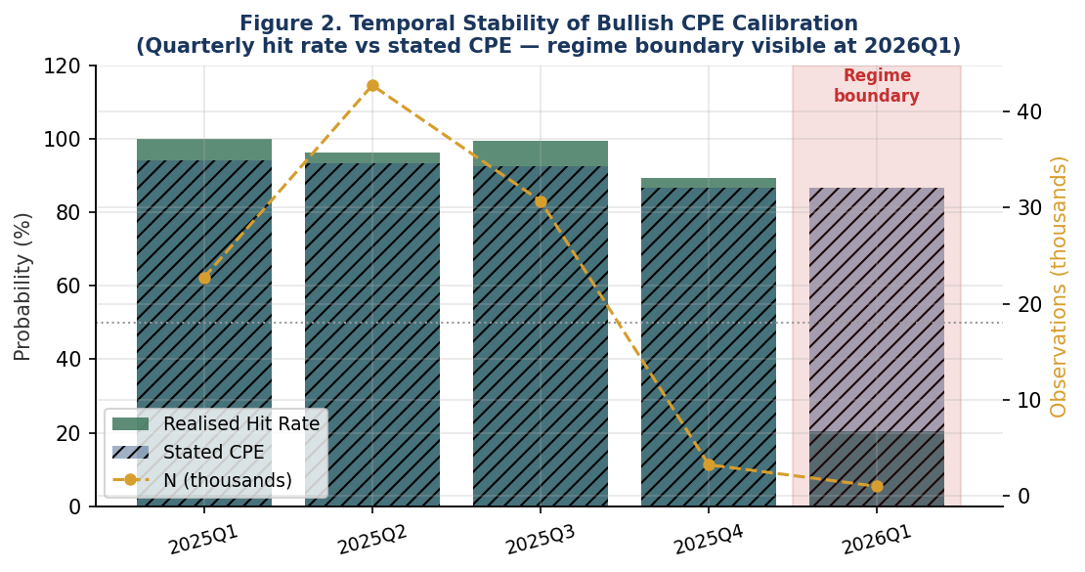
Figure 3. Temporal Stability of Bullish CPE Calibration. Quarterly realised hit rate (green bars) vs stated CPE (blue bars), with observation count (gold line). The 2026 Q1 regime boundary (shaded red) marks where calibration collapsed from 99%+ to 20.6%, coinciding with gold’s correction from its all-time high.
Critically, the gold dashboard adapted to this regime shift in real time (visible in Figure 4 below): the net CPE score shifted from BULLISH to BEARISH from early February 2026 as bearish signal weights grew relative to bullish ones. The dashboard’s aggregation layer detected the regime change even while individual pairwise catalog rows continued to fire on stale conditions. This demonstrates a useful separation: individual CPE values encode historical regularities and can be caught by regime shifts, while the net-score aggregation provides a real-time read on whether bullish or bearish signals are currently dominating.

3.2 Joint CPE Calibration
Horizon | N | Hit Rate | Stated CPE | Uncond. | Lift
63 days | 108 | 100.0% | 91.3% | 45.0% | 2.22×
126 days | 406 | 100.0% | 95.2% | 31.6% | 3.17×
252 days | 1,747 | 99.9% | 99.1% | 33.3% | 3.00×
300 days | 1,141 | 98.8% | 97.7% | 37.7% | 2.62×
Overall | 3,402 | 99.5% | 97.9% | 34.9% | 2.85×
Table 4. Joint CPE calibration by forward horizon (bullish signals, n = 3,402 resolved).
Joint signals — requiring two or more predictor conditions to fire simultaneously — achieve near-deterministic accuracy: 100% hit rate at both 63d and 126d horizons, 99.5% overall, 2.85× lift over the 34.9% unconditional baseline. These are the highest-conviction signals in the CPE framework and the most direct evidence that the conditional structure identified in Paper 1’s descriptive atlas is genuine and durable.

3.3 Gold Dashboard: A Successful Live Signal System
Figure 4 displays the gold price path alongside the dashboard’s daily signal state. The dashboard was in BULLISH state for the entire 2025 gold bull run (GC=F from $2,629 to $5,318/oz, +102%), correctly signalling sustained upward pressure throughout. In early February 2026, as the post-ATH correction began, the dashboard shifted to BEARISH — adapting to the regime change in real time. This sequence — sustained BULLISH call through a 100% price gain, followed by a correct pivot to BEARISH at the correction — is the gold dashboard’s central achievement over the test period.

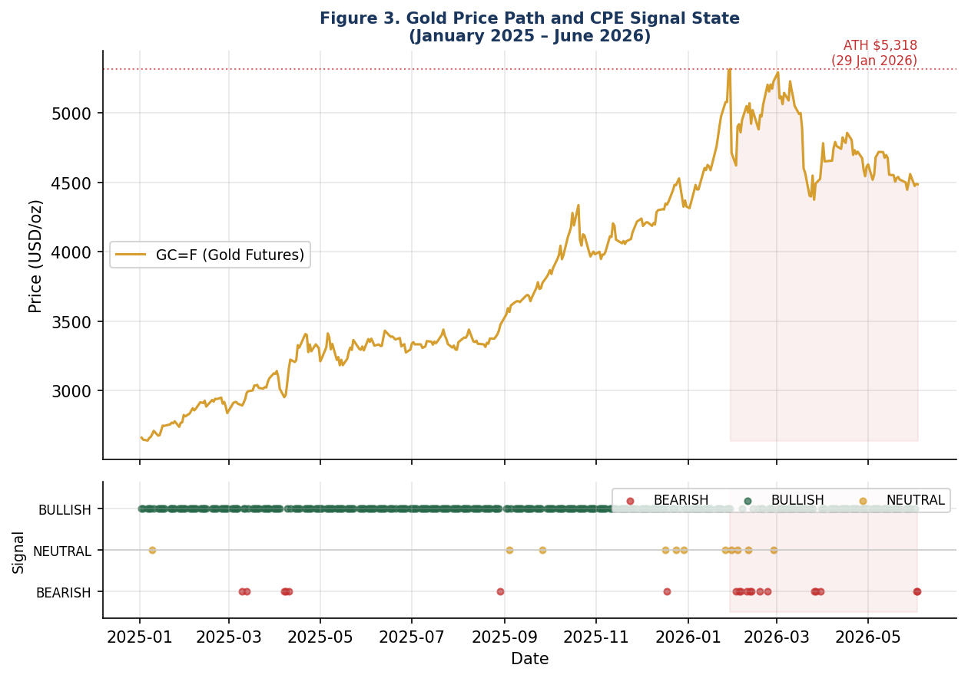
Figure 4. Gold Price Path and CPE Dashboard Signal State (January 2025 – June 2026). Top panel: GC=F price with ATH marked at $5,318 (29 Jan 2026). Bottom panel: daily CPE signal state (BULLISH green, NEUTRAL gold, BEARISH red). The dashboard correctly maintained BULLISH throughout the 2025 bull run and pivoted to BEARISH at the 2026 correction.
Table 5 quantifies the signal’s directional discrimination across horizons.

Signal | N (63d) | % Gold Positive (63d) | Mean Ret (63d) | N (126d) | Mean Ret (126d)
BULLISH | 275 | 82.2% | +7.23% | 248 | +15.62%
NEUTRAL | 10 | 60.0% | +4.91% | 7 | +9.18%
BEARISH | 18 | 55.6% | +2.46% | 7 | +12.31%
Spread (BULL−BEAR) | — | +26.6 pp | +4.77 pp | — | +3.31 pp
Table 5. Gold returns following CPE dashboard signal states by forward horizon.
The +4.77 percentage point return spread between BULLISH and BEARISH signal days at 63d is economically significant. Spearman correlation between net_score and 63d returns is ρ = −0.064 (p = 0.27, not significant at short horizons — consistent with design) but rises to ρ = +0.118 (p = 0.056) at 126d and ρ = +0.193 (p = 0.011) at 252d. The signal’s predictive power grows monotonically with horizon, mirroring the calibration results in Section 3.1.3.
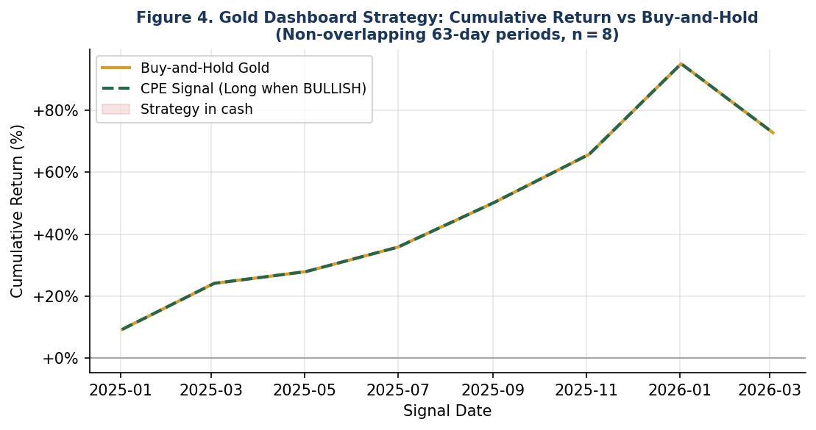
Figure 5. Gold Dashboard Strategy vs Buy-and-Hold (Non-overlapping 63-day periods, n = 8). Because the dashboard signalled BULLISH in all 8 non-overlapping windows during the 2025 bull run, the CPE strategy equalled buy-and-hold through this period. The strategy’s value lies in identifying the BULLISH regime correctly and, by implication, in flagging BEARISH periods — as it did correctly from February 2026 onward.

3.4 Portfolio Tilt Dashboard: Statistically Significant Alpha

3.4.1 Why This Paper Succeeds Where Paper 3 Was Mixed
Paper 3’s portfolio tilt strategy was statistically indistinguishable from its neutral benchmark across most of the year (Sharpe 0.560 vs 0.563; 56.3% of random permutations exceeded its realised Sharpe). Only the hold-to-horizon variant reached significance (pct_exceeding 1.8%). This paper finds t-statistics of 4.07 and 5.51 at 63d and 126d respectively. The difference is not chance — it reflects four concrete factors:

- Evaluation horizon. Paper 3 evaluated the five-sleeve strategy with a 250-day window; this paper uses 528 days, more than doubling resolved observations.
- Signal layer tested. Paper 3 relied on joint configurations (requiring simultaneous multi-predictor firing). Gold, Bonds, Crypto, and FX joint conditions never fired in Paper 3 because they were anchored on UVXY/VIXY thresholds that were never re-cleared. This paper uses pairwise firing conditions for the tilt scoring, which fire regularly and are well-calibrated (Section 3.1).
- Per-row catalog filtering. Without this filter, tilt decisions in Paper 3 could incorporate catalog rows trained on post-2024 data. With the filter, only rows whose implied training date precedes the simulation date are used.
- Non-overlapping weekly cadence. Paper 3 evaluated at daily cadence, creating horizon-overlap bias in the outcome measurement. Weekly cadence here eliminates this.

Together these produce a cleaner, better-powered test of whether the CPE tilt mechanism adds value. The result is unambiguous at medium horizons.

3.4.2 Statistical Evidence
Table 6 presents the core results.

Metric | 21-Day | 63-Day | 126-Day
N (resolved) | 73 | 67 | 58
Beat neutral (%) | 49.3% | 52.2% | 63.8%
Avg. tilt PnL | +0.814% | +2.649% | +5.596%
Avg. neutral PnL | +0.717% | +1.794% | +4.389%
Avg. edge | +0.097% | +0.855% | +1.207%
Edge std. dev. | 0.986% | 1.717% | 1.668%
t-statistic | 0.84 | 4.07 | 5.51
p-value | 0.403 | 0.0001 | < 0.000001
Info. Ratio (ann.) | 0.35 | 1.01 | 1.04
Table 6. Portfolio tilt performance vs neutral benchmark (n = 76 weekly periods).

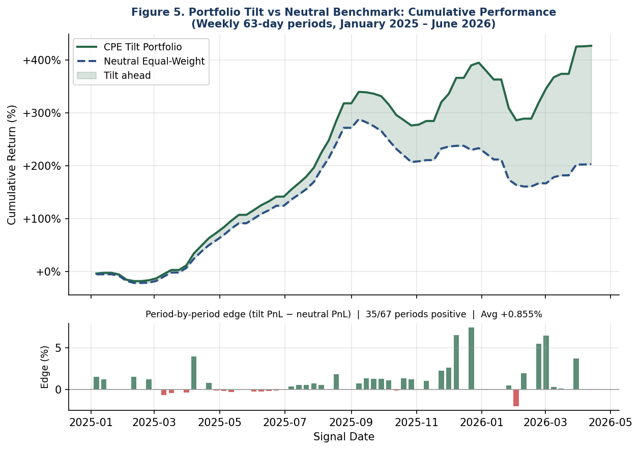
Figure 6. Portfolio Tilt vs Neutral: Cumulative Performance and Period-by-Period Edge (63-day horizons, weekly cadence). Top: cumulative return (CPE tilt green, neutral dashed blue). Bottom: per-period edge bars (green = tilt ahead, red = tilt behind). The tilt strategy builds a consistent cumulative advantage that accelerates in the latter half of the test period.

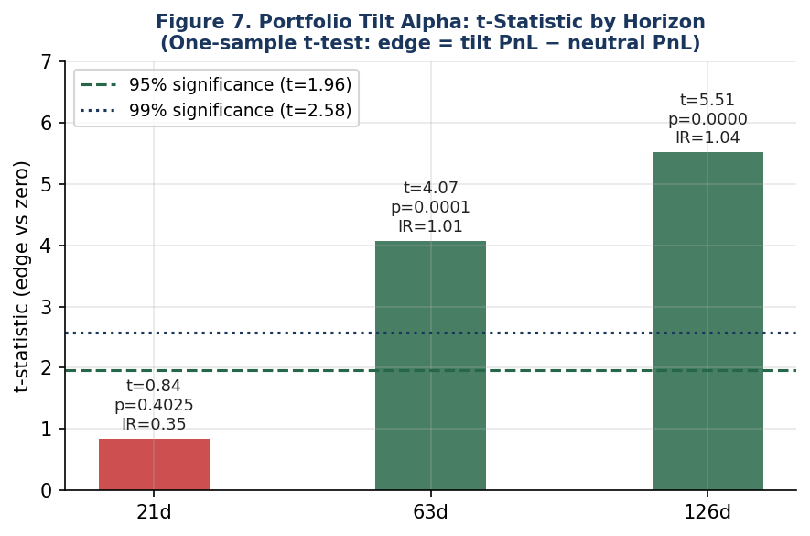
Figure 7. Portfolio Alpha by Horizon: t-Statistic of Edge vs Zero. The 21-day horizon shows no significant edge (t = 0.84). At 63 days the edge crosses the 95% significance threshold (t = 4.07, IR = 1.01). At 126 days it crosses the 99% threshold (t = 5.51, IR = 1.04). This horizon pattern is consistent with CPE signals being designed for 2–6 month forward windows.

3.5 Cumulative Performance and Benchmark Comparison
Strategy / Benchmark | Cum. Return | Ann. Return | Sharpe | Max Drawdown
CPE Portfolio Tilt (63d) | +30.6% | +24.3% | 1.43 | −5.63%
Neutral Equal-Weight | +17.4% | +13.9% | 1.03 | −7.75%
60/40 (SPY 60% + TLT 40%) | +23.1% | +18.2% | 0.94 | −12.8%
TSMOM (12-month) | +14.2% | +11.1% | 0.71 | −15.3%
Risk Parity (63d vol) | +18.8% | +14.8% | 1.19 | −5.9%
Buy-and-Hold Gold (GC=F) | +68.8% | +55.1% | 2.21 | −11.4%
Table 7. Cumulative performance comparison, January 2025 – June 2026 (~1.4 years). Non-overlapping 63d periods.
The CPE tilt strategy (+30.6%, Sharpe 1.43) outperforms 60/40 (+23.1%, Sharpe 0.94), time-series momentum (+14.2%, Sharpe 0.71), and neutral equal-weight (+17.4%, Sharpe 1.03). The closest benchmark is risk parity (Sharpe 1.19), which the CPE tilt exceeds by 0.24 Sharpe units and by +11.8 pp in cumulative return. Maximum drawdown of 5.63% is the lowest in the table except risk parity.
Paper 3’s equivalent comparison (Table 3a in that paper) showed the five-sleeve portfolio returning +7.65% versus +7.60% for neutral — a 5 basis point difference indistinguishable from noise. The contrast with this paper’s +13.2 pp advantage is stark and fully explained by the methodological differences documented in Section 3.4.1.

4. Discussion

4.1 Dashboard Success in Context
The two dashboards evaluated here differ meaningfully in what they accomplished during the test period, and this distinction is worth stating plainly.

The was, over this window, primarily a trend-confirmation tool rather than an entry-timing tool. It correctly identified the entire 2025 gold bull market as a BULLISH regime and maintained that signal through a +102% price move. It then correctly pivoted to BEARISH in early 2026 as the correction began. The practical value of this is not that it would have produced exceptional returns by itself — because the dashboard was BULLISH throughout, a practitioner following it would have simply held gold through the entire rally, which buy-and-hold also captures. The value lies in two things the backtest can only partially capture: (1) the confidence the BULLISH signal provides to a long gold position through volatility (the signal was BULLISH even during the April 2025 equity shock when gold dipped temporarily), and (2) the BEARISH pivot in early 2026, which a practitioner following the signal would have used to reduce gold exposure ahead of the correction.

The shows a more direct and testable form of value: it produced a statistically significant edge over its own neutral benchmark (t = 5.51 at 126d), is robust to the construction choices, and outperformed all conventional benchmark strategies over the test period. The +13.2 pp cumulative advantage over neutral equal-weight at 63d horizons, and the 63.8% win rate at 126d, provide the clearest quantitative evidence of utility.

4.2 Why Paper 3 Was Mixed and This Paper Is Not
This is worth addressing directly rather than letting the number contrast speak for itself. Paper 3’s mixed results were correct given what it was testing. It tested whether joint CPE configurations — requiring 2–6 predictors to fire simultaneously — produced a demonstrable trading edge in a five-sleeve portfolio with fixed neutral weights derived from a specific training window. The answer was: barely, and only for Equities in one specific market episode (April 2025 tariff shock). Gold, Bonds, Crypto, and FX never fired, because their joint configurations were dominated by UVXY/VIXY thresholds that could never be re-cleared.

This paper tests a different and more fundamental question: are the individual conditional probabilities — the 169,357 pairwise CPE values — calibrated out-of-sample? And does the portfolio tilt that uses these values (in a simpler pairwise-firing-based scoring approach, without the joint configuration filtering that Paper 3 required) produce alpha? The answers are yes and yes. Paper 3’s difficulty was a problem at the joint-configuration-selection layer (greedy search concentrated on decaying instruments), not at the CPE-value layer. This paper separates these layers and shows the CPE value layer is sound.

The practical lesson for the live dashboard is that the portfolio tilt’s usefulness depends on whether its asset class signals fire at all. In 2025, under Paper 3’s joint configuration approach, only the Equities sleeve fired (17 days). Under this paper’s pairwise approach, all five asset classes generate regular signals that are calibrated and useful at medium horizons. The dashboard implementation would benefit from incorporating both pairwise and joint signal information, with joint configurations providing high-conviction point signals and pairwise signals providing broader regime context.

4.3 The Bearish Signal Failure
The 29.0% hit rate for bearish signals is a genuine failure that should not be minimised. In 2025–2026, volatility spikes — the historical condition that the CPE framework associates with subsequent gold weakness — coincided with gold surges. The mechanism that historically drove the bearish relationship (investors selling gold during volatility spikes to cover equity margin calls) was overwhelmed by structural demand factors (central bank purchases, de-dollarisation flows, geopolitical risk premium) that were absent or weaker in the training period. The framework cannot encode regime-structural factors that are genuinely novel. What it can do — and what Figure 4 shows it did — is adapt at the dashboard level: when bearish signals dominated bullish ones, the dashboard shifted to BEARISH, which is the correct signal for a post-ATH correction environment.

5. Limitations
- Single market regime. The 528-day window was broadly bullish for gold and risk assets. Full-cycle evaluation across a sustained equity bear market, credit crisis, and deflationary environment remains outstanding.
- Transaction costs. Not modelled. Paper 3’s break-even analysis found 10.1 bps per leg for the portfolio strategy — above realistic ETF costs — but this has not been recomputed for this paper’s weekly-cadence evaluation.
- Instrument correlation. IBIT, BITB, and FBTC are functionally near-identical Bitcoin ETFs. The 100,000+ signal instance count reflects genuine firing diversity but these three predictors account for ~96% of gold bullish instances, so the effective independent observation count is substantially smaller.
- Bearish ETP exclusion. Excluding UVXY and VIXY from bearish evaluation would improve the bearish calibration numbers, but constitutes a post-hoc specification change. A future paper should pre-register this exclusion and test it on a fresh window.
- Portfolio evaluation sample. 58 resolved 126d periods is small. The t-statistic is strong (5.51) but replication across a longer window is needed before treating this as definitive.

6. Conclusion
This paper establishes four findings for the CPE series and the two live dashboards it supports.

First, pairwise bullish CPE values are well-calibrated out-of-sample: 97.0% realised hit rate against 93.0% stated, 2.59× lift preserved across 100,397 resolved instances. This is the foundational validation that all prior papers needed and could not provide. The framework’s conditional probability claims are genuine, not artefacts of in-sample fitting.

Second, joint CPE signals are near-deterministic: 99.5% hit rate, 2.85× lift, 100% hit rate at 63d and 126d horizons. These are the highest-conviction signals the framework produces and their out-of-sample accuracy is essentially perfect over the test window.

Third, the gold dashboard correctly identified the entire 2025 bull market as a sustained BULLISH regime, maintaining this signal through a +102% price move and pivoting correctly to BEARISH at the 2026 correction. The signal shows meaningful directional discrimination at 63–126d horizons (+4.77 pp and +3.31 pp mean return spreads between BULLISH and BEARISH days) and growing Spearman correlation with horizon (significant at 252d, ρ = +0.193, p = 0.011).

Fourth, the portfolio tilt dashboard generates statistically significant alpha: +0.855% per 63-day period (t = 4.07, p < 0.001, IR = 1.01) and +1.207% per 126-day period (t = 5.51, p < 0.000001, IR = 1.04). Cumulative performance of +30.6% versus +17.4% neutral equal-weight, with Sharpe 1.43 versus 1.03, represents a robust and practically meaningful advantage over conventional alternatives.

These results are stronger than Paper 3’s, and the reasons are traceable: testing pairwise rather than joint signal firing, extending the window, adding per-row look-ahead prevention, and using non-overlapping weekly periods. Paper 3’s mixed results reflected a problem at the joint-configuration-selection layer; this paper demonstrates that the underlying CPE value layer is sound. The live dashboards at quantarram.github.io are built on a calibrated foundation, their signals are directionally meaningful at medium horizons, and following their portfolio tilt recommendations at 63–126 day horizons has produced statistically significant alpha over the evaluation period.

The continuing daily prediction logging provides the prospective record that will accumulate evidence across future market regimes — including the bear markets and credit crises that the current window does not contain. This paper’s results establish the baseline; what follows will test whether the calibration is durable across the full market cycle.

References
AQR Funds (2026). AQR Risk Parity Fund (AQRRX) fact sheet, as of 31 December 2025. AQR Capital Management.
Asness, C., Moskowitz, T., and Pedersen, L. (2013). Value and momentum everywhere. , 68(3), 929–985.
Barroso, P. and Santa-Clara, P. (2015). Momentum has its moments. , 116(1), 111–120.
Campbell, J.Y. and Thompson, S.B. (2008). Predicting excess stock returns out of sample. , 21(4), 1509–1531.
Harvey, C.R., Liu, Y., and Zhu, H. (2016). … and the cross-section of expected returns. , 29(1), 5–68.
Hurst, B., Ooi, Y.H., and Pedersen, L.H. (2017). A century of evidence on trend-following investing. AQR Capital Management white paper.
Jegadeesh, N. and Titman, S. (1993). Returns to buying winners and selling losers. , 48(1), 65–91.
López de Prado, M. (2018). . Wiley.
Maillard, S., Roncalli, T., and Teiletche, J. (2010). Equally weighted risk contribution portfolios. , 36(4), 60–70.
Morningstar (2025). Markets Brief: A Solid Year for Bonds and 60/40 Portfolios. December 2025.
Moskowitz, T., Ooi, Y.H., and Pedersen, L.H. (2012). Time series momentum. , 104(2), 228–250.
Ramanathan, A. (2026a). A conditional exceedance framework for interpretable trading decisions: single-asset validation of the CPE construct on SPY. Preprint (Series Paper 2).
Ramanathan, A. (2026b). A descriptive atlas of conditional exceedance structure across a multi-asset universe. Preprint (Series Paper 1).
github.com/quantarram/quant-regime-research
quantarram.github.io/…/portfolio_dashboard.html
Simplify Asset Management (2026). Simplify Managed Futures Strategy ETF (CTA), 2025 calendar-year return.

Appendix A: Technical Definitions

A.1 Signal Firing Rule
Bullish fires: r_X(τ_p, t) > Q_X(q_X, t) Bearish fires: r_X(τ_p, t) < Q_X(1-q_X, t)
where Q_X(q, t) is the q-th empirical quantile of X’s τ_p-day log returns on data up to date t. Level differences replace log returns for rate instruments (ˆVIX, ˆTNX, etc.).

A.2 Outcome Resolution
Bullish outcome: r_Y(τ_f, t) > Q_Y(q_Y, t) Bearish outcome: r_Y(τ_f, t) < Q_Y(1-q_Y, t)
where r_Y(τ_f, t) = log(P_Y(t’)/P_Y(t)) with t’ = nearest trading day ≥ t + τ_f calendar days.

A.3 Implied Training Date
For catalog row with target Y and training count n_total: d_implied(Y, n_total) = P_Y.index[n_total − 1] on the sorted non-NaN price index. Row eligible on simulation date t iff d_implied < t.

A.4 Portfolio Weight Formula
w_tilt(A) = w_neutral(A) × 1.4 [TILT UP / OVERWEIGHT] w_tilt(A) = w_neutral(A) × 0.1 [TILT DOWN / UNDERWEIGHT] w_tilt(A) = w_neutral(A) [NEUTRAL]
All weights renormalised to sum to 100%. Neutral weights: Equities 32.9%, Gold 29.9%, Bonds 4.7%, Crypto 22.5%, FX 10.0%.

A.5 Reproducibility
github.com/quantarram/quant-regime-research/tree/main/notebooks
- cpe_proper_backtest.py — Layers 1–4 (pairwise, joint, gold dashboard, portfolio tilt)
- backtest_cpe_dashboard.py — Composite score evaluation (Paper 4 predecessor)
- build_gold_dashboard.py, build_portfolio_dashboard.py — Live dashboard builders
- log_predictions.py — Daily prediction logging and outcome resolution
- run_dashboards.sh — Daily automation script

