1. Connecting and getting data from wristband algorithm.
   1. Definition:
      * This algorithm proposes general method to connect and get data from wristband device using bluetooth LE standard.
   2. Define Problem:
      * Every wristband has an unique way for connect and getting data. We must provides a common interface for connecting device and getting information from wristband.
   3. Solution:
      * To solve this problem, we follow these steps:
        + Step 1: Setting up BLE:

* Application will get Bluetooth Adapter Object from system for getting BLE devices list.
* Application will enable BLE functionality of system.
  + - * Step 2: Finding BLE Devices:
* Firstly, we have to implement a callback named LeScanCallback. This callback is called when Android OS detects a new device. This callback will do following actions:
  + - Get device name, device address and add this device to device list.
    - Show device list to user.
* On Android 4.3 and above, Android OS has supported two methods startLEScan and stopLEScan for BluetoothAdapter. We only can start startLEScan when user logged in to system and will stop stopLEScan when user select one device.
  + - * Step 3: Connecting to GATT Server:
* Firstly, application has to start a service. In that service, we have to implement a callback named BluetoothGattCallback. This callback is called when Android OS get an event from wristband.

This callback has following events:

* + - Connection state change event: If wristband state is connected, system will get data from wristband.
    - Services discovered event: When connect with wristband, wristband will send wristband profile. Structure of wristband’s profile(BLE Device’s profile) like below image. We will analytic wristband profile to get device name and get data from wristband device follow list characteristic of that device.

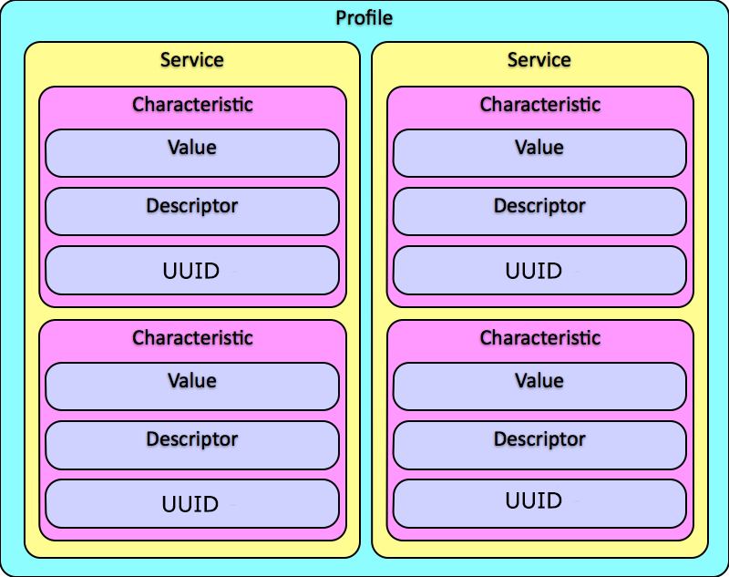

* + - Characteristic read event: When we call readCharacteristic() function, Android OS will read data of Wristband Characteristic. After that, Android OS will send value of wristband characteristic to this callback event.
* Secondly, application creates a BluetoothReceiver to receive and analytic data that has received in BluetoothGattCallback.
* Finally, application will call method “connect” of BluetoothDevice class. After that, Android OS send command with wristband. Wristband will send to Android OS wristband’s profile. Android OS will send wristband’s profile to BluetoothGattCallback.

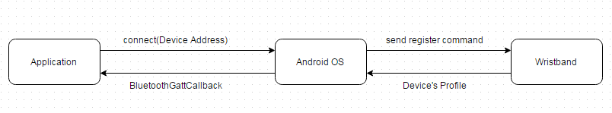

* + - * Step 4: Receiving Data From Wristband.
* When we need get data from wristband, we will call function readCharacteristic() (This function has implemented in BluetoothGatt class from Android OS).
* Android OS will get data from wristband and send it to BluetoothGattCallback.
* BluetoothGattCallback will send data to Bluetooth Receiver. Bluetooth Receiver will receive data and notice to function call readCharacteristic().

1. Analytic meal.
   1. Defination:
   2. Define Problem:
   3. Solution:
2. Analytic voice.
   1. Defination:
   2. Define Problem:
   3. Solution: