# Software Requirement Specification

## User Requirement Specification

### Admin requirement

Admin is people who manages staff. Administrator can use some following functions:

* Manage account includes:
* Delete account
* Update account
* Insert account

## System Requirement Specification

### List of Use Case

* + - 1. **Web Application**
         1. **<Admin> Overview Use Case**

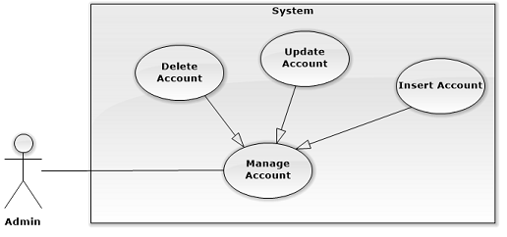

* + - * 1. **<Admin> Insert Account**

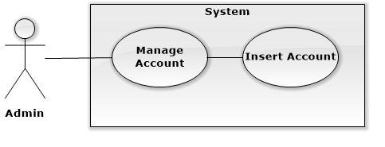

|  |  |  |  |
| --- | --- | --- | --- |
| USE CASE – WA01 | | | |
| Use Case No. | WA01 | **Use Case Version** | 2.0 |
| Use Case Name | Insert Account | | |
| Author | KhuongMH | | |
| Date | 23/09/2015 | **Priority** | High |
| Actor:   * Admin   Summary:   * This use case allows admin to create new account and insert it to system.   Goal:   * Admin can create new account and insert it to system.   Triggers:   * Admin sends command to insert new account to system.   Preconditions:   * User has to logged in to the system as Admin role.   Post Conditions:   * Success: Admin is able to create new account and insert it to system. * Fail: Show error message.   Main Success Scenario:   |  |  |  | | --- | --- | --- | | Step | Actor Action | System Response | | 1 | Admin click on “Create New Account” on menu | System list out information of account in system and components:   * Username: Text * Password: Text * Confirm Password: Text * Full Name: Text * Address: Text * Role: ComboBox * Register: Button * Cancel: Button | | 2 | Admin fill in information of account and click on “Register” button.  [Alternative 1] |  | | 3 | Admin sends command to create new account to system. | System shows message account has been created successfully.  [Exception 1] |   Alternative Scenario:   |  |  |  | | --- | --- | --- | | Step | Actor Action | System Response | | 1 | Admin click on “Cancel” button. | System redirect to previous page. |   Exceptions:   |  |  |  | | --- | --- | --- | | Step | Actor Action | System Response | | 1 | Admin sends command to create new account to system | System shows error message user cannot create because duplicated username. |   Relationships: N/A  Business Rules:   * New Account will be set status standard is De-activate. * All information about account still remain in the system. | | | |

**1.2.1.1.3 <Admin> Update Account**

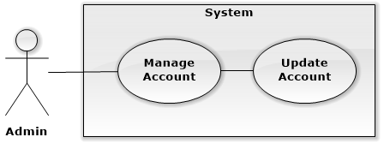

|  |  |  |  |
| --- | --- | --- | --- |
| USE CASE – WA02 | | | |
| Use Case No. | WA02 | **Use Case Version** | 2.0 |
| Use Case Name | Update Account | | |
| Author | KhuongMH | | |
| Date | 23/09/2015 | **Priority** | High |
| Actor:   * Admin   Summary:   * This use case allows admin to update account’s profile.   Goal:   * Admin can update account’s profile.   Triggers:   * Admin sends command to update account’s profile to system.   Preconditions:   * User has to logged in to the system as Admin role.   Post Conditions:   * Success: Admin is able to update account’s profile and send it to system. * Fail: Show error message.   Main Success Scenario:   |  |  |  | | --- | --- | --- | | Step | Actor Action | System Response | | 1 | Admin search username which want to update and click on username | System list out information of account in system and components:   * Username: Text, read-only * New Password: Text * Confirm New Password: Text * Full Name: Text * Address: Text * Role: ComboBox * Status: ComboBox * Update: Button * Cancel: Button | | 2 | Admin fill in updated information of account and click on “Update” button.  [Alternative 1] |  | | 3 | Admin sends command to update account to system. | System shows message account has been created successfully.  [Exception 1] |   Alternative Scenario:   |  |  |  | | --- | --- | --- | | Step | Actor Action | System Response | | 1 | Admin click on “Cancel” button. | System redirect to previous page. |   Exceptions: N/A  Relationships: N/A  Business Rules: N/A | | | |