### List of Use Case

##### <Doctor> View Patient Medical History

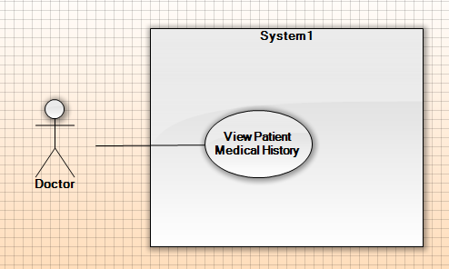

|  |  |  |  |
| --- | --- | --- | --- |
| **USE CASE – UCA02** | | | |
| **Use Case No.** | UCA01 | **Use Case Version** | 1.1 |
| **Use Case Name** | View Patient Medical History | | |
| **Author** | AnhPN | | |
| **Date** | 23/09/2015 | **Priority** | High |
| **Actor:**   * Doctor.   **Summary:**   * This use case allows Doctor views medical history of patient.   **Goal:**   * Show medical history of patient for doctor.   **Triggers:**   * Doctor sends command to view medical history of patient request.   **Preconditions:**   * User logged in the system by role doctor before. * Doctor selected a patient before.   **Post Conditions:**   * **Success:** Medical history of patient show for doctor. * **Fail:** Show error message   **Main Success Scenario:**   |  |  |  | | --- | --- | --- | | Step | Actor Action | System Response | | 1 | Doctor goes to view medical history of patient. | System display   * Name: text, read only. * Age: text, read only. * Gender: text, read only. * Illness: text, read only. * Status: text, read only. * Description: text area, read only. * List day of medical history of patient with information:   + Date: the day when doctor make prescription, format day dd/mm/yyyy, ex: “29/10/2015”.  + Appointment: appointment of Date, format day dd/mm/yyyy, ex: “29/10/2015”.  - Status: “treating” or “finish”. | | 2 | Doctor select an appointment to view.  [Alternative 1] | System display medical history of patient in that day.  System display patient’s information   * Name: text, read only. * Age: text, read only. * Gender: text, read only. * Information date: text, read only. * Height: text, read only. * Weight: text, read only. * Medical history: table, read only. * Clinical symptoms: table, read only.   Suggest treatment information.  Diagnostic: text, read only.  - Medicines:  + Name of medicine: text, read only.  + Number of times per day: text, read only.  + Number of quantity per time: text, read only.  - Food:  + Name of food: text, read only.  + Time: text, read only.  - Practice:  + Name of practice: text, read only.  + Intensity: text, read only.   * Appointment Date: text, read only.   Note: text, read only. |   **Alternative Scenario:**  [Alternative 1]   |  |  |  | | --- | --- | --- | | No | Actor Action | System Response | | 1 | Doctor send command to view day request.  If the day to view is current day. | Show make prescription. |   **Exceptions:** N/A  **Relationships:** N/A  **Business Rules:**   * List day of medical history of patient must have at least one record. * Sorted descending by day of Date. | | | |

##### <Doctor> Make appointment.

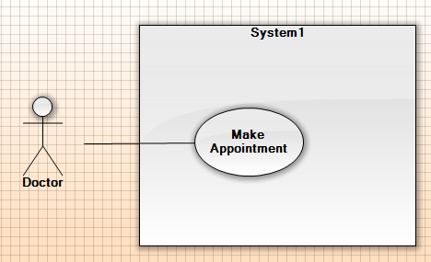

|  |  |  |  |
| --- | --- | --- | --- |
| **USE CASE – UCA05** | | | |
| **Use Case No.** | UCA03 | **Use Case Version** | 1.0 |
| **Use Case Name** | Make appointment | | |
| **Author** | AnhPN | | |
| **Date** | 24/09/2015 | **Priority** | High |
| **Actor:**   * Doctor.   **Summary:**   * This use case allows doctor to make appointment with patient.   **Goal:**   * New appointment record is added into system.   **Triggers:**   * Doctor sends command to create appointment request.   **Preconditions:**   * User log in the system by role doctor.   **Post Conditions:**   * **Success:** New appointment is sent to patient. * **Fail:** Show error message.   **Main Success Scenario:**   |  |  |  | | --- | --- | --- | | Step | Actor Action | System Response | | 1 | Doctor goes medical history of patient view. | System display   * Name: text, read only. * Age: text, read only. * Gender: text, read only. * Illness: text, read only. * Status: text, read only. * Description: text area, read only. * List day of medical history of patient with information:   + Date: the day when doctor make prescription, format day dd/mm/yyyy, ex: “29/10/2015”.  + Appointment: appointment of Date, format day dd/mm/yyyy, ex: “29/10/2015”.   * Status: “treating” or “finish”. | | 2 | Doctor send command to make appointment request. | System show popup calendar.   * Appointment Date: format day dd/mm/yyyy, ex: “29/10/2015”. | | 3 | Doctor input day for appointment |  | | 4 | Doctor send command to make appointment request.  [Alternative 1] | System show message successful and send to patient.  [Exception 1] |   **Alternative Scenario:**   |  |  |  | | --- | --- | --- | | No | Actor Action | System Response | | 1 | Doctor send command to cancel request | System close popup calendar. |   **Exceptions:**   |  |  |  | | --- | --- | --- | | No | Actor Action | System Response | | 1 | Doctor input invalid date and send command to make appointment request. | System ask user to input valid date. |   **Relationships:** N/A.  **Business Rules:**   * Appointment date must be in the future and not over 15 days form current day. Format day “dd/mm/yyyy”, ex: 25/09/2015. * When popup calendar, appointment date get default day is next 7 days form current day. | | | |

##### <Scheduler> Suggest Treatment

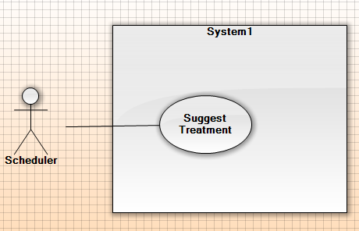

|  |  |  |  |
| --- | --- | --- | --- |
| **USE CASE – UCA02** | | | |
| **Use Case No.** | UCA02 | **Use Case Version** | 1.1 |
| **Use Case Name** | Suggest Treatment | | |
| **Author** | AnhPN | | |
| **Date** | 23/09/2015 | **Priority** | High |
| **Actor:**   * Scheduler.   **Summary:**   * This use case allows scheduler suggest treatment for doctor.   **Goal:**   * Doctor can be suggested base on regimen.   **Triggers:**   * Doctor send command to make prescription request.   **Preconditions:**   * User log in the system by role doctor.   **Post Conditions:**   * Success: Show suggest treatment. * Fail: Log error.   **Main Success Scenario:**   |  |  |  | | --- | --- | --- | | Step | Actor Action | System Response | | 1 | Doctor goes make prescription of patient view. | System display patient’s information   * Name: text, read only. * Age: text, read only. * Gender: text, read only. * Information date: text, read only. * Height: text, read only. * Weight: text, read only. * Medical history: table, read only. * Clinical symptoms: table, read only.   Suggest treatment information.  Diagnostic: free text input, required, length 3-40.  - Medicines:  + Name of medicine: free text input, required, length 3-20.  + Number of times per day: free text input, required, length 3-10.  + Number of quantity per time: free text input, required, length 3-10.  - Food:  + Name of food: free text input, required, length 3-20.  + Time: 3 option, breakfast or lunch or dinner.  - Practice:  + Name of practice: free text input, required, length 3-20.  + Intensity: free text input, required, length 3-10.   * Appointment Date: default 1 week form current day, format day “dd/mm/yyyy/”.   Note: free text area. | | 2 | Doctor input diagnostic. | System validation information. | |  | Doctor send command to suggest prescription | System display patient suggest treatment information.  Diagnostic: free text input, required, length 3-40.  - Medicines:  + Name of medicine: free text input, required, length 3-20.  + Number of times per day: free text input, required, length 3-10.  + Number of quantity per time: free text input, required, length 3-10.  - Food:  + Name of food: free text input, required, length 3-20.  + Time: 3 option, breakfast or lunch or dinner.  - Practice:  + Name of practice: free text input, required, length 3-20.  + Intensity: free text input, required, length 3-10.   * Appointment Date: default 1 week form current day, format day “dd/mm/yyyy/”, required.   Note: free text area. |   **Alternative Scenario:** N/A  **Exceptions:** N/A  **Relationships:** N/A  **Business Rules:**   * Doctor input diagnostic, system get regimen treatment for diagnostic. * System compare number of day treatment of patient with range days of regimen phase. * System suggest medical, foods, practices form information of regimen phase. * If doctor change the diagnostic, current medical history will be finished. New medical history is created. | | | |

##### <Doctor> Make prescription.

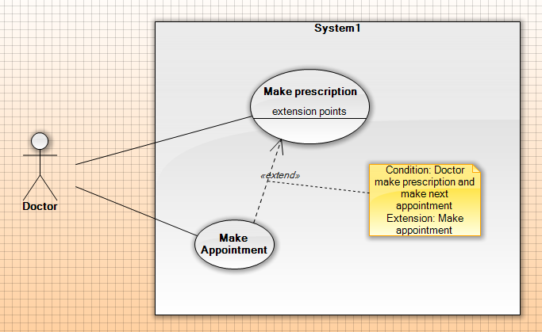

|  |  |  |  |
| --- | --- | --- | --- |
| **USE CASE – UCA06** | | | |
| **Use Case No.** | UCA06 | **Use Case Version** | 1.0 |
| **Use Case Name** | Make prescription | | |
| **Author** | AnhPN | | |
| **Date** | 24/09/2015 | **Priority** | High |
| **Actor:**   * Doctor.   **Summary:**   * This use case allows doctor to make prescription to patient.   **Goal:**   * New prescription data is created.   **Triggers:**   * Doctor send command to make prescription request.   **Preconditions:**   * Actor log in the system by role doctor.   **Post Conditions:**   * **Success:** New prescription is sent to patient. * **Fail:** Display error message.   **Main Success Scenario:**   |  |  |  | | --- | --- | --- | | Step | Actor Action | System Response | | 1 | Doctor send command to make prescription request. | System display patient’s information   * Name: text, read only. * Age: text, read only. * Gender: text, read only. * Information date: text, read only. * Height: text, read only. * Weight: text, read only. * Medical history: table, read only. * Clinical symptoms: table, read only.   Suggest treatment information.  Diagnostic: free text input, required, length 3-40.  - Medicines:  + Name of medicine: free text input, required, length 3-20.  + Number of times per day: free text input, required, length 3-10.  + Number of quantity per time: free text input, required, length 3-10.  - Food:  + Name of food: free text input, required, length 3-20.  + Time: free text input, required, length 5-15.  - Practice:  + Name of practice: free text input, required, length 3-20.  + Intensity: free text input, required, length 3-10.  Note: free text area. | | 2 | Doctor input diagnostic, medicines, food, practice, Note, appointment date. | System validate information, display popup request for confirmation.  [Exception 1] | | 3 | Doctor send command to submit request. | System display popup finish treatment request for confirmation. | | 4 | Doctor send command to confirmation request.  [Alternative 1] | System display popup make appointment request for confirmation.   * Appointment Date: default 1 week form current day, format day “dd/mm/yyyy/”, required. | | 5 | Doctor input appointment date | System validate information  [Exception 2] | | 6 | Doctor send command to Yes request.  [Alternative 2] | System create new prescription, send detail to android application, show message” Create new prescription success”. |   **Alternative Scenario:**  [Alternative 1]   |  |  |  | | --- | --- | --- | | No | Actor Action | System Response | | 1 | Doctor send command to No request. | System close popup confirmation. |   [Alternative 2]   |  |  |  | | --- | --- | --- | | No | Actor Action | System Response | | 1 | Doctor send command to No request. | System create new prescription without appointment date, send detail to android application, show message” Create new prescription success”. |   **Exceptions:**   |  |  |  | | --- | --- | --- | | No | Actor Action | System Response | | 1 | Doctor send command to submit request. | System shows error message to ask doctor input missing required fields | | 2 | Appointment date is invalid day. | System shows error message to notify doctor input valid day. |   **Relationships:** Suggest treatment.  **Business Rules:**   * The prescription must be included medicines. Otherwise, prescription can be include foods and practices. * Appointment date must be in the future and not over 15 days form current day. Format day “dd/mm/yyyy”, ex: 25/09/2015. * When popup calendar, appointment date get default day is next 7 days form current day. | | | |